**RESUME**

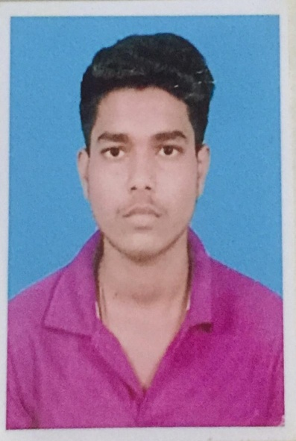

Name : AKASH KOIRI

Age : 17 Years

Sex : M

Date of birth : September 04, 2004

MobileNo. : +91 9330471483

E-mail id : akashkumarkoiri@gmail.com

Address : Khudiram Pally, Bagdipara Road, Kanchrapara,

24 Pgs (N), West Bengal, India

Religion : Hinduism

Languages : Hindi, English, Bengali

**Computer**

**knowladge**  : MS Office, Programming (Python,C,HTML,CSS), Basic Hardware, Software & OS installation knowledge, Basic Networking knowledge

Hobbies : Programming, Playing CTF, Bug Bounty Hunting, Learning New Technologies

**EDUCATION :**

|  |  |  |  |  |
| --- | --- | --- | --- | --- |
| **Course** | **Group** | **Board** | **Pass Year** | **Marks (Percentile)** |
| 10th | Arts | West Bengal Board Of Secondary Education | 2020 | 57 |
| 12th | Arts | West Bengal Council Of Higher Secondary Education | 2022 | 68.4 |
| D.I.T | Computer | Institute of professional studies | 2021 | 74 |

* **Declaration** : The above information is true and correct to the best of our knowledge and belief

Date :

Place : Signature : ...................................