**Q3. Write the code to center a div using CSS Flexbox.**

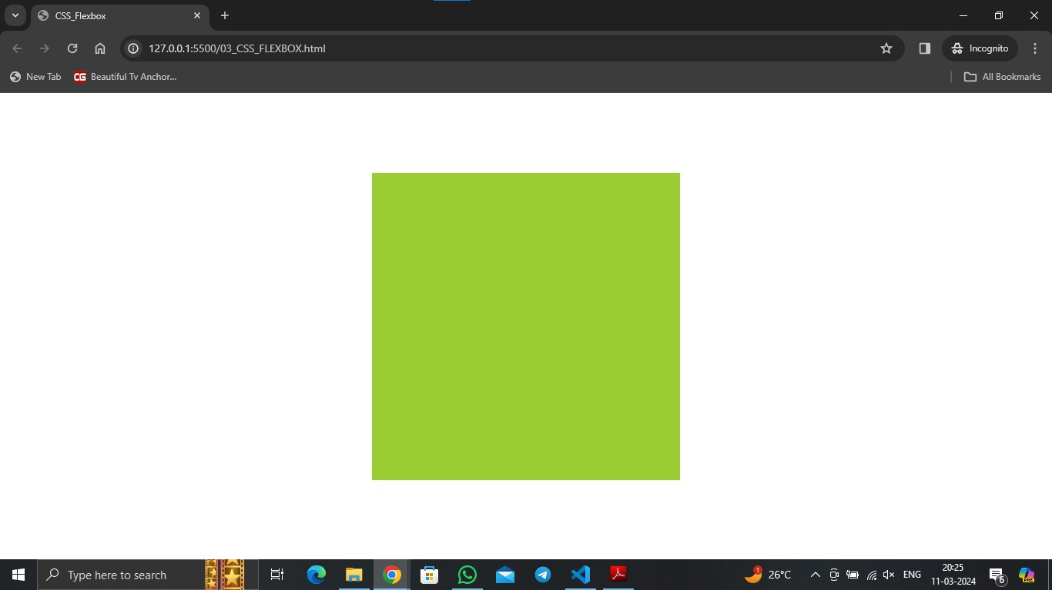**Ans:** 03_CSS_FLEXBOX.html

**Q4. A client of yours wants to add a pricing section on their website to showcase their newly introduced plans.**

**You have to build the pricing section for their business. They have provided you with the figma design for the same.**

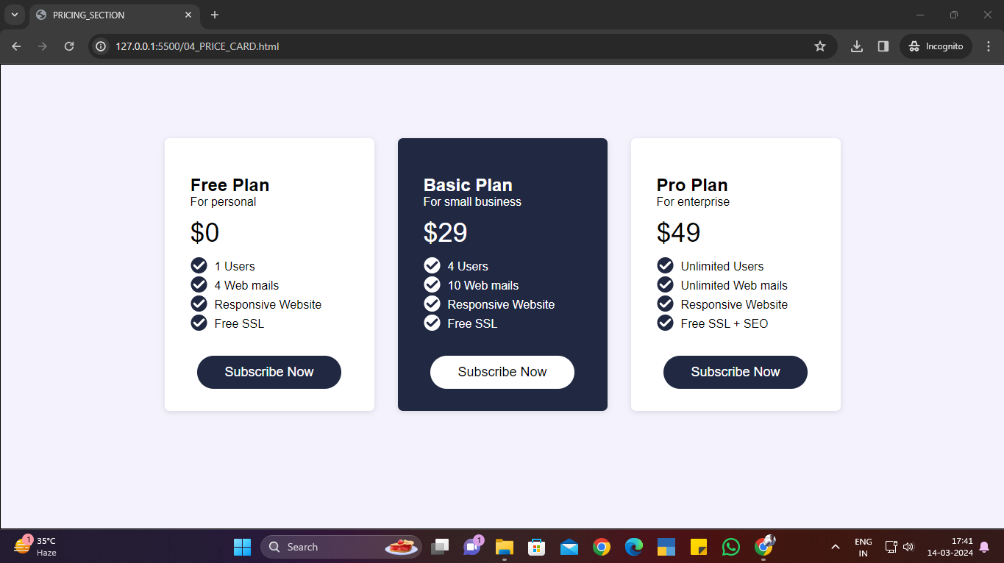**Ans:** 05_PRICE_CARD.html and 05_PRICE_CARD.css

**Q5. Build a clone of the IRCTC Ticket booking page**

**Ans:** 05_irctc.html and 05_irctc.css

