1. 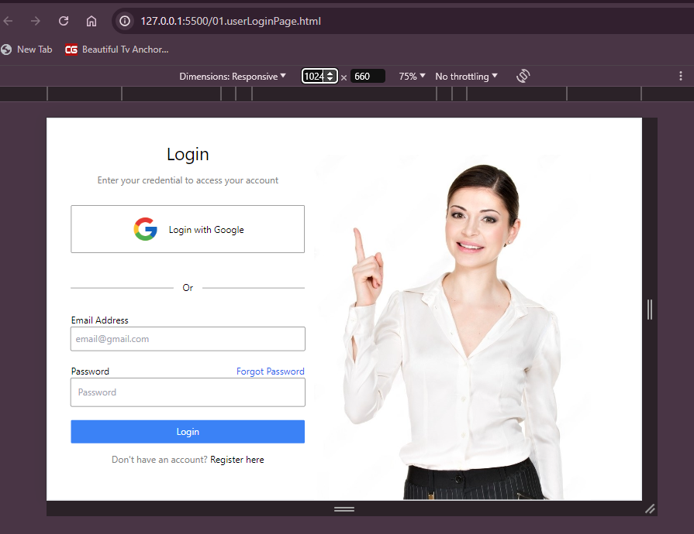**TAILWINDCSS USER LOGIN PAGE**

First Output: **(minimum width of 1024px)**

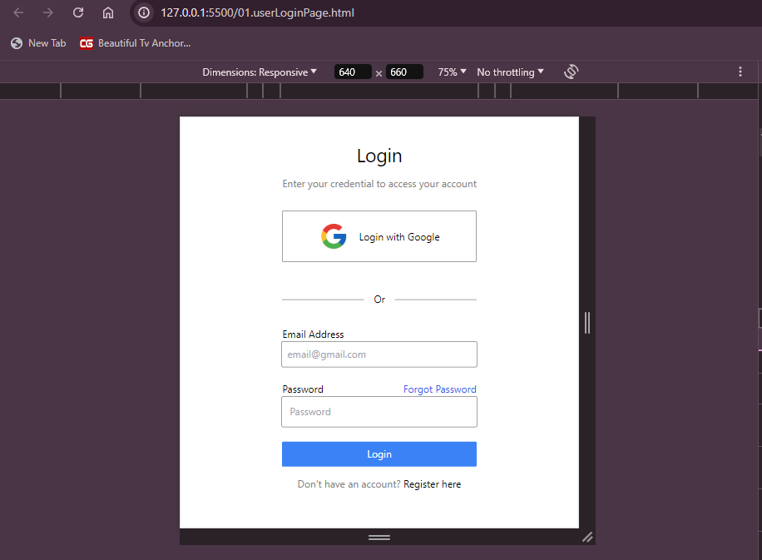

Second Output: **(minimum width of 640px)**

Second Output: **(minimum width of 1280px)**

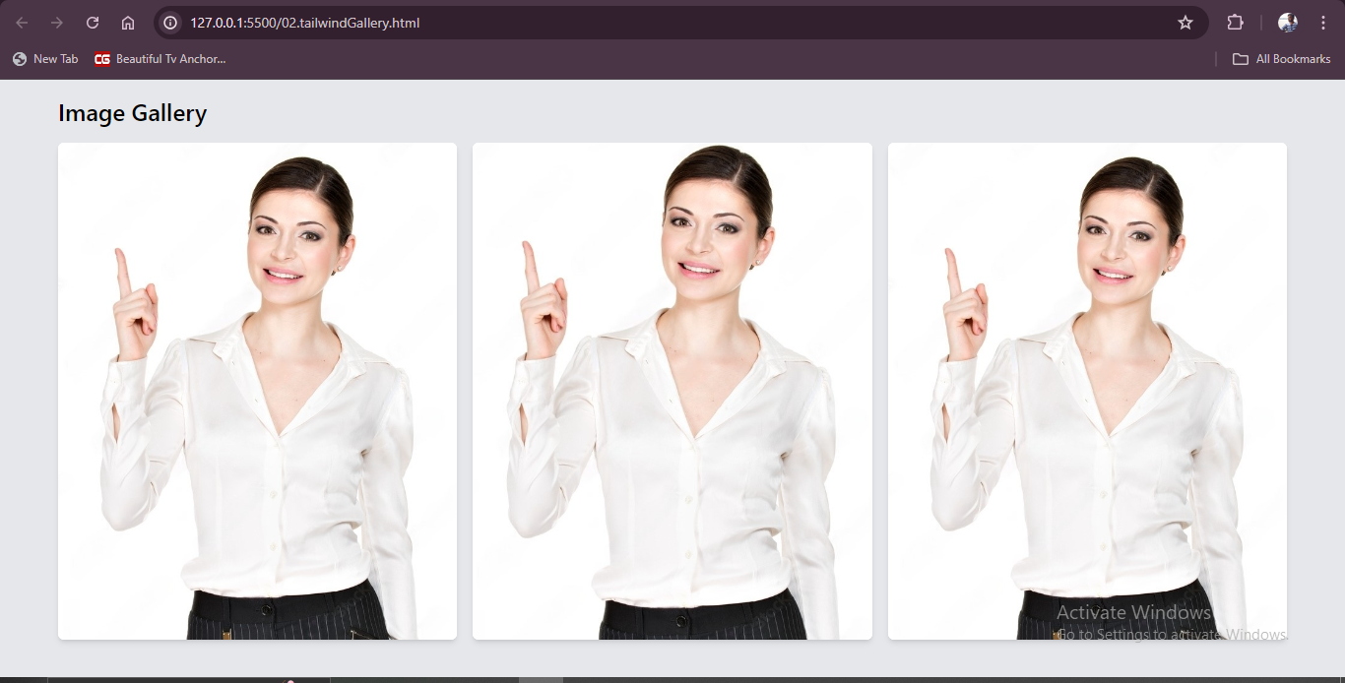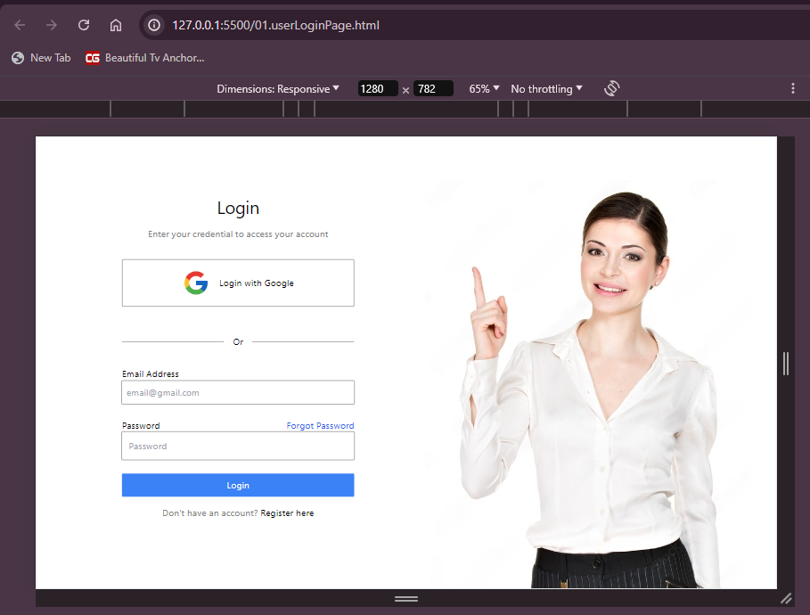

1. **TAILWINDCSS GALLERY**

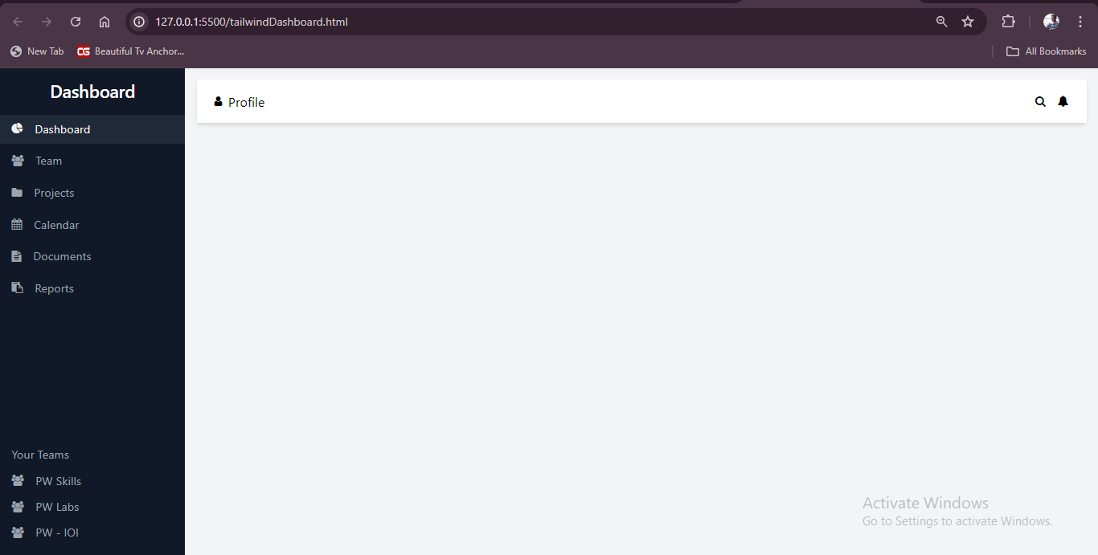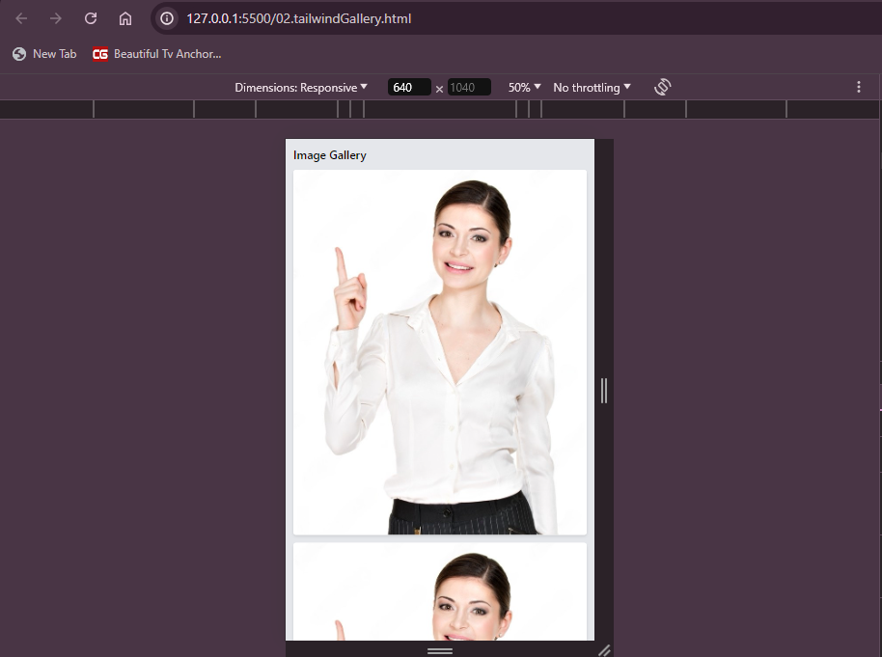

1. **TAILWINDCSS DASHBOARD**