VOYARA
SMART TRAVEL INDIA

System Design
Architecture, booking flow, data design, pricing engine, security and scaling

VOYARA is a MERN stack travel portal for India. Payment in this version is a demo.

How VOYARA is built, why it is built that way, and where it would need to change to grow. The diagrams use Mermaid, which GitHub and VS Code (with the Markdown Preview Mermaid extension) draw automatically.

1. Goals and limits
What the system must do
- Let a traveler explore all 36 Indian states and union territories and pick the places they want to visit.
- Find hotels near those places, with real distances.
- Take the traveler through rooms, dates, meals, local travel and activities to one correct price.
- Hold a booking, take a (demo) payment, and let the traveler cancel with the right refund.
- Give an admin a view of bookings, revenue and which services guests choose.
Design rules
Rule | Meaning
The server decides the price | The browser sends only choices (room, meals, vehicle, activities). The server looks up the prices and adds them up. A changed number in the browser can never change what is charged.
Free outside data is a helper, not a dependency | If the map service is slow or down, curated places, saved hotels and cached results still work.
Real data where it exists, generated data where it doesn't | Hotel names, places and restaurants are real. Prices, most star ratings and most amenities are generated, and stay the same for each hotel.
Secure by default in production | Strict headers, rate limits, input cleaning, a locked-down upload route, and refusal to start with a weak secret.

Known limits (on purpose, for a demo-scale product): payment is a demo, hotel prices are generated, there is no hotel-owner login, and the last-room booking is not fully protected against two people paying at the same instant (see section 9).

2. The big picture
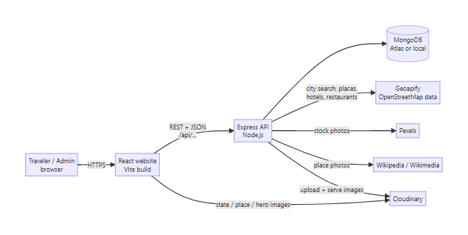
In production one Node process serves both the API (/api/...) and the built website (client/dist), so there is no cross-site setup and no CORS to manage. In development the website runs on Vite (port 5173) and talks to the API on port 5000.

3. Layers
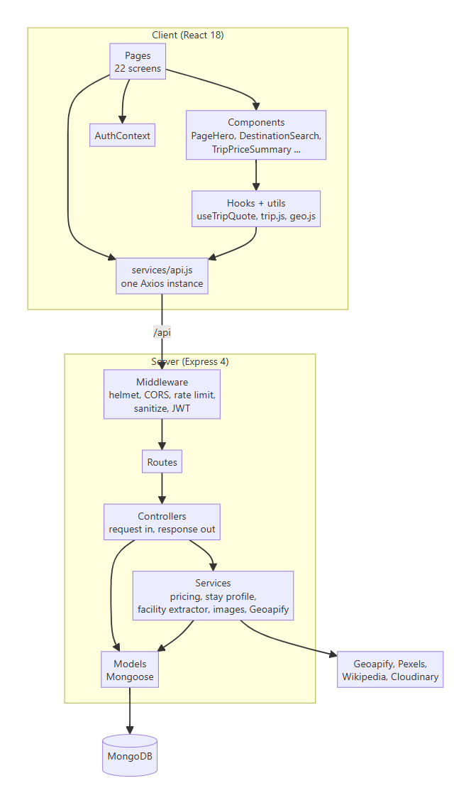
Layer | Responsibility | Does NOT do
Pages | One screen each, owns that screen's state | Price maths
Components / hooks | Reusable pieces, the live price box | Talk to the database
Routes | Map a URL to a controller, attach middleware | Business logic
Controllers | Validate input, call services and models, shape the reply | Long calculations
Services | The real logic: pricing, hotel profiles, facility reading, image lookup | Know about HTTP
Models | Shape and rules of stored data | Anything else

4. The booking journey (the core flow)
Part 1: from search to a free room
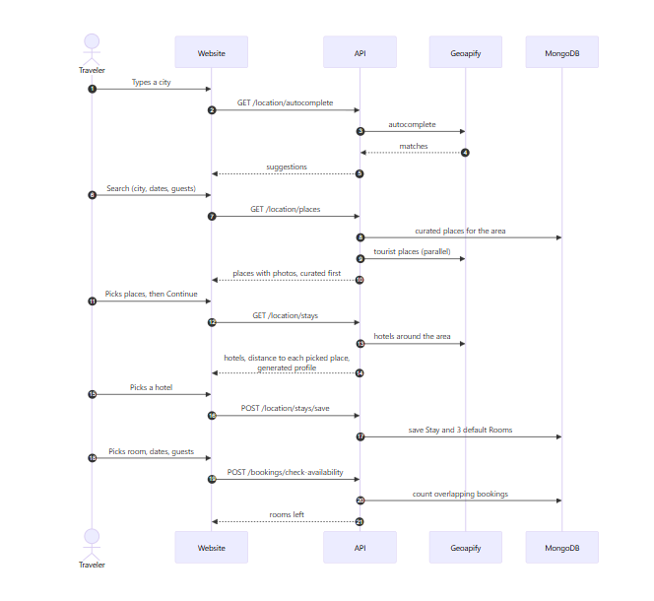
Part 2: from extras to a confirmed booking
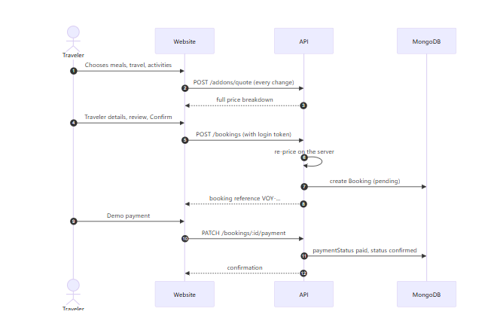
The trip is carried from page to page in the browser's router state (utils/trip.js), so nothing is stored on the server until the booking is created.

Booking states
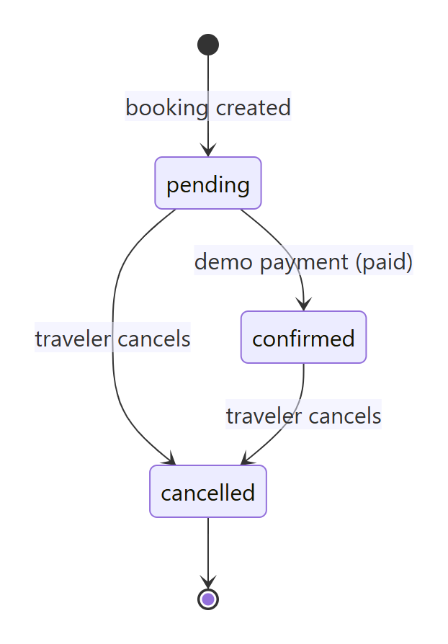
Status | Payment status | Rooms held?
pending | pending | Yes
confirmed | paid | Yes
cancelled | refunded (when a refund applies) or unchanged | No, the rooms are free again

Cancellation rule: full refund when the hotel offers free cancellation and check-in is more than 24 hours away. Otherwise the booking is cancelled with no refund. The traveler sees the exact amount before confirming.

5. Data design
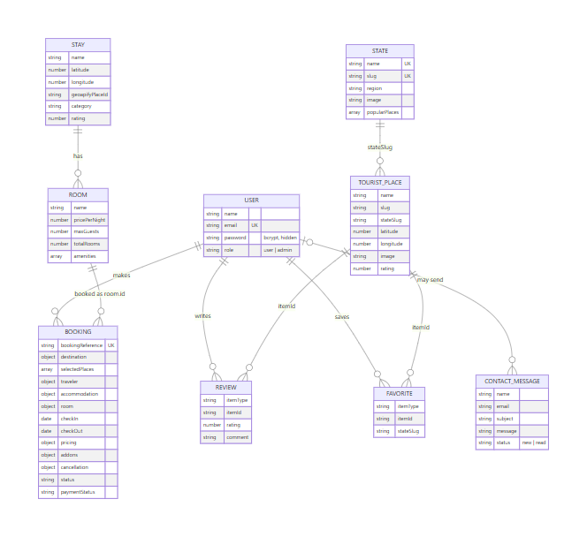
Why a booking copies data instead of pointing at it. A booking stores the hotel name, room name, price per night, traveler and every priced extra *as they were at booking time*. Later changes to a hotel or a price never rewrite a past booking, and My Trips and the admin page need no extra lookups.
Indexes
Collection | Index | Why
users | email unique | login, no duplicate accounts
bookings | bookingReference unique, user | confirmation lookup, My Trips
reviews | user + itemType + itemId unique | one review per person per place
favorites | user + itemType + itemId unique | saving twice is harmless
tourist places | stateSlug + slug, text on name/description/city | place pages, search
states | name, slug unique, text index | state lookup, search
stays, rooms | location and stay | find a hotel's rooms

Availability
For a room and a date range, the server adds up the rooms of every pending or confirmed booking that overlaps the range (existing.checkIn < new.checkOut and existing.checkOut > new.checkIn) and subtracts that from the room's totalRooms. Cancelling a booking removes it from that count, so the rooms come back automatically. No counter is stored, so it cannot drift out of sync.

6. Pricing engine
Pricing lives in one place, server/services/addonCatalog.js, and is used by both the live quote and the booking.
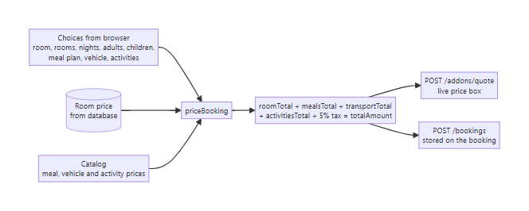
Part | How it is worked out
Room | pricePerNight x rooms x nights
Meals | Base per person per night (breakfast 250, lunch 400, dinner 450) times a factor that grows with the room price (0.7 to 2.5). Children under 12 pay half. Plans: Room only, Breakfast, Half board, Full board, or any single meals.
Local travel | Cab, SUV, bus or bike, AC or non-AC, per day, times days. Bike is non-AC only.
Activities | Six fixed experiences, plus nearby attractions priced by a stable formula from their id. Per person.
Tax | 5% of room plus add-ons

Because the same function prices the quote and the booking, the price on the screen and the price charged cannot disagree.

Generated hotel profile
stayProfile.js turns a hotel's id into a stable price, star class, rating, amenity list and free-cancellation flag. The same hotel always gets the same result. Names that sound luxury (palace, resort, grand) are priced higher. When the map data does list a fact (stars, Wi-Fi, parking, pool, phone, website), that real fact wins and the app marks it "listed". facilityExtractor.js reads those facts from the raw map tags.

7. Security design
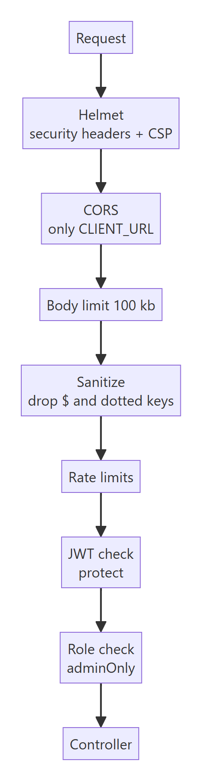
Threat | Defence
Stolen or guessed passwords | bcrypt (cost 12), 8+ characters with a letter and a number, login limited to 20 wrong tries per 15 minutes per address
Forged login tokens | Signed with JWT_SECRET. Production refuses to start if the secret is under 32 characters or on a list of weak ones
NoSQL injection | Request bodies and queries are cleaned: keys starting with $ or containing . are dropped. Types are checked in controllers
Price tampering | The browser never sends a price. The server re-prices every booking
Reading someone else's trip | Every booking lookup filters by the logged-in user's id
Admin pages | Checked on the server (adminOnly), not just hidden in the menu
Open upload route | Upload routes need login and admin
Contact form spam and injection | A hidden trap field, a limit of 5 messages per 15 minutes, plain-text validation (objects and arrays rejected), length limits, and messages shown as text. Only admins can list them
Scraping and floods | Limits on the API (1500 / 15 min), search (90 / min), booking (60 / 15 min), contact (5 / 15 min). Active in production, or in development with RATE_LIMIT=on
Clickjacking, sniffing, XSS | Helmet headers and a content security policy
Leaking details on errors | In production a server error returns a generic message, the health check hides database details
Secrets in code | All keys are in server/.env, which is never committed

Only a real "not logged in" answer (401 or 403) signs a user out on the website. A busy server or a short network drop does not.

8. Performance and reliability
Technique | Where | Effect
Parallel category queries | Places search | One slow category does not hold up the rest
1 hour in-memory cache | Places results | Repeat searches return instantly. Thin results are not cached
Theme applied before first paint | index.html | No white flash in dark mode, no layout change
Motion only on opacity and transform | Client | Smooth on phones, no layout jumps. Skipped for reduced motion
Photo time budget and backoff | Place and hotel images | A rate-limited photo service (429) cannot freeze the page
Curated places first | Places | Always something useful to show, even if the map service is slow
Lazy-loaded pages and split bundles | Client | Each page loads only its own code
gzip compression | Server | Smaller responses
Photos from Cloudinary with f_auto,q_auto | Client | Right format and size per device
Graceful shutdown | Server | On stop, finishes current requests and closes the database
Health check | GET /api/health | Returns 503 when the database is down, so a host can restart or alert
Startup checks | config/env.js | Missing or weak settings stop the server with a clear message

9. Trade-offs and what to change at larger scale
Today | Why | If traffic grows
One Node process | Simple, cheap, enough for a demo | Run several copies behind a load balancer. Move the rate limiter and the places cache to Redis so the copies share them
In-memory places cache | No extra service | Redis
Availability counted on read | No drift, simple | Wrap "check, then create" in a MongoDB transaction, or use an atomic counter per room per night, so two people cannot take the last room at the same instant
Demo payment | No money, no risk | Replace PATCH /bookings/:id/payment with a real gateway (Razorpay, Stripe): create an order, then confirm only on the gateway's signed webhook
Generated hotel prices | No free hotel price API exists | Connect a channel manager or hotel partner API, or add a hotel-owner portal to set real prices and photos
Images fetched on demand, then saved | Free tiers | A background job that pre-fills images, plus a CDN
No emails | Out of scope | Send the confirmation and cancellation by email (SES, SendGrid) from a queue
Admin is read-only | Enough to monitor | Add actions: mark refunded, edit places and hotels, export

10. Deployment
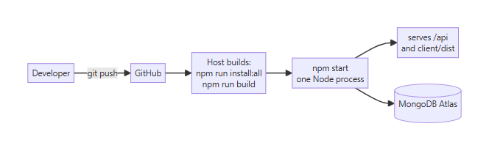
Hosting on one platform (Render, Railway, a VPS):
- Create a MongoDB Atlas cluster and put its address in MONGO_URI.
- Set NODE_ENV=production, a 48-byte JWT_SECRET, and the Geoapify, Cloudinary and Pexels keys.
- Build command: npm run install:all && npm run build. Start command: npm start.
- First start loads the 36 states and 234 places by itself.
- Make yourself admin: npm run make-admin -- you@example.com.
If the website is hosted separately (Vercel, Netlify), set CLIENT_URL on the server to the website's address and VITE_API_URL on the website to the server's address ending in /api.

