DATA 298A Workbook 2
Report Sections 3 and 4: Data Engineering and Model Development
Item | Value
Team, section and topic | Team 6, Section 22, Topic 12: Neurosymbolic Verification of LLM-Generated Clinical Discharge and Treatment Plans
Date | November 11, 2026
Assignment | Assignment 6 (Workbook 2), file T6.A6.docx
Evidence | notebooks/workbook2.ipynb (all tables and figures), src/clinverify/warehouse.py, src/clinverify/models/model_a.py, scripts/run_pipeline.py; repository commit <commit hash after the Workbook 2 code is committed>

Team members and the sections each person wrote
Team member | Sections written
Ritika Mukesh Neema | sections
Rajesh Paruchuri | sections
Akashkumar Senthilkumar | sections
Sneha Singh | sections
Shruthi Thirukumaran | sections

How patient data is handled in this report. Every count, statistic, metric and figure below is computed on the real credentialed data (MIMIC-IV-Ext-CDM v1.1 and MIMIC-IV v3.1) on a team member's own approved machine. The PhysioNet data use agreement does not allow record text to be passed to anyone who has not signed it, so the record samples that sections 3.2 to 3.5 ask for are shown with synthetic rows produced by src/clinverify/data/synthetic.py. They have exactly the real schema and go through exactly the same pipeline functions; the real samples are in the executed notebook, which stays on the authorised machine. Model A runs on a local GPU, so no record text is sent to a hosted LLM.

3 Data Engineering

3.1 Data Process
Author: team member
The project's raw data are two credentialed PhysioNet datasets. MIMIC-IV-Ext-CDM v1.1 (Hager et al., 2024 [3][4]) is the working set: 2,400 curated hospital admissions with one of four abdominal pathologies, split into nine record tables (history, physical examination, labs, microbiology, radiology, ICD codes, procedures and the discharge diagnosis). MIMIC-IV v3.1 (Johnson et al., 2023 [6]) is used for one thing only: its admissions table maps each admission to a patient, so the splits can be grouped by patient.
The data move through seven steps. Every step is a function in src/clinverify/data (or models/model_a.py), so the notebook that produced this report and the warehouse pipeline in section 4.5 run the same code.
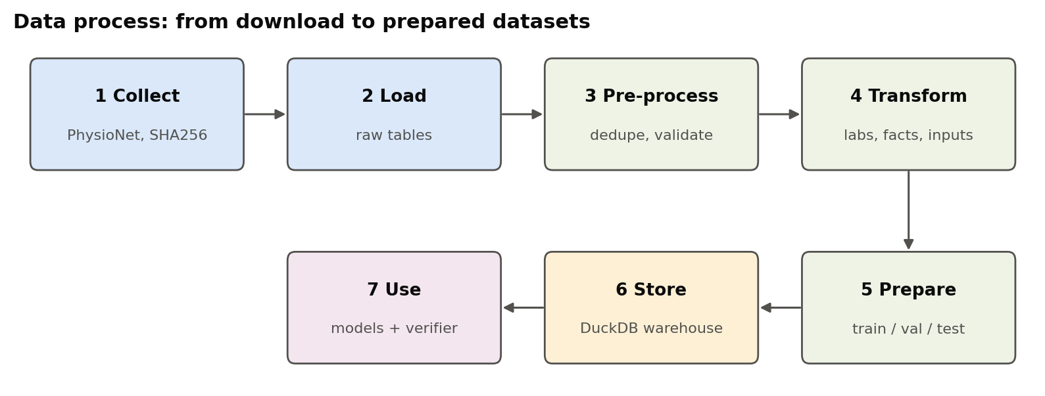
Figure 3.1-1. Data process from download to model evaluation. Produced by notebooks/workbook2.ipynb, section 3.1.
Table 3.1-1. Data process steps, tools and outputs.
step | tool / code | input | output | workbook section
1 Collect | PhysioNet download (per person, signed DUA) | Ext-CDM v1.1 + MIMIC-IV v3.1 admissions | files on disk + SHA256 check | 3.2
2 Load | pandas read_csv | 9 Ext-CDM tables + lab mapping + pathology ids | raw tables (raw layer) | 3.2, 4.5
3 Pre-process | ext_cdm.clean_tables, validate_tables | raw tables | deduplicated, validated tables | 3.3
4 Transform | ext_cdm.transform_tables, case_facts, model_a.case_inputs | cleaned tables | parsed labs, case table, case facts, model input, TF-IDF matrix | 3.4
5 Prepare | frozen split file (seed 298, grouped by patient) | case table | train 1,840 / validation 460 / test 100 | 3.5
6 Store | DuckDB warehouse + data-quality gate | all of the above | raw / staging / mart / ops schemas | 4.5
7 Use | Models A to E, Z3 verifier, evaluation harness | mart tables | plans, verifier results, metrics | 4.4

Two rules hold across the whole process. First, patient data never enter the repository: it holds code, case-ID split lists and aggregate counts only, and .gitignore blocks data files. Second, the answer is never shown to a model: the discharge diagnosis, ICD codes and procedures are used to build labels and case facts for scoring, but they are removed from every model input (section 3.4.4).

3.2 Data Collection
Author: team member

3.2.1 Data sources
Table 3.2-1. Data sources.
dataset | version | publisher | licence | role | files used | size used (MB)
MIMIC-IV-Ext-CDM | 1.1 | PhysioNet (Hager et al. 2024) | PhysioNet Credentialed Health Data License 1.5.0 | working set: 2,400 curated admissions | 10 | 18
MIMIC-IV | 3.1 | PhysioNet (Johnson et al. 2023) | PhysioNet Credentialed Health Data License 1.5.0 | hosp/admissions: hadm_id -> subject_id for patient-grouped splits | 1 | 19.9

Both datasets are downloaded by each team member from PhysioNet with their own credentialed account after signing each dataset's data use agreement (Ext-CDM has its own agreement, separate from MIMIC-IV). The download command is wget -r -N -c -np against physionet.org/files/<dataset>/<version>/. Only hosp/admissions.csv.gz (19.9 MB) is needed from MIMIC-IV, so the multi-gigabyte event tables are not downloaded.

3.2.2 Data parameters and quantity
Each record table is keyed by hadm_id (the hospital admission). pathology_ids.json gives the label of every case: appendicitis 957, cholecystitis 648, pancreatitis 538, diverticulitis 257. PhysioNet ships a SHA256SUMS.txt with every dataset; all 12 Ext-CDM files match, and all 2,400 cases link to a MIMIC-IV admission, covering 2,383 patients.
Table 3.2-2. Quantity and parameters of the raw tables (179,956 rows in 10 tables).
table | MB | rows | columns | cases covered | parameters (columns)
history_of_present_illness | 2.62 | 2,400 | 2 | 2,400 | hadm_id, hpi
physical_examination | 1 | 2,400 | 2 | 2,400 | hadm_id, pe
discharge_diagnosis | 0.14 | 2,400 | 2 | 2,400 | hadm_id, discharge_diagnosis
icd_diagnosis | 0.94 | 17,357 | 2 | 2,400 | hadm_id, icd_diagnosis
icd_procedures | 0.18 | 2,917 | 4 | 1,660 | hadm_id, icd_code, icd_title, icd_version
discharge_procedures | 0.09 | 2,122 | 2 | 1,810 | hadm_id, discharge_procedure
laboratory_tests | 5.5 | 138,788 | 5 | 2,400 | hadm_id, itemid, valuestr, ref_range_lower, ref_range_upper
microbiology | 0.28 | 4,403 | 4 | 1,856 | hadm_id, test_itemid, valuestr, spec_itemid
radiology_reports | 7.19 | 5,960 | 6 | 2,400 | hadm_id, note_id, modality, region, exam_name, text
lab_test_mapping | 0.08 | 1,209 | 6 |  | itemid, label, fluid, category, count, corresponding_ids

3.2.3 Raw data samples
Synthetic rows with the real schema (see the note at the start). The real first rows of each table are shown in section 3.2.3 of the executed notebook.
Table 3.2-3. laboratory_tests, raw (synthetic sample).
hadm_id | itemid | valuestr | ref_range_lower | ref_range_upper
20000000 | 50931 | 85.8 mg/dL | 70 | 100
20000000 | 50912 | 1.3 mg/dL
20000000 | 51301 | 11.4 K/uL
20000000 | 51006 | 8.8 mg/dL | 6 | 20

Table 3.2-4. radiology_reports, raw (synthetic sample).
hadm_id | note_id | modality | region | exam_name | text
20000000 | SYN-20000000-0 | MRCP | Abdomen | SYNTHETIC EXAM | SYNTHETIC report text 0.
20000000 | SYN-20000000-1 | Ultrasound | Abdomen | SYNTHETIC EXAM | SYNTHETIC report text 1.
20000001 | SYN-20000001-0 | MRCP | Abdomen | SYNTHETIC EXAM | SYNTHETIC report text 0.

Table 3.2-5. icd_procedures, raw (synthetic sample).
hadm_id | icd_code | icd_title | icd_version
20000007 | P94 | SYNTHETIC procedure | 10
20000008 | P40 | SYNTHETIC procedure | 10
20000016 | P32 | SYNTHETIC procedure | 10

3.3 Data Pre-processing
Author: team member
Pre-processing has three parts: removing exact duplicates, deciding how each missing value is handled, and validating the cleaned tables. The tools are pandas and ext_cdm.clean_tables / ext_cdm.validate_tables.

3.3.1 Cleaning: duplicates
75 exact duplicate rows were removed (68 in icd_procedures, 5 in discharge_procedures, 2 in icd_diagnosis). No case-level table had a duplicate case.
Table 3.3-1. Rows before and after duplicate removal.
table | rows_before | duplicate_rows | rows_after | null_cells_pct | cases_covered
history_of_present_illness | 2,400 | 0 | 2,400 | 0 | 2,400
physical_examination | 2,400 | 0 | 2,400 | 0 | 2,400
discharge_diagnosis | 2,400 | 0 | 2,400 | 0 | 2,400
icd_diagnosis | 17,357 | 2 | 17,355 | 0 | 2,400
icd_procedures | 2,917 | 68 | 2,849 | 0 | 1,660
discharge_procedures | 2,122 | 5 | 2,117 | 0.02 | 1,810
laboratory_tests | 138,788 | 0 | 138,788 | 11.6 | 2,400
microbiology | 4,403 | 0 | 4,403 | 0 | 1,856
radiology_reports | 5,960 | 0 | 5,960 | 0 | 2,400

3.3.2 Missing values
Only seven columns have missing values. Reference ranges are missing for 29% of lab rows; they are kept as missing, not imputed, because a reference range is a fact about one lab test, not a statistic that can be estimated. Those labs are flagged unknown in section 3.4. The single empty discharge procedure is dropped.
Table 3.3-2. Missing values and how each is handled.
table | column | missing | missing_pct | handling
discharge_procedures | discharge_procedure | 1 | 0 | drop row (empty procedure)
laboratory_tests | ref_range_lower | 40,265 | 29 | keep as missing; flag = 'unknown' (not imputed: reference ranges are lab-specific facts)
laboratory_tests | ref_range_upper | 40,265 | 29 | keep as missing; flag = 'unknown' (same reason)
lab_test_mapping | itemid | 118 | 9.8 | drop row (cannot be joined)
lab_test_mapping | fluid | 268 | 22.2 | keep as missing (descriptive only)
lab_test_mapping | category | 294 | 24.3 | keep as missing (descriptive only)
lab_test_mapping | count | 294 | 24.3 | keep as missing (descriptive only)

3.3.3 Validation
validate_tables checks that labels are unique, required columns exist, case-level tables have one row per case, no hadm_id is empty or unknown, every case has the tables it must have, and no history note is empty. It passes on the cleaned tables. To show it works, the notebook also feeds it a deliberately corrupted copy (three duplicated cases, ten emptied history notes, the hadm_id column dropped from labs, an unknown case in microbiology, radiology removed for 1% of cases). Every problem is caught:
Table 3.3-3. Problems reported on the corrupted copy.
problem caught on the corrupted copy
laboratory_tests: missing columns ['hadm_id']
history_of_present_illness: 3 duplicated hadm_id in a one-row-per-case table
microbiology: 1 hadm_id not in pathology_ids.json
radiology_reports: 28 cases have no rows
history_of_present_illness.hpi: 10 empty values

The same validation is the data-quality gate of the warehouse load (section 4.5).

3.3.4 Pre-processed data samples
Table 3.3-4. discharge_procedures before pre-processing (synthetic sample: row 1 has an empty procedure).
hadm_id | discharge_procedure
20000002
20000007 | SYNTHETIC discharge procedure
20000011 | SYNTHETIC discharge procedure
20000004 | SYNTHETIC discharge procedure

Table 3.3-5. discharge_procedures after pre-processing (empty row dropped).
hadm_id | discharge_procedure
20000002
20000007 | SYNTHETIC discharge procedure
20000011 | SYNTHETIC discharge procedure

3.4 Data Transformation
Author: team member
Transformation turns the cleaned tables into four target formats: (1) normalised tables, (2) a case table with one row per admission, (3) one model-input text per case, and (4) a TF-IDF feature matrix for the classical model. Tools: pandas (ext_cdm.transform_tables), regular expressions over ICD titles (case_facts.py), the model-input builder (model_a.case_inputs) and scikit-learn's TfidfVectorizer.
Table 3.4-1. Transformation log.
table | input | operation | output | why
text tables (hpi, pe, radiology, discharge dx) | raw free text | strip, collapse repeated whitespace, cast to str | normalised text + word_count | consistent formatting; length is a simple input-size feature
laboratory_tests | valuestr (e.g. '2.5 mmol/L') | split into number, unit and '<'/'>' qualifier; non-numeric results (e.g. NEG) stay as text | value (float), unit, qualifier, value_is_numeric | numeric comparison against reference range
laboratory_tests | value, ref_range_lower/upper | flag low / normal / high; 'unknown' if range missing | flag | abnormal-only views of labs; no invented reference ranges
lab_test_mapping | itemid (float, some null) | drop rows without itemid, cast to int | itemid (int), label | join readable lab names onto laboratory_tests
all case tables | hadm_id + pathology_ids.json | join pathology label to each case | cases_master (hadm_id, pathology, counts per table) | label for stratified splits and per-class EDA

3.4.1 Lab parsing and flagging
Table 3.4-2. Lab strings before (valuestr) and after parsing (synthetic sample).
valuestr | ref_range_lower | ref_range_upper | value | unit | qualifier | flag | label
85.8 mg/dL | 70 | 100 | 85.8 | mg/dL |  | normal | Glucose
1.3 mg/dL |  |  | 1.3 | mg/dL |  | unknown | Creatinine
11.4 K/uL |  |  | 11.4 | K/uL |  | unknown | White Blood Cells
8.8 mg/dL | 6 | 20 | 8.8 | mg/dL |  | normal | Urea Nitrogen
1.2 mmol/L | 0.5 | 2 | 1.2 | mmol/L |  | normal | Lactate

Table 3.4-3. Lab flags after transformation (real data, 138,788 rows).
flag | rows | share_%
normal | 68,820 | 49.6
unknown | 42,933 | 30.9
high | 17,525 | 12.6
low | 9,510 | 6.9

3.4.2 Case table and case facts
Table 3.4-4. cases_master, one row per case (synthetic sample).
hadm_id | pathology | n_laboratory_tests | n_microbiology | n_radiology_reports | n_icd_diagnosis | hpi_words
20000000 | appendicitis | 6 | 0 | 2 | 1 | 16
20000002 | appendicitis | 8 | 0 | 3 | 8 | 80
20000003 | appendicitis | 7 | 1 | 3 | 3 | 78
20000004 | appendicitis | 8 | 1 | 2 | 6 | 54

Case facts are the clinical facts the rules need (for example, whether appendicitis was complicated). They are derived from ICD titles and the discharge diagnosis, and are used only by the verifier, never shown to a model. In strict mode a fact the record does not establish stays unknown; it is never guessed. The table shows how many facts the real records establish:
Table 3.4-5. Case facts established from the records (real data).
pathology | cases | fact | true | false | unknown
appendicitis | 957 | complicated | 246 | 1 | 710
pancreatitis | 538 | necrotizing | 7 | 89 | 442
pancreatitis | 538 | infection | 38 | 0 | 500
pancreatitis | 538 | biliary | 69 | 24 | 445
pancreatitis | 538 | cholangitis | 37 | 0 | 501
pancreatitis | 538 | biliary_obstruction | 86 | 0 | 452
pancreatitis | 538 | mild | 0 | 120 | 418
diverticulitis | 257 | complicated | 121 | 36 | 100
diverticulitis | 257 | alarm_symptoms | 14 | 0 | 243

3.4.3 Model input format
Each case becomes one text in a fixed section order with fixed limits: history, physical examination, labs (abnormal first, at most 40), microbiology (at most 15) and up to 3 radiology reports of at most 1,500 characters each. The discharge diagnosis, ICD codes and procedures are withheld. A test in the repository checks that no model input contains its case's discharge diagnosis. Synthetic example:
HISTORY OF PRESENT ILLNESS
SYNTHETIC history note for case 20000000. Pain reported. Pain reported. Pain reported. Pain reported. Pain reported.
PHYSICAL EXAMINATION
SYNTHETIC exam for case 20000000: vitals recorded.
LABORATORY RESULTS
- Glucose: 85.8 mg/dL
- Creatinine: 1.3 mg/dL
- White Blood Cells: 11.4 K/uL
- Urea Nitrogen: 8.8 mg/dL
- Lactate: 1.2 mmol/L
- Anion Gap: NEG
IMAGING
MRCP Abdomen (SYNTHETIC EXAM): SYNTHETIC report text 0.
Ultrasound Abdomen (SYNTHETIC EXAM): SYNTHETIC report text 1.

3.4.4 Feature matrix for the classical model
Model E uses a TF-IDF matrix of word 1- and 2-grams (up to 50,000 features, words only, sub-linear term frequency). The vocabulary is fit on the training split only, so no validation or test text leaks into the features.

3.5 Data Preparation
Author: team member
The split is fixed and versioned (data/splits/ext_cdm_splits_v2.json). It holds the 100-case held-out test set named in the project abstract; 20% of the remaining cases go to validation and the rest to training. It is stratified by pathology with seed 298 and grouped by patient, so all admissions of one patient land in the same split. (Version 1 split by admission and let five patients cross splits; version 2 has none.) The file's SHA-256 is pinned in the evaluation protocol (docs/evaluation_protocol.json), and scoring refuses a changed split. The notebook re-checks both on every run: hash matches, no case and no patient in two splits.
Table 3.5-1. Train / validation / test splits (real data).
split | cases | patients | appendicitis | cholecystitis | diverticulitis | pancreatitis | share_%
train | 1,840 | 1,828 | 733 | 497 | 197 | 413 | 76.7
val | 460 | 457 | 184 | 124 | 49 | 103 | 19.2
test | 100 | 98 | 40 | 27 | 11 | 22 | 4.2

Each split is exported as one table with one row per case: the case ID, the label, the model-input text and its length. Models A and E read these. The test split is not used anywhere in this report; it stays untouched until the team freezes Model A's settings.
Table 3.5-2. Prepared dataset rows (synthetic sample).
hadm_id | split | pathology | model_input | input_chars
20000000 | train | appendicitis | HISTORY OF PRESENT ILLNESS SYNTHETIC history note for case … | 506
20000001 | val | pancreatitis | HISTORY OF PRESENT ILLNESS SYNTHETIC history note for case … | 729
20000002 | train | appendicitis | HISTORY OF PRESENT ILLNESS SYNTHETIC history note for case … | 1,119

3.6 Data Statistics
Author: team member
Table 3.6-1 follows the data through the four stages. Raw to pre-processed loses 1,284 rows: the 75 duplicates plus the 1,209-row lab mapping, which is joined into the lab table rather than kept as its own table. Transformation adds the case table and parsed columns; preparation produces the three splits.
Table 3.6-1. Summary across raw, pre-processed, transformed and prepared data.
stage | tables | rows | columns | cases | what changed
Raw | 10 | 179,956 | 29 | 2,400 | files as downloaded
Pre-processed | 9 | 178,672 | 29 | 2,400 | 75 exact duplicates removed; validation passes
Transformed | 10 | 181,071 | 46 | 2,400 | labs parsed and flagged, text normalised, case table, model inputs, TF-IDF features
Prepared | 3 | 2,400 | 10 | 2,400 | train 1,840 / val 460 / test 100, no patient in two splits

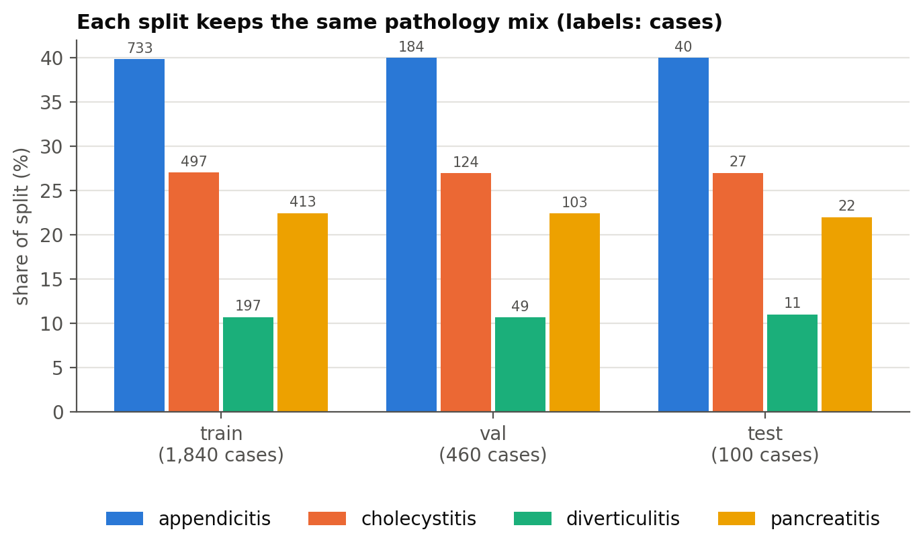
Figure 3.6-1. Class balance by split. Stratification keeps each pathology's share the same in train, validation and test; appendicitis is 40% of cases, which is why macro-averaged metrics are reported. Produced by notebooks/workbook2.ipynb, section 3.6.2.
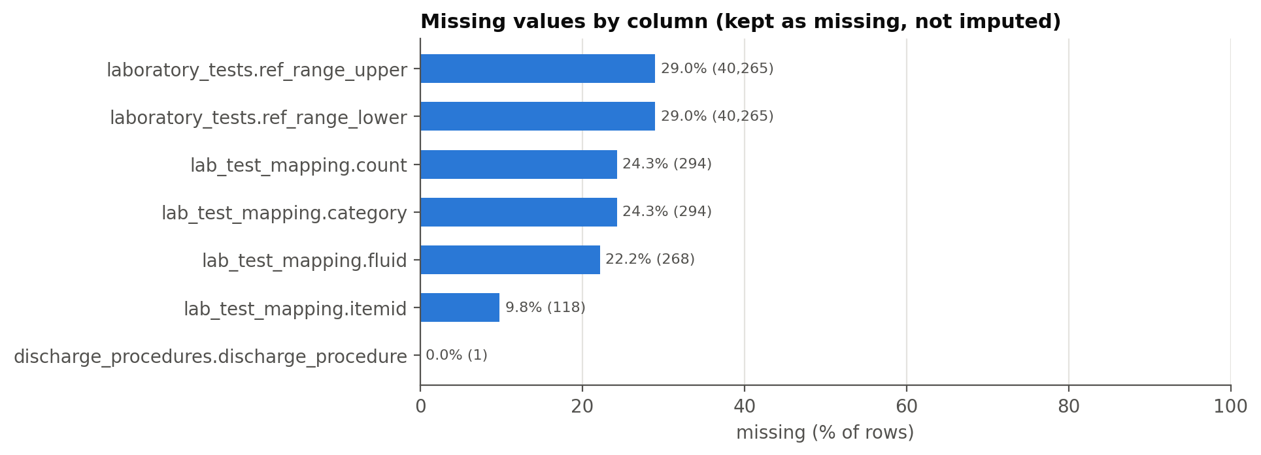
Figure 3.6-2. Missing values by column after pre-processing (kept as missing, not imputed). Produced by notebooks/workbook2.ipynb, section 3.6.2.
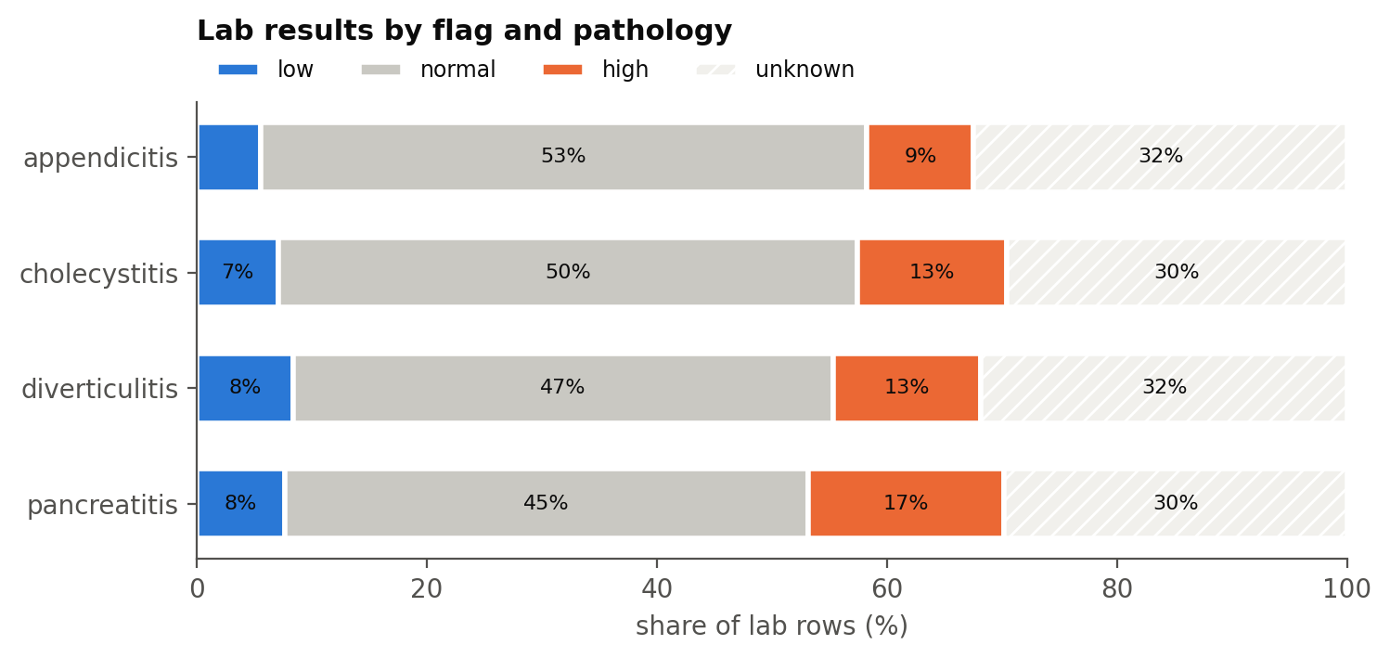
Figure 3.6-3. Lab flags by pathology after transformation. Produced by notebooks/workbook2.ipynb, section 3.6.2.
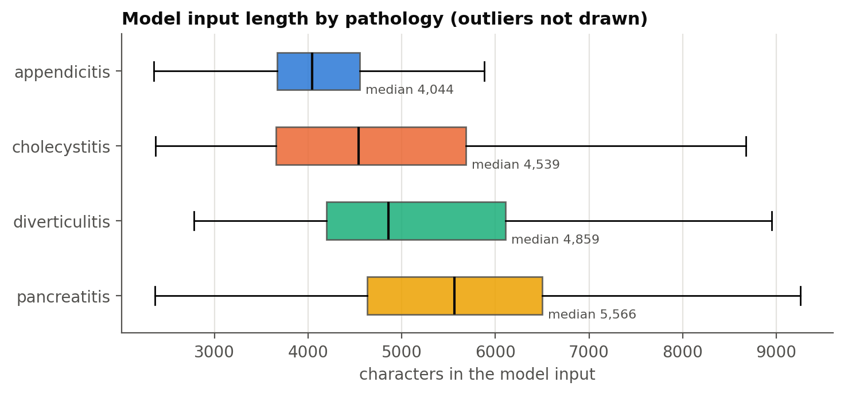
Figure 3.6-4. Length of the model input by pathology (prepared data). Produced by notebooks/workbook2.ipynb, section 3.6.2.
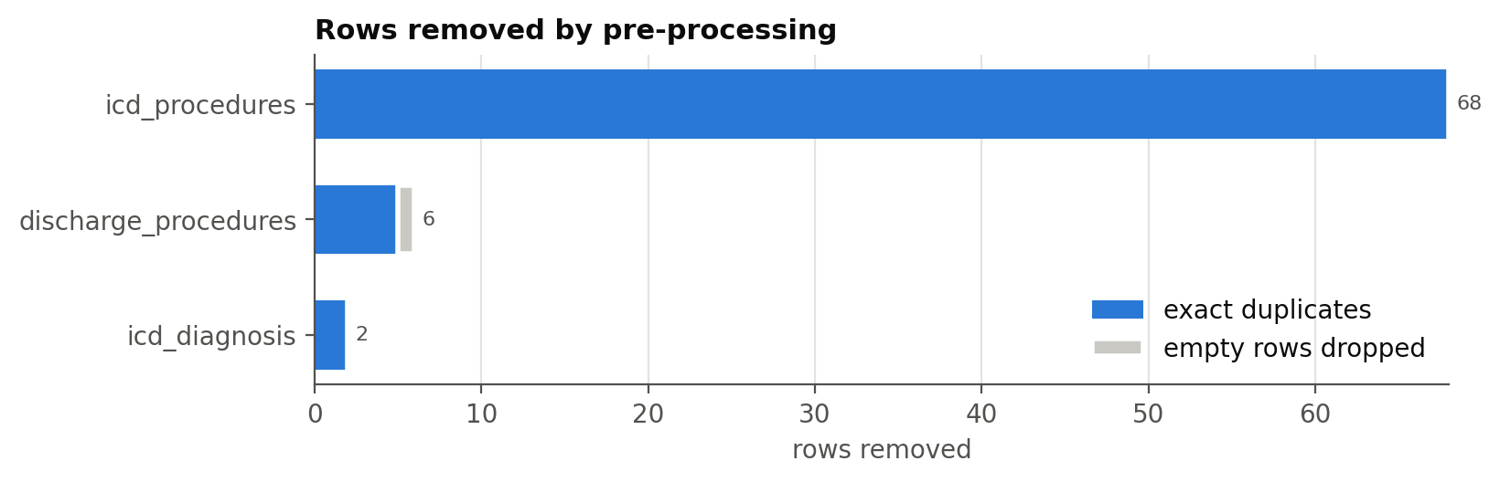
Figure 3.6-5. Rows removed by pre-processing, by table. Produced by notebooks/workbook2.ipynb, section 3.6.2.
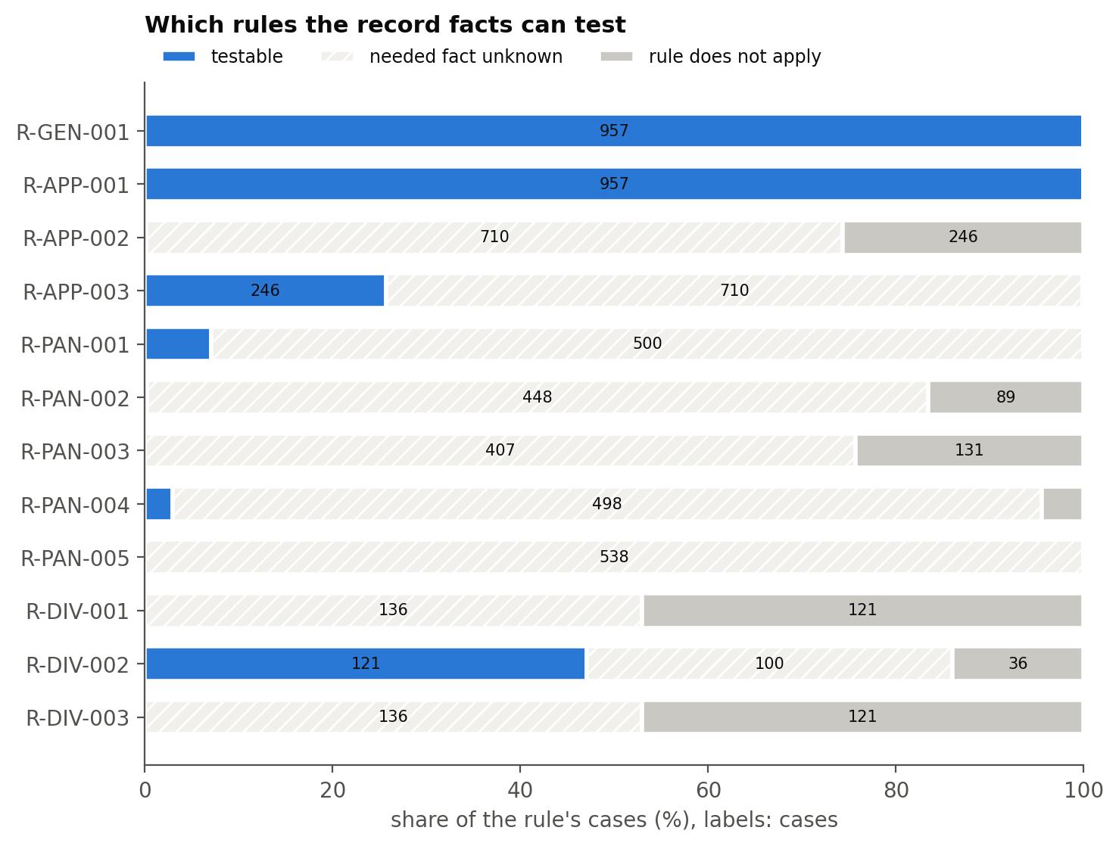
Figure 3.6-6. Which of the 12 rules the record facts can test. Most facts are unknown in the records, and four rules (R-PAN-003, R-PAN-005, R-DIV-001, R-DIV-003) are never testable on these cases. This caps the verifier-based metric in section 4.4. Produced by notebooks/workbook2.ipynb, section 3.6.2.

4 Model Development

4.1 Model Proposals
Author: team member
We propose five models plus the reproduced published baseline. All five produce a structured plan (diagnosis, treatments, post-operative antibiotic days) that the Z3 verifier checks against the team's rule catalog (v2.1, 12 rules). Models A and E are built and evaluated in 298A (section 4.4); B, C and D are built in 298B.
Table 4.1-1. Proposed models.
# | Model | Concept | Architecture / algorithm | Input | Phase
A | LLM plan generator | An LLM writes the diagnosis and plan directly; the verifier checks it afterwards | Decoder-only transformer: Qwen2.5-14B-Instruct, 4-bit, local; greedy decoding; output constrained to the plan JSON schema | Model-input text | 298A (built)
B | LLM to formal specification | The LLM translates the case into a formal specification; a solver does the reasoning | LLM translation into SMT-LIB / Z3 facts + Z3 solve (Logic-LM [9], SatLM [14]) | Model-input text | 298B
C | Solver-in-the-loop repair (innovative) | Model A, but every rejected plan goes back to the LLM with the broken rule's ID and message, for at most k rounds | LLM + Z3 verifier as an external critic (LLM-Modulo [7]) | Model-input text + verifier feedback | 298B
D | LLM + classical planner | The LLM maps the case to a PDDL problem; a classical planner builds a plan that satisfies the domain | LLM translation + Fast Downward [5] on a hand-written clinical PDDL domain (LLM+P [8]) | Model-input text + domain model | 298B
E | Classical ML + guideline template | A text classifier predicts the diagnosis; a fixed per-diagnosis template gives the treatment | TF-IDF (1–2-grams) + multinomial logistic regression [10] | TF-IDF matrix | 298A (built)
— | Reproduced baseline | Hager et al. (2024) autonomous clinical decision making [3] | OASST 70B (Llama 2 base) in the authors' framework | Interactive information requests | 298A (needs a larger GPU)

Innovation (Model C). No paper in our reviewed set closes the loop between an LLM and a formal verifier that uses team-written clinical rules. Model C returns the exact broken rule and its message to the LLM, which tests the LLM-Modulo claim [7] that an external, sound critic repairs plans better than self-critique (Valmeekam et al. [13] report 88/100 with verifier feedback against 55/100 with self-critique on Blocksworld).
Why Model E was added. Model E is a cheap statistical reference point. It runs in milliseconds on a CPU and produces class probabilities, so it is the only model with ROC curves and log loss. If E matches A on diagnosis, then any value the LLM adds must come from the plan, not the label. Team: confirm Model E as the fifth model.
The majority-class predictor (always "appendicitis") is reported beside them as the floor every model must beat.

4.2 Model Supports
Author: team member

4.2.1 Platform, environment and tools
Everything that touches patient data runs on one local machine, as the data use agreement requires. The environment below was recorded by the notebook at run time.
Table 4.2-1. Measured environment.
component | version / value
OS | Linux-6.18.33.2-microsoft-standard-WSL2-x86_64-with-glibc2.43
CPU | x86_64
Python | 3.13.15
GPU | NVIDIA GeForce RTX 5060 Ti, 16311 MiB, 616.92
Ollama server | 0.40.12
Model A weights | qwen2.5:14b
git commit | 4b14e30
pandas | 2.2.3
numpy | 2.1.3
scikit-learn | 1.9.1
duckdb | 2.0.0
z3-solver | 5.3.1.0
matplotlib | 3.10.0

Table 4.2-2. Model configuration and supporting tools.
Item | Value
Model A serving | Ollama 0.40.12 HTTP API on localhost; qwen2.5:14b Q4_K_M weights (digest 7cdf5a0187d5), 100% on the GPU, about 10 GB of 16 GB VRAM
Model A decoding | temperature 0, top_p 1, seed 298, at most 256 new tokens, 8,192-token context; output constrained by a JSON schema
Model A prompt | fixed system + user template, SHA-256 995be554a9b0ab5a… recorded with every run
Model E training | scikit-learn TfidfVectorizer + LogisticRegression; C chosen by 5-fold GridSearchCV on train (macro F1)
Verifier | Z3 SMT solver, rule catalog v2.1 (12 rules), strict mode for unknown facts
Warehouse | DuckDB single-file database (section 4.5)
Quality | pytest suite (135 tests) on every push in GitHub Actions; synthetic data only in CI

4.2.2 Architecture and data flow
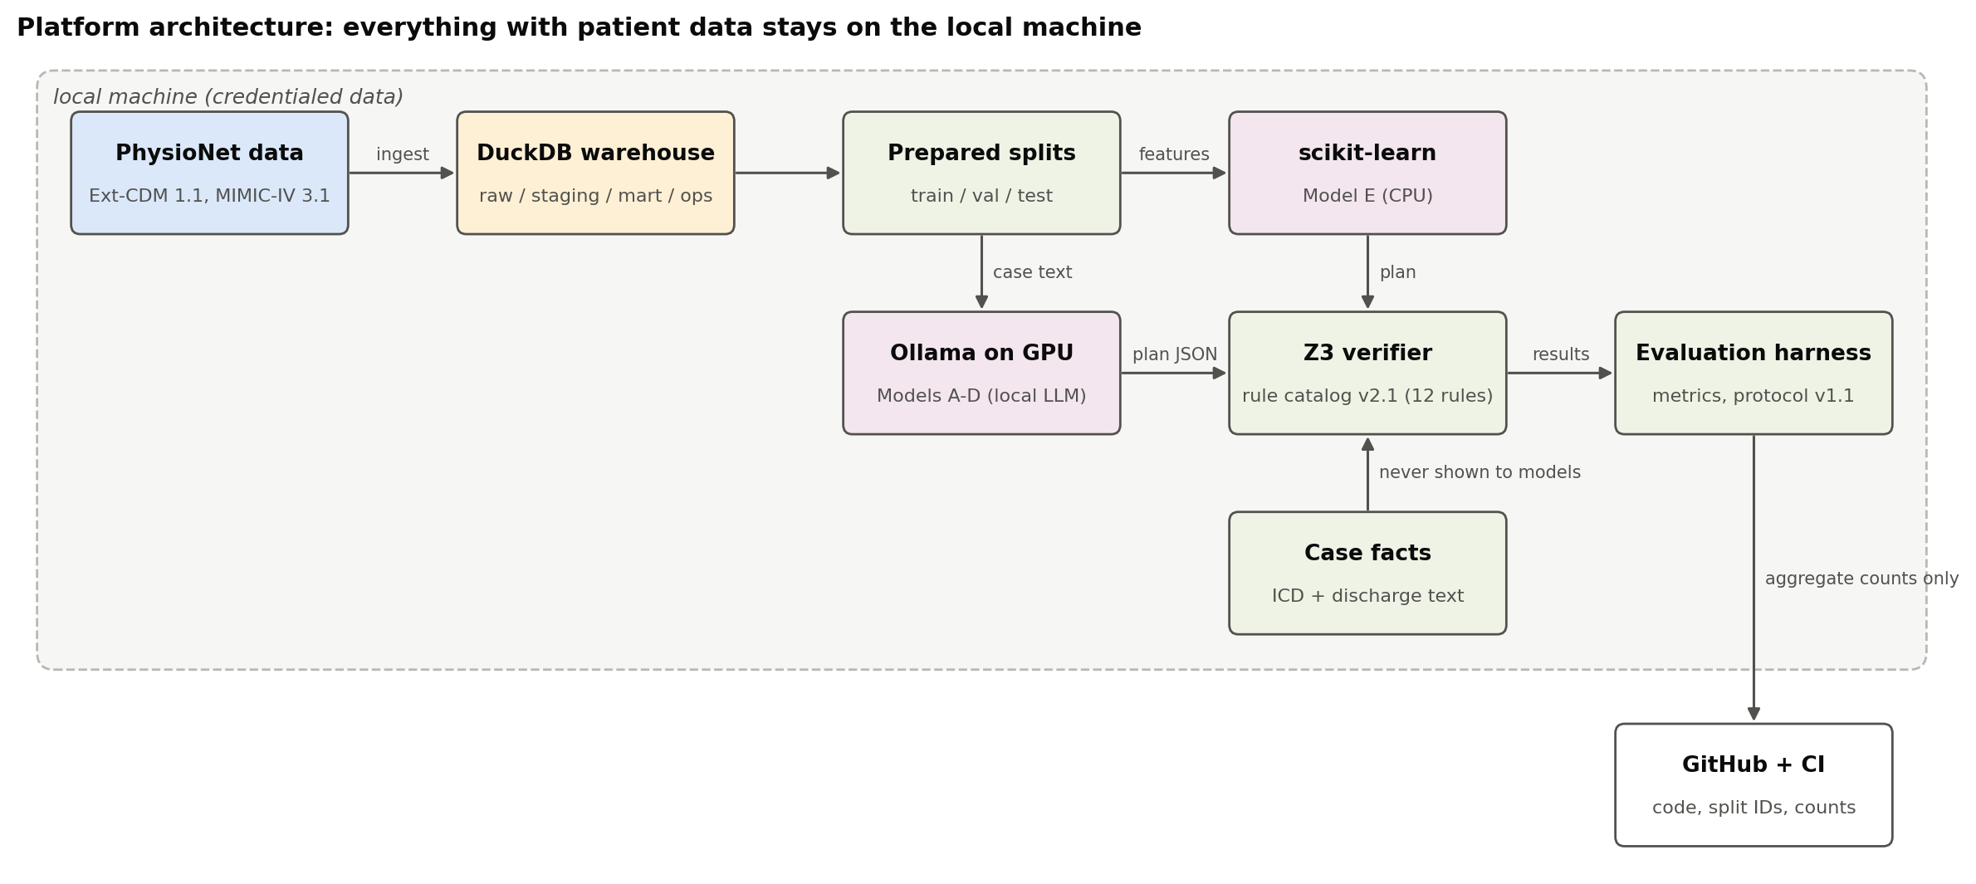
Figure 4.2-1. Platform architecture. Credentialed data, models and verifier stay on the local machine; only code and aggregate results go to GitHub. Produced by notebooks/workbook2.ipynb, section 4.2.2.
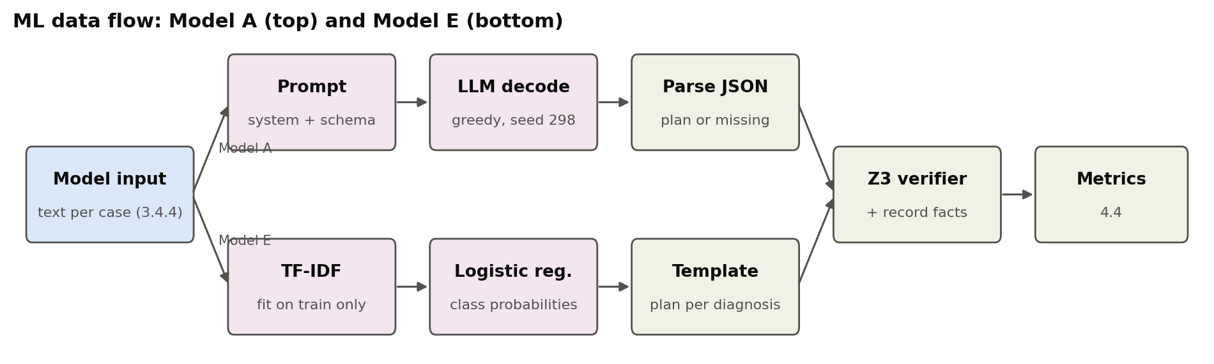
Figure 4.2-2. ML data flow for the two models built in 298A. Produced by notebooks/workbook2.ipynb, section 4.2.3.

4.3 Model Comparison and Justification
Author: team member
Table 4.3-1. Comparison of the five models.
 | A: LLM generator | B: LLM → formal spec | C: solver-in-the-loop | D: LLM + planner | E: classical ML
Targeted problem | Can an LLM write a plan that passes the rules without help? | Does moving reasoning into a solver make plans faithful to the case? | Can explicit rule feedback turn failing plans into passing ones? | Can plans be valid by construction? | How much does an LLM add over a cheap classifier?
Features | Full record text | Full record text | Record text + violated rule ID and message | Record text + PDDL domain | TF-IDF 1–2-grams
Approach | Deep learning (transformer LLM, prompting) | Deep learning + symbolic (SMT) | Deep learning + symbolic critic | Deep learning + classical planning | Statistics / classical ML
Strengths | Simplest; no translation step; closest to the baseline paper | The explanation is the solver's proof; inconsistencies are caught | Uses the rule catalog directly and names the broken rule | Planner output always satisfies the domain; auditable | Fast, deterministic, calibrated probabilities and ROC; easy to explain
Limitations | No correction step; LLMs skip guideline treatment [3]; output can be unparseable | Translation errors; the formal language must cover each disease | Repairs only what the rules cover; unknown facts give no feedback; extra generations cost time | Needs a clinical PDDL domain, which does not exist; lab-conditional rules fit actions badly | Bag of words ignores negation and order; treatment is a fixed template
Justification | The reference every other model is compared against | Tests the Logic-LM / SatLM claim in a clinical setting | The project's main hypothesis (LLM-Modulo) | Tests LLM+P; shows where planning formalisms break | A statistical floor for the LLM models

All five are scored on the same fixed splits, with the same verifier and the same metrics, so only the method changes between them. The Hager et al. baseline is kept outside the five as the published reference; it measures autonomous diagnosis, a different task from plan validity.
What the 298A results already show. On the validation split, Model A and Model E reach the same diagnosis accuracy (0.887), but Model E's plans pass the verifier more often (supported checked acceptance 0.188 against 0.146 for Model A). Model E's plan is a fixed guideline template, so it cannot omit a required treatment; Model A writes its own plan and sometimes does. This is the gap Model C is designed to close, and it supports building C rather than tuning A further.

4.4 Model Evaluation Methods
Author: team member
Metric definitions follow docs/metrics.md (evaluation protocol v1.1, frozen October 23, 2026). Every model is scored on the validation split (460 cases). The 100-case test split is reserved for the formal test once Model A's settings are frozen.
Table 4.4-1. Evaluation metrics.
Metric | Type | Models | Meaning
Diagnosis accuracy, per-pathology accuracy | Classification | All | Share of cases with the right pathology
Macro precision / recall / F1, confusion matrix | Classification | All | Balanced over four classes (appendicitis is 40%)
ROC-AUC (one-vs-rest), log loss | Probabilistic | E | Ranking quality and calibration; an LLM's greedy output has no class probabilities
Supported checked acceptance rate (primary) | Verifier | A–E | Correct diagnosis + plan accepted + at least one decided blocking rule, over covered cases
Plan status mix, violations by rule | Verifier | A–E | Valid / violated / insufficient information, and which rules fail
Unparseable / missing output rate | Robustness | A–D | Outputs that cannot be scored count as failures
Latency per case, tokens per second | Cost | A–E | What a run costs
Escape rate ≤ 0.05, adjudicated validity (goal 0.85) | Human-labelled | A–E | Need independent plan labels; reported as unavailable until they exist
Repair success rate, translation fidelity | Secondary | C, B | 298B

4.4.1 Results on the validation split
Table 4.4-2. Model comparison, validation split (460 cases).
model | cases | accuracy | macro F1 | macro P | macro R | ROC-AUC | log loss | supported checked acceptance | missing | ms / case
Majority class | 460 | 0.4 | 0.143 | 0.1 | 0.25 |  |  | 0.143 | 0
Model E (TF-IDF + LR) | 460 | 0.887 | 0.853 | 0.861 | 0.847 | 0.979 | 0.316 | 0.188 | 0 | 0.02
Model A (qwen2.5:14b) | 460 | 0.887 | 0.855 | 0.867 | 0.853 |  |  | 0.146 | 0 | 2,268

Model E. The regularisation strength was chosen by 5-fold cross-validation on the training split (macro F1 0.762 at C = 0.3 rising to 0.831 at C = 30); the validation split was used once. It reaches accuracy 0.887, macro F1 0.853, macro ROC-AUC 0.979 and log loss 0.316, at 0.021 ms per case.
Model A. All 460 validation cases were generated in one fixed-cohort run (seed 298, 1,043 s, 2.3 s and about 21 output tokens/s per case on the RTX 5060 Ti). No output was missing or unparseable, and no case was retried. It reaches accuracy 0.887 and macro F1 0.855. Its plan file is results/model_runs/model_a_qwen2.5_14b_val_seed298.jsonl (case IDs and plan fields only).
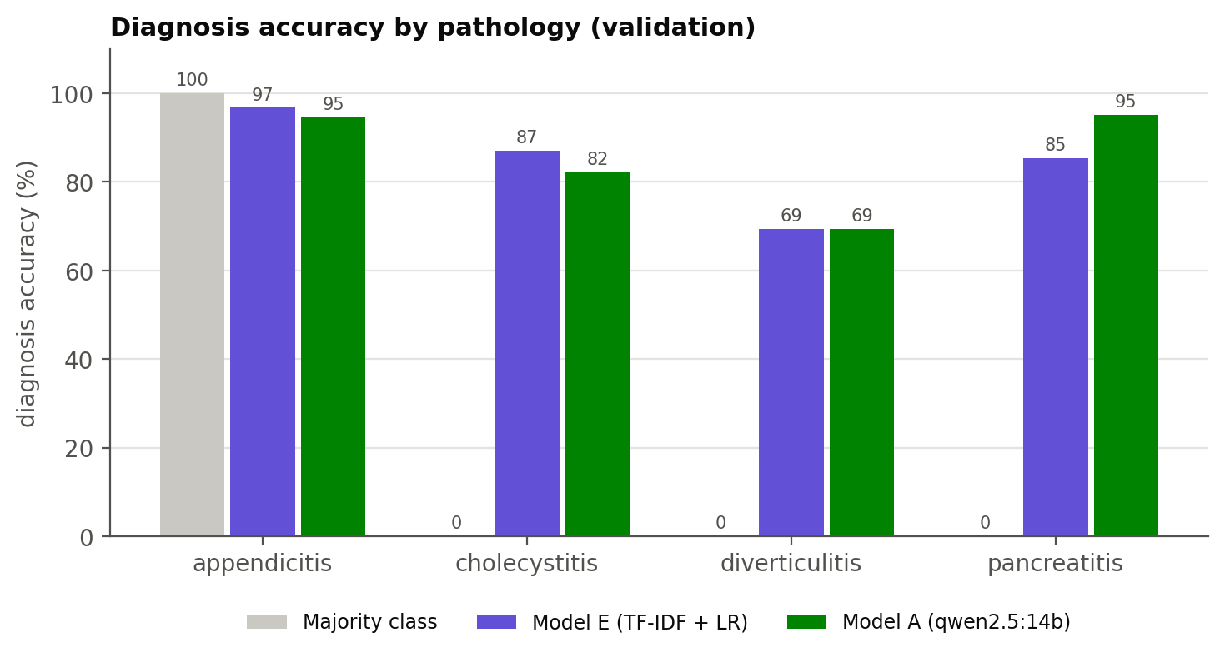
Figure 4.4-1. Diagnosis accuracy by pathology, validation split. Produced by notebooks/workbook2.ipynb, section 4.4.5.
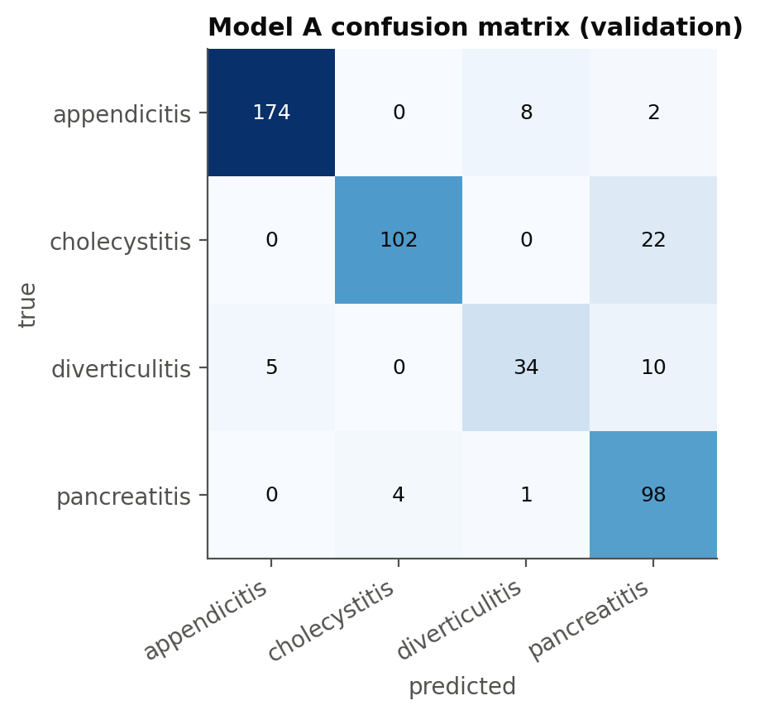
Figure 4.4-2. Model A confusion matrix. Its most common error is predicting pancreatitis for cholecystitis (22 cases); both present with upper-abdominal pain and raised enzymes. Produced by notebooks/workbook2.ipynb, section 4.4.4.
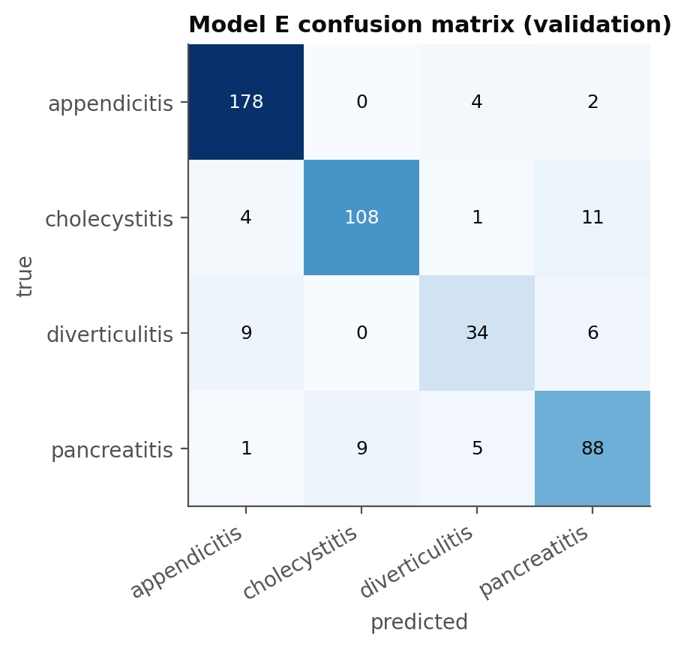
Figure 4.4-3. Model E confusion matrix. Produced by notebooks/workbook2.ipynb, section 4.4.3.
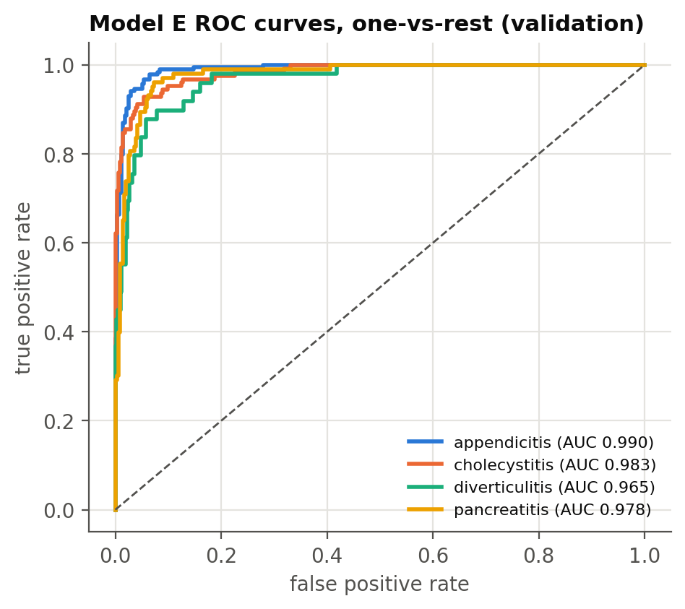
Figure 4.4-4. Model E ROC curves, one-vs-rest. Diverticulitis, the smallest class (49 validation cases), has the lowest AUC. Produced by notebooks/workbook2.ipynb, section 4.4.3.

4.4.2 Verifier results for Model A
Table 4.4-3. Model A plan status (460 plans).
plan status | plans
insufficient information | 280
violated | 123
valid | 57

Table 4.4-4. Rules Model A's plans violate.
rule | violating plans
R-GEN-001 | 106
R-APP-003 | 46
R-DIV-002 | 14
R-APP-002 | 2
R-PAN-002 | 1

Most plans end as insufficient information: the facts a rule needs are unknown in the record (Figure 3.6-6), so the verifier refuses to decide rather than guess. Among decided plans, the most common violation is R-GEN-001, followed by the complicated-appendicitis rule R-APP-003.

4.4.3 Reading the numbers
- Diagnosis accuracy here is the full-information setting (the whole record at once). Hager et al.'s 54.9% for OASST 70B is the autonomous setting, where the model has to request each test, so the two numbers are not comparable.
- Supported checked acceptance has no numeric target in protocol v1.1. Even a perfect diagnosis cannot push it above roughly 23–25% on the covered cases, because most record facts are unknown. A low value is mostly a coverage limit of the records, not a model failure. The majority-class floor is 0.143.
- Model A has no ROC curve or log loss: greedy LLM decoding returns a label without class probabilities. Model E covers those metrics.
- Escape rate and the 0.85 adjudicated validity need independent human plan labels. They are reported as unavailable, never estimated.
- Limitation: Model E's best C (30) is the largest value in the search grid, so a larger C might do slightly better. Widen the grid (e.g. up to 300) and rerun section 4.4.3 before the final submission.
- All numbers are from one validation run per model; the protocol's seeds 299 and 300 for Model A are planned for the formal test run.

4.5 Data Pipeline Demo: Ingestion, Transformation, Warehouse, Monitoring
Author: team member
The section 3 functions are packaged as one pipeline (src/clinverify/warehouse.py) that loads a local DuckDB warehouse (MIMIC_DIR/warehouse/clinverify.duckdb). DuckDB is a single-file analytical database [12]: it needs no server, and the data stays on the authorised machine. A command-line entry point (scripts/run_pipeline.py) runs the same function for scheduling.
Table 4.5-1. Warehouse layers.
Layer | Contents | Written by
raw | Downloaded tables as read: 9 Ext-CDM tables, lab mapping, pathology labels, MIMIC-IV admission → patient map | ingest
staging | Cleaned and transformed tables (deduplicated, normalised text, parsed and flagged labs) | stage
mart | cases (one row per case, with split and patient), case_facts, model_inputs | mart
ops | pipeline_runs, step_log, dq_results: counts only, no patient text | every run

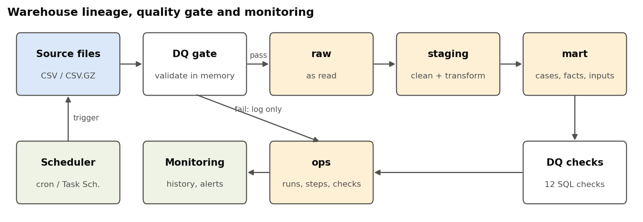
Figure 4.5-1. Warehouse lineage from source files through raw, staging and mart. Produced by notebooks/workbook2.ipynb, section 4.5.2.

4.5.1 Ingestion and transformation
One run ingests 728,384 raw rows (including 546,028 MIMIC-IV admissions for the patient map), stages and transforms them, builds the mart, and runs 14 data-quality checks, in about 5 seconds. Row counts reconcile across layers: for example discharge_procedures goes from 2,122 raw rows to 2,116 staged rows (5 duplicates and 1 empty procedure removed, as in section 3.3).
Table 4.5-2. Tables and rows per layer after the last run.
layer | table | rows | columns
mart | case_facts | 890 | 4
mart | cases | 2,400 | 9
mart | model_inputs | 2,400 | 5
raw | admissions | 546,028 | 2
raw | discharge_diagnosis | 2,400 | 2
raw | discharge_procedures | 2,122 | 2
raw | history_of_present_illness | 2,400 | 2
raw | icd_diagnosis | 17,357 | 2
raw | icd_procedures | 2,917 | 4
raw | lab_test_mapping | 1,209 | 6
raw | laboratory_tests | 138,788 | 5
raw | microbiology | 4,403 | 4
raw | pathology_ids | 2,400 | 2
raw | physical_examination | 2,400 | 2
raw | radiology_reports | 5,960 | 6
staging | discharge_diagnosis | 2,400 | 3
staging | discharge_procedures | 2,116 | 2
staging | history_of_present_illness | 2,400 | 3
staging | icd_diagnosis | 17,355 | 2
staging | icd_procedures | 2,849 | 4
staging | laboratory_tests | 138,788 | 11
staging | microbiology | 4,403 | 4
staging | physical_examination | 2,400 | 3
staging | radiology_reports | 5,960 | 7

4.5.2 Data-quality checks
Table 4.5-3. Data-quality checks of the last clean run (run `f148718a8b6f`): 14 of 14 pass.
check_name | layer | status | observed | expected
raw: validate_tables problems (gate) | raw | pass | 0 | 0
staging.history_of_present_illness: one row per case | staging | pass | 0 | 0
staging.physical_examination: one row per case | staging | pass | 0 | 0
staging.discharge_diagnosis: one row per case | staging | pass | 0 | 0
staging.laboratory_tests: no rows lost by transform | staging | pass | 138,788 | 138,788
staging.laboratory_tests: flag in allowed set | staging | pass | 0 | 0
mart.cases: one row per benchmark case | mart | pass | 2,400 | 2,400
mart.cases: every case has a split | mart | pass | 0 | 0
mart.cases: train split size | mart | pass | 1,840 | 1,840
mart.cases: val split size | mart | pass | 460 | 460
mart.cases: test split size | mart | pass | 100 | 100
mart.cases: no patient in two splits | mart | pass | 0 | 0
mart.model_inputs: no empty model input | mart | pass | 0 | 0
mart.case_facts: facts only for covered pathologies | mart | pass | 0 | 0

Quality gate. The raw checks run in memory before anything is written. If one fails, nothing is published, the last good warehouse stays as it was, and the run is still logged.

4.5.3 Monitoring and management
To demonstrate the gate, the notebook feeds the pipeline the corrupted copy from section 3.3.3. Run 05355fea2a02 is caught by the gate in under a second, logged as failed_checks, and publishes nothing; the clean run that follows passes all checks. The run history in ops.pipeline_runs is what an alert or dashboard reads.
Table 4.5-4. Run history (ops.pipeline_runs).
run_id | started_at | status | duration_s | trigger | n_cases | n_checks | n_checks_failed
f148718a8b6f | 2026-10-28 10:29:38 | ok | 5.26 | notebook | 2,400 | 14 | 0
05355fea2a02 | 2026-10-28 10:29:37 | failed_checks | 0.58 | notebook-fault-demo |  | 1 | 1
ec1adddb6d3c | 2026-10-28 10:29:31 | ok | 5.55 | notebook | 2,400 | 14 | 0
748d6b2982be | 2026-10-28 10:10:02 | ok | 5.62 | cli-demo | 2,400 | 14 | 0
5f76622200f5 | 2026-10-28 10:09:55 | ok | 5.39 | notebook | 2,400 | 14 | 0
bee876315271 | 2026-10-28 10:09:54 | failed_checks | 0.67 | notebook-fault-demo |  | 1 | 1
ca2a707c711b | 2026-10-28 10:09:48 | ok | 5.51 | notebook | 2,400 | 14 | 0
bce8e81b82b2 | 2026-10-28 09:30:33 | ok | 5.2 | manual | 2,400 | 14 | 0

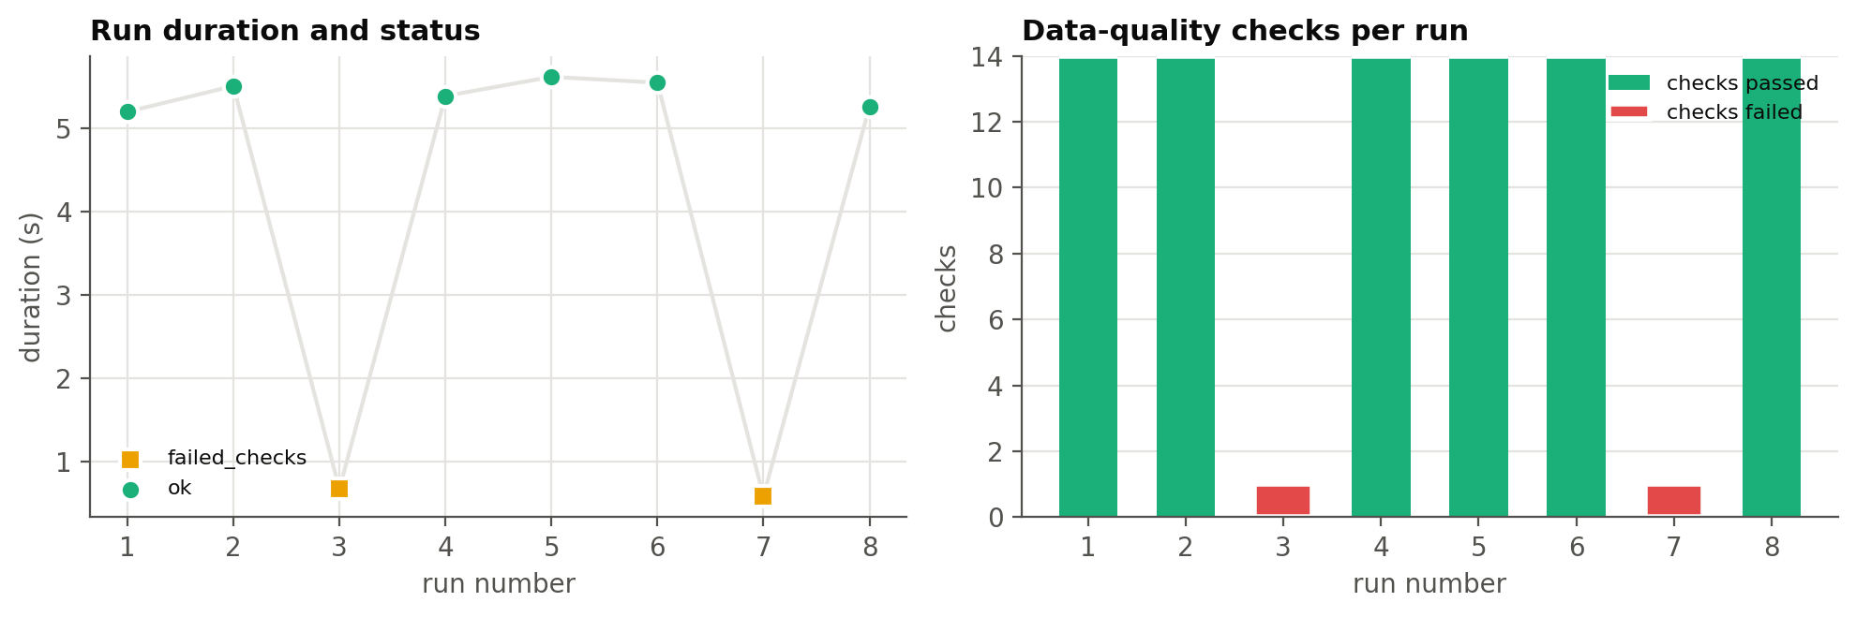
Figure 4.5-2. Pipeline monitoring: run duration and status (left), checks passed and failed per run (right). Runs 3 and 7 are the deliberate fault-injection runs. Produced by notebooks/workbook2.ipynb, section 4.5.3.

4.5.4 Scheduling and alerting
scripts/run_pipeline.py exits with 0 when the run is ok, 1 when a check fails and 2 on an error, so any scheduler can alert on a non-zero exit. Nightly at 02:00 with cron on Linux / WSL:
0 2 * * * cd <repo> && MIMIC_DIR=$HOME/data/mimic .venv/bin/python scripts/run_pipeline.py --trigger cron >> $HOME/data/mimic/warehouse/cron.log 2>&1
On Windows, Task Scheduler runs the same command through wsl.exe. python scripts/run_pipeline.py --history prints the run log at any time. A step-by-step live demo script is in workbook/T6.A6_pipeline_demo.md.

References
[1] de Moura, L., & Bjørner, N. (2008). Z3: An efficient SMT solver. Tools and Algorithms for the Construction and Analysis of Systems (TACAS), LNCS 4963, 337–340. https://doi.org/10.1007/978-3-540-78800-3_24
[2] Goldberger, A. L., Amaral, L. A. N., Glass, L., Hausdorff, J. M., Ivanov, P. C., Mark, R. G., Mietus, J. E., Moody, G. B., Peng, C.-K., & Stanley, H. E. (2000). PhysioBank, PhysioToolkit, and PhysioNet. Circulation, 101(23), e215–e220.
[3] Hager, P., Jungmann, F., Holland, R., Bhagat, K., Hubrecht, I., Knauer, M., Vielhauer, J., Makowski, M., Braren, R., Kaissis, G., & Rueckert, D. (2024). Evaluation and mitigation of the limitations of large language models in clinical decision-making. Nature Medicine, 30, 2613–2622. https://doi.org/10.1038/s41591-024-03097-1
[4] Hager, P., et al. (2024). MIMIC-IV-Ext Clinical Decision Making (MIMIC-IV-Ext-CDM), version 1.1. PhysioNet. https://physionet.org/content/mimic-iv-ext-cdm/1.1/ — verify authors and title on the PhysioNet page.
[5] Helmert, M. (2006). The Fast Downward planning system. Journal of Artificial Intelligence Research, 26, 191–246.
[6] Johnson, A. E. W., Bulgarelli, L., Shen, L., et al. (2023). MIMIC-IV, a freely accessible electronic health record dataset. Scientific Data, 10, 1. https://doi.org/10.1038/s41597-022-01899-x
[7] Kambhampati, S., Valmeekam, K., Guan, L., Verma, M., Stechly, K., Bhambri, S., Saldyt, L. P., & Murthy, A. B. (2024). Position: LLMs can't plan, but can help planning in LLM-Modulo frameworks. ICML 2024, PMLR 235, 22895–22907.
[8] Liu, B., Jiang, Y., Zhang, X., Liu, Q., Zhang, S., Biswas, J., & Stone, P. (2023). LLM+P: Empowering large language models with optimal planning proficiency. arXiv:2304.11477.
[9] Pan, L., Albalak, A., Wang, X., & Wang, W. Y. (2023). Logic-LM: Empowering large language models with symbolic solvers for faithful logical reasoning. Findings of EMNLP 2023, 3806–3824.
[10] Pedregosa, F., et al. (2011). Scikit-learn: Machine learning in Python. Journal of Machine Learning Research, 12, 2825–2830.
[11] Qwen Team (2024). Qwen2.5 technical report. arXiv:2412.15115.
[12] Raasveldt, M., & Mühleisen, H. (2019). DuckDB: An embeddable analytical database. Proceedings of SIGMOD 2019, 1981–1984.
[13] Valmeekam, K., Marquez, M., & Kambhampati, S. (2023a). Can large language models really improve by self-critiquing their own plans? arXiv:2310.08118.
[14] Ye, X., Chen, Q., Dillig, I., & Durrett, G. (2023). SatLM: Satisfiability-aided language models using declarative prompting. NeurIPS 36. arXiv:2305.09656.

Submission checklist (not part of the report)
Check | Yes / No
Every section is written as report prose, not as notes | Yes
Every number comes from the run recorded in the notebook (run IDs, model digest, plan file named) | Yes
Every figure names the notebook section that produced it | Yes
No record text from MIMIC appears in this document (samples are synthetic) | Yes
Each section names the team member who wrote it | No: fill the author lines
Repository commit recorded on the title page | No: commit the Workbook 2 code first

Self-assessment and gap register
Report section | Our rating | If below good: what is missing | Owner | Lands by
3.1–3.6 Data engineering | rating
4.1 Model proposals | rating | Team sign-off on Model E as the fifth model | owner | date
4.2–4.3 Supports and comparison | rating
4.4 Evaluation | rating | Widen Model E's C grid; Model A seeds 299/300; human plan labels for escape rate | owner | date
4.5 Pipeline demo | rating | Live demo rehearsal (workbook/T6.A6_pipeline_demo.md) | owner | date

