Workbook 2: Report Sections 3 and 4
Item | Entry
Team, section and topic | Team 6, Section 22, Topic 12: Neurosymbolic Verification of LLM-Generated Clinical Discharge and Treatment Plans
Date | November 11, 2026

Team members and the sections each person wrote
Team member | Sections written
Sneha | 3.1, 3.3, 3.4, 3.6 and 4.4: pipeline, cleaning and transformation, case facts, statistics, rule catalog and evaluation protocol
Ritika | 3.5: fixed patient-grouped splits (data/splits/ext_cdm_splits_v2.json)
Rajesh | 3.5: patient-level leakage check (docs/split_leakage_check.md)
Akash | 3.2 and 4.1 to 4.3: data collection and provenance; model proposals; platform, Model A and the warehouse; model comparison. Also ran the baseline reproduction and the Model A validation reported in the carry-forward table, not in section 4.4, which is Sneha's. 4.5 and 4.6 are left as headings, as the template asks.
Shruthi | 4.2: environment and CI (.github/workflows), the model architecture figure (PR #10), slides 1 to 4 and speaker notes (PR #11), the guarded Model A generation command and its tests (PR #12), and the Model A adapter-training package (PR #16, in review; real training has not been run)

3 Data Engineering

3.1 Data Process
Author: Sneha
We use two PhysioNet datasets, MIMIC-IV v3.1 and MIMIC-IV-Ext-CDM v1.1. The process has seven steps, in this order: download and check every file against its published SHA-256 value, check that every case links to MIMIC-IV, clean duplicates, handle missing values, transform text and lab values, validate the result, and finally explore the data and fix the train, validation and test splits.
The patient files stay on each person's own machine in ~/data/mimic. The cleaned and transformed tables exist only in memory while the code runs. What goes into the repository is code, case IDs for the splits, and counts and figures with no patient text.
The same steps also run as a script, scripts/run_pipeline.py, which loads the tables into a local DuckDB warehouse with three layers (raw, staging, mart) and an ops log. The raw data-quality checks run first, and a run that fails them writes nothing, so the last good warehouse stays as it was. scripts/scheduled_pipeline.sh runs it on a schedule with a retry and an alert log. The warehouse file lives outside the repository, with the data.
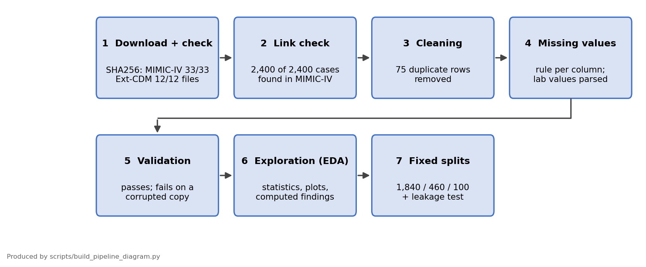
Figure 1. The data pipeline, from download to fixed splits.
Stage | Output | Where it lives
Raw data | MIMIC-IV v3.1 and Ext-CDM v1.1 | ~/data/mimic, outside the repository, never committed
Cleaned and transformed tables | in memory only | patient files are never written into the repository
Splits | case IDs only | data/splits/ext_cdm_splits_v2.json
Aggregate results | counts and figures | results/ and docs/images/

3.2 Data Collection
Author: Akash
MIMIC-IV v3.1 is about 9.9 GB and holds hospital records. MIMIC-IV-Ext-CDM v1.1 is 17 MB and was built by Hager et al. (2024) from MIMIC-IV. It contains 2,400 cases in four abdominal pathologies: appendicitis (957), cholecystitis (648), pancreatitis (538) and diverticulitis (257). Ext-CDM is the working set. MIMIC-IV is used to check that every case exists in the source (all 2,400 admissions are among its 546,028) and to map each admission to its patient for the split.
Sources. docs/data_collection.md and docs/data_engineering.md; counts per pathology from the Ext-CDM case lists, recomputed from the real-data run on Nov 11 to 12, 2026 (notebooks/data_pipeline_demo.ipynb).
Item | Value
Access | PhysioNet credentialed access and a signed data use agreement for each person. Data is not shared between people.
Integrity | every file matches SHA256SUMS.txt: MIMIC-IV 33 of 33 files, Ext-CDM 12 of 12 files
Link check | all 2,400 hadm_id values exist in MIMIC-IV admissions
Use rules | no sharing or re-identification; MIMIC text is never sent to hosted LLM APIs

The Ext-CDM tables, with their raw size:
Table | Rows | Columns
history_of_present_illness | 2,400 | hadm_id, hpi
physical_examination | 2,400 | hadm_id, pe
discharge_diagnosis | 2,400 | hadm_id, discharge_diagnosis
icd_diagnosis | 17,357 | hadm_id, icd_diagnosis
icd_procedures | 2,917 | hadm_id, icd_code, icd_title, icd_version
discharge_procedures | 2,122 | hadm_id, discharge_procedure
laboratory_tests | 138,788 | hadm_id, itemid, valuestr, ref_range_lower, ref_range_upper
microbiology | 4,403 | hadm_id, test_itemid, valuestr, spec_itemid
radiology_reports | 5,960 | hadm_id, note_id, modality, region, exam_name, text

Sample raw records. The real records are credentialed patient data and cannot be reproduced in a report. The samples below come from the synthetic stand-in that the repository generates (scripts/make_synthetic_data.py). It has the same tables and columns, with random values and nothing derived from real patients.
Table | hadm_id | Example row (synthetic)
history_of_present_illness | 20000000 | hpi: SYNTHETIC history note for case 20000000. Pain reported.
laboratory_tests | 20000000 | itemid 50931, valuestr "96.6 mg/dL", ref_range_lower and ref_range_upper missing
radiology_reports | 20000000 | note_id SYN-20000000-0, modality MRCP, region Abdomen, SYNTHETIC report text
microbiology | 20000115 | test_itemid 90001, valuestr NEGATIVE, spec_itemid 70001

3.3 Data Pre-processing
Author: Sneha
Pre-processing removes exact duplicate rows and handles missing values with one rule per column. A repeated hadm_id in an event table is kept when the rest of the row differs, because one admission can have many labs or procedures.
Rule | Table | Rows before | Rows removed | Rows after
Exact duplicate rows | icd_diagnosis | 17,357 | 2 | 17,355
Exact duplicate rows | icd_procedures | 2,917 | 68 | 2,849
Exact duplicate rows | discharge_procedures | 2,122 | 5 | 2,117
Empty procedure (cannot be used) | discharge_procedures | 2,117 | 1 | 2,116
Missing lab reference range: kept, flagged unknown | laboratory_tests | 138,788 | 0 (40,265 rows, 29.0%, flagged) | 138,788
Text is formatted the same way in every text table: strip the ends, collapse repeated spaces and line breaks into one space. This rewrote 2,400 of 2,400 history notes, 2,193 of 2,400 examination notes, 5,960 of 5,960 radiology reports and 761 of 2,400 discharge diagnoses.
 | Before (invented example) | After
Text cell | RLQ pain for two days. Nausea. | RLQ pain for two days. Nausea.

Outliers are counted and kept. 24 histories are longer than the 99th percentile (621 words), and many lab rows are outside their reference range. Both are real clinical records, so dropping them would remove the cases the rules matter most for.
Validation checks run twice. They pass on the cleaned tables and fail on a copy that was broken on purpose (duplicate case ids, empty text, missing columns). That shows the checks can catch a real problem.
Sources. notebooks/data_pipeline_demo.ipynb, sections 2.1 to 2.6 (text-format counts and the outlier count come from its outputs; the outlier count 24 and the 99th percentile 621 were recomputed on Nov 11 to 12, 2026).

3.4 Data Transformation
Author: Sneha
The transforms turn free text and lab strings into columns the rules can compare. Each one has a reason.
Table | Input | Operation | Output | Why
text tables | raw free text | strip, collapse whitespace | text and word count | one format; length as an input-size feature
laboratory_tests | valuestr, e.g. "2.5 mmol/L" | split into number, unit and < or > qualifier; non-numeric stays text | value, unit, qualifier, value_is_numeric | compare against the reference range
laboratory_tests | value and reference range | flag low, normal or high; unknown if the range is missing | flag | no invented ranges
lab_test_mapping | itemid | drop rows without it, cast to int | itemid, label | readable lab names
all case tables | hadm_id and pathology_ids.json | join the pathology label | cases_master (2,400 rows, 7 columns) | label for stratified splits and per-class analysis

Result on the lab table: 103,209 of 138,788 values are numeric (74.4%) and 1,295 carry a < or > qualifier. Flags: normal 68,820, high 17,525, low 9,510, unknown 42,933 (30.9%, either no numeric value or no reference range).
Sources. notebooks/data_pipeline_demo.ipynb, section 2.4; the lab counts and flags (138,788 rows; 103,209 numeric; 1,295 with a qualifier; normal 68,820, high 17,525, low 9,510, unknown 42,933) were recomputed on Nov 11 to 12, 2026. Case-fact rules: docs/case_facts_mapping.md.
Transformed sample (synthetic) | valuestr | value | unit | flag
laboratory_tests, hadm_id 20000000 | 96.6 mg/dL | 96.6 | mg/dL | unknown (no reference range in the row)

Case facts for the rules
The rules check a plan against facts about the patient, such as whether the appendicitis is complicated. Ext-CDM does not store these as fields, so we work them out from each admission's ICD diagnosis titles. The discharge diagnosis text is used in one way only: to add a complication that is written there, current and not negated. Each fact comes out true, false or unknown. True needs explicit evidence, false needs a title that says so, and everything else stays unknown, so a rule that needs it answers "insufficient information" instead of guessing. Three facts (oral or enteral feeding possible, low risk, colorectal screening up to date) cannot be derived from the record at all.
Pathology | Fact | Cases | True | False | Unknown
appendicitis | complicated | 957 | 246 | 1 | 710
pancreatitis | necrotizing | 538 | 7 | 89 | 442
pancreatitis | infection | 538 | 38 | 0 | 500
pancreatitis | biliary | 538 | 69 | 24 | 445
pancreatitis | cholangitis | 538 | 37 | 0 | 501
pancreatitis | biliary_obstruction | 538 | 86 | 0 | 452
pancreatitis | mild | 538 | 0 | 120 | 418
diverticulitis | complicated | 257 | 121 | 36 | 100
diverticulitis | alarm_symptoms | 257 | 14 | 0 | 243

3.5 Data Preparation
Author: Ritika (fixed splits), Rajesh (leakage check)
We hold out 100 cases as the test set named in the abstract. Of the remaining 2,300, 20% (460) are validation and the rest (1,840) are training. The split is stratified by pathology with seed 298 and grouped by patient, so all admissions of one patient go to the same split. It is stored as case IDs only and versioned in git (data/splits/ext_cdm_splits_v2.json).
Split | Rows | % of total | Stratified on | Leakage check and result
Train | 1,840 | 76.7 | pathology, seed 298, grouped by patient | no case ID in two splits, no patient in two splits: pass
Validation | 460 | 19.2 | same | same: pass
Test | 100 | 4.2 | same | same: pass. Class mix 40 / 27 / 22 / 11 (appendicitis, cholecystitis, pancreatitis, diverticulitis)

What the leakage check found. The first split divided cases by admission ID. It had no shared admissions, but 5 patients appeared in two splits, one of them in the test set (4 in both train and validation, 1 in both train and test). We rebuilt the split grouped by patient (version 2). It has the same sizes and class mix, and 0 patients in more than one split. Version 2 is the split the project uses, and its test set differs from version 1 by 5 cases. The test set is not used to tune rules or models.
Sources. data/splits/ext_cdm_splits_v2.json (1,840 / 460 / 100, grouped by subject_id), docs/split_leakage_check.md and docs/data_engineering.md.
Split | Sample case IDs (pathology)
Train | 20000602 (appendicitis), 20001800 (pancreatitis), 20005465 (pancreatitis)
Validation | 20009550 (pancreatitis), 20014929 (pancreatitis), 20121534 (cholecystitis)
Test | 20418179 (pancreatitis), 20870068 (appendicitis), 20880304 (appendicitis)
Prepared samples are IDs and labels because the notes and labs behind them are patient text.

3.6 Data Statistics
Author: Sneha
The table gives the size of the data at each stage. Rows and columns are summed over the nine tables.
Stage | Rows | Columns | Notes
Raw | 178,747 | 29 | 9 Ext-CDM tables as downloaded, 2,400 cases
Pre-processed | 178,672 | 29 | 75 exact duplicate rows removed
Transformed | 178,671 | 39 | text normalised, lab values parsed and flagged; cases_master adds 2,400 rows by 7 columns
Prepared | 1,840 / 460 / 100 | 7 | cases in train, validation and test, grouped by patient

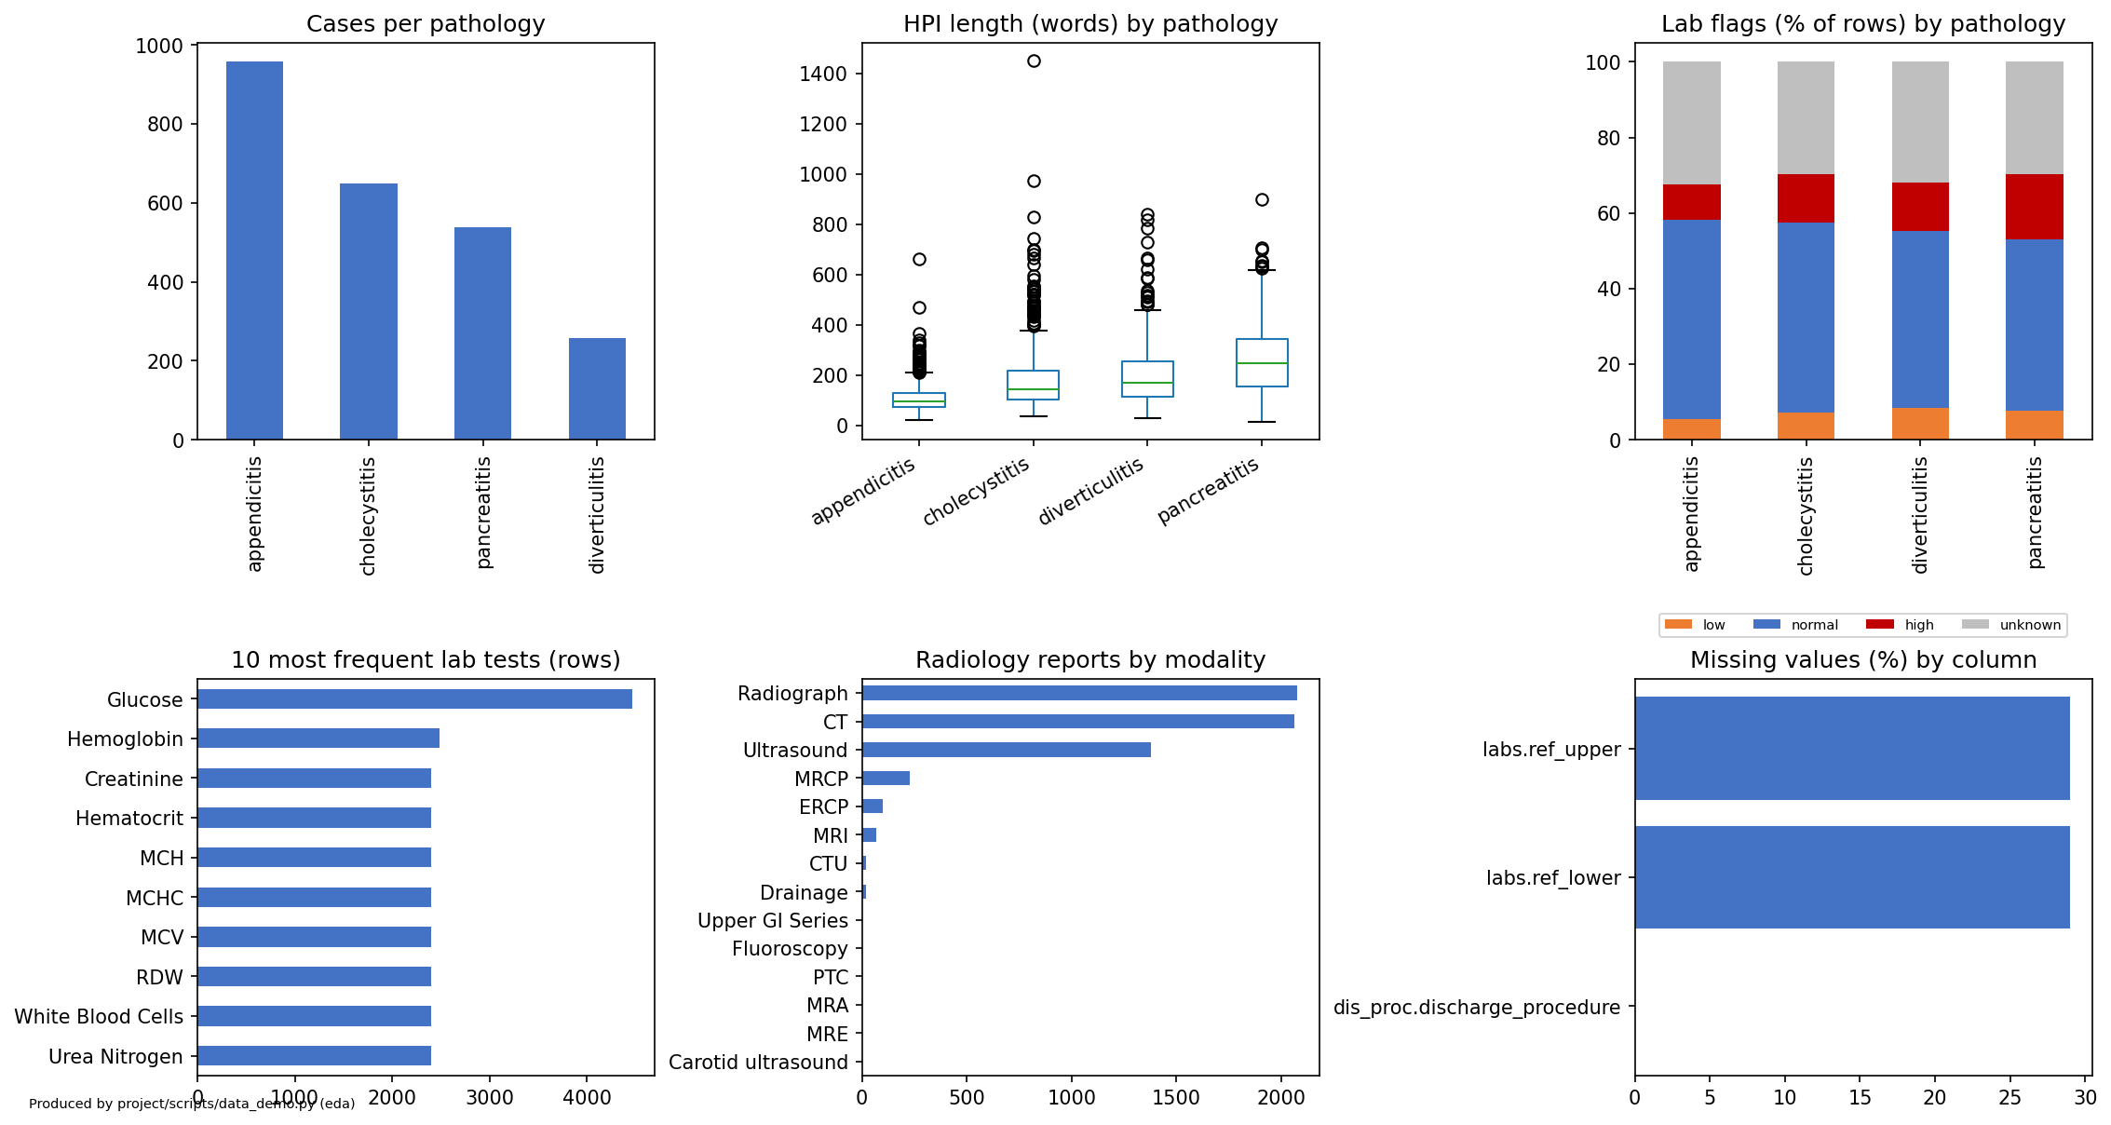
Figure 2. Exploratory analysis: class balance, history length, lab flags and correlation of per-case counts.
- Class imbalance: appendicitis has 957 cases and diverticulitis 257, about 3.7 times as many. One overall accuracy number would mostly reflect appendicitis, so results are reported per pathology next to the overall number.
- History length: the median history is 131 words and the longest 1,450. The median is 95 words for appendicitis and 248 for pancreatitis.
- Labs: 30.9% of lab rows cannot be flagged and stay unknown. Of the rows that can be flagged, 28.2% are abnormal.
- Per case, on average: 57.8 lab rows, 2.5 radiology reports, 7.2 ICD diagnoses and 172 history words. Figure 2b shows how these counts relate: no pair shows a strong linear correlation.
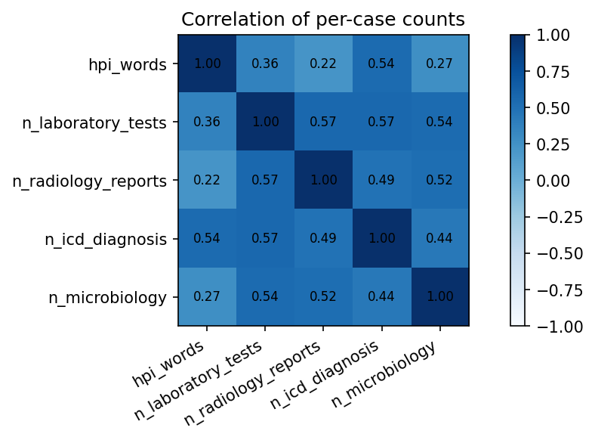
Figure 2b. Pearson correlation of per-case counts (history words, lab rows, radiology reports, ICD diagnoses, microbiology rows), N = 2,400 cases. Generated by notebooks/data_pipeline_demo.ipynb (cell 37) from the real-data run. Aggregates only; no patient text.
Interpretation. The correlations are weak to moderate, from 0.22 to 0.57. Lab, radiology, microbiology and ICD-diagnosis counts are moderately correlated with each other (0.44 to 0.57): cases with many labs also tend to have many radiology reports, cultures and diagnoses. History length is the least tied to the others (0.22 to 0.36 with labs, radiology and microbiology; 0.54 with diagnosis count). No pair shows a strong linear correlation. Pearson correlation on skewed counts with outliers kept on purpose is a rough guide only; a rank correlation was not computed.
Sources. Figure 2 and the statistics above: notebooks/data_pipeline_demo.ipynb and results/eda_summary.csv; per-case means, medians and the history-length medians per pathology were recomputed on Nov 11 to 12, 2026. Demographic shares: notebooks/workbook2.ipynb (population table), not recomputed for this report.

Coverage and population gaps
The 2,400 cases are 53% female and 47% male. By age: 35% are 18 to 39, 32% are 40 to 59, 20% are 60 to 74 and 13% are 75 or older. By recorded race: 65% White, 13% Black, 8% Hispanic or Latino, 6% Asian and 8% other, unknown or declined. 90% have English as their language. Groups below 10 cases are merged so that no small cell is shown.
Gap | Evidence | Who it could be less accurate or less safe for
One hospital system | MIMIC-IV comes from a single academic medical centre | Patients and practices unlike that centre: other regions, community and rural hospitals
Four diagnoses only | cases were selected for appendicitis, cholecystitis, diverticulitis and pancreatitis | Patients whose abdominal pain has another cause. The system cannot answer "none of these"
No treatment rules for cholecystitis | 27 of the 100 test cases are cholecystitis and return "diagnosis not covered" | Cholecystitis patients are not checked at all
Many case facts unknown | 710 of 957 appendicitis cases and most pancreatitis facts are unknown from the codes | Cases with generic diagnosis codes are checked by fewer rules than cases with specific codes
Uneven demographic mix | 65% White, 8% Hispanic or Latino, 6% Asian; 10% not English or unknown | Smaller groups have few cases, so a difference in results for them would be hard to detect
Demographics not yet compared with results | Model A has been run on the validation split only, and its results are not broken down by group | Whether validity differs by age, sex, race or language is untested and is planned for 298B
Guidelines from 2025 and 2026, mostly US and European | the rule sources in section 4.1 | Settings where those guidelines are not the standard of care

4 Model Development

4.1 Model Proposals
Author: Akash
The project checks a language model's discharge or treatment plan with a verifier that the team builds, so that a plan is not trusted just because it reads well. The verifier turns the plan into a structured form and tests it against 12 team-written rules with the Z3 solver. When a plan breaks a rule, the verifier returns the rule ID and a message. A rule is blocking, or advisory when its source only suggests the action; an advisory finding is reported but does not make the plan invalid. The catalog is version 2.1, built from 2025 and 2026 guidelines. The first reviewer has read all 12 rules. The second reviewer and the clinical review are still pending, so the catalog is implemented and tested but not clinically validated.
We build four models, one in 298A and three in 298B. The reproduced baseline is listed separately and is not one of the four. All of them are scored on the same 100 test cases with the same verifier.
# | Model | Concept / architecture | Built in | Owner
1 | A | An LLM generates the discharge and treatment plan directly. The plan is parsed into the structured form and checked by the Z3 verifier. The LLM is prompted, with no project fine-tuning. | 298A | Akash
2 | B | Proposed for 298B. Input: the admission record text (history, examination, labs, microbiology, radiology) and no record-derived facts. Architecture: an LLM turns the record and the clinical goals into a formal specification, a JSON list of constraints on the plan (diagnosis, allowed treatment concepts, required durations) that maps to Z3 terms. Algorithm: a Z3 solver finds a treatment set that satisfies the specification and the rule catalog; the LLM then writes the plan text from the solved set. The result is checked by the same verifier as Model A. | 298B | Rajesh
3 | C | Proposed for 298B. Input: the same record as Model A. Architecture: Model A's generator plus a repair loop around the Z3 verifier. Algorithm: generate a plan, verify it, return the names and messages of the violated rules to the LLM, and regenerate; stop when no rule is violated or after a fixed number of rounds (proposed: 3). Unknown rule outcomes are not fed back as violations. The final plan is scored by the same verifier as Model A. | 298B | Shruthi (proposed; to confirm)
4 | D | Proposed for 298B. Input: the same record as Model A. Architecture: an LLM writes the initial state and the goal in PDDL from the record, and a classical planner (for example Fast Downward) searches for an action sequence. Algorithm: the actions are the treatment concepts of the plan schema, with preconditions taken from the rule catalog; the found action sequence is rendered back to the structured plan and checked by Z3. It is the hardest to build, because lab-dependent and conditional rules are hard to write as preconditions. | 298B | Ritika
- | Baseline | Hager et al. (2024), autonomous task, 2,400 cases in the paper. The best open model, OASST 70B, reaches 54.9% mean diagnostic accuracy (Fig. 3 of the paper). It measures diagnosis, not plan validity, so it is not directly comparable with our validity metric. Our reproduction is reduced-scale (see the carry-forward table). | 298A | Akash

4.2 Model Supports
Author: Akash (platform, Model A, warehouse), Shruthi (environment and CI)
Everything that touches patient data runs on a local machine. Only code, documents, case IDs and aggregate counts go to GitHub. MIMIC text is never sent to a hosted LLM, which PhysioNet's rules require, so the models run locally. Model A runs on one team machine with an NVIDIA RTX 5060 Ti (16 GB) through Ollama, using the qwen2.5:14b model with output constrained to a JSON schema. Model A is prompted, not trained: it reads the whole record in one prompt, decodes greedily (temperature 0, seed 298, 8,192-token context) and has no project fine-tuning.
Sources. Model A code and prompt: src/clinverify/models/model_a.py, prompt hash 995be554, model digest 7cdf5a0187d5 (docs/validation_summary.json; T6-110, T6-28). Streamlit prototype and baseline notes: PR #1. Model A validation: PR #6. Generation command: PR #12 (T6-183). Architecture figure: PR #10 (T6-181). Scheduled pipeline: commit 32d19ef.
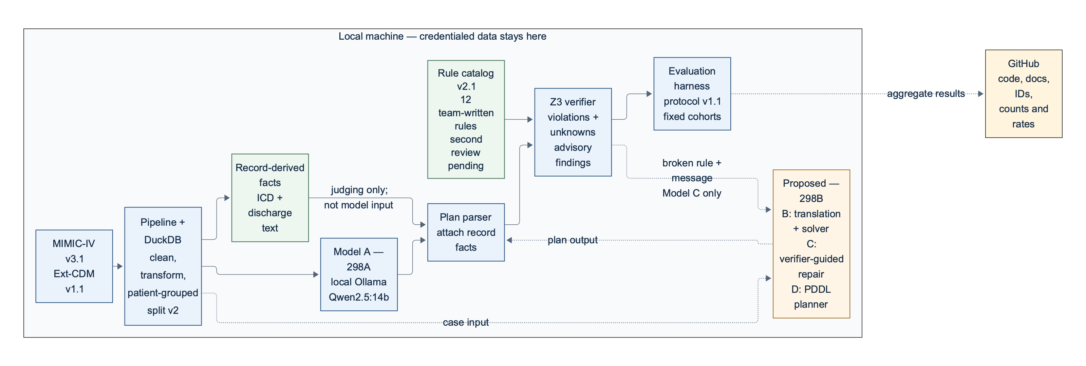
Figure 3. Platform and data flow. Models B to D are proposed for 298B.
Part | What it is
Language and libraries | Python (runs verified on 3.13, GitHub Actions uses 3.12), pandas, numpy, matplotlib, scikit-learn, duckdb, z3-solver 5.3.1 and pytest, pinned in requirements.txt
Where code is checked | unit tests with pytest, run in GitHub Actions on every push, plus a quickstart run on synthetic data
Where data lives | outside the repository, in ~/data/mimic. .gitignore blocks data files
Where the models run | local only: one team machine with an NVIDIA RTX 5060 Ti (16 GB), run under WSL2. Model A is served by Ollama 0.40.12 as qwen2.5:14b (Q4_K_M, 4-bit weights); the plan is a JSON object checked against a schema
Task tracking | Linear board for Team 6, with cycles and labels for data, model, eval and infra
Warehouse and schedule | DuckDB single file with raw, staging, mart and ops layers. python scripts/run_pipeline.py builds it; scripts/scheduled_pipeline.sh runs it on a schedule with a retry and an alert log
Live prototype | Streamlit app (app/demo_app.py): pick a validation case, verify Model A's plan with Z3, and inject a fault to see the verifier name the broken rule

4.3 Model Comparison and Justification
Author: Akash
The four models differ in how the LLM and the solver work together. The table compares them on the problem each targets, the approach, and where it is likely to be strong or weak. The strengths and limitations are our reading of the papers and the data so far. Model A has been run only on the validation split and Models B, C and D do not exist yet, so the table compares designs, not results.
 | Model A | Model B | Model C | Model D
Targeted problem | plain plan generation, the reference for the rest | plans that are faithful to a formal reading of the case | plans that are corrected until they pass the rules | plans that are valid by construction for a planning domain
Input | the whole record in one prompt: history of present illness, physical examination, laboratory results, microbiology and radiology reports, trimmed to fit an 8,192-token context (the full-information setting of Hager et al.). No discharge diagnosis, ICD codes or case facts | case text | case text plus verifier feedback | case text plus a domain model
Approach | LLM prompting | LLM translation plus a deterministic solver (Logic-LM, SatLM, Faithful-CoT) | LLM plus an external critic in a loop (LLM-Modulo, Logic-LM self-refine) | LLM translation plus a classical planner (LLM+P)
Strength | simplest, closest to the baseline paper, no translation step | the solver does the reasoning, so the explanation matches the answer | uses the rule catalog directly and names the broken rule | the planner's output follows the domain model
Limitation | no correction step. Hager et al. report that LLMs often skip guideline-recommended treatment | translation errors, counted as translation fidelity; the formal language must cover each diagnosis | can only repair what the rules cover; an unknown fact gives no feedback; extra solver calls and generations | needs a clinical planning domain written in PDDL, which does not exist yet
Built in | 298A | 298B | 298B | 298B

Model A is the current preferred approach for 298A. Among Models A to D it is the only one built and measured (the reference model E was also evaluated, but it is not one of the four), and it is the plain generator that Models B, C and D are meant to improve on. This is not a claim that it is the best model. On the 460 validation cases it names the right diagnosis in 88.7% of cases (macro F1 0.855), but its checked acceptance is 49 of 336 covered cases (14.6%). Checked acceptance counts a covered case only when the diagnosis is correct, the verifier accepts the plan, and at least one non-advisory clinical rule was actually decided; the scope guard, advisory-only rules and not-applicable rules earn no credit (docs/metrics.md). The verdicts over all 460 validation cases are 57 valid, 123 violated and 280 insufficient information (docs/validation_summary.json). Its limits are that it is prompted, not trained; it never sees why a plan failed; decoding is greedy, so the three seeds give identical output; it is a 4-bit 14B local model; and the rules behind the verdicts are not clinically validated. Model A would lose to the others in these cases:
- Model A loses to B, C and D whenever correction matters, because it never sees why a plan failed.
- Model B loses when the notes are too long or messy to translate correctly. Pancreatitis notes have a median of 248 words against 95 for appendicitis.
- Model C loses when most facts are unknown. Six of 12 rules can be checked on at most one case from the facts alone, so there is little to feed back.
- Model D loses when a care step cannot be written as an action with a precondition, as with the lab-dependent and conditional guideline rules.

4.4 Model Evaluation Methods
Author: Sneha
The definitions below are protocol version 1.1, committed to the repository on October 23, 2026 (commit 84c3ca5), before any model result exists. They are not to be changed after results appear. The full definitions are in docs/metrics.md and docs/evaluation_protocol.json.
Metric | Why this metric | Benchmark or split it is measured on | Committed on
diagnosis_accuracy | the baseline paper's headline number, so we can compare with a published reference | all 100 test cases | Oct 23, 2026
supported_checked_acceptance_rate (primary, descriptive, no numeric target) | share of covered cases with a correct diagnosis and a plan accepted after at least one decided blocking clinical rule; scope-only or advisory-only acceptance earns no credit | the 73 covered test cases | Oct 23, 2026
joint_success_rate | correct diagnosis and an accepted plan together | all 100 test cases | Oct 23, 2026
Escape rate, target <= 0.05 | bad plans that the verifier lets through | independently labelled plans (labelling not yet done) | Oct 23, 2026
adjudicated_treatment_validity_rate, research goal 0.85 | independent human judgement of treatment validity | record-evaluable covered cases (human review not yet done) | Oct 23, 2026

- Of the 100 test cases, 73 (appendicitis, pancreatitis, diverticulitis) are covered by the rules. The 27 cholecystitis cases are reported as unsupported for treatment, not as treatment failures.
- Each run uses seeds 298, 299 and 300. Missing or unparseable plans count as failures and stay in the denominator. Results are reported per pathology next to the overall number.
- Unknown and not-applicable rule outcomes, and advisory findings, are reported with the rates. A plan with an unknown blocking input is never counted as valid.

4.5 First Model Implementation

4.6 Baseline Reproduction

References
1. Guan, L., Valmeekam, K., Sreedharan, S., & Kambhampati, S. (2023). Leveraging pre-trained large language models to construct and utilize world models for model-based task planning. NeurIPS 36. https://arxiv.org/abs/2305.14909
2. Hager, P., Jungmann, F., Holland, R., Bhagat, K., Hubrecht, I., Knauer, M., Vielhauer, J., Makowski, M., Braren, R., Kaissis, G., & Rueckert, D. (2024). Evaluation and mitigation of the limitations of large language models in clinical decision-making. Nature Medicine, 30, 2613-2622. https://doi.org/10.1038/s41591-024-03097-1
3. Hekmatnejad, M., Simms, A. M., & Fainekos, G. (2019). Model checking clinical decision support systems using SMT. arXiv:1901.04545. https://arxiv.org/abs/1901.04545
4. Huang, J., Chen, X., Mishra, S., Zheng, H. S., Yu, A. W., Song, X., & Zhou, D. (2024). Large language models cannot self-correct reasoning yet. ICLR. https://arxiv.org/abs/2310.01798
5. Kambhampati, S., Valmeekam, K., Guan, L., Verma, M., Stechly, K., Bhambri, S., Saldyt, L. P., & Murthy, A. B. (2024). Position: LLMs can't plan, but can help planning in LLM-Modulo frameworks. ICML, PMLR 235, 22895-22907. https://proceedings.mlr.press/v235/kambhampati24a.html
6. Liu, B., Jiang, Y., Zhang, X., Liu, Q., Zhang, S., Biswas, J., & Stone, P. (2023). LLM+P: Empowering large language models with optimal planning proficiency. arXiv:2304.11477. https://arxiv.org/abs/2304.11477
7. Olausson, T. X., Inala, J. P., Wang, C., Gao, J., & Solar-Lezama, A. (2024). Is self-repair a silver bullet for code generation? ICLR. https://arxiv.org/abs/2306.09896
8. Pan, L., Albalak, A., Wang, X., & Wang, W. Y. (2023). Logic-LM: Empowering large language models with symbolic solvers for faithful logical reasoning. Findings of EMNLP 2023, 3806-3824. https://doi.org/10.18653/v1/2023.findings-emnlp.248
9. Shinn, N., Cassano, F., Berman, E., Gopinath, A., Narasimhan, K., & Yao, S. (2023). Reflexion: Language agents with verbal reinforcement learning. NeurIPS 36. https://arxiv.org/abs/2303.11366
10. Singhal, K., Azizi, S., Tu, T., Mahdavi, S. S., et al. (2023). Large language models encode clinical knowledge. Nature, 620, 172-180. https://doi.org/10.1038/s41586-023-06291-2
11. Valmeekam, K., Marquez, M., & Kambhampati, S. (2023a). Can large language models really improve by self-critiquing their own plans? arXiv:2310.08118. https://arxiv.org/abs/2310.08118
12. Valmeekam, K., Marquez, M., Olmo, A., Sreedharan, S., & Kambhampati, S. (2023b). PlanBench: An extensible benchmark for evaluating large language models on planning and reasoning about change. NeurIPS 36 (Datasets and Benchmarks). https://arxiv.org/abs/2206.10498
13. Ye, X., Chen, Q., Dillig, I., & Durrett, G. (2023). SatLM: Satisfiability-aided language models using declarative prompting. NeurIPS 36. https://arxiv.org/abs/2305.09656
14. Cárdenas-Jaén, K., et al. (2026). Ibero-Latin American guidelines on acute pancreatitis. United European Gastroenterology Journal, 14, e70190. https://pmc.ncbi.nlm.nih.gov/articles/PMC13240590/
15. de Moura, L., & Bjørner, N. (2008). Z3: An efficient SMT solver. TACAS. https://doi.org/10.1007/978-3-540-78800-3_24
16. Johnson, A. E. W., et al. (2023). MIMIC-IV, a freely accessible electronic health record dataset. Scientific Data, 10, 1. https://doi.org/10.1038/s41597-022-01899-x
17. Lee, K.-M., et al. (2026). Korean guidelines for acute colonic diverticulitis. Intestinal Research, 24, 428-463. https://pmc.ncbi.nlm.nih.gov/articles/PMC13434530/
18. Lyu, Q., et al. (2023). Faithful chain-of-thought reasoning. arXiv:2301.13379. https://arxiv.org/abs/2301.13379
19. Oniani, D., et al. (2024). Enhancing large language models for clinical decision support by incorporating clinical practice guidelines.
20. Peery, A. F., et al. (2026). ACG clinical guideline on colonic diverticulitis. American Journal of Gastroenterology, 121, 1549-1561 (abstract only).
21. Podda, M., et al. (2026). 2025 WSES Jerusalem guidelines for acute appendicitis. JAMA Surgery, 161, 283-295 (abstract only).
22. Salö, M., et al. (2025). Swedish national guidelines for acute appendicitis. BJS Open, 9, zrae165. https://pmc.ncbi.nlm.nih.gov/articles/PMC11980984/

Submission checklist (not part of the report)
Check | Yes / No
Every section above is written as report prose, not as notes | Yes
Splits are fixed, version-controlled, and the leakage check is reported | Yes
Metrics were committed before any results existed | Yes (protocol v1.1, commit 84c3ca5, Oct 23, 2026; the first saved results are dated Nov 3)
Four models named, with the reproduced baseline listed separately | Yes
Every claim links to a commit, run, dataset version or Linear issue | Yes, with two exceptions. Every section now has a Sources line (file, notebook section, commit, PR or Linear issue). The numbers in 3.2 to 3.6 and the Model A figures in 4.3 were recomputed or read from docs/validation_summary.json on Nov 11 to 12, 2026, and Rajesh's earlier check (T6-192) covered sections 3 and 4.1 to 4.4. Exceptions: the text-format counts in 3.3 and the demographic shares in 3.6 are taken from notebook outputs and were not recomputed.
Each section names the team member who wrote it | Yes

Self-assessment and gap register
Report section | Our rating | If below good: what is missing | Owner | Lands by
3.1 to 3.6 | good | none known. Notes and labs are not shown, only case IDs and counts, because the data is credentialed | Sneha | n/a (nothing missing)
4.1 | poor | owners for B, C and D are proposed, not yet confirmed by Rajesh, Shruthi and Ritika; the designs are proposals with no implementation or results | Akash | Nov 19, 2026 (owners confirmed)
4.2 | good | none known. Figure 3 shows the current architecture | Akash | Nov 11 (done)
4.3 | good | the team has not yet reviewed the strengths and limitations; the preferred model is stated as Model A for 298A, not as the best model | Akash | Dec 7, 2026 (final report)
4.4 | good | the label scorer and schema are built (docs/adjudication_labels.md); the human eligibility review and the human plan labels are still pending, so the escape rate and the 0.85 research goal cannot be measured yet | Sneha | Dec 7, 2026 (final report)
References | good | check details against the originals | Ritika | Dec 7, 2026 (final report)

Carry-forward from Workbook 1
Anything promised in Workbook 1 that did not land, and any section 1 or 2 text revised since.
Item | Why it did not land, or what changed | Owner | New target
Plan validity at least 0.85 (abstract) | With the facts the record supports, no model can reach 0.85 automatically. The ceiling on the 73 covered test cases is 47 (64.4%) for the legacy diagnostic and 18 (24.7%) for the checked metric, even with a perfect diagnosis. Protocol 1.1 removes 0.85 as an automatic target. | Sneha | 0.85 kept only as a research goal on independently human-adjudicated plans. No numeric target on the automatic rates.
Escape rate at most 0.05 (abstract) | unchanged | Sneha | unchanged, measured on independently labelled plans
Human check of the derived case facts (116 cases) | done on 2026-10-27 by one team member: 116 of 116 reviewed, 100% agreement with the extraction. It is a consistency check against the mapping, not an independent clinician review | Sneha (first check); Rajesh (second review) | Rajesh completes the second review on his own authorised machine by Nov 19, 2026; an independent clinician review is not planned
Second review of the rule catalog | first review is done; the second review is not done yet | Akash (second reviewer) | Akash signs docs/rule_signoff.md by Nov 19, 2026, after actually reviewing the rules
Baseline reproduction (Hager et al., 54.9%) | a reduced-scale run is done: Llama 3.1 8B (4-bit), 400 cases, mean diagnostic accuracy 47.4% against 54.9% in the paper. It is not like-for-like, because the 70B models do not fit on the team GPU (docs/baseline_notes.md). The write-up stays under headings 4.5 and 4.6, per the template | Akash | write up in the final report (Dec 7). The skipped appendicitis case is explained: a missing value in the reference's procedures field, so it is left unscored rather than counted wrong (about 0.7 points). At 100 cases per pathology the 95% interval is about plus or minus 10 points (docs/baseline_notes.md). 14 of the 400 baseline cases (2 appendicitis, 9 diverticulitis, 3 pancreatitis) are also among the 100 test cases. They were drawn on Nov 1, after split v2 was fixed, and only per-pathology accuracy was computed from them; nothing was tuned or selected on them
Three generation seeds (298, 299, 300) | Model A decodes greedily (temperature 0), so the three seeds give identical output and the standard deviation is 0. The metric definitions are unchanged. The team decides before the test run whether to raise the temperature | Akash | Akash and Sneha decide with the team by Nov 24, 2026 and record it in docs/model_a_freeze_checklist.md before any test generation

