**Name=Akash Mishra**

**Group=CS1**

**Roll no. = 102197001**

**Probability and Statistics (UCS410)**

**Experiment 1: Basics of R programming**

**(1) Create a vector c = [5,10,15,20,25,30] and write a program which returns the max-**

**imum and minimum of this vector.**

**CODE**

**num = c(5, 10, 15, 20, 25, 30)**

**print('Original vector is:')**

**print(num)**

**print(paste("Maximum value :",max(num)))**

**print(paste("Minimum value :",min(num)))**

**OUTPUT**

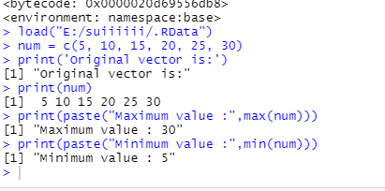

**(2)Write a program in R to find factorial of a number by taking input from user. Please**

**print error message if the input number is negative.**

**PROGRAM**

num = as.integer(readline(prompt="Enter a number: "))

factorial=1

if(num<0){

print("error for putting negative number")

}else if(num==0){

print("your value is 1")

}else{

for(i in 1:num){

factorial=factorial*i

}

print(paste("The factorial of", num ,"is",factorial))

}

SNIPPET

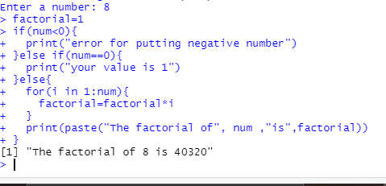

**(3) Write a program to write first n terms of a Fibonacci sequence. You may take n as an**

**input from the user.**

**CODE**

total_terms = as.integer(readline(prompt="NO OF TERMS REQUIRED? "))

num1 = 0

num2 = 1

count = 2

if (total_terms <= 0) {

print("Please enter a positive integer")

} else {

if (total_terms == 1) {

print("Fibonacci sequence:")

print(num1)

} else {

print("Fibonacci sequence:")

print(num1)

print(num2)

while (count < total_terms ) {

nxt = num1 + num2

print(nxt)

num1 = num2

num2 = nxt

count = count + 1

}

}

}

OUTPUT

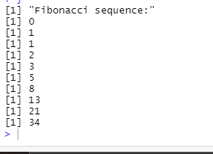

**(4) Write an R program to make a simple calculator which can add, subtract, multiply**

**and divide.**

add <- function(x, y) {

return(x + y)

}

subtract <- function(x, y) {

return(x - y)

}

multiply <- function(x, y) {

return(x * y)

}

divide <- function(x, y) {

return(x / y)

}

print("Select operation.")

print("1.Add")

print("2.Subtract")

print("3.Multiply")

print("4.Divide")

choice = as.integer(readline(prompt="Enter choice[1/2/3/4]: "))

num1 = as.integer(readline(prompt="Enter first number: "))

num2 = as.integer(readline(prompt="Enter second number: "))

operator <- switch(choice,"+","-","*","/")

result <- switch(choice, add(num1, num2), subtract(num1, num2), multiply(num1, num2), divide(num1, num2))

print(paste(num1, operator, num2, "=", result))

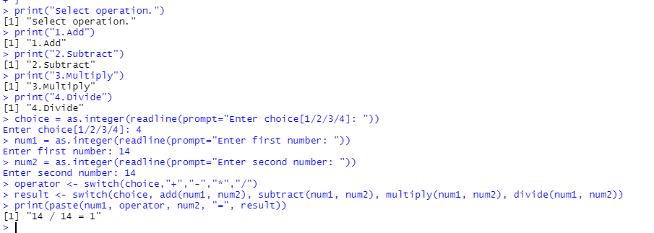

**(5) Explore plot, pie, barplot etc. (the plotting options) which are built-in functions in R.**

x<-c(17,19,22,25,78)

png(file="barplot.png")

barplot(x,xlab="attendance of 5 days in lab",

ylab ="count",col="white",

col.axis="darkgreen",

col.lab="darkgreen")

dev.off()

