**Name = Akash Mishra**

**Roll No = 102197001**

**Probability and Statistics (UCS410)**

**Experiment 3: Probability distributions**

1. Roll 12 dice simultaneously, and let X denotes the number of 6’s that appear. Calculate the probability of getting 7, 8 or 9, 6’s using R. (Try using the function pbinom; If we set S = {get a 6 on one roll}, P(S) = 1/6 and the rolls constitute Bernoulli trials; thus X ∼ binom(size=12, prob=1/6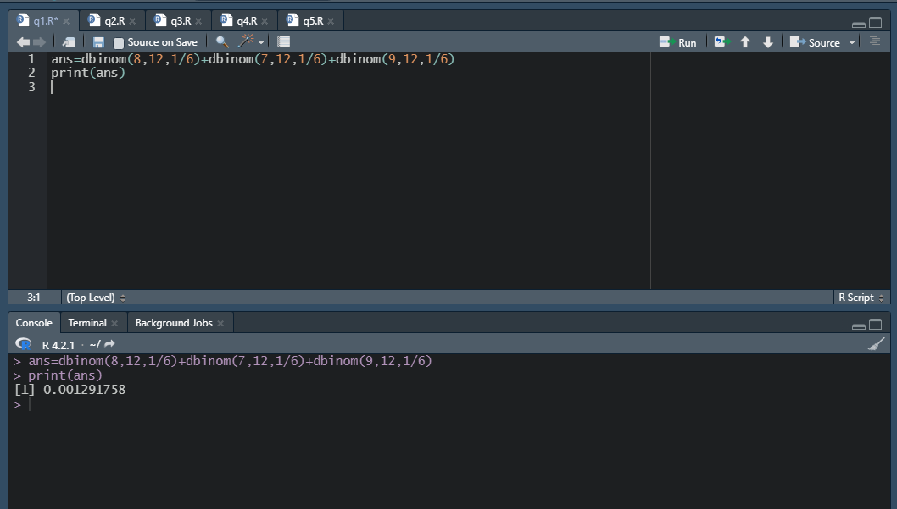) and we are looking for P(7 ≤ X ≤ 9).
2. Assume that the test scores of a college entrance exam fits a normal distribution. Furthermore, the mean test score is 72, and the standard deviation is 15.2. What is the percentage of students scoring 84 or more in the exam?

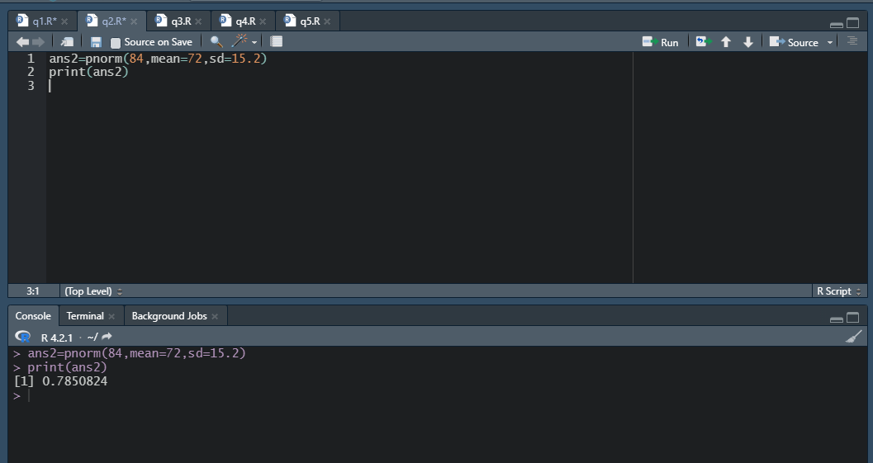

1. On the average, five cars arrive at a particular car wash every hour. Let X count the number of cars that arrive from 10AM to 11AM, then X ∼Poisson(λ = 5). What is probability that no car arrives during this time. Next, suppose the car wash above is in operation from 8AM to 6PM, and we let Y be the number of customers that appear in this period. Since this period covers a total of 10 hours, we get that Y ∼ Poisson(λ = 5×10 = 50). What is the probability that there are between 48 and 50 customers, inclusive?

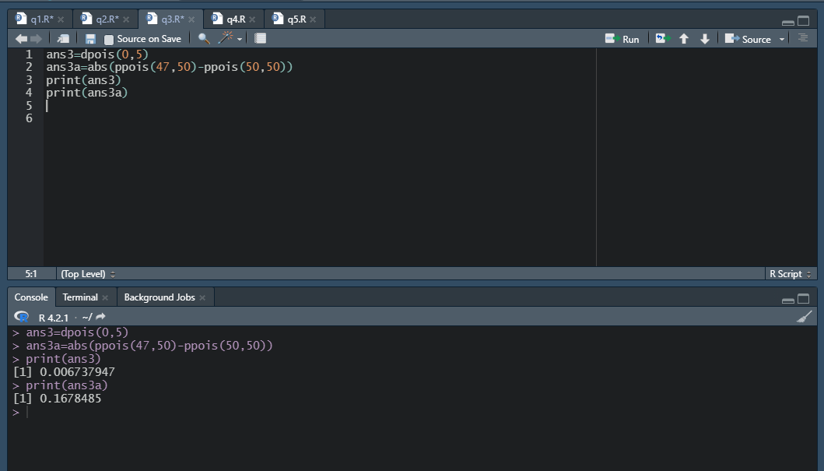

1. Suppose in a certain shipment of 250 Pentium processors there are 17 defective processors. A quality control consultant randomly collects 5 processors for inspection to determine whether or not they are defective. Let X denote the number of defectives in the sample. Find the probability of exactly 3 defectives in the sample, that is, find P(X = 3).

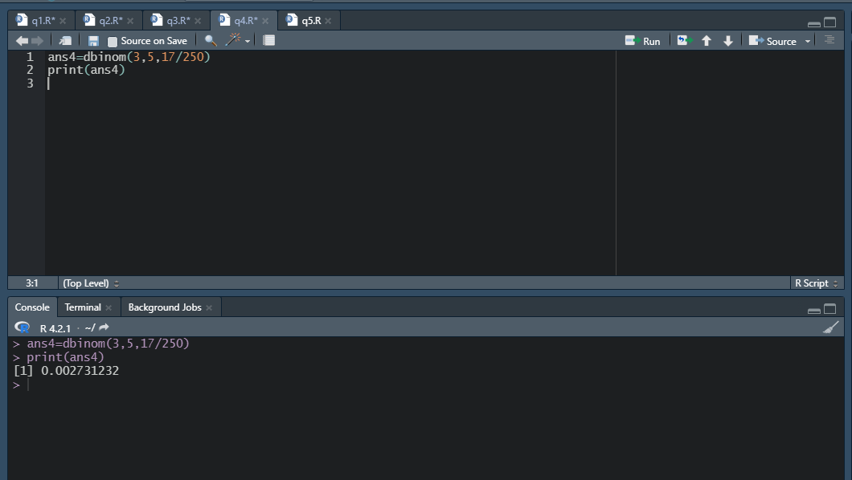

(5) A recent national study showed that approximately 44.7% of college students have used Wikipedia as a source in at least one of their term papers. Let X equal the number of students in a random sample of size n = 31 who have used Wikipedia as a source.

(a) How is X distributed?

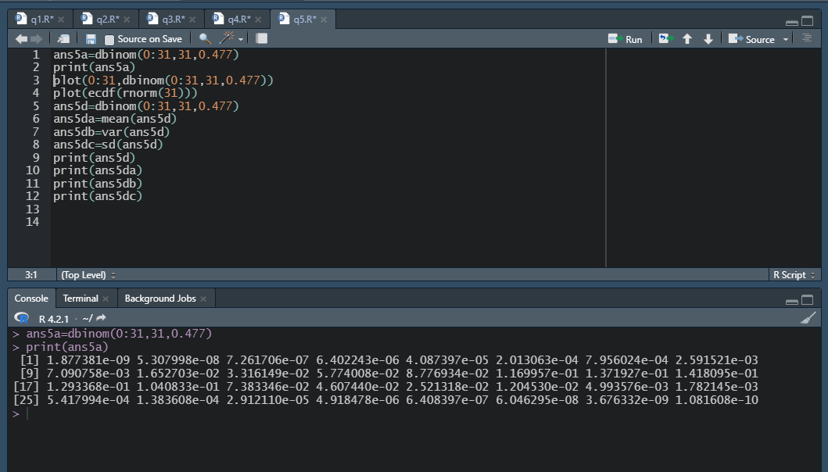

(b) Sketch the probability mass function.

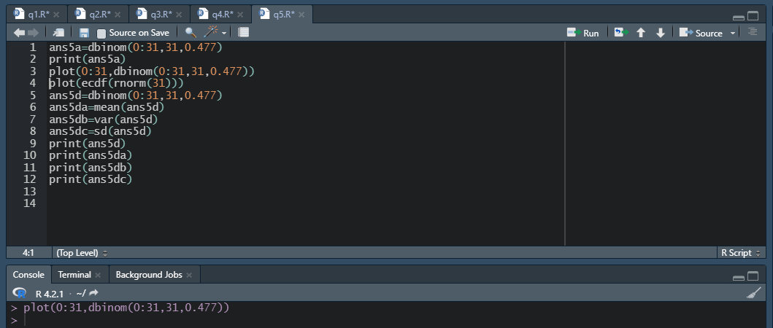

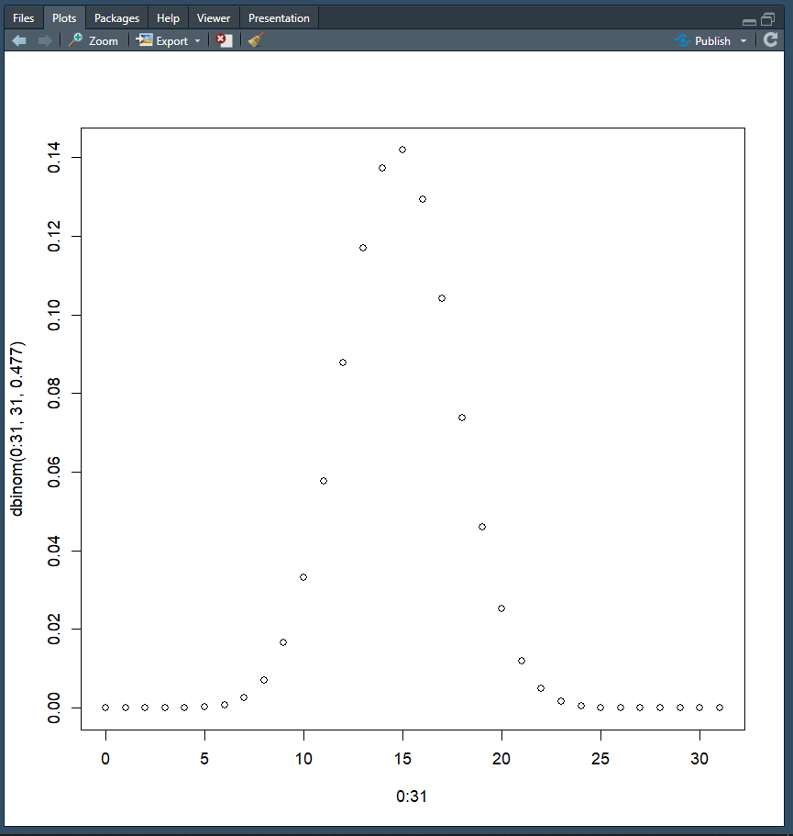

(c) Sketch the cumulative distribution function.

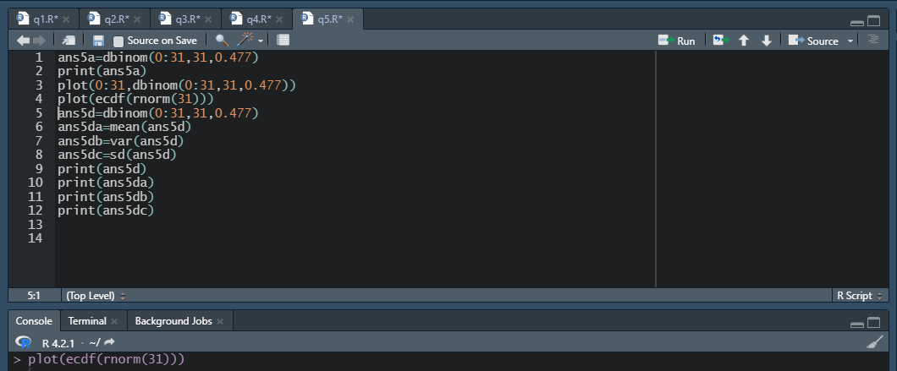

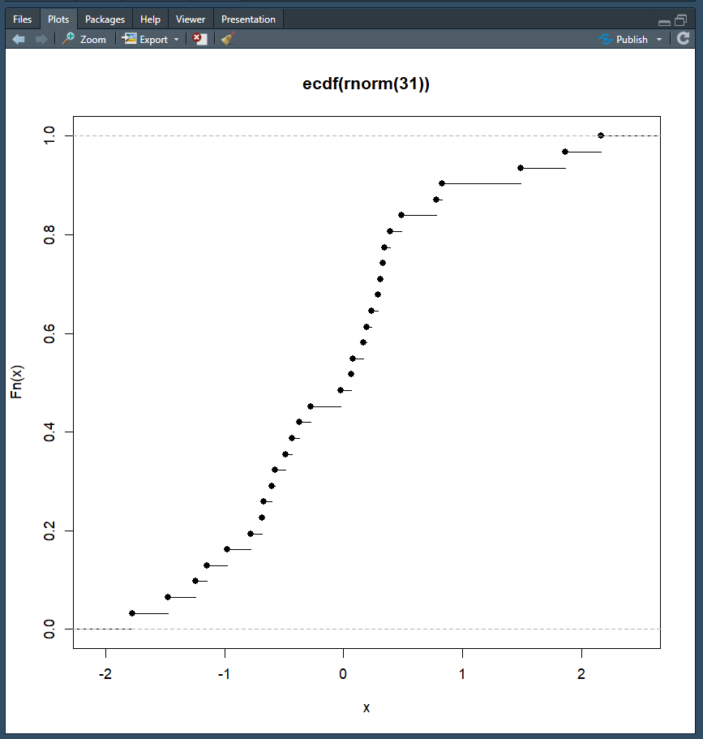

(d) Find mean, variance and standard deviation of X.

