Probability and Statistics (UCS410)

**Experiment 5**

**(**Continuous Probability Distributions)

1. Consider that X is the time (in minutes) that a person has to wait in order to take a flight. If each flight takes off each hour X ~ U(0, 60). Find the probability that

(a) waiting time is more than 45 minutes, and



(b) waiting time lies between 20 and 30 minutes.

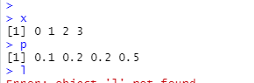

2. The time (in hours) required to repair a machine is an exponential distributed random variable with parameter λ = 1/2.

(a) Find the value of density function at x = 3.

(b) Plot the graph of exponential probability distribution for 0 ≤ x ≤ 5.

(c) Find the probability that a repair time takes at most 3 hours.

(d) Plot the graph of cumulative exponential probabilities for 0 ≤ x ≤ 5.

(e) Simulate 1000 exponential distributed random numbers with λ = ½ and plot the simulated data.

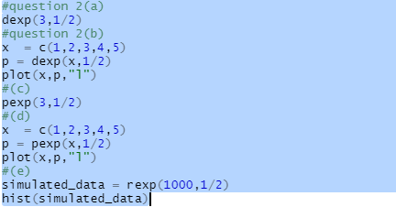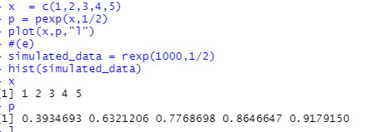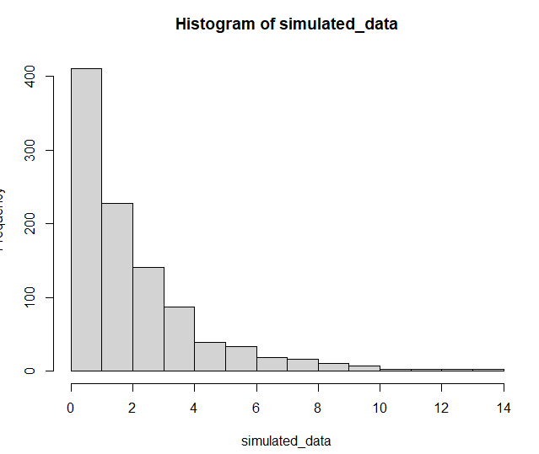

3. The lifetime of certain equipment is described by a random variable X that follows Gamma distribution with parameters α = 2 and β = 1/3.

(a) Find the probability that the lifetime of equipment is at least 1 unit of time. (b) 