**Name = Akash Mishra**

**Roll No = 102197001**

**Probability and Statistics (UCS410)**

**Experiment 6**

**(Joint probability mass and density functions)**

(1) The joint probability density of two random variables X and Y is

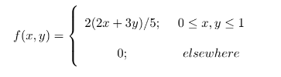

Then write a R-code to

1. check that it is a joint density function or not? (Use integral2())

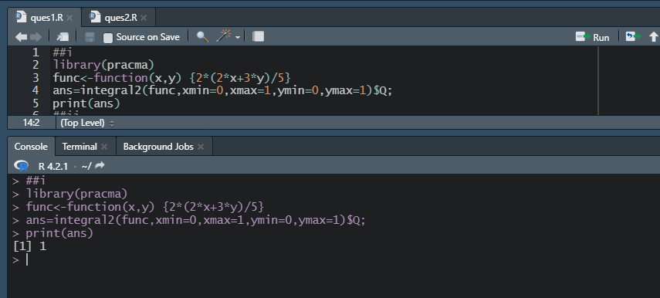

1. find marginal distribution g(x) at x = 1.

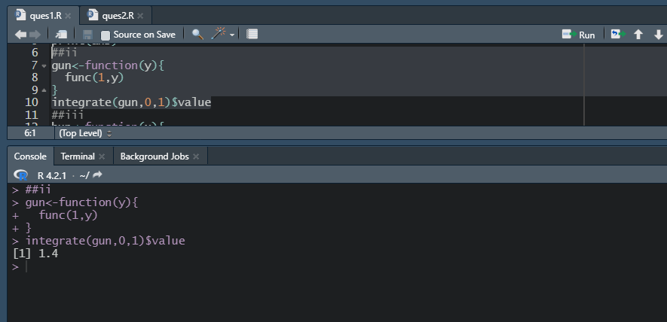

1. find the marginal distribution h(y) at y = 0.

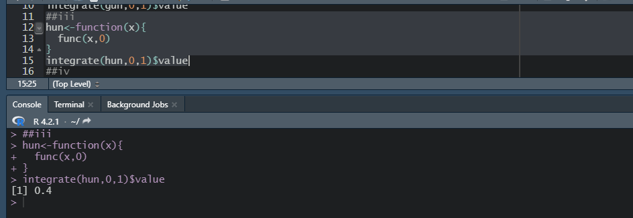

1. find the expected value of g(x, y) = xy.

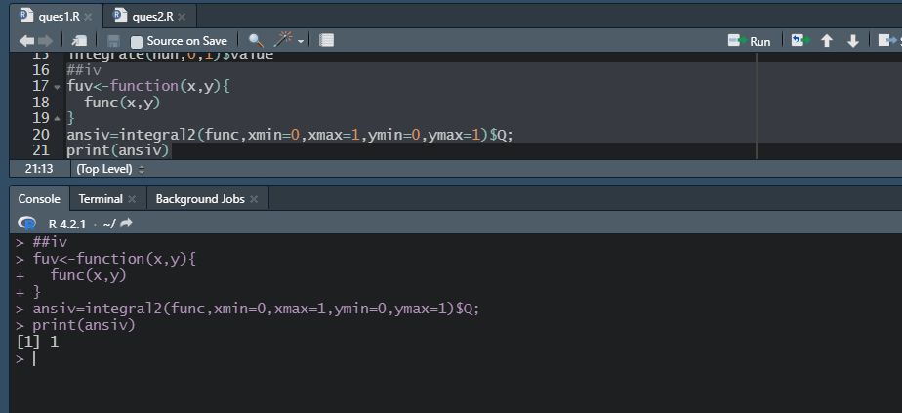

(2) The joint probability mass function of two random variables X and Y is

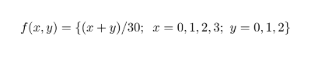

Then write a R-code to

1. display the joint mass function in rectangular (matrix) form.

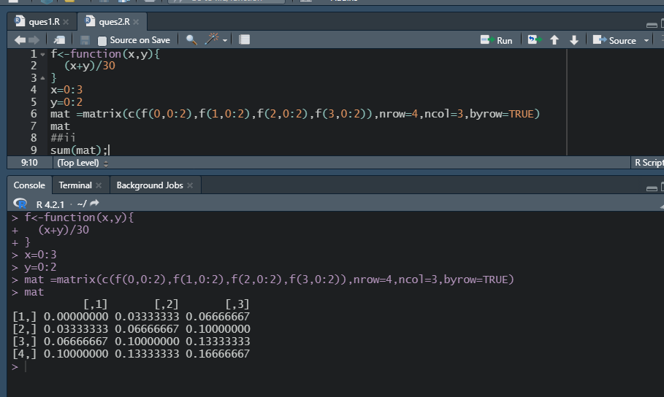

1. check that it is joint mass function or not? (use: Sum())

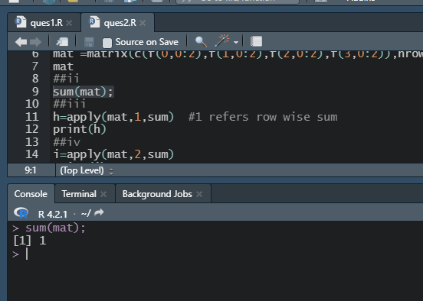

1. find the marginal distribution g(x) for x = 0, 1, 2, 3. (Use:apply())

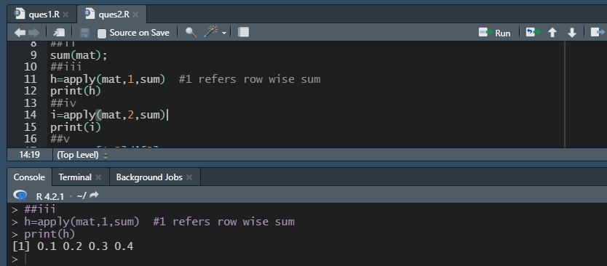

1. find the marginal distribution h(y) for y = 0, 1, 2. (Use:apply())

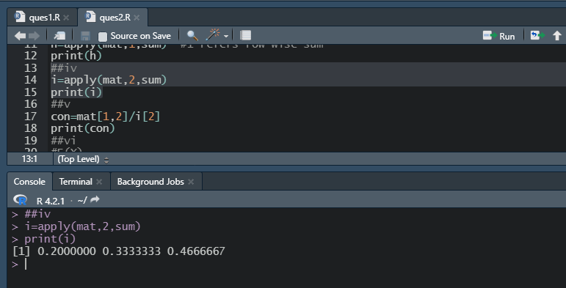

1. find the conditional probability at x = 0 given y = 1.

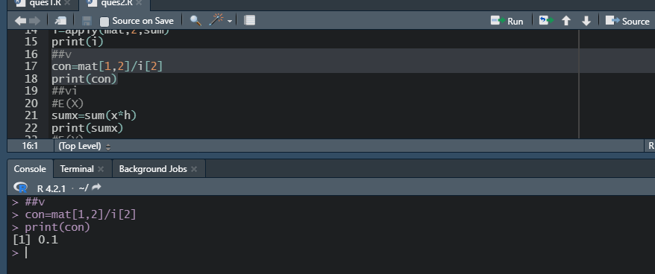

1. find E(x), E(y), E(xy), V ar(x), V ar(y), Cov(x, y) and its correlation coefficient.

