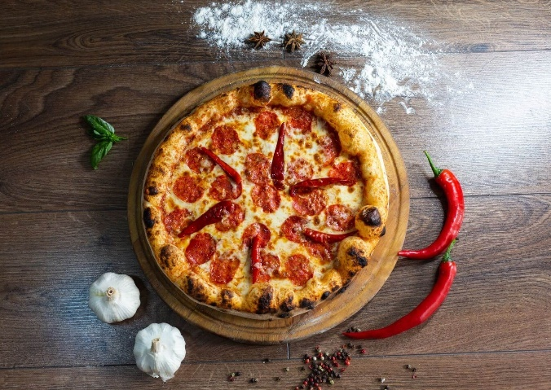


Pizza Sales Analysis Dashboard
Business Intelligence & Sales Performance Analysis
End-to-End Sales Performance Analysis Project

Akash Modi
Data Analyst
Tools: SQL | Power BI | Excel

Business Problem & Objective
Business Context:
Plato’s Pizza is a restaurant that has been collecting transactional sales data over the past year.
However, the management team lacked clear visibility into sales patterns, customer preferences, and peak business periods, making it difficult to make timely, data-driven business decisions.

Project Objectives:
The goal of this analysis was to use historical sales data to:
- Identify the busiest days and hours of operation
- Understand overall sales performance using key metrics
- Analyze best and worst performing pizzas
- Discover customer ordering behavior and trends
- Provide insights to support operational and revenue optimization

Dataset Overview
Dataset Source: Download Dataset
The dataset used for this project is the Pizza Sales Dataset provided as part of the Maven Pizza Challenge.
It contains detailed transactional sales data collected over a one-year period.

KEY DATA FIELDS
Key Data Fields:
- Order ID & Order Date
- Order Time
- Pizza Name
- Pizza Category
- Pizza Size
- Quantity Sold
- Total Price (Revenue)

DATA PREPARATION
Data Preparation:
- Ensured correct data types for date, time, and numeric fields
- Verified revenue calculations (Quantity × Unit Price)
- Structured the dataset to support time-based and product-level analysis

TOOLS & METHODOLOGY
Tools Used:
- SQL: Used for data querying, aggregation, and calculation of business metrics.
- Excel: Excel: Used for initial data validation and exploratory checks.
- Power BI: Used for data modeling, creating measures, and building the interactive dashboard.

ANALYTICAL METHODOLOGY
Methodology:
- Loaded and prepared the dataset for analysis
- Created key business metrics such as total revenue, total orders, and average order value
- Analyzed sales trends by time (hour, day, month)
- Evaluated product performance by pizza category, size, and individual pizzas
- Designed a dashboard to communicate insights clearly and effectively

KEY BUSINESS KPIs
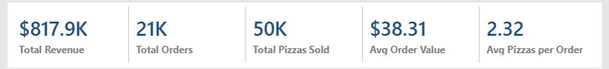
KPI Summary:
The dashboard highlights key performance indicators that provide an overall view of business performance.
These metrics help assess revenue generation, customer purchasing behavior, and order efficiency.
These KPIs act as a performance baseline before deeper trend and product-level analysis
Key Insights:
- The business generated strong overall revenue during the analyzed period
- Average Order Value indicates consistent customer spending per order
- Average pizzas per order provide insight into customer ordering patterns

BUSIEST HOURS & DAYS
Sales Trends by Time:
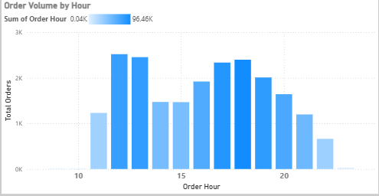

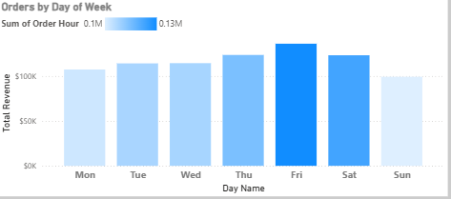

Analysis:
The time-based analysis highlights clear peak periods in pizza sales. Sales volume increases significantly during specific hours, clearly reflecting lunch and dinner rush periods.
Certain days of the week consistently generate higher order volumes.
Business Impact:
- Helps optimize staff scheduling
- Supports better preparation during peak demand
- Improves operational efficiency
SALES BY CATEGORY & SIZE
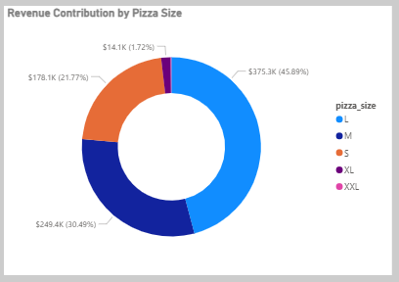
Sales Analysis by Pizza Category & Size:

Analysis:
The category-level analysis shows that certain pizza categories contribute a significantly higher share of total revenue.
Similarly, pizza size plays an important role in revenue generation, with larger sizes contributing more to total sales. This suggests customer preference for value-based purchasing.
Insight:
Understanding category and size performance helps the business focus promotions and inventory planning on high-impact products.

BEST & WORST SELLING PIZZAS
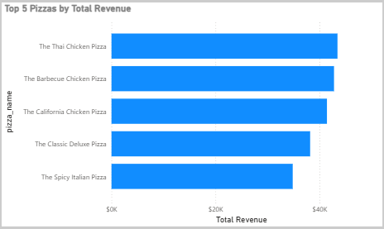
Findings:
The analysis identifies a clear set of top-performing pizzas that consistently generate high revenue.
At the same time, a few pizzas contribute significantly less to overall sales.
Business Insight:
- Top-selling pizzas represent strong customer preference and should be promoted further
- Low-performing pizzas may require pricing review, repositioning, or promotional strategies
- Low-performing pizzas may also be evaluated for seasonal demand or regional preference before removal.

BUSINESS RECOMMENDATIONS
Based on the analysis of sales trends and product performance, the following recommendations can help improve business outcomes:
- Focus promotional efforts on top-selling pizzas during peak hours
- Optimize staffing levels based on high-demand time periods
- Review pricing or marketing strategies for low-performing pizzas
- Use category and size insights to guide inventory and menu planning
CONCLUSION
This project analyzed one year of pizza sales data to uncover key insights related to revenue, customer behavior, and product performance.
Using SQL and Power BI, an interactive dashboard was created to visualize trends, identify top and low-performing products, and highlight peak business periods.
The insights generated from this analysis can support data-driven decision-making, helping the business improve operational efficiency and increase revenue.
This project demonstrates practical, job-ready skills in SQL, data visualization, and business-oriented data analysis.

APPENDIX A: SQL QUERIES
The following SQL queries were used to extract, aggregate, and analyze the pizza sales data for this project.
These queries supported the calculation of key metrics and insights visualized in the dashboard.
- Total Revenue:
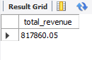

SELECT
ROUND (SUM (total_price), 2) AS total_revenue
FROM pizza_sales;

- Total Orders:
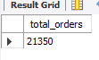

SELECT
COUNT(DISTINCT order_id) AS total_orders
FROM pizza_sales;

- Total Pizzas Sold:
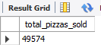

- Average Order Value:
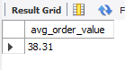

SELECT
ROUND(
SUM(total_price) / COUNT(DISTINCT order_id), 2
) AS avg_order_value
FROM pizza_sales;

- Sales by Hour / Day:
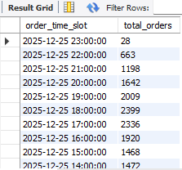

SELECT
DATE_FORMAT(order_time, '%Y-%m-%d %H:00:00') AS order_time_slot,
COUNT(DISTINCT order_id) AS total_orders
FROM pizza_sales
GROUP BY order_time_slot
ORDER BY order_time_slot DESC;

Orders by day of week:
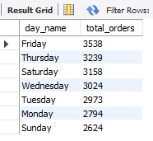

SELECT
DAYNAME(order_date) AS day_name,
COUNT(DISTINCT order_id) AS total_orders
FROM pizza_sales
GROUP BY DAYNAME(order_date)
ORDER BY total_orders DESC;

- Revenue by Category & Size:
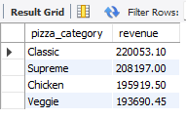

SELECT
pizza_category,
ROUND(SUM(total_price), 2) AS revenue
FROM pizza_sales
GROUP BY pizza_category
ORDER BY revenue DESC;

- Top & Bottom Selling Pizzas
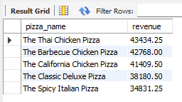

SELECT
pizza_name,
ROUND(SUM(total_price), 2) AS revenue
FROM pizza_sales
GROUP BY pizza_name
ORDER BY revenue DESC
LIMIT 5;
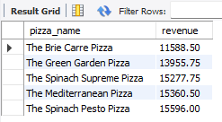

SELECT
pizza_name,
ROUND(SUM(total_price), 2) AS revenue
FROM pizza_sales
GROUP BY pizza_name
ORDER BY revenue ASC
LIMIT 5;

