Exercise-4

The Employee Management System is a Java-based application that allows users to manage employee records. It provides functionalities to add, search, display, and delete employee information, as well as maintain a simple database of employee IDs and salaries.

## Classes

1. Employee

This class represents an individual employee with attributes such as ID, name, position, and salary.

Methods:

Getters for all attributes

toString()`: Returns a string representation of the employee

2. EmployeeDatabase

This class handles the persistence of employee data to a text file.

Attributes:

`DATABASE_FILE`: String (constant)

Methods:

- `updateDatabase(List<Employee> employees)`: Writes employee data to the file

- `displayDatabase()`: Reads and displays the contents of the database file

### 3. EmployeeManagementSystem

This class manages the core functionalities of the system, including adding, searching, displaying, and deleting employees.

#### Attributes:

- `employees`: Employee[] (array to store employees)

- `size`: int (current number of employees)

- `database`: EmployeeDatabase (instance to handle database operations)

#### Methods:

- `addEmployee(Employee employee)`: Adds a new employee to the system

- `searchEmployee(int employeeId)`: Searches for an employee by ID

- `traverseEmployees()`: Displays all employees in the system

- `deleteEmployee(int employeeId)`: Deletes an employee from the system

- `displayDatabase()`: Displays the contents of the database

### 4. Main

This class contains the main method and handles user interaction through a console menu.

#### Methods:

- `main(String[] args)`: Entry point of the application, manages the menu loop

- `addEmployee(EmployeeManagementSystem ems, Scanner scanner)`: Handles user input for adding an employee

- `searchEmployee(EmployeeManagementSystem ems, Scanner scanner)`: Handles user input for searching an employee

- `deleteEmployee(EmployeeManagementSystem ems, Scanner scanner)`: Handles user input for deleting an employee

## Functionality

1. **Add Employee**: Users can add a new employee by entering their ID, name, position, and salary.

2. **Search Employee**: Users can search for an employee by their ID.

3. **Display All Employees**: The system can display all employees currently in the system.

4. **Delete Employee**: Users can delete an employee by their ID.

5. **Display Database**: The system can display the contents of the database file, showing employee IDs and salaries.

## Time Complexity Analysis

- Add Employee: O(1) amortized (O(n) when array resizing is needed)

- Search Employee: O(n) in the worst case

- Display All Employees: O(n)

- Delete Employee: O(n) in the worst case

- Database Update: O(n) as it writes all employees to the file each time

Where n is the number of employees in the system.

## Limitations and Potential Improvements

1. The current implementation uses an array, which has limitations in terms of dynamic sizing and efficiency for large datasets.

2. The database is a simple text file, which may not be suitable for large-scale applications or concurrent access.

3. The search operation is linear, which can be slow for large datasets.

Potential improvements could include:

- Using more efficient data structures like ArrayList or HashMap

- Implementing a proper database system for better data management

- Adding more advanced search and sort functionalities

- Implementing error handling and input validation

- Adding a graphical user interface for better user experience

**Class Diagram**

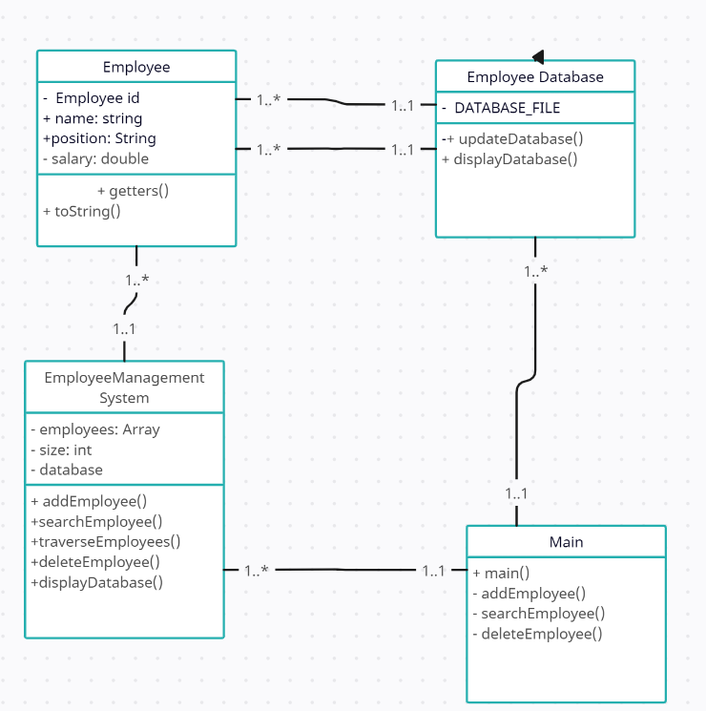

Implementation

Link: code is here