**CRUD operation**

* Created a 4-variable name, description, price, stock, and image in the array
* All the variables are stored in the product. schema name as a string, price and stock as a number, and image as an array
* 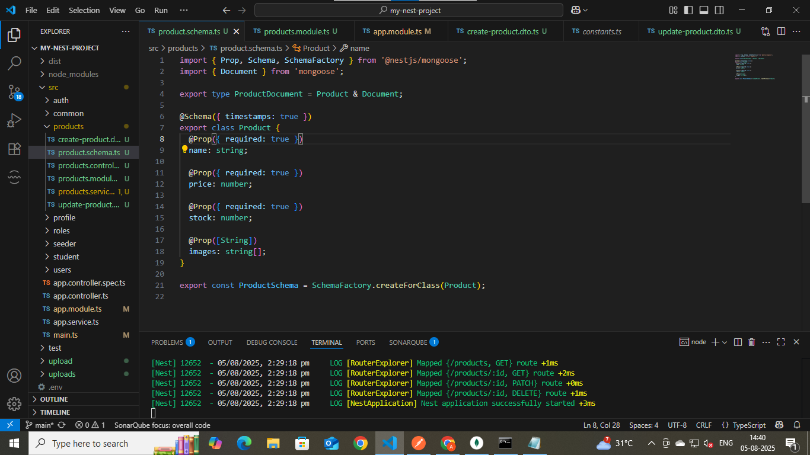
* Create all the services like find, findOne, update, and delete
* 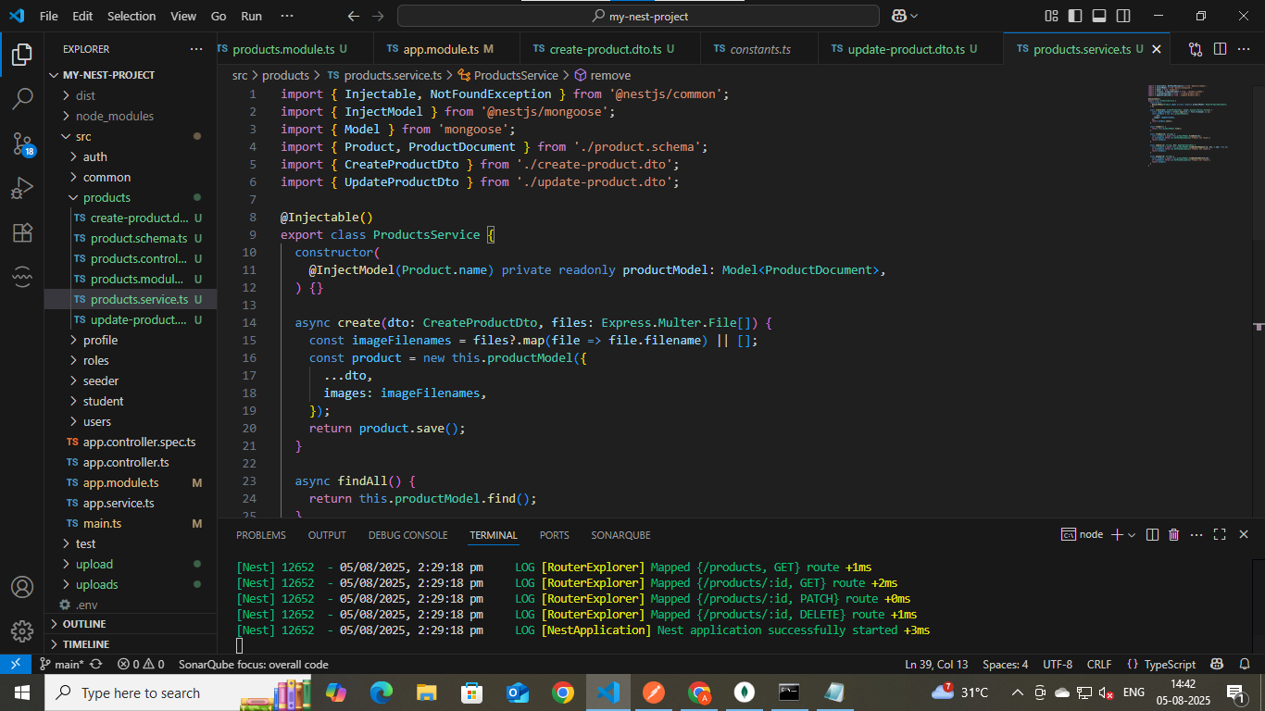
* Created a controller for the data in that image, which selects up to 5
* 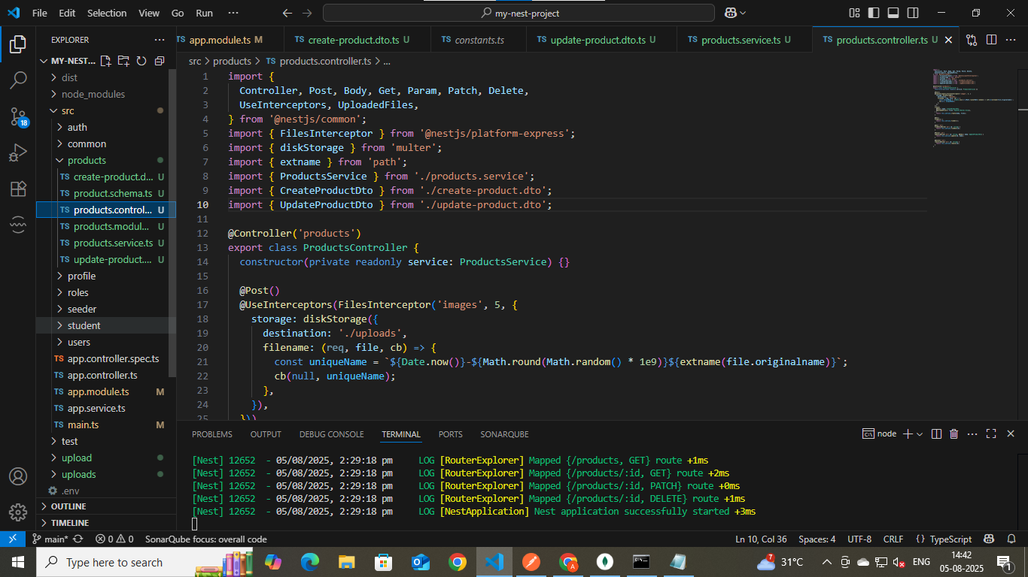
* CRUD Application using Postman
* 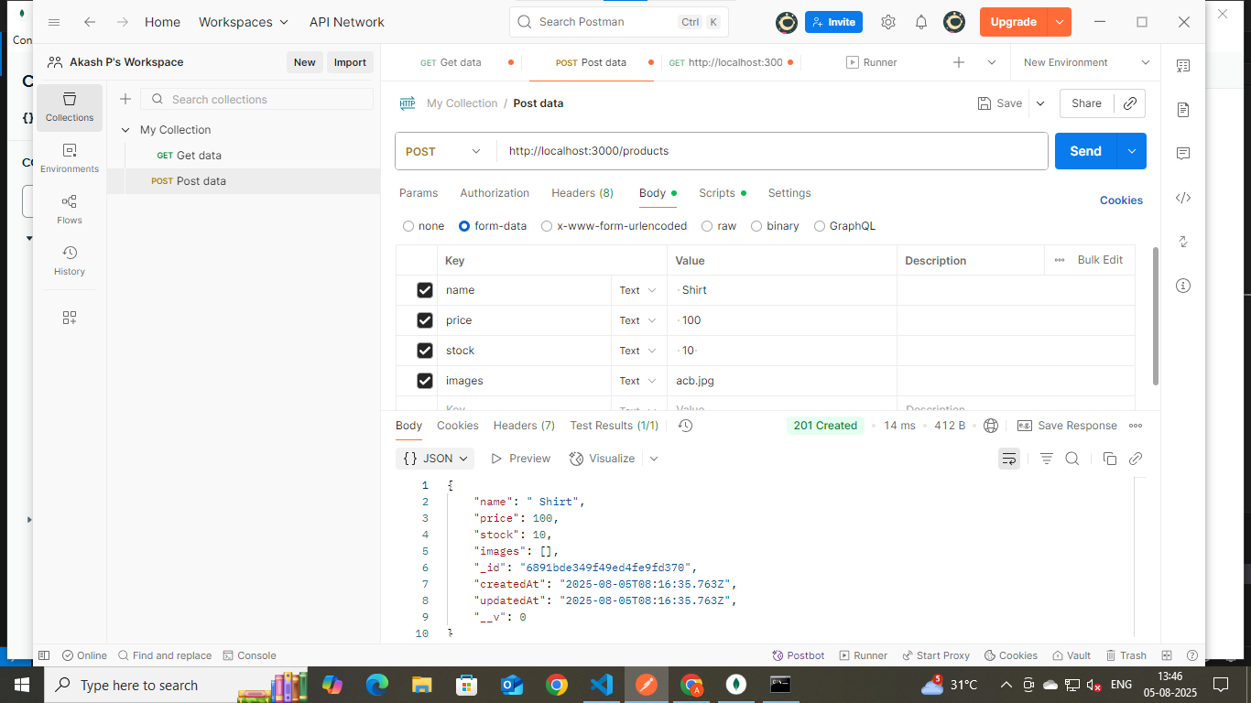
* 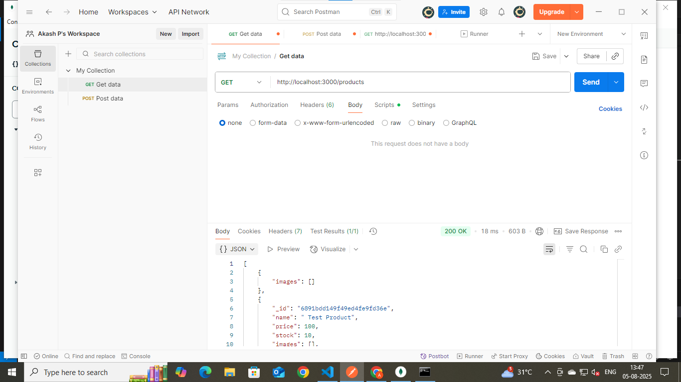
* 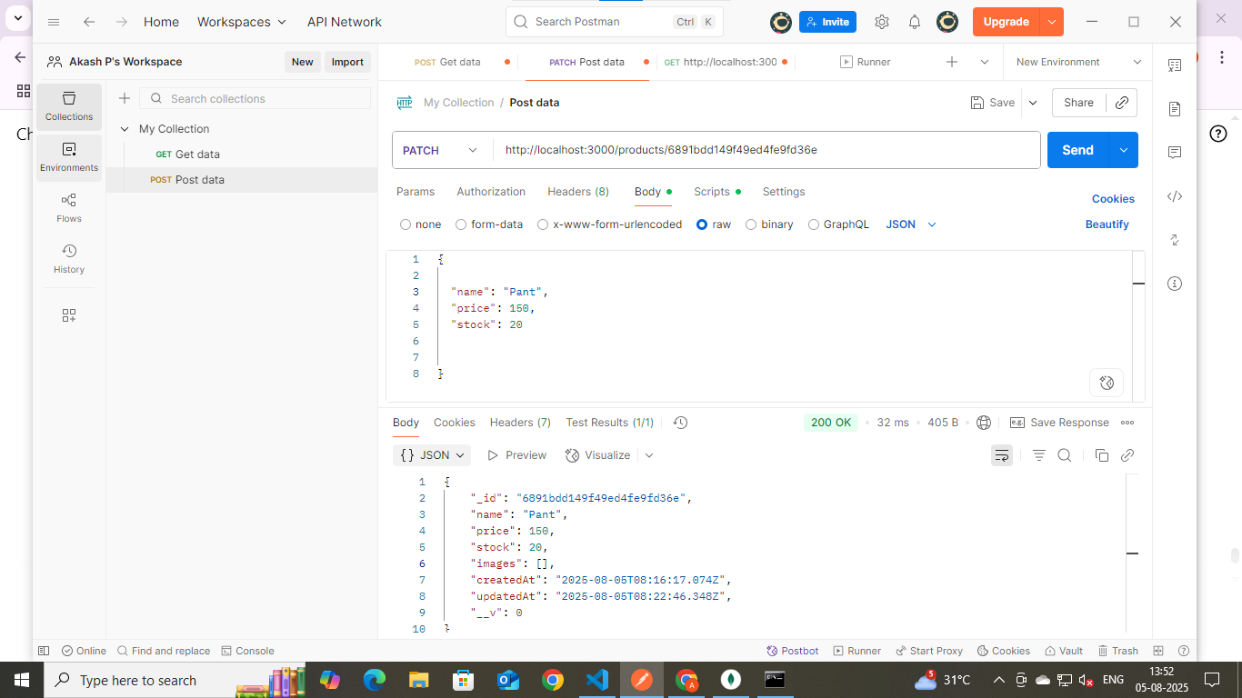
* 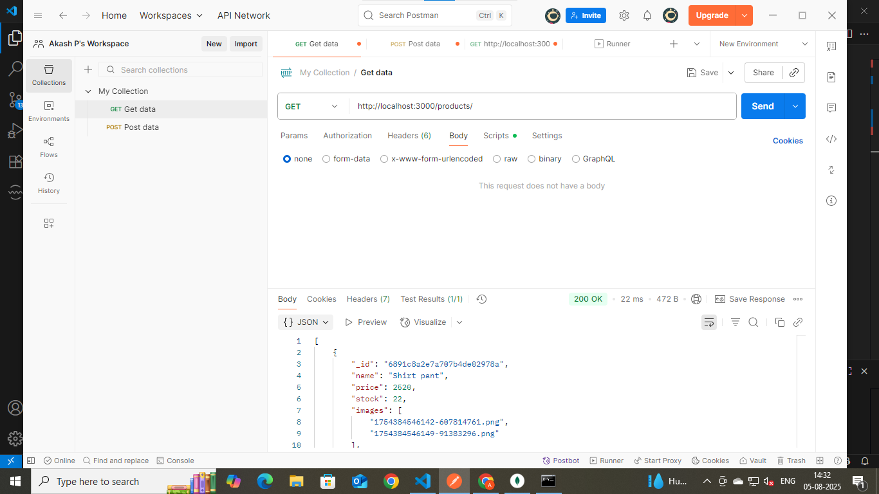
* 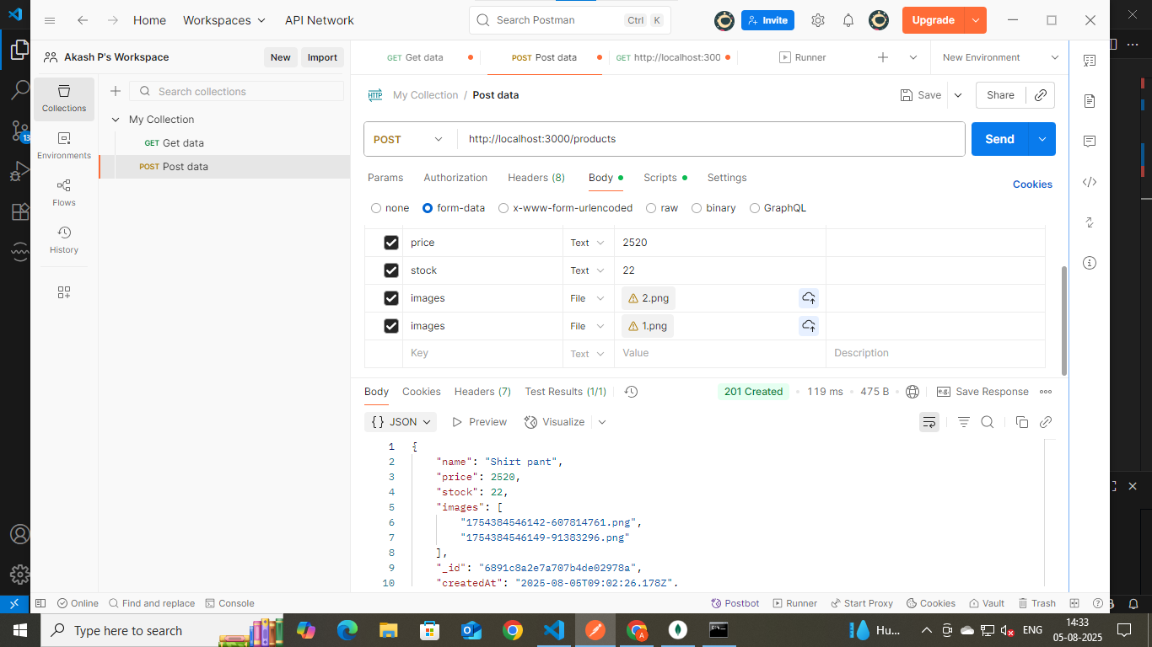
* In MongoDB
* 
 