**single and multiple image upload for products (using multer)**

1. Create a schema for a database (initializing the variable for storing in the database

* 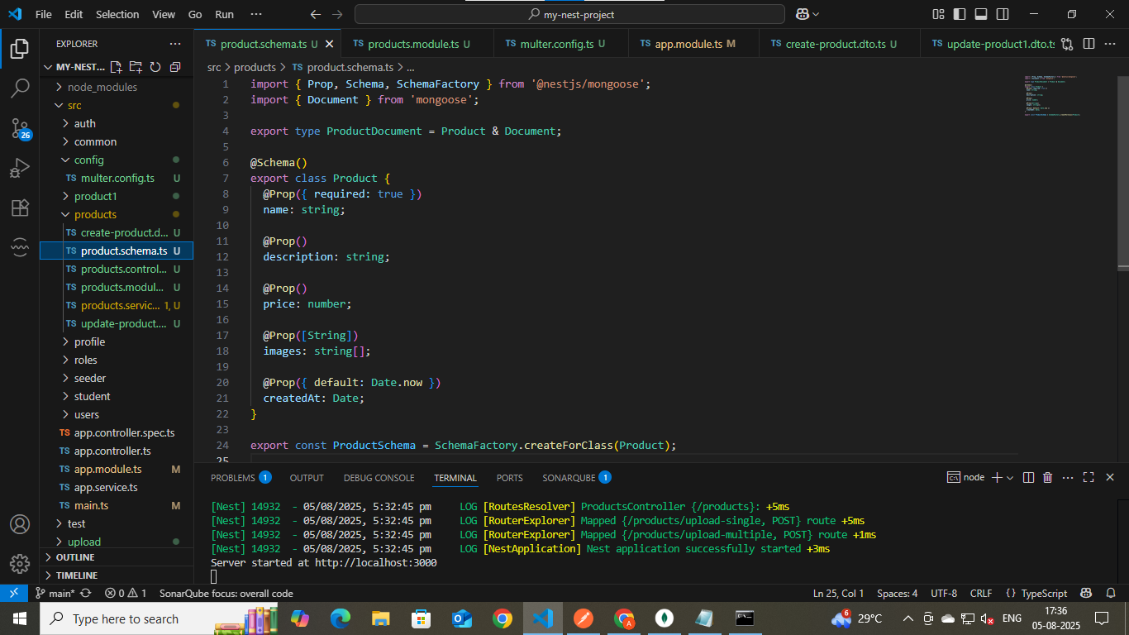
* MongoDB
* Store all the values in the database
* 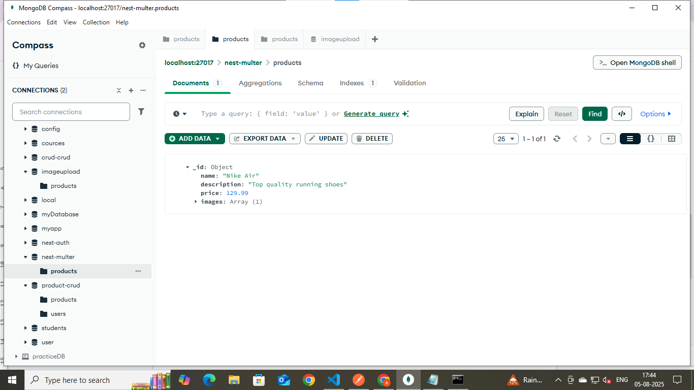
* PostMan
* By using Postman, insert the user data using the POST method
* 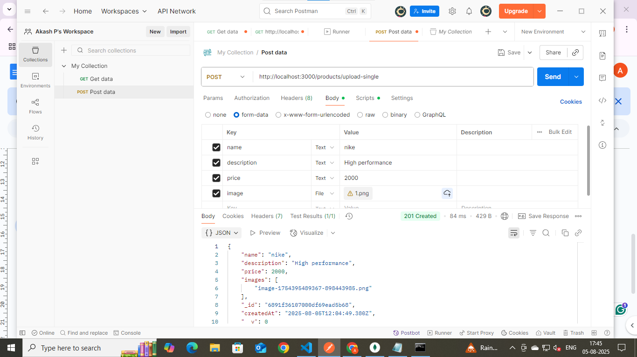
* Upload all the documents, which include Image, Word, and PDF
* Three files uploaded: image 1, image 2, and docx
* 