1. Creating and Renaming Files/Directories

Create a directory named test_dir using mkdir.

Inside test_dir, create an empty file called example.txt.

Rename example.txt to renamed_example.txt using mv

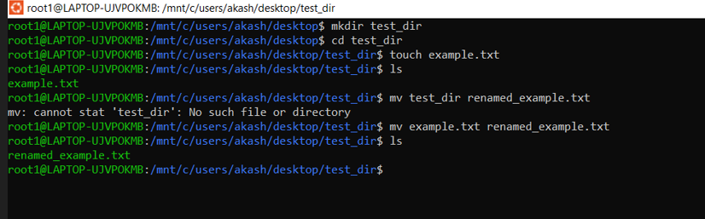

1.mkdir test_dir  
This creates a new directory called test_dir  
2. cd test_dir

cd test_dir moves you into the test_dir directory.

3.touch example.txt

touch example.txt creates an empty file named example.txt.

4. mv example.txt renamed_example.txt

This renames the file from example.txt to renamed_example.txt.

2. Viewing File Contents

Use cat to display the contents of /etc/passwd.

Display only the first 5 lines of /etc/passwd using head.

Display only the last 5 lines of /etc/passwd using tail.

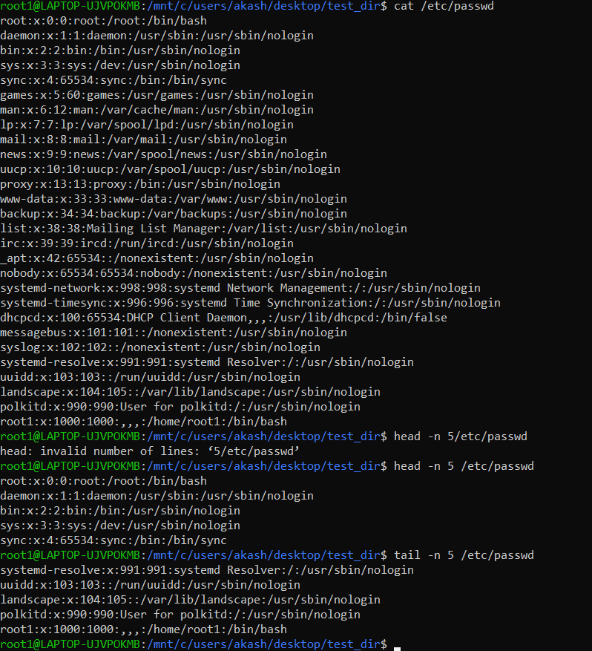

1.cat /etc/passwd  
This displays the entire contents of the /etc/passwd file.

2. head -n 5 /etc/passwd  
Shows the first 5 lines of the file.

3. tail -n 5 /etc/passwd  
Shows the last 5 lines of the file  
  
3.Searching for Patterns

Use grep to find all lines containing the word "root" in /etc/passwd.

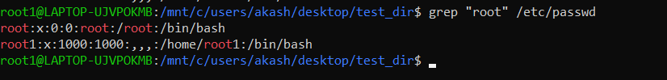

4. Zipping and Unzipping

Compress the test_dir directory into a file named test_dir.zip using zip.

Unzip test_dir.zip into a new directory named unzipped_dir.

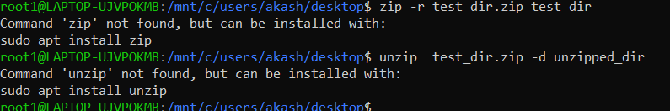

zip -r test_dir.zip test_dir compresses the test_dir directory into a file named test_dir.zip.  
Unzips test_dir.zip into a new directory called unzipped_dir

5. Downloading Files

Use wget to download a file from a URL (e.g., <https://example.com/sample.txt>).



6. Changing Permissions

Create a file named secure.txt and change its permissions to read-only for everyone using chmod.

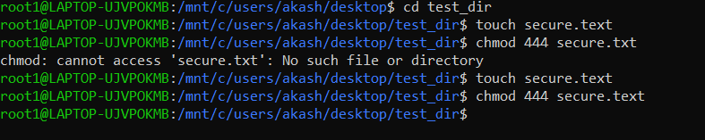

chmod 444 secure.txt makes the file read-only for everyone (owner, group, others).

7. Working with Environment Variables

Use export to set a new environment variable called MY_VAR with the value "Hello, Linux!"

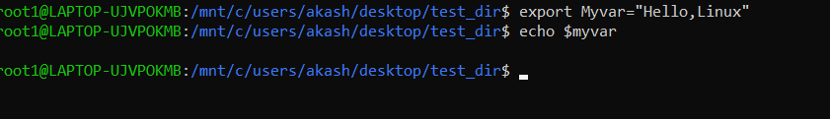

export sets a new environment variable.

echo $Myvar displays the value of Myvar