**Instruction Fine-Tuning and Instruction Tuning in LLMs**

**Introduction**

* Instruction fine-tuning is one of the major advancements in recent **language modeling research**.
* It enables **better conversations** with language models, making them follow **instructions more accurately** rather than just predicting the next word.
* Traditional **pre-trained language models** (also called **base models**) learn from large datasets using **next-word prediction** but **struggle to follow specific instructions**.

**🔹 Limitations of Pre-trained Language Models**

* Pre-trained models, such as **decoder-based models**, are trained using **next-word prediction**.
* Example:
  + If we ask a base model:  
    **"What is the national flower of India?"**
  + Instead of answering **"Lotus"**, the model might generate: **"What is the national animal of India? What is the national bird of India?"**
  + This happens because the model is just predicting the next word based on probability, **not actually answering the question**.

**Why do Pre-trained Models Fail at Following Instructions?**

1. **They are not trained to explicitly understand and execute instructions.**
2. **They generate responses based on continuation rather than answering questions properly.**
3. **They might provide generic responses instead of relevant answers.**

💡 **Key Takeaway**: **Next-word prediction alone does not ensure that a model follows instructions properly.** This is why **instruction tuning** is necessary.

**Why Do We Need Instruction Tuning?**

* The goal of **instruction tuning** is to teach language models **how to follow and understand instructions**.
* This is done by training them on **instruction-based datasets** where:
  + Each example contains:
    - **Instruction**: The task description
    - **Input**: The specific input data (if required)
    - **Output**: The correct response
* By learning from such structured data, the model **understands how to follow instructions properly**.

**Multi-Task Learning in NLP**

* **Multi-task learning** is another powerful technique in **Natural Language Processing (NLP)**.
* Instead of training a model for a **single** task, it is trained on **multiple tasks simultaneously** to improve overall performance.

💡 **Example:**

* A model is trained on:
  1. **Sentiment Analysis**
  2. **Machine Translation**
* It is **not explicitly told which task is which**, but it learns to handle different tasks correctly based on **input-output patterns**.

**Problems with Traditional Multi-Task Learning**

* If a **new task** (e.g., **grammatical correctness checking**) appears during testing, the model struggles because:
  + It **was not explicitly trained for that task**.
  + It **doesn’t know how to process it**.
* Example:
  + If the model sees a **new linguistic acceptability task** (e.g., checking if a sentence is grammatically correct), it **has no clue what to do** because it **never saw such examples during training**.

💡 **Key Insight**: Traditional multi-task learning **fails to generalize well to new tasks**.

**🔹 Solution: Using Instructions to Describe Tasks**

* Instead of **only providing input-output pairs**, we can **describe tasks explicitly using natural language instructions**.
* This helps models generalize better to **new unseen tasks** during inference.

💡 **Example:**

1. **Sentiment Analysis**
   * **Instruction**: "Predict the sentiment of the sentence."
   * **Input**: "This movie was action-packed and thrilling!"
   * **Output**: "Positive"
2. **Machine Translation**
   * **Instruction**: "Translate the sentence into Hindi."
   * **Input**: "It has been raining continuously for the past few days."
   * **Output**: "पिछले कुछ दिनों से लगातार बारिश हो रही है।"

✅ **By training models with explicit task instructions, they can generalize to new tasks more effectively.**

**🔹 Instruction Tuning: The Core Idea**

* **Instruction tuning** is a **fine-tuning technique** where large language models are trained on **instruction-based datasets**.
* These datasets contain **task descriptions, inputs, and expected outputs**.

**Example from Research Paper on Instruction Tuning**

* During training, the model is fine-tuned using **various tasks** like:
  + **Common-sense reasoning**
  + **Translation**
  + **Text classification**
* Each example consists of:
  + **Instruction**: What task to perform
  + **Input**: (Optional) Task-related input
  + **Output**: The expected result

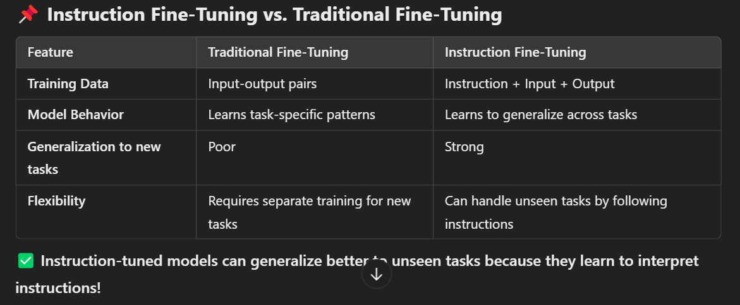

**Instruction vs. Prompting**

* **Fine-tuning changes the model’s parameters**, whereas **prompting does not**.
* **In fine-tuning**, the model learns from examples where instructions are provided along with the task.
* **In prompting**, we **don’t change the model’s parameters**, but we **guide** the model’s output by providing it with a well-structured prompt.

💡 **Example:**

* **Fine-tuning Example** (Model trained with instruction)
  + "Translate the sentence into Spanish: *The new office building was built in less than three months.*"
  + **Model output:** "El nuevo edificio de oficinas fue construido en menos de tres meses."
* **Prompting Example** (Just providing an instruction at inference time)
  + "**Translate to Spanish:** *The new office building was built in less than three months.*"
  + **Model output:** "El nuevo edificio de oficinas fue construido en menos de tres meses."

✅ **In instruction tuning, the model is explicitly trained to handle such instructions, making it more reliable than simple prompting.**

**🔹 Instruction Tuning Improves Model Generalization**

* **Traditional multi-task models fail on new tasks** because they are not explicitly trained to follow instructions.
* **Instruction-tuned models** can generalize to unseen tasks by understanding natural language instructions.
* Example:
  + If an instruction-tuned model is given **a new grammatical correctness task**, it can still handle it well because it was trained to **follow instructions, not just memorize tasks**.

✅ **Goal of Instruction Tuning:**

* Enable LLMs to **generalize to new tasks**.
* Improve performance by **explicitly training models on instruction-following**.
* Make AI **more flexible and adaptable**.

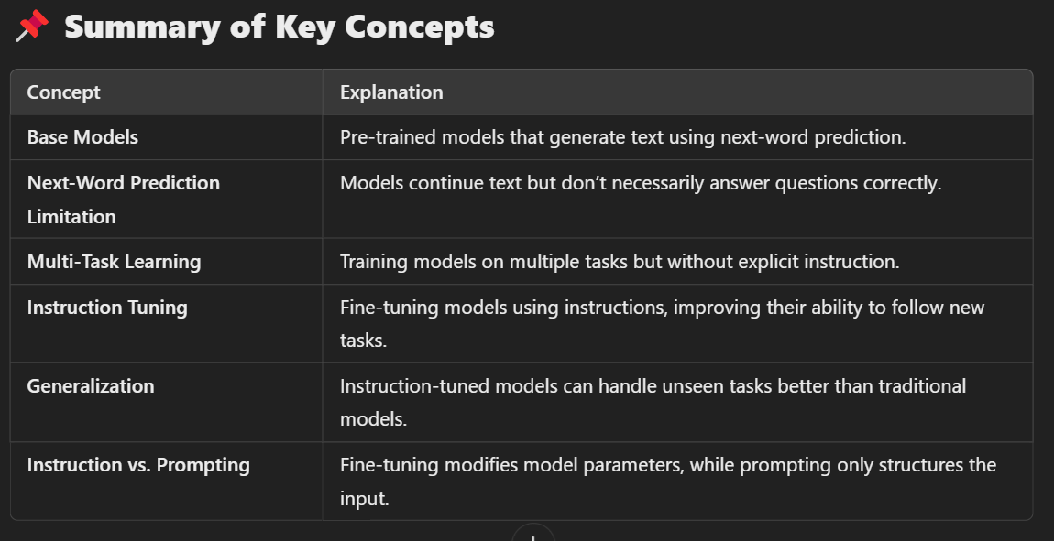

**Conclusion**

* **Instruction fine-tuning is a major improvement in LLMs.**
* It allows models to **understand and follow instructions**, leading to **better generalization**.
* By training on **instruction-based datasets**, models can adapt to **new, unseen tasks** more effectively.