**Comparison Between GPT-3 and GPT-4: Scaling Laws and Emerging Properties**

**1. Introduction to Scaling Laws and GPT-3**

* Before GPT-3, the standard machine learning paradigm consisted of three main steps:
  1. **Pre-training**: A model is trained on a large raw corpus of data.
  2. **Fine-tuning**: The model is adjusted using a task-specific dataset.
  3. **Prediction**: The model is used for inference.
* GPT-3 introduced a paradigm shift by demonstrating that large-scale pre-trained models could perform various tasks without the need for fine-tuning. Instead, they could rely on **prompt-based learning**.

**2. Traditional Pre-training and Fine-tuning Approaches**

* **Pre-training**:
  + Models are trained on vast amounts of raw text data to learn syntactic and semantic structures.
  + Example: T5 pre-training involved passing corrupted sequences and predicting the actual sequence.
* **Fine-tuning**:
  + The model is further trained on task-specific data to refine its performance.
  + Applied for sentiment analysis, summarization, question-answering, etc.
  + Example: Using datasets like FLAN for instruction-based fine-tuning.

**3. GPT-3’s Shift to Prompt-Based Learning**

* GPT-3 (introduced in 2020) proposed that sufficiently large models **do not require fine-tuning** to perform well on downstream tasks.
* The model is pre-trained on a massive dataset, allowing it to generalize across tasks.
* Instead of modifying model parameters via fine-tuning, users can provide a **well-structured prompt** to achieve the desired output.

**4. Emerging Properties and Few-Shot Learning**

* GPT-3 exhibited a surprising emergent property: it could generalize tasks it had not explicitly seen during training.
* Few-shot learning refers to the ability of the model to perform tasks with only a few examples or even a single example.
* GPT-3 demonstrated:
  + **Zero-shot learning**: Performing tasks with no prior examples.
  + **One-shot learning**: Performing tasks with a single example.
  + **Few-shot learning**: Performing tasks with a small number of examples.

**5. Performance Trade-offs**

* While GPT-3’s prompt-based learning is powerful, fine-tuned models often outperform it in accuracy.
* Example:
  + A fine-tuned model for sentiment analysis will likely perform better than GPT-3 prompted for sentiment analysis.
  + However, GPT-3 achieves ~70-80% of the fine-tuned model’s performance without requiring additional training data.

**6. Challenges in Model Scaling and Emerging Phenomena**

* Key research questions:
  1. How well does prompt-based learning scale with model size?
  2. Is there a threshold model size beyond which emergent properties appear?
  3. Can smaller models (e.g., 7 billion parameters) achieve similar performance to larger models (e.g., 175 billion parameters)?
* The scaling laws indicate that **larger models generally perform better**, but there is an optimal balance between size and computational efficiency.

**7. Comparison Between GPT-3 and GPT-4**

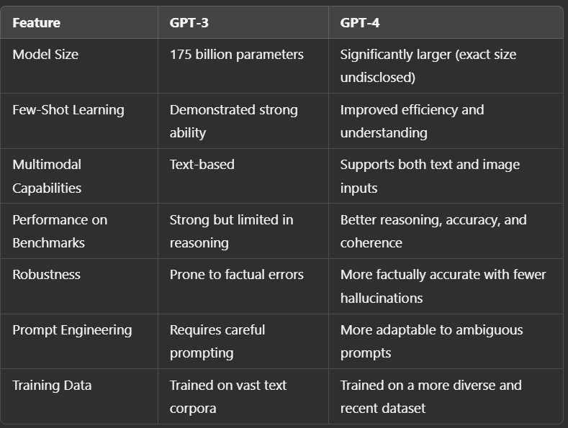

**8. Key Takeaways**

* **GPT-3’s key innovation**: Prompt-based learning replaces traditional fine-tuning for many tasks.
* **Emerging phenomena**: Large-scale models exhibit generalization abilities without explicit task-specific training.
* **GPT-4 improvements**:
  + More reliable and factually accurate.
  + Enhanced multimodal understanding (text and images).
  + Better contextual awareness and reasoning.

**9. Conclusion**

* The advancements from GPT-3 to GPT-4 highlight the power of scaling laws in deep learning.
* While prompt-based learning is powerful, fine-tuning remains useful for high-accuracy applications.
* Future models will likely continue to push the boundaries of generalization, requiring less supervision and delivering more human-like responses.

**In-Depth Notes on Prompting**

**1. Traditional Machine Learning Framework vs. Prompt-Based Learning**

* **Traditional Fine-Tuning:**
  + The model parameters are updated iteratively using training examples.
  + Training involves feeding batches of examples, updating gradients, and refining the model.
  + Not all parameters are necessarily updated—some remain static while others adapt.
* **Prompt-Based Learning (GPT-3 and beyond):**
  + The model parameters remain **unchanged** after pre-training.
  + Instead of updating parameters via fine-tuning, users craft **prompts** to guide the model’s behavior.
  + **Challenge:** There is no universally optimal prompt format, requiring trial and error.
  + Prompt engineering has become a crucial skill in AI development and job recruitment.

**2. Types of Prompt-Based Learning**

**Zero-Shot Learning**

* The model is given only a **task description** without any examples.
* Example:
  + **Prompt:** "Translate English to French. Cheese:"
  + The model must infer the translation without prior context.
* **Challenges:**
  + The way the task is framed (syntax, punctuation) affects the model's response.
  + Small variations in formatting (e.g., : vs. ->) can impact accuracy.
  + Researchers are still studying how sensitive models are to prompt modifications.

**One-Shot Learning**

* The model is given **one example** in addition to the task description.
* Example:
  + **Prompt:** "Translate English to French. Cat -> Chat. Cheese -> "
  + The model now has a reference example to base its response on.

**Few-Shot Learning**

* The model is given **multiple examples** before performing the task.
* Example:
  + **Prompt:** "Translate English to French.
    - Cat -> Chat
    - Dog -> Chien
    - Cheese -> "
* More examples help the model understand the task better, but there’s **no guarantee** of optimal accuracy.
* **Constraints:**
  + The number of examples must fit within the model’s **context window** (e.g., 4K or 10K tokens).
  + If too many examples are required, fine-tuning may be a better approach.

**3. Limitations and Challenges in Prompting**

* **Prompt Sensitivity:**
  + Small changes in syntax can significantly impact output.
  + Example: -> vs. : vs. = might yield different results.
* **Optimal Prompt Selection:**
  + There is no universal method for determining the best prompt.
  + Researchers are working on ways to quantify prompt effectiveness.
* **Context Window Limits:**
  + Models can only process a fixed number of tokens in a prompt.
  + If extensive examples are needed, fine-tuning or parameter-efficient tuning (e.g., adapter layers) may be better.

**4. Parameter-Efficient Fine-Tuning (PEFT) Alternatives**

* If many examples (e.g., 1,000+) are required, direct prompting is inefficient.
* **Fine-Tuning Alternatives:**
  + **Adapter Layers:** Add new layers to a model and fine-tune only these layers.
  + **LoRA (Low-Rank Adaptation):** A method that fine-tunes fewer parameters while maintaining efficiency.
  + **Prefix-Tuning:** Modifies only the input embeddings rather than full model parameters.

**5. Future of Prompt Engineering**

* Researchers continue to explore why LLMs respond differently to small prompt variations.
* Labs worldwide are investigating **contextual learning** and how models adapt dynamically.
* The long-term goal is to **standardize** prompting strategies and improve model robustness against syntax changes.

**6. Key Takeaways**

* **Traditional fine-tuning** updates model parameters, while **prompting** keeps them static.
* **Zero-shot, one-shot, and few-shot prompting** allow models to perform tasks without fine-tuning.
* **Prompt sensitivity** remains an open research question—small changes in formatting can lead to different outputs.
* If too many examples are needed, **parameter-efficient fine-tuning** (like adapter layers) is a better alternative.
* **Prompt engineering** is a growing field, critical for optimizing LLM performance and usability.

Based on the prompt generated the model need to map the parameter that need to accumulate/map the relavant parameters and output the result this parameter matching is not as easy as it heres.

**In-Depth Notes on Large Language Models (LLMs) and Advanced Prompting Techniques**

**1. Introduction to Prompting in LLMs**

* Traditional fine-tuning updates model parameters iteratively, whereas **prompting** keeps them static and guides responses through structured input.
* The new paradigm replaces fine-tuning with prompting, making models more adaptable without additional training.
* The key steps in modern LLM frameworks:
  1. **Pre-training**: Training on large-scale internet text data.
  2. **Prompting**: Writing structured prompts instead of fine-tuning.
  3. **Prediction**: Model generates responses based on prompts.

**2. Prompt-Based Learning vs. Fine-Tuning**

* **Fine-Tuning Approach:**
  + Uses labeled task-specific data for training.
  + Updates model parameters to improve task performance.
  + Requires large datasets and computational resources.
* **Prompting Approach:**
  + No parameter updates; model performance depends on prompt quality.
  + Works on pre-trained models without additional task-specific training.
  + More flexible, but sensitive to variations in prompt formatting.

**3. Types of Prompting**

**Zero-Shot Learning**

* The model is provided only with a task description, no examples.
* Example: "Translate English to French. Cheese:"
* **Challenges:**
  + The exact formatting of the task description affects performance.
  + Small syntax variations can change the model’s response.
  + Sensitivity to punctuation, symbols, and wording.

**One-Shot Learning**

* The model is given one example in addition to the task description.
* Example:
  + "Translate English to French. Cat -> Chat. Cheese -> "
* The single example helps the model understand the task structure.

**Few-Shot Learning**

* The model is provided with multiple examples.
* Example:
  + "Translate English to French.
    - Cat -> Chat
    - Dog -> Chien
    - Cheese -> "
* More examples improve accuracy, but there is no guaranteed optimal number.
* **Constraints:**
  + Limited by the model’s **context window** (e.g., 4K or 10K tokens).
  + Too many examples require fine-tuning rather than prompting.

**4. Empirical Study: TriviaQA Dataset**

* **TriviaQA** is an open-domain question-answering dataset used to compare fine-tuned and prompt-based models.
* **Comparison Setup:**
  + A fine-tuned model is trained specifically on TriviaQA.
  + A GPT model is used with **zero-shot, one-shot, and few-shot (64 examples) prompting.**
  + Accuracy is measured against increasing model size (0.1B to 175B parameters).
* **Findings:**
  + **At large scales (175B parameters), few-shot models outperform fine-tuned models.**
  + **A 13B model using few-shot prompting performs comparably to a fine-tuned model.**
  + The gap between fine-tuned and prompted models narrows as model size increases.
* **Implication:**
  + Since fine-tuning requires large datasets, few-shot prompting offers a lightweight alternative with **only 64 examples.**

**5. Understanding Model Behavior in Prompting**

* **Why do LLMs perform well on TriviaQA?**
  + GPT models are trained on massive web datasets that likely include indirect exposure to TriviaQA answers.
  + Instead of learning specific questions, models generalize from their exposure to similar linguistic patterns.
  + If an entirely **unseen** question were asked, model performance might drop significantly.

**6. Prompting for Non-English Tasks (Machine Translation Study) :: (View PPT for better understanding)**

* **Data Distribution:**
  + 93% of pre-training data is in English, and **only 7% is in other languages.**
* **Comparison of Models:**
  + **Supervised MT models:** Trained specifically for translation tasks.
  + **Fine-tuned models:** Pre-trained on multilingual corpora and then fine-tuned.
  + **GPT models (zero-shot, one-shot, few-shot):** No task-specific training.
* **Findings:**
  + **Few-shot prompting in GPT achieves results competitive with fine-tuned models.**
  + In English-to-French translation, few-shot GPT achieves a BLEU score of **40.6** vs. **39.9** for a fine-tuned model.
  + **Non-English performance remains strong despite limited training data.**

**7. Scaling Effects: Does Model Size Always Improve Accuracy?**

* **Increasing model parameters does not guarantee a proportional increase in accuracy.**
* **Findings from Multiple Benchmarks:**
  + As model size increases, accuracy improves **but not exponentially.**
  + Example: A large leap in parameters from GPT-2 to Megatron does not yield a huge accuracy gain.
  + Accuracy shows a **linear increase**, whereas parameter size grows exponentially.

**8. Prompting vs. Fine-Tuning for Complex Tasks**

* **Reading Comprehension (SQuAD Benchmark):**
  + Fine-tuned models achieve **90.7% accuracy**, while GPT models with prompting struggle at **85% or lower.**
  + For complex tasks, fine-tuning remains a **better strategy** if ample training data is available.

**9. Challenges in Deploying Large-Scale Models**

* **Computational Constraints:**
  + Large models (175B parameters) **cannot be easily moved or deployed** due to size.
  + Cloud-based deployment is necessary, but **fine-tuning large models is expensive.**
* **Prompt Prefixing Strategy:**
  + Instead of full prompts, researchers propose **pre-training task-specific prefixes** that act as condensed instructions.
  + **API-based solutions:** Pre-trained models with different API endpoints for different tasks.
  + Allows users to call a specialized task **without loading the entire model.**

**10. Key Takeaways**

* **Prompting replaces fine-tuning** for many NLP tasks but is sensitive to syntax variations.
* **Few-shot prompting can outperform fine-tuned models** when given a sufficiently large model (e.g., 175B parameters).
* **Scaling laws indicate diminishing returns**—increasing model size does not guarantee exponential accuracy improvements.
* **Fine-tuning remains superior for complex tasks** like reading comprehension where large datasets exist.
* **Pre-trained APIs and prefix-based prompts** are emerging solutions for real-world deployment of LLMs.

**11. Future Directions in LLM Research**

* **Understanding Prompt Sensitivity:**
  + How small changes in syntax affect model accuracy.
  + Developing standardized prompt optimization strategies.
* **Parameter-Efficient Fine-Tuning (PEFT):**
  + Exploring **adapter layers, LoRA, and prefix-tuning** to fine-tune large models without excessive computational costs.
* **Building More Multilingual Models:**
  + Current models favor English, but improving performance in **low-resource languages** is a key research area.
* **Hybrid Approaches:**
  + Combining **prompting and fine-tuning** for optimal performance.
  + Example: **Fine-tuning on small adapter layers while leveraging prompt-based learning.**

This comprehensive study of **prompting vs. fine-tuning** outlines the strengths, limitations, and future possibilities of LLM-driven AI models.