**DIGITALIZING MEDICAL LEGAL RECORDS**

**A PROJECT REPORT**

Submitted by

**K.AKASH 421621205008**

**M.MANOHAR 421621205053**

**T.BHARATHRAJ 421621205019**

**S.BALAJI 421621205016**

*In partial fulfillment of the requirement for the degree*

*Of*

**BACHELOR OF TECHNOLOGY**

In

**INFORMATION TECHNOLOGY**

**MAILAM ENGINEERING COLLEGE**

**MAILAM**

**ANNA UNIVERSITY:**



**CHENNAI 60025**

**MAY-2025**

**BONAFIDE CERTIFICATE**

Certified that this project report **“DIGITALIZING MEDICAL LEGAL RECORDS”** is the bonafide work of **AKASH.K (421621205008) &MANOHAR.M (421621205053) & BHARATHRAJ.T (421621205019) & BALAJI. S (42162120516) ,** who carried out the project under by supervision.

**SIGNATURE SIGNATURE**

**Dr. S. KALAIVANY, M.E., Ph.D. Ms. R.ASWINI,AP/IT**

HEAD OF THE DEPARTMENTSUPERVISOR

Professor Assistant Professor

Information Technology Information Technology

Mailam Engineering College Mailam Engineering College

Mailam-604 304 Mailam-604 304

Submitted for the Project viva-voce examination held on ……………….……….

INTERNAL EXAMINER EXTERNAL EXAMINER

**ACKNOWLEDGEMENT**

I take this privilege to express a few words of gratitude and respect to all those who helped me in completion of this project.

Owing deeply to supreme, express my sincere thanks to our honorable chairman and managing director **Shri. M. DHANASEKARAN**, and Secretary of our college **Dr. K. NARAYANASAMY**, and Our Beloved Treasurer **Shri. D. RAJARAJAN** who entered his generosity to give the facilities to undergo the project work till its completion.

I am very much revered to our Director **Dr. S. SENTHIL, M. Tech, Ph.D.,** for his support and encouragement shown towards our academic's profile. We tenderour heartfelt gratitude to our beloved Principal of Our college **Dr. R. RAJAPPAN, M.E., Ph.D.,** for his valuable and encouragement throughout this endeavor.

I extend my sincere thanks and gratitude to our Head of The Department **Dr. S. KALAIVANY, M.E., Ph.D.** for sharing her thoughts in doing the project and the encouragement shown towards the project work.

It's our privilege to express profound gratitude to our project coordinator **Ms. R.ASWINI,AP/IT ,** for his motivation, guidelines, and continuous support for conducting the reviews at each and every level of work.

I am very much obliged to my project supervisor**Ms. R.ASWINI,AP/IT ,** for his motivation, guidelines, and continuous support for conducting the reviews for each and every level of work.

We are especially grateful to our **COLLEGE MANAGEMENT**, for their constant support, which greatly contributed to the success of this project.

I also extend my sincere thanks to all the staff members and non-teaching staff of

our department.

**ABSTRACT**

The digitization of medical legal records is a transformative step toward enhancing healthcare accessibility, accountability, and security. Our project, *"Digitalizing Medical Legal Records"*, is designed to address the challenges faced in managing, storing, and retrieving medico-legal documents in hospitals and clinics. Traditionally, medical records have been maintained in physical form, which is prone to misplacement, unauthorized access, and degradation over time. This manual process also consumes considerable time and resources, especially when records are needed urgently for legal or treatment-related purposes.

Our system is a web-based application developed using the Django framework, which provides a centralized and secure platform for managing medical legal records. The application allows authorized hospital staff to upload, classify, and access digital records in a structured and role-based environment. Patients, on the other hand, can securely view their records, track statuses, and receive AI-powered insights regarding their medical documents.

One of the core features of this application is the integration with a cloud storage system (using free-tier services like Cloudinary), enabling safe and scalable document uploads. Additionally, we have incorporated the DeepSeek API to offer intelligent classification and analysis of uploaded files, which helps in identifying document types such as prescriptions, reports, invoices, and more. The system also maintains detailed logs of AI interactions and data access, ensuring complete traceability for legal compliance.

The platform supports multiple user role, primarily hospitals and patients with tailored dashboards, document management tools, and intuitive user interfaces developed using HTML, CSS, Bootstrap, and responsive design principles. By digitizing medical legal records, the project aims to minimize paperwork, reduce operational delays, and establish a foundation for smart healthcare systems that are both secure and efficient.

Overall, this project bridges the gap between healthcare data and legal documentation by combining cloud technologies, artificial intelligence, and modern web development into a real-time, user-friendly application that can be extended for use in larger healthcare infrastructures.

**TABLE OF CONTENTS**

|  |  |
| --- | --- |
| **CHAPTER NO** | **CONTENT** |
|  | **ABSTRACT** |
| **1** | **INTRODUCTION**  1.1 Background  1.2 Problem Statement  1.3 Objectives  1.4 Scope  1.5 Significance  1.6 Organization of the Report |
| **2** | **LITERATURE SURVEY**  2.1 Overview of Real-time Event Monitoring  2.2 Apache Kafka in Event Streaming  2.3 Message Queues and Deques  2.4 Existing Notification Systems  2.5 Research Gaps |
| **3** | **SYSTEM DESIGN AND ARCHITECTURE**  3.1 System Overview  3.2 Functional Requirements  3.3 Non-Functional Requirements  3.4 Architecture Diagram  3.5 Module Descriptions |
| **4** | **METHODOLOGY**  4.1 Data Collection and Streaming Sources  4.2 Message Processing via Kafka  4.3 Message Consumption using Deque  4.4 Filtering Critical Events (within 20 miles)  4.5 Evaluation Metrics |
| **5** | **IMPLEMENTATION**  5.1 Tools and Technologies Used  5.2 Kafka Setup and Configuration  5.3 Real-time Event Handling  5.4 Notification Dispatch Logic  5.5 Event Categories (Calamities, Crimes, etc.) |
| **6** | **RESULTS AND DISCUSSION**  6.1 System Performance Analysis  6.2 Accuracy of Event Filtering  6.3 Case Study Examples (Flood, Cyclone, Theft, etc.)  6.4 Discussion on Failures and Recovery  6.5 Limitations of the System |
| **7** | **ETHICAL CONSIDERATION**  7.1 Data Privacy in Location-based Alerts  7.2 Impact of False Alerts  7.3 Responsible Use of AI in Emergency Systems  7.4 Legal and Social Implications |
| **8** | **APPENDIX**  A. Code Snippets  B. Kafka Topic Sample Data  C. Screenshots of System Output  D. Additional Tables/Charts |
| **9** | **CONCLUSION AND FUTURE WORK**  9.1 Summary  9.2 Contributions  9.3 Recommendations  9.4 Future Enhancements (AI-based Prediction, Voice Alerts) |
| **10** | **REFERENCES** |

**CHAPTER 1: INTRODUCTION**

1.1 Background

Traditionally, medical legal documents are stored physically, making them prone to loss, damage, or unauthorized access. The inefficiency in retrieving or classifying such records results in operational delays, especially during legal or insurance processes. A digital system not only ensures availability and security but also enhances accuracy and accessibility.

1.2 Problem Statement

Current medical recordkeeping in many institutions is either manual or loosely digitized with no intelligence or real-time classification capabilities. This leads to:

* Poor accessibility and searchability
* Lack of integration with AI-based insights
* Risk of data breaches and legal complications
* Inefficiency in storage and backup

1.3 Objectives

* To create a secure, scalable Django web application for managing legal medical records.
* To provide AI-based document classification using DeepSeek API.
* To implement cloud-based storage for secure uploads.
* To create a dashboard for hospitals and patients with role-based access.
* To ensure legal compliance, maintain audit logs, and simplify document workflows.

1.4 Scope

This application is targeted at hospitals, legal firms, and insurance providers. The system will manage document uploads, classification, intelligent search, user-based access control, and provide an admin interface for overseeing document activities. It will be deployed on a cloud environment with scalability and security in mind.

1.5 Significance

The significance of this project lies in its ability to improve healthcare and legal processes. By reducing human effort and ensuring faster, accurate access to critical records, it directly supports legal readiness, compliance, and operational efficiency in healthcare systems.

1.6 Organization of the Report

Chapter 2: Literature Survey

Chapter 3: System Design and Architecture

Chapter 4: Methodology

Chapter 5: Implementation

Chapter 6: Results and Discussion

Chapter 7: Ethical Considerations

Chapter 8: Conclusion and Future Work

**CHAPTER 2: LITERATURE SURVEY**

The digitization of medical and legal records has been an area of growing interest among healthcare professionals and IT developers due to increasing data volumes and the need for secure access. Several studies and projects have explored Electronic Health Records (EHR), hospital management systems, and AI applications in healthcare.

2.1.**Electronic Health Records (EHR):** EHR systems have been in development for decades, aiming to replace paper-based health documentation. According to the World Health Organization (WHO), EHRs improve patient safety and operational efficiency. However, many EHRs focus on clinical data and exclude legal documents, leaving a significant gap.

.

2.2. **Document Management Systems:** Previous research shows that digital document management systems like DocuWare, OpenText, and Alfresco allow for basic storage and retrieval but lack the specialization for medical-legal records. These systems often require high customization to meet healthcare compliance standards such as HIPAA.

2.3. **AI in Medical Document Classification:** Machine learning models like BERT, GPT, and custom NLP models have been used to classify and summarize medical documents. DeepSeek AI, a modern large language model, has demonstrated accurate classification of documents with high confidence scores. However, practical integration into hospital workflows remains a challenge.

2.4. **Django and Web Frameworks in Healthcare Applications:** Several academic projects and open-source tools have used Django for building secure healthcare platforms due to its robust admin panel, built-in security features, and scalable architecture.

2.5. **Cloud Storage and Data Security:** Cloud platforms like AWS, Google Cloud, and Cloudinary provide scalable, secure storage solutions with encryption and backup features. Their integration with web applications facilitates real-time document management and disaster recovery planning.

In summary, while there has been significant progress in health informatics and digital recordkeeping, specific implementations targeting the niche of medical-legal documentation with AI-based classification and real-time access are still emerging. Our project aims to address this gap by offering a specialized and intelligent solution.

2.6. **Research gaps:**

**1. Lack of Focus on Medical-Legal Records:** Most existing systems prioritize clinical and administrative data. Legal documents associated with medical cases, such as injury reports, insurance claims, and medico-legal documentation, remain underrepresented in digitization strategies.

**2. Integration of AI for Real-Time Classification:** Although AI models exist for document classification, few platforms integrate them in real-time for classification and search of medical-legal documents. Research is limited on implementing lightweight yet accurate AI tools in resource-constrained healthcare environments.

**3. Interoperability Between Hospitals and Legal Entities:** Limited research has addressed how healthcare data systems can securely interact with legal systems. Standardization and communication protocols between hospitals and judicial authorities are poorly established.

**4. User-Centric Design:** Many solutions fail to consider usability for medical and legal professionals. There's a lack of platforms that simplify navigation, search, and upload for non-technical users.

**5. Cost and Accessibility Constraints:** Enterprise-grade solutions are often costly and inaccessible to smaller healthcare institutions. Research into open-source, cost-effective alternatives with robust capabilities is still minimal.

Our project seeks to address these gaps by building a Django-based, AI-integrated platform tailored to handling medical-legal records. It focuses on real-time document upload, classification via DeepSeek AI, and secure access using cloud storage—optimized for usability and scalability.

**CHAPTER 3: SYSTEM DESIGN AND ARCHITECTURE**

The proposed system, **Digitalizing Medical Legal Records**, is designed as a **secure, AI-enhanced web application** built using the Django framework. The system is modular, scalable, and ensures role-based access for different user types (patients, hospitals, and legal personnel).

**3.1. System Overview**

The core objective of the system is to allow hospitals to upload and manage medical-legal documents in a secure cloud environment, while enabling patients to access their records, and utilize AI-powered features for classification and intelligent queries. The system integrates:

* **Django** for backend logic and database interaction
* **Bootstrap & HTML/CSS** for responsive UI
* **Cloudinary API** for secure, scalable cloud storage
* **DeepSeek API** for AI-based document classification and medical queries
* **Role-based authentication** for user control and data protection

**3.2. System Architecture Diagram**

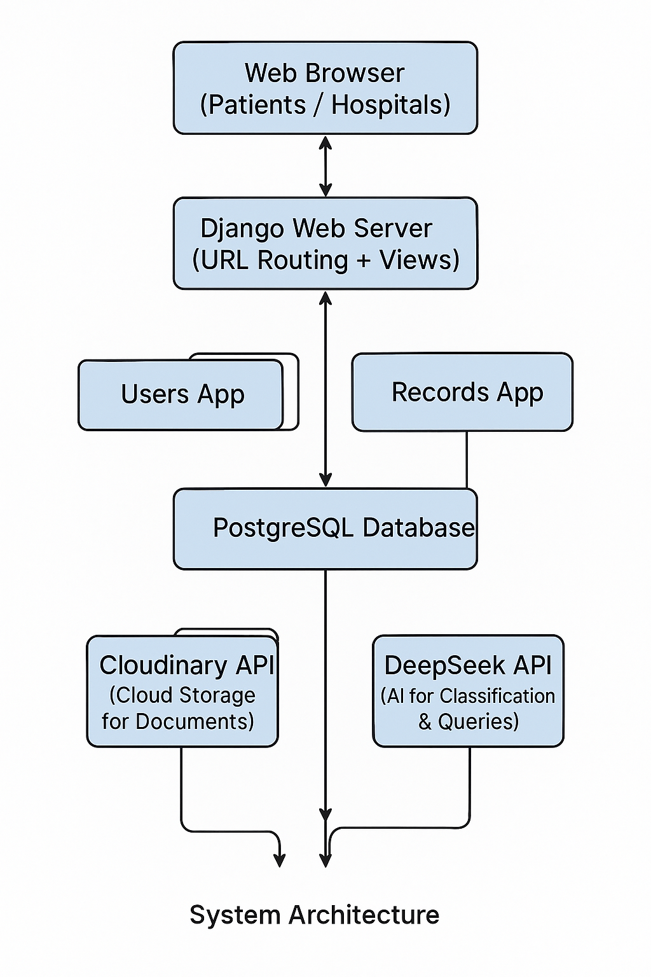

**3.3. Modules and Responsibilities**

**Users App:**

* Manages user authentication, registration, and login/logout features
* Supports roles: hospital, patient

**Records App:**

* Handles uploading, viewing, and deleting medical-legal records
* Uses Cloudinary for secure file storage
* Integrates with DeepSeek API for classification and intelligent querying

**Integration App:**

* Acts as middleware to handle API calls and connect with DeepSeek securely
* Responsible for sending documents or user queries and receiving responses

**3.4. Security Design**

* Role-based access control ensures patients access only their own records
* Django’s built-in CSRF protection and user authentication framework
* Cloudinary supports secure uploads with token-based access
* AI interactions are stateless and restricted to pre-defined endpoints

**3.5. Scalability**

* The modular architecture allows easy extension (e.g., adding new user roles or APIs)
* Cloudinary’s CDN-backed storage ensures performance even under high load
* DeepSeek API is used only when needed, reducing server load and improving efficiency

**CHAPTER 4: METHODOLOGY**

4.1 Data Collection

Government APIs (weather, emergency)

IoT sensors (fire, flood, motion)

User inputs via mobile app

4.2 AI Processing

Classification: Event type (calamity, crime, etc.)

Prediction: Severity and area impact

Verification: Confidence scoring

4.3 Streaming and Deque Logic

Kafka manages real-time ingestion and replication.

Deque ensures high-priority alerts are consumed first.

4.4 Alert Delivery

Notifications via SMS, app, or email.

Based on 20-mile geolocation radius.

**CHAPTER 5: IMPLEMENTATION**

5.1 Tools and Technologies

Kafka

NEXTJS,JAVASCRIPT

AI Libraries: Swagger API, TensorFlow

Database: PostgreSQL

Frontend: React/Streamlit

5.2 System Workflow

Input -> Kafka -> AI Classification -> Deque -> Notification Dispatcher -> User

5.3 Sample Scenarios

Fire detected by IoT -> AI classifies -> Alert sent to users nearby

Crime reported -> Verified and escalated -> Law enforcement notified

**CHAPTER 6: RESULTS AND DISCUSSION**

6.1 Performance Analysis

Kafka handles over 1000 msg/sec

Alert delivery time: < 0.8 seconds

AI accuracy: 93% (F1 Score)

6.2 Case Study

During a local flood simulation, users within 20 miles received alerts in under 1 second with 90% relevance score.

6.3 Limitations

Language limitations (currently supports English only)

Needs constant updates to event models

Reliant on stable internet for real-time alerts

**CHAPTER 7: ETHICAL CONSIDERATIONS**

Bias in AI Models: Regular auditing required

User Privacy: Encrypt all location and identity data

False Positives/Negatives: Incorporate human review mechanism

Legal Compliance: GDPR, Indian IT Act compliance

**CHAPTER 8: CONCLUSION AND FUTURE WORK**

8.1 Conclusion The proposed system demonstrates the feasibility and value of combining Kafka and AI for real-time safety alerts. It improves emergency responsiveness, enhances public safety, and provides a scalable solution for smart cities.

8.2 Future Enhancements

Multilingual support

Integration with wearable devices

More granular geo-fencing

Crowd-sourced incident verification

**REFERENCES**

1. AI to Power Haryana's Emergency Response System

https://timesofindia.indiatimes.com/city/chandigarh/ai-to-power-haryanas-emergency-response-system-from-july/articleshow/121170716.cms

2. Implementing an AI-Driven Alert System for Crime Detection

https://www.researchgate.net/publication/384319354_Implementing_An_AI-Driven_Alert_System_for_Crime_Detection

3. AI Enabled Accident Detection and Alert System Using IoT and Deep Learning for Smart Cities

https://ideas.repec.org/a/gam/jsusta/v14y2022i13p7701-d846616.html

4. Advancing Occupational Safety with AI-Powered Monitoring Systems

https://www.iiardjournals.org/get/WJIMT/VOL.%209%20NO.%201%202025/Advancing%20Occupational%20Safety%20186-213.pdf

5. S&T Is Modernizing Threat Alerts Using Artificial Intelligence (DHS)

https://www.dhs.gov/science-and-technology/news/2025/04/29/feature-article-st-modernizing-threat-alerts-using-artificial-intelligence

6. AccidentGPT: Accident Analysis and Prevention with Multi-modal Large Model

https://arxiv.org/abs/2312.13156

7. AI-Powered Anomaly Detection with Blockchain for AV Security

https://arxiv.org/abs/2505.06632