**Subqueries**

**Subquery:-**

* Query embedded in another query is called subquery.
* One query is called inner/child/subquery.
* Another query is called outer/parent/main query.
* The result of inner query acts as an input to outer query.
* Outer query can be INSERT,UPDATE,DELETE,SELECT
* Inner query must be always SELECT
* Subqueries can appear in

WHERE CLAUSE

HAVING CLAUSE

FROM CLAUSE

SELECT CLAUSE

**Types of SUBQUERIES :-**

* Single Row Subqueries
* Multi Row Subqueries
* Nested Queries
* Muliti Column Subqueries
* Co-related Subqueries

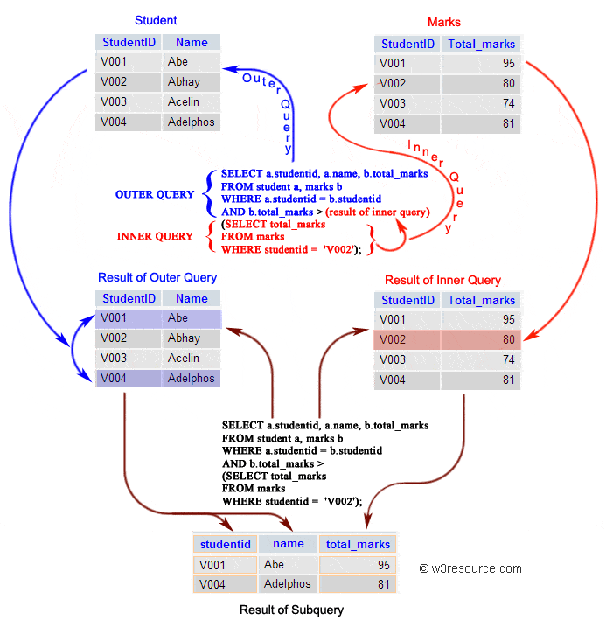**SINGLE ROW SUBQUERIES:-**

If inner query returns only one row then it is called single row subquery.

**Syntax :-**

**SELECT <collist> FROM <tabname>**

**WHERE colname OP (SELECT statement)**

**OP** can be < > <= >= = <>

**Example :-**

**Subqueries in WHERE clause :-**

Display employee records whose job equals to job of SMITH?

**SQL>SELECT * FROM emp**

**WHERE job = (SELECT job FROM emp WHERE ename=’SMITH’) ;**

Display employee name earning maximum salary ?

**SQL>SELECT ename FROM emp**

**WHERE sal = (SELECT MAX(sal) FROM emp) ;**

Display all records except last record ?

**SQL>SELECT * FROM emp**

**WHERE ROWID <(SELECT MAX(ROWID) FROM emp) ;**

**Subqueries with BETWEEN operator:-**

Display employee reocrds earning salary between min sal of 10 dept and max sal of 30 dept ?

**SQL>SELECT * FROM emp**

**WHERE sal BETWEEN (SELECT MIN(sal) FROM emp WHERE deptno=10)**

**AND**

**(SELECT MAX(sal) FROM emp WHERE deptno=30) ;**

**Subqueries in HAVING clause:-**

Display departmentss whose avg(sal) geater than avg(sal) of 10 dept?

**SQL>SELECT deptno FROM emp**

**GROUP BY deptno**

**HAVING AVG(sal) > (SELECT AVG(sal) FROM emp**

**WHERE deptno=10) ;**

**Subqueries in UPDATE command :-**

Update employee salary to maximum salary whose empno=7369 ?

**SQL>UPDATE emp SET sal = (SELECT MAX(sal) FROM emp) WHERE EMPNO=7369 ;**

Swap employee salaries whose empno in (7369,7499) ?

**SQL>UPDATE emp SET sal=DECODE(empno,7369,(SELECT sal FROM emp**

**WHERE empno=7499),**

**7499,(SELECT sal FROM emp**

**WHERE empno=7369) );**

**Subqueries in DELETE command:-**

Delete employee record whose job equals to job of SMITH ?

**SQL>DELETE FROM emp**

**WHERE job= (SELECT job FROM emp WHERE ename=’SMITH’);**

**Multi Row Subqueries:-**

if inner query returns more than one row then it is called multi row subquery.

**Syntax :-**

**SQL>SELECT <collist> FROM <tabname>**

**WHERE colname OP (SELECT statement) ;**

OP must be IN , NOT IN, ANY, ALL

**Example :-**

Displaye employee records whose job equals to job of SMITH or job of BLAKE ?

**SQL>SELECT * FROM emp**

**WHERE job IN (SELECT job FROM emp WHERE ename IN (‘SMITH’,’BLAKE’));**

Displaye employee records who are

earning minimum and maximum salaries ?

**SQL>SELECT * FROM emp WHERE sal IN (SELECT MIN(sal) FROM emp**

**UNION**

**SELECT MAX(sal) FROM emp);**

Display 4th,7th,11th record in EMP table ?

**SQL>SELECT * FROM emp**

**WHERE ROWID IN (SELECT DECODE(ROWNUM,4,ROWID,**

**7,ROWID,**

**11,ROWID)**

**FROM emp);**

**ANY operator:-**

Compares a value to each value in a list or returned by a query. Must be preceded by =, !=, >, <, <=, >=. Evaluates to FALSE if the query returns no rows.

**Example:-**

Select employees whose salary is greater than any salesman’s salary ?

**SQL>SELECT ename FROM emp**

**WHERE SAL > ANY ( SELECT sal FROM emp WHERE job = 'SALESMAN');**

**ALL operator :-**

Compares a value to every value in a list or returned by a query. Must be preceded by =, !=, >, <, <=, >=. evaluates to TRUE if the query returns no rows.

**Example:-**

Select employees whose salary is greater than every salesman’s salary ?

**SQL>SELECT ename FROM emp**

**WHERE SAL > ALL ( SELECT sal FROM emp WHERE job = 'SALESMAN');**

**Nested Queries:-**

🡪A subquery embedded in another subquery is called NESTED QUERY.

🡪Queries can be nested upto 255 level.

**Example :-**

Display employee name earning second maximum salary ?

**SQL>SELECT ename FROM emp**

**WHERE sal = (SELECT MAX(sal) FROM EMP**

**WHERE sal < (SELECT MAX(sal) FROM emp)) ;**

Update the employee salary to maximum salary of SALES dept ?

**SQL>UPDATE emp**

**SET sal = (SELECT MAX(sal) FROM emp**

**WHERE deptno = (SELECT deptno FROM dept**

**WHERE dname=’SALES’)) ;**

**Multi Column Subqueries:-**

If inner query returns more than one column value then it is called MULTI COLUMN subquery.

**Example :-**

Display employee names earning maximum salaries in their dept ?

**SQL>SELECT ename FROM emp**

**WHERE (deptno,sal) IN (SELECT deptno,MAX(sal)**

**FROM emp**

**GROUP BY deptno) ;**

**Co-related Subqueries:-**

If a subquery references one or more columns of parent query is called CO-RELATED subquery because it is related to outer query. This subquery executes once for each and every row of main query.

**Example :-**

🡪Display employee names earning more than avg(sal) of their dept ?

**SQL>SELECT ename FROM emp x**

**WHERE sal > (SELECT AVG(sal) FROM emp**

**WHERE deptno=x.deptno);**

🡪Display employee names earning more than their manager ?

**SQL>SELECT ename FROM emp x**

**WHERE sal > (SELECT sal FROM emp**

**WHERE empno=x.mgr);**

🡪Delete duplicate records in a table ?

**SQL>DELETE FROM emp X**

**WHERE ROWID > (SELECT MIN(ROWID) FROM emp**

**WHERE empno=x.empno**

**AND**

**ename=x.ename**

**AND**

**sal=x.sal) ;**

Display top 3 maximum salaries in emp table ?

**SQL>SELECT DISTINCT sal FROM emp a**

**WHERE 3 > (SELECT COUNT(DISTINCT sal)**

**FROM emp b**

**WHERE a.sal < b.sal) ;**

**Using EXISTS operator :-**

🡪EXISTS operator returns TRUE or FALSE.

🡪If inner query returns at least one record then EXISTS returns TRUE otherwise returns FALSE.

🡪ORACLE recommends EXISTS and NOT EXISTS operators instead of IN and NOT IN.

Display dept which not empty ?

**SQL>SELECT * FROM dept d**

**WHERE EXISTS (SELECT * FROM emp WHERE deptno =d.deptno) ;**

Display dept which is empty ?

**SQL>SELECT * FROM dept d**

**WHERE NOT EXISTS (SELECT * FROM emp**

**WHERE deptno = d.deptno);**