Part I. Sorting

1. Quick Sort

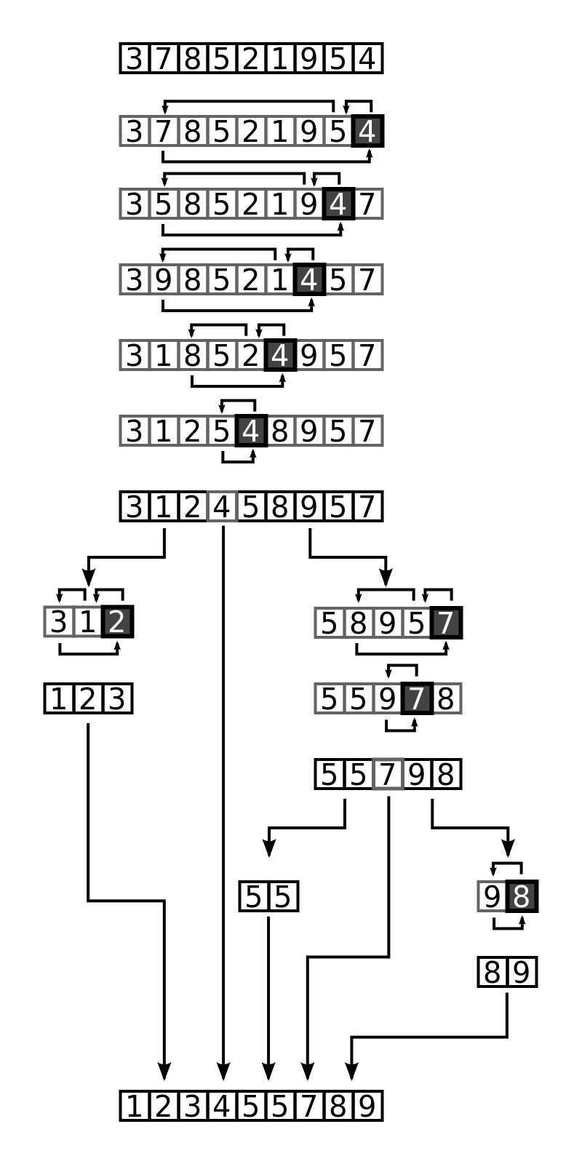

* key steps

select pivot(last or first element) 🡪 divide 🡪 conquer(recursive) 🡪 merge back

* leftmost sub list is sorted first

1. merge sort

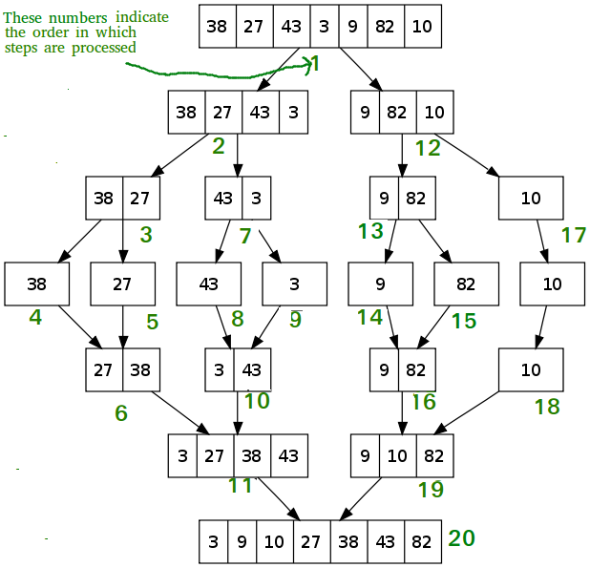

* Key steps:

Select midpoint 🡪divide (left and right sub-lists )🡪conquer(recursive) on left and right sub-lists 🡪merging back to sub-list in each recursive step

* leftmost sub list is sorted first