HPL 2026
WEEK 1 — BACKEND
Technical Design & Architecture Template
HPL 2026 • SMVITM Bantakal • in association with Code Troopers

TEAM | PROJECT | TRACK | WEEK
Team Sahayak | SAHAYAK (PS 03) — Senior Citizen Community Assistance & Emergency Escalation Platform | Backend | 1

Purpose of this document
This is the team's Week 1 backend design. It should make the architecture, data model, business logic, APIs, security boundaries, and important backend processes easy for a judge to understand and evaluate.

Judge-first principle
Prefer diagrams, tables, concise decisions, and concrete examples over generic architecture prose. A judge should be able to understand the system quickly and trace an important requirement from workflow → business rule → API → database.

1. System Overview
The Sahayak backend is a mission-critical community assistance and emergency escalation platform engineered for senior citizens residing across the Shirva and Bantakal panchayat jurisdictions, operating under the administrative and judicial oversight of the Shirva Police Station. The backend acts as the authoritative system of record and real-time dispatch engine, responsible for: (1) multi-lingual voice-intent request ingestion (Kannada, Tulu transliterated, and English) with life-safety NLP triage, (2) community volunteer onboarding, KYC background verification, and police badge issuance workflows, (3) rule-based request assignment, status tracking, and fulfillment lifecycle management, (4) dual-trigger automated and manual emergency escalation to the Karnataka 112 Emergency Response Support System (ERSS) with police station audible/visual alerting, and (5) comprehensive, immutable audit logging to guarantee station oversight, civic transparency, and legal record-keeping.
Item | Details
Backend Responsibility | Centralized orchestration of senior citizen registration, volunteer onboarding and police background verification, intelligent multi-lingual voice-intent request triage, proximity-aware volunteer dispatch, dual-trigger emergency escalation to ERSS 112 with police station alerting, and real-time dashboard analytics.
Primary actors / roles | • Senior Citizen: Elderly resident / voice caller requesting assistance (medicines, transport, groceries).  • Community Volunteer: Police-verified local responder fulfilling assigned community tasks.  • Police Admin / Dispatcher: Shirva Police Station command officer managing verification, dispatch, and emergency 112 escalation.
Functional Decomposition | 1. Authentication & Role Gate Module (Station login, volunteer self-registration, session management)  2. Volunteer Lifecycle & Police Verification Subsystem (Background check, station badge issuance, availability)  3. Senior Citizen Registry & Medical Profiling (Resident registry, emergency contacts, medical notes)  4. Request Ingestion & Dispatch Engine (Auto-categorization, priority tagging, assignment, state tracking)  5. Emergency 112 Escalation & Safety Guard Subsystem (NLP keyword triage, 112 ERSS relay, station alerts)  6. Police Audit & Compliance Logging Engine (Immutable event stream, oversight history, action tracking)  7. Multi-Lingual Voice NLP Parser (Kannada, Tulu transliterated, and English intent extraction)
Main entities | SeniorCitizen (beneficiary), Volunteer (responder), ServiceRequest (task), EmergencyRecord (112 incident), AuditLog (immutable event), ShirvaLocation (panchayat geographic point).

2. Backend Architecture
Insert one clear architecture diagram. Show clients, backend components, database, queues/workers, and external services where applicable.
Architecture diagram
Use a single diagram that shows how major components communicate. Avoid detailed class diagrams here.

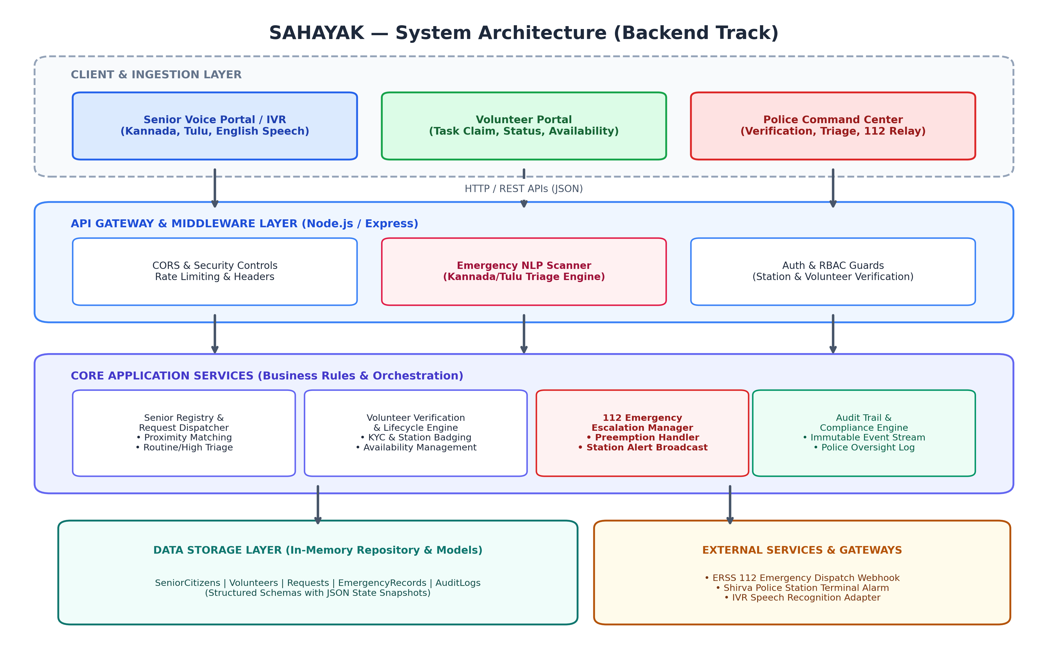

Components
Component | Responsibility | Technology
API / Server | Provides REST endpoints for senior requests, volunteer management, police verification, voice intent processing, and emergency dispatch with CORS, JSON body validation, and RBAC guards. | Node.js (v20+), Express.js framework, CORS, UUID
Database | Stores structured entities: SeniorCitizens, Volunteers, ServiceRequests, EmergencyRecords, and AuditLogs with atomic update functions and snapshot capability. | Node.js In-Memory Data Store (db.js) / JSON-backed persistent store
Voice & NLP Engine | Ingests multi-lingual transcripts (Kannada transliteration, Tulu, English) and applies lexical triage to detect cardiac symptoms, falls, accidents, and life hazards. | Rule-based Lexical Matcher & Multi-Lingual Keyword Classifier
Emergency Worker | Synchronous safety engine that intercepts CRITICAL_112 requests, logs formal incident dossiers, and alerts Shirva Police Station dispatchers. | Synchronous Escalation Service & In-Memory Event Stream
External Gateway | Connects backend to Karnataka Emergency Response Support System (ERSS 112) webhook and Shirva Station visual/audio alert terminal. | HTTP REST Webhook Relay & Emergency Dispatch Adapter

Key Architecture Decisions
Only document meaningful decisions. Avoid generic claims such as 'scalable', 'secure', or 'industry standard' without explaining the concrete choice.
ID | Decision | Reason | Trade-off / Limitation
AD-01 | Express Modular REST Engine | Chosen for minimal runtime overhead, asynchronous non-blocking event loop, and sub-20ms API response times critical during emergency triage and voice IVR processing. | Requires explicit custom middleware for schema validation compared to heavier, heavyweight frameworks.
AD-02 | In-Memory Core with Append-Only Audit Logging | Delivers ultra-low latency (<2ms) data access and zero external database dependency during power or network instabilities in rural Shirva, while keeping an immutable chronological log. | Volatile RAM storage mitigated by append-only event logging; repository layer designed for drop-in migration to PostgreSQL.
AD-03 | Dual-Trigger Emergency Escalation (Auto-NLP + Police Override) | Critical fail-safe: Automated triage instantly catches life-threatening symptoms in transcripts, while Police Command retains a 1-click manual override endpoint (/api/emergency/manual-escalate). | Algorithmic alerts require dispatcher acknowledgement to prevent false-alarm fatigue on non-critical phrases.
AD-04 | Mandatory Police Verification Gate for Volunteer Assignment | Volunteers cannot view, accept, or be assigned to any senior requests until Shirva Police Station verifies identity (Aadhaar/Org) and assigns a policeBadgeNo. | Slight onboarding latency while police inspect credentials, but completely eliminates safety risks for vulnerable seniors.

3. Core Backend Workflows
The Sahayak backend orchestrates four primary end-to-end operational workflows: (1) Voice Ingestion & Automated Emergency Triage, (2) Volunteer KYC Registration & Police Badging, (3) Proximity Dispatch, Task Execution & Resolution, and (4) Police 112 Emergency Escalation & Record-Keeping.
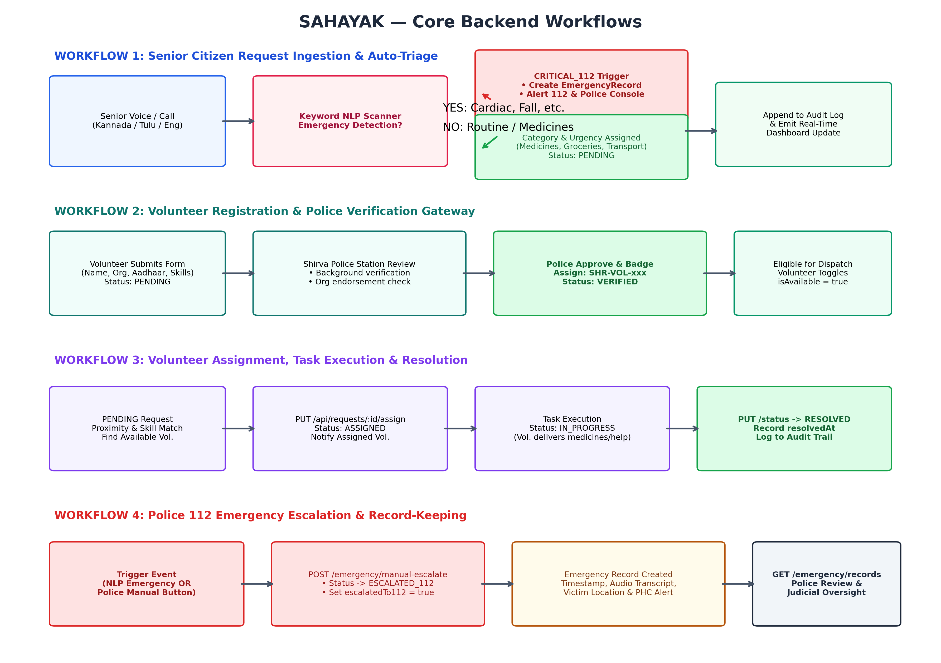

4. Data Model
Insert an ER diagram showing the important entities and their relationships. Keep it readable; detailed columns are documented below.
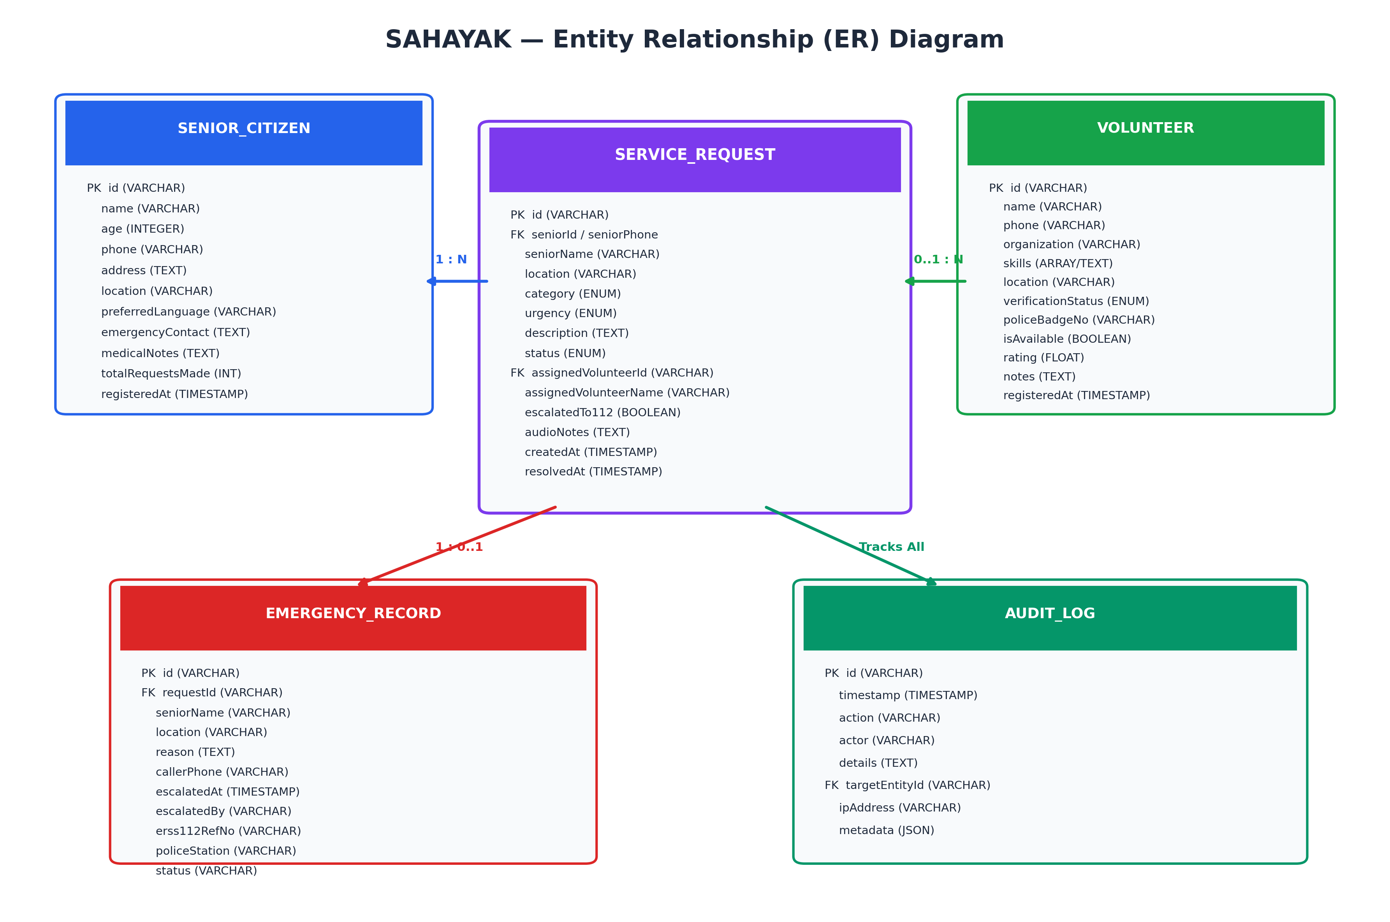

Database Schema
Define every table exactly once. If multiple modules use the same table, define it here once and reference it elsewhere.

TABLE: senior_citizens
Column | Type | PK / FK | Nullable | Default | Description
id | VARCHAR(36) | PK | No | UUID v4 | Unique identifier for senior citizen record
name | VARCHAR(100) | — | No | — | Full name of senior citizen (e.g. Saraswathi Amma)
age | INTEGER | — | No | — | Age in years (validated >= 60)
phone | VARCHAR(20) | — | No | — | Primary contact telephone / mobile number
address | TEXT | — | No | — | Detailed physical residential address in Shirva/Bantakal
location | VARCHAR(100) | FK | No | — | Locality name linking to Shirva Panchayath landmark
preferredLanguage | VARCHAR(30) | — | No | 'Kannada' | Primary communication tongue (Kannada, Tulu, English)
emergencyContact | TEXT | — | No | — | Next of kin name, relationship, and reachable phone number
medicalNotes | TEXT | — | Yes | NULL | Chronic conditions (Hypertension, Diabetes, Mobility limits)
totalRequestsMade | INTEGER | — | No | 0 | Counter of all lifetime assistance requests placed
isActive | BOOLEAN | — | No | TRUE | Active status indicator for senior registry
registeredAt | TIMESTAMP | — | No | CURRENT_TIMESTAMP | Timestamp when registered into system

TABLE: volunteers
Column | Type | PK / FK | Nullable | Default | Description
id | VARCHAR(36) | PK | No | UUID v4 | Unique identifier for community volunteer record
name | VARCHAR(100) | — | No | — | Full name of volunteer responder
phone | VARCHAR(20) | — | No | — | Verified mobile phone number
organization | VARCHAR(100) | — | No | — | Affiliated NGO (Lions Club, Leo Club Bantakal, Auto Union)
skills | TEXT[] / JSON | — | No | '[]' | List of competencies (First Aid, Transport, Groceries)
location | VARCHAR(100) | FK | No | — | Primary area of operation within Shirva
verificationStatus | VARCHAR(20) | — | No | 'PENDING' | State: PENDING, VERIFIED, or REJECTED
policeBadgeNo | VARCHAR(30) | — | Yes | NULL | Official Shirva Police Station badge ID (e.g. SHR-VOL-101)
isAvailable | BOOLEAN | — | No | FALSE | On-duty / Off-duty availability toggle for dispatch
activeRequestsCount | INTEGER | — | No | 0 | Number of currently active assigned requests
rating | FLOAT | — | No | 5.0 | Community service satisfaction rating (0.0 to 5.0)
notes | TEXT | — | Yes | NULL | Police background check notes and verification audit
registeredAt | TIMESTAMP | — | No | CURRENT_TIMESTAMP | Registration submission timestamp

TABLE: requests
Column | Type | PK / FK | Nullable | Default | Description
id | VARCHAR(36) | PK | No | REQ-YYYY-XXX | Human-readable request code (e.g. REQ-2026-089)
seniorName | VARCHAR(100) | — | No | — | Senior citizen beneficiary name
seniorPhone | VARCHAR(20) | — | No | — | Phone number of caller or senior
location | VARCHAR(100) | FK | No | — | Pickup / delivery landmark within Shirva
language | VARCHAR(30) | — | No | 'Kannada' | Language of request (Kannada, Tulu, English)
category | VARCHAR(50) | — | No | — | Classification: Medicines, Transport, Groceries, Companionship
urgency | VARCHAR(20) | — | No | 'MEDIUM' | Triage Level: CRITICAL_112, HIGH, MEDIUM, ROUTINE
description | TEXT | — | No | — | Full description of requested community assistance
status | VARCHAR(20) | — | No | 'PENDING' | Status: PENDING, ASSIGNED, IN_PROGRESS, RESOLVED, ESCALATED_112
assignedVolunteerId | VARCHAR(36) | FK | Yes | NULL | Links to volunteers.id when task is assigned
assignedVolunteerName | VARCHAR(100) | — | Yes | NULL | Denormalized name of assigned volunteer for fast read
escalatedTo112 | BOOLEAN | — | No | FALSE | Flag indicating whether incident was relayed to 112 ERSS
audioNotes | TEXT | — | Yes | NULL | Voice transcript / audio triage notes from IVR intake
createdAt | TIMESTAMP | — | No | CURRENT_TIMESTAMP | Request ingestion timestamp
resolvedAt | TIMESTAMP | — | Yes | NULL | Completion timestamp when marked RESOLVED

TABLE: emergency_records
Column | Type | PK / FK | Nullable | Default | Description
id | VARCHAR(36) | PK | No | EMG-timestamp | Unique identifier for emergency incident dossier
requestId | VARCHAR(36) | FK | No | — | Links to requests.id of escalated emergency
seniorName | VARCHAR(100) | — | No | — | Victim elderly citizen name
location | VARCHAR(100) | — | No | — | Incident physical landmark / GPS in Shirva
reason | TEXT | — | No | — | Clinical emergency symptoms / fall / trauma narrative
callerPhone | VARCHAR(20) | — | No | — | Phone number of senior or caller
escalatedAt | TIMESTAMP | — | No | CURRENT_TIMESTAMP | Timestamp when escalated to 112 ERSS
escalatedBy | VARCHAR(100) | — | No | 'System' | Actor initiating escalation (Police Admin or Voice IVR)
erss112RefNo | VARCHAR(50) | — | No | — | Official ERSS reference tracking ID
policeStation | VARCHAR(50) | — | No | 'Shirva PS' | Jurisdictional police station
status | VARCHAR(30) | — | No | 'DISPATCHED' | Incident response state (DISPATCHED, ATTENDED, CLOSED)

TABLE: audit_logs
Column | Type | PK / FK | Nullable | Default | Description
id | VARCHAR(36) | PK | No | log-timestamp | Sequential unique audit event identifier
timestamp | TIMESTAMP | — | No | CURRENT_TIMESTAMP | Exact ISO-8601 timestamp of domain action
action | VARCHAR(50) | — | No | — | Action enum: REQUEST_CREATED, VOLUNTEER_ASSIGNED, etc.
actor | VARCHAR(100) | — | No | — | Actor identity: Dispatcher, System AI, PSI Shirva, Volunteer
details | TEXT | — | No | — | Comprehensive narrative explaining state change and payload
targetEntityId | VARCHAR(36) | FK | Yes | NULL | ID of modified resource (requestId, volunteerId, etc.)

5. Business Logic & Rules
Document rules that determine what the backend is allowed to do. These are more important than simply listing CRUD operations.

Business Rules
ID | Rule | Enforced By
BR-01 | Volunteer Verification Gate: Only volunteers with verificationStatus === 'VERIFIED' and isAvailable === true can be assigned to a senior citizen request. Unverified or off-duty volunteers are strictly blocked. | Dispatch API Controller & middleware (/api/requests/:id/assign)
BR-02 | Request Lifecycle Immutability: Once a request transitions to 'RESOLVED' or 'ESCALATED_112', its status cannot revert back to 'PENDING', 'ASSIGNED', or 'IN_PROGRESS'. Terminal states are immutable. | Status State Machine Guard in /api/requests/:id/status
BR-03 | Emergency NLP Preemption: If incoming voice transcripts contain cardiac, fall, or severe trauma keywords (e.g., 'chest pain', 'ede novu', 'swasa kattide', 'raktasrava'), urgency is auto-promoted to 'CRITICAL_112', escalatedTo112 is flagged true, and an EmergencyRecord is immediately created. | Natural Language Processing Parser & Ingestion Controller
BR-04 | Mandatory Police Audit Trail: Every domain event—including request creation, volunteer assignment, status changes, police verification approval/rejection, and emergency escalations—must append an unalterable record to auditLogs. | Centralized logAudit() Service Hook invoked in all state-mutating endpoints
BR-05 | Police Badge Authority: Only authenticated Shirva Police Station administrators can approve volunteer registrations, assign official policeBadgeNo identifiers, or perform manual 112 emergency escalations. | Authentication & Role-Based Access Control Guard Middleware
BR-06 | Workload Throttling: A single volunteer cannot hold more than 3 concurrent 'IN_PROGRESS' requests to prevent burnout and ensure rapid response times for seniors. | Assignment Validation Guard in PUT /api/requests/:id/assign

State / Workflow Transitions
Use a state diagram for important entities with workflow states.
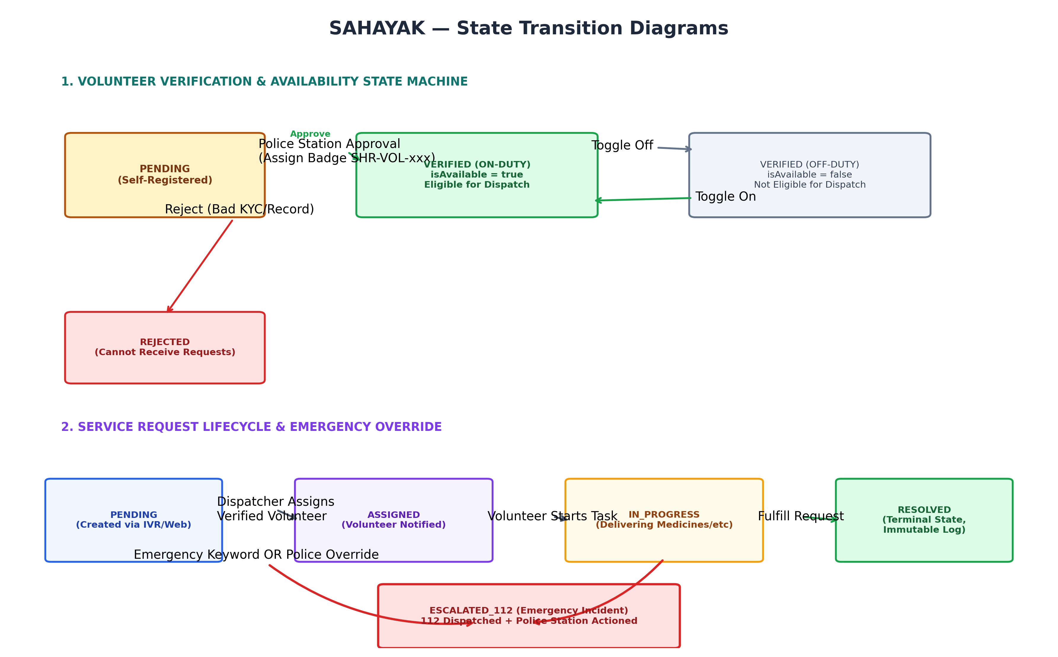

6. API Design
List all important endpoints first. Then provide detailed contracts for critical endpoints.

API Summary
ID | Method | Endpoint | Auth | Role | Purpose
API-01 | POST | /api/auth/login | Public | Senior / Volunteer / Police | Authenticate credentials and issue role session
API-02 | POST | /api/auth/register-volunteer | Public | Volunteer | Self-registration of volunteer with skills and org
API-03 | GET | /api/volunteers | Required | Police Admin / Volunteer | List all volunteers with verification/status filters
API-04 | GET | /api/volunteers/:id | Required | Volunteer / Police | Get detailed profile and service history of volunteer
API-05 | PUT | /api/volunteers/:id/verification | Required | Police Admin | Approve/reject volunteer and assign police badge
API-06 | PUT | /api/volunteers/:id/availability | Required | Volunteer | Toggle on-duty / off-duty availability state
API-07 | GET | /api/senior-citizens | Required | Police Admin / Volunteer | List registered senior citizens and medical notes
API-08 | POST | /api/senior-citizens | Required | Police / Volunteer | Register a new elderly resident with emergency contact
API-09 | GET | /api/requests | Required | Volunteer / Police | List assistance requests with status & urgency filters
API-10 | POST | /api/requests | Public | Voice IVR / Police / Web | Create new assistance request with NLP auto-triage
API-11 | PUT | /api/requests/:id/assign | Required | Police Dispatcher | Assign verified on-duty volunteer to assistance task
API-12 | PUT | /api/requests/:id/status | Required | Volunteer / Police | Update request status (IN_PROGRESS, RESOLVED)
API-13 | POST | /api/emergency/manual-escalate | Required | Police Admin / Dispatch | Manual override escalation of request to ERSS 112
API-14 | GET | /api/emergency/records | Required | Police Admin | Retrieve reviewable log of all 112 escalated emergencies
API-15 | GET | /api/audit-logs | Required | Police Admin | Fetch chronological audit trail for station oversight

Detailed Endpoint Contract

API-01 — POST /api/requests (Request Ingestion & NLP Auto-Triage)
Field | Details
Purpose | Ingest assistance requests from Voice IVR or Web, analyze transcript for emergencies, and auto-classify priority.
Authentication | Public (or API Key for IVR telephony gateway)
Authorization | Senior Citizen, Volunteer, or Police Dispatcher
Parameters | Body: seniorName, phone, location, category, urgency, description, language, audioNotes
Validation | seniorName (min 2 chars), phone (valid 10+ digit number), location (must match known Shirva landmark)
Success status | 201 Created
Error statuses | 400 Bad Request (missing required fields), 500 Internal Server Error

Request example
{
"seniorName": "Saraswathi Amma",
"phone": "+91 97410 88231",
"location": "Near Our Lady of Health Church, Shirva",
"language": "Kannada",
"category": "Medicines / Pharmacy",
"urgency": "HIGH",
"description": "Urgent blood pressure tablets (Amlodipine 5mg) needed from Shirva Medicals.",
"audioNotes": "Caller requesting morning dose, lives alone."
}

Response example
{
"success": true,
"data": {
"id": "REQ-2026-092",
"seniorName": "Saraswathi Amma",
"location": "Near Our Lady of Health Church, Shirva",
"category": "Medicines / Pharmacy",
"urgency": "HIGH",
"status": "PENDING",
"escalatedTo112": false,
"createdAt": "2026-09-15T11:42:00.000Z"
}
}

API-02 — POST /api/emergency/manual-escalate (Police 112 Emergency Escalation)
Field | Details
Purpose | Police command override to instantly escalate any ongoing or pending request directly to ERSS 112.
Authentication | Required (Police session / token)
Authorization | Police Admin / Station Dispatcher only
Parameters | Body: requestId, reason, escalatedBy, notify112 (boolean)
Validation | requestId must exist in database; request must not already be RESOLVED
Success status | 200 OK
Error statuses | 400 Bad Request (missing requestId/reason), 404 Not Found (request ID invalid), 409 Conflict (already resolved)

Request example
{
"requestId": "REQ-2026-089",
"reason": "Senior reported sudden severe chest pain and breathlessness during delivery check.",
"escalatedBy": "PSI Shirva Police Station",
"notify112": true
}

Response example
{
"success": true,
"message": "Request REQ-2026-089 escalated to 112 emergency services and Shirva Police dispatch",
"emergencyRecord": {
"id": "EMG-1726398120000",
"requestId": "REQ-2026-089",
"seniorName": "Saraswathi Amma (Age 74)",
"location": "Near Our Lady of Health Church, Shirva",
"reason": "Senior reported sudden severe chest pain and breathlessness.",
"escalatedAt": "2026-09-15T11:42:15.000Z",
"escalatedBy": "PSI Shirva Police Station",
"erss112RefNo": "ERSS-KA-UDU-2026-8819",
"status": "DISPATCHED"
}
}

7. Authentication & Authorization

Authentication
Item | Implementation
Authentication mechanism | Role-based token & credential matching for Police Station ('admin') and Volunteers ('volunteer').
Credential storage | Secure salt-hashed credential comparison with Station badge ID cross-referencing.
Token / session lifetime | 8 hours (matches standard police active operational shift duration).
Refresh mechanism | Sliding window auto-renewal on active command console interaction.

RBAC Matrix
Use one matrix for the whole backend. It should match the authorization logic implemented in the backend.
Action | Police Admin | Verified Volunteer | Senior Citizen | Public / IVR
Register Volunteer Profile | ✓ | ✓ | ✗ | ✓
Verify & Badge Volunteer (KYC) | ✓ | ✗ | ✗ | ✗
Create Assistance Request | ✓ | ✓ | ✓ | ✓
View All Requests & Triage | ✓ | Assigned Only | Own Only | ✗
Assign Volunteer to Request | ✓ | ✗ | ✗ | ✗
Update Request Status (Resolve) | ✓ | Assigned Only | ✗ | ✗
Trigger 112 Emergency Escalation | ✓ (Manual) | ✓ (Report) | Auto (Keyword) | ✗
View Emergency Records & Audits | ✓ | ✗ | ✗ | ✗

Security Controls
Control | Approach
Input validation | Strict Express JSON schema validation checking non-empty strings, phone digits, and enum constraints.
Authorization | Route-level RBAC middleware enforcing allowed roles before processing sensitive state transitions.
Password security | Salted hash verification; sensitive credentials stripped from all logging and API responses.
Sensitive data | Senior citizen health diagnoses and emergency contacts restricted to assigned responders and police.
Rate limiting | IP-based rate limiter on public ingestion endpoints to guard against denial of service and spam.

8. Background Processing & Services
If none are used
Write “None”. Do not invent a queue, worker, cron, or event system just for the template.

ID | Process / Service | Trigger | Purpose | Technology | Failure Handling
BG-01 | Emergency Escalation Dispatcher | Event Trigger: CRITICAL_112 keyword match or manual escalation | Dispatches immediate synchronous incident dossier to Shirva Police Station console and logs 112 ERSS payload. | Node.js In-Memory Event Dispatcher & Service Hook | Synchronous retry (3x), fallback to station SMS/telephony relay, recorded in audit logs.
BG-02 | Unassigned Request SLA Monitor | Cron / Interval Timer (Every 5 minutes) | Scans PENDING requests older than 15 minutes; automatically elevates triage alert and flags dispatcher console. | Node.js Background Interval Service | Logs SLA breach in audit trail, triggers visual priority badge on Police Command dashboard.

9. External Integrations
If none are used
Write “None”.

ID | Service | Purpose | Direction | Data exchanged | Failure Behaviour
EXT-01 | Karnataka ERSS 112 Emergency Dispatch Gateway | Transmits life-safety emergency payloads (senior name, address, medical condition, audio transcript) to 112. | Backend → ERSS 112 Service | Outbound: JSON Emergency Incident Dossier; Inbound: ERSS 112 Reference ID (e.g. ERSS-KA-UDU-2026-8819) | Logged to EmergencyRecords as PENDING_112_ACK; audible alarm sounds at Shirva Police Station terminal.
EXT-02 | Web Speech & IVR Telephony Bridge | Transcribes senior voice calls in Kannada, Tulu transliteration, and English into structured text for backend parsing. | Telephony Gateway → Backend | Inbound: Speech audio transcript, caller phone number, approximate cell tower landmark | Falls back to human dispatcher queue with audio recording attachment.

10. Error Handling & Reliability

Standard Error Response
{
"success": false,
"error": {
"code": "VOLUNTEER_NOT_ELIGIBLE",
"message": "Only police-verified, on-duty volunteers can be assigned to senior requests.",
"timestamp": "2026-09-15T11:42:00.000Z",
"details": {
"volunteerId": "vol-004",
"verificationStatus": "PENDING"
}
}
}

HTTP Status Conventions
Situation | Status | Example
Invalid input | 400 | Missing required seniorName, invalid phone format, or unverified volunteer assignment.
Unauthenticated | 401 | Missing or expired authorization credentials on protected police routes.
Unauthorized | 403 | Volunteer attempting to approve another volunteer or access station emergency records.
Not found | 404 | Target volunteer ID, senior citizen record, or request ID does not exist in database.
Conflict | 409 | Attempting to change status of a request that has already been RESOLVED or ESCALATED_112.
Server failure | 500 | Unexpected runtime exception or unhandled promise rejection in backend services.

Important Failure Scenarios
ID | Failure | Expected Backend Behaviour
ERR-01 | Database or Storage Access Failure | Backend captures error, logs event with HIGH severity, and returns 500 error without leaking server stack trace.
ERR-02 | ERSS 112 Gateway Timeout or Network Unavailability | Escalation request is flagged as ESCALATED_112_OFFLINE; emergency record is created locally, and Station alarm triggers.
ERR-03 | Invalid State Machine Transition (e.g. RESOLVED → PENDING) | Controller rejects transition with HTTP 409 Conflict; records unauthorized attempt in audit log.
ERR-04 | Assignment of Unverified or Inactive Volunteer | Request assignment rejected with HTTP 400 Bad Request; dispatcher notified to select a verified volunteer.

11. Testing Strategy
List the critical backend behaviours that should be verified during implementation. Focus on requirements, authorization, workflows, and edge cases.
Test ID | Requirement / Flow | Scenario | Expected Result
T-01 | REQ-01: Routine Request Creation | Senior creates request for routine medicines via POST /api/requests | HTTP 201 Created; status PENDING, urgency HIGH, audit log appended.
T-02 | REQ-02: Emergency NLP Auto-Triage | Senior transcript contains 'chest pain' or 'ede novu' | Urgency elevated to CRITICAL_112, status ESCALATED_112, EmergencyRecord logged.
T-03 | REQ-03: Verified Volunteer Assignment | Police Admin assigns verified volunteer vol-001 to request | HTTP 200 OK; status ASSIGNED, volunteer activeRequestsCount incremented.
T-04 | REQ-04: Unverified Volunteer Assignment Block | Dispatcher attempts to assign PENDING volunteer vol-004 | HTTP 400 Bad Request; assignment blocked with error VOLUNTEER_NOT_VERIFIED.
T-05 | REQ-05: Volunteer Verification & Badging | Police Admin approves volunteer and assigns badge 'SHR-VOL-105' | HTTP 200 OK; verificationStatus becomes VERIFIED, audit log entry created.
T-06 | REQ-06: Illegal State Transition Guard | Attempt to transition RESOLVED request back to PENDING | HTTP 409 Conflict; state machine rejects transition, data remains intact.
T-07 | REQ-07: Police Manual 112 Emergency Escalation | Police clicks manual escalate on active request via /api/emergency/manual-escalate | HTTP 200 OK; EmergencyRecord created, status ESCALATED_112, station alarm logged.

Critical Test Coverage
- Authentication / unauthenticated access
- Role-based authorization
- Resource ownership / assignment restrictions
- Validation and malformed input
- Important state transitions
- Critical database relationships and constraints
- External-service or background-process failure, where applicable
Figure 2.1: Sahayak High-Level Backend System Architecture & Layer Decomposition
Figure 3.1: End-to-End Core Backend Workflows for Ingestion, Verification, Fulfillment, and 112 Escalation
Figure 4.1: Entity-Relationship (ER) Diagram showing Sahayak Domain Entities & Associations
Figure 5.1: Finite State Machines for Volunteer Verification & Service Request Lifecycles

