**Hands on 1**

**CREATE A SPRING WEB PROJECT USING MAVEN**

**CODE:**

**SpringLearnApplication.java**

package com.cognizant.spring_learn;

import org.springframework.boot.SpringApplication;

import org.springframework.boot.autoconfigure.SpringBootApplication;

import org.springframework.context.annotation.ImportResource;

*@SpringBootApplication*

*@ImportResource*("classpath:country.xml")

public class SpringLearnApplication {

public static void main(String[] args) {

System.***out***.println("Successfully Created the Spring Web project using Maven");

SpringApplication.*run*(SpringLearnApplication.class, args);

}

}

**OUTPUT**

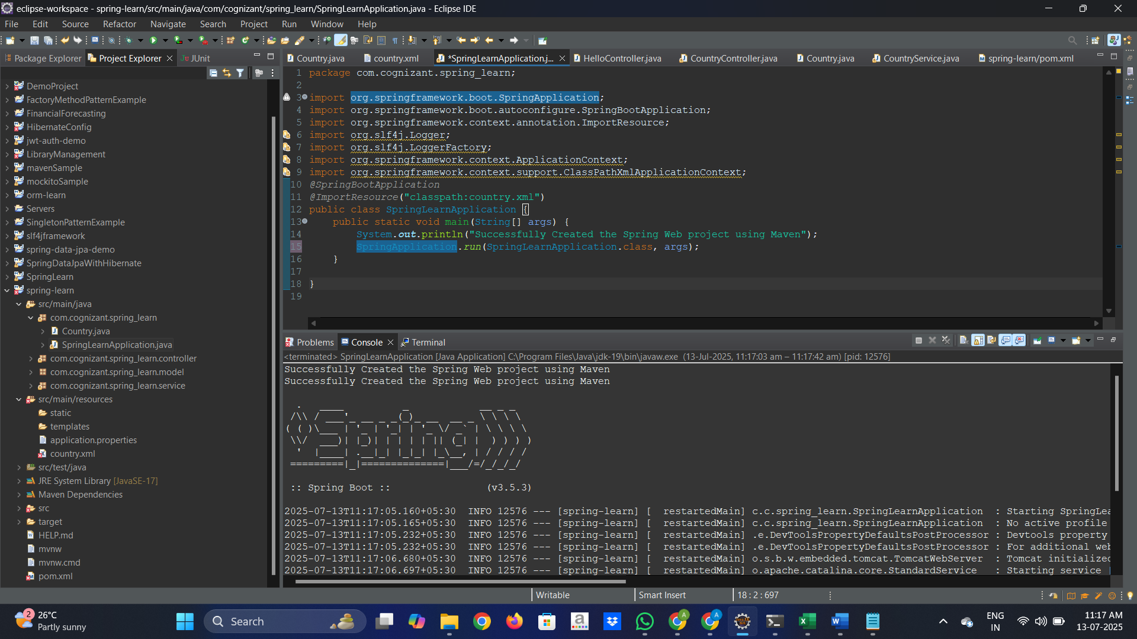

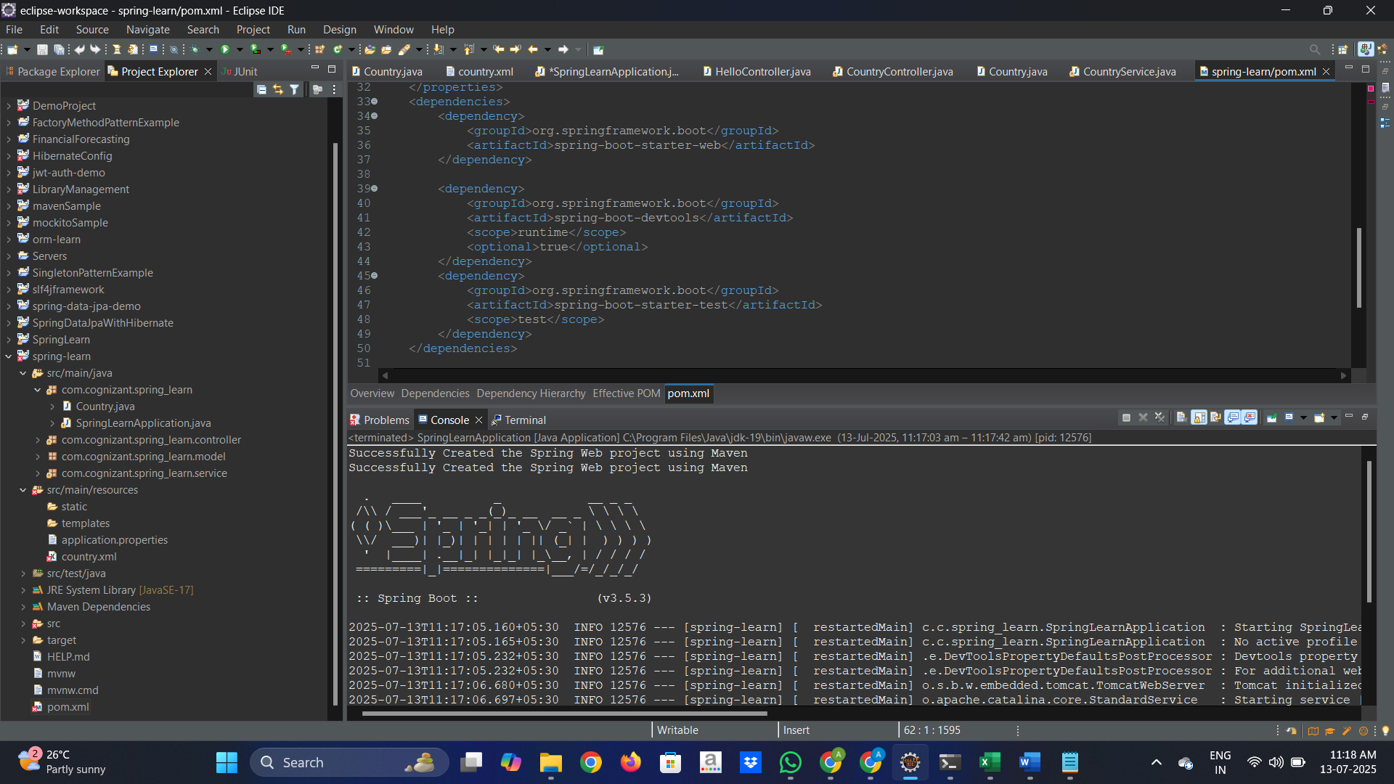

**Hands on 4**

**Spring Core – Load Country from Spring Configuration XML**

**Scenario**

An airlines website is going to support booking on four countries. There will be a drop down on the home page of this website to select the respective country. It is also important to store the two-character ISO code of each country.

**IMPLEMENTATION**

**SpringLearnApplication.java**

package com.cognizant.spring_learn;

import org.springframework.boot.SpringApplication;

import org.springframework.boot.autoconfigure.SpringBootApplication;

import org.springframework.context.annotation.ImportResource;

import org.slf4j.Logger;

import org.slf4j.LoggerFactory;

import org.springframework.context.ApplicationContext;

import org.springframework.context.support.ClassPathXmlApplicationContext;

*@SpringBootApplication*

*@ImportResource*("classpath:country.xml")

public class SpringLearnApplication {

private static final Logger ***LOGGER*** = LoggerFactory.*getLogger*(SpringLearnApplication.class);

public static void main(String[] args) {

System.***out***.println("displayCountry() started");

ApplicationContext context = new ClassPathXmlApplicationContext("country.xml");

System.***out***.println("Spring context loaded");

Country country = context.getBean("country", Country.class) System.***out***.println("Bean loaded: " + country);

}

public static void displayCountry() {

ApplicationContext context = new ClassPathXmlApplicationContext("country.xml");

Country country = context.getBean("country", Country.class);

***LOGGER***.debug("Country : {}", country.toString());

}

}

**Country.java**

package com.cognizant.spring_learn;

import org.slf4j.Logger;

import org.slf4j.LoggerFactory;

public class Country {

private static final Logger ***LOGGER*** = LoggerFactory.*getLogger*(Country.class);

private String code;

private String name;

public Country() {

***LOGGER***.debug("Inside Country Constructor.");

}

public String getCode() {

***LOGGER***.debug("Getting country code: {}", code);

return code;

}

public void setCode(String code) {

***LOGGER***.debug("Setting country code: {}", code);

this.code = code;

}

public String getName() {

***LOGGER***.debug("Getting country name: {}", name);

return name;

}

public void setName(String name) {

***LOGGER***.debug("Setting country name: {}", name);

this.name = name;

}

*@Override*

public String toString() {

return "Country [code=" + code + ", name=" + name + "]";

}

}

**Country.xml**

<?xml version="1.0" encoding="UTF-8"?>

<beans xmlns="http://www.springframework.org/schema/beans"

xmlns:xsi="http://www.w3.org/2001/XMLSchema-instance"

xsi:schemaLocation="http://www.springframework.org/schema/beans

https://www.springframework.org/schema/beans/spring-beans.xsd">

<bean id="country" class="com.cognizant.spring_learn.Country">

<property name="code" value="IN"/>

<property name="name" value="India"/>

</bean> </beans>

**OUTPUT:**

