**HELLO WORLD RESTFUL WEB SERVICE**

**SCENARIO**

Write a REST service in the spring learn application created earlier, that returns the text "Hello World!!" using Spring Web Framework.

**CODE:**

**SpringLearnApplication.java**

package com.cognizant.spring_learn;

import org.springframework.boot.SpringApplication;

import org.springframework.boot.autoconfigure.SpringBootApplication;

import org.springframework.context.annotation.ImportResource;

@SpringBootApplication

@ImportResource("classpath:country.xml")

public class SpringLearnApplication {

public static void main(String[] args) {

SpringApplication.run(SpringLearnApplication.class, args);

}

}

**HelloController.java**

package com.cognizant.spring_learn.controller;

import org.slf4j.Logger;

import org.slf4j.LoggerFactory;

import org.springframework.web.bind.annotation.GetMapping;

import org.springframework.web.bind.annotation.RestController;

@RestController

public class HelloController {

private static final Logger LOGGER=LoggerFactory.getLogger(HelloController.class);

@GetMapping("/hello")

public String sayHello()

{

LOGGER.info("Start Log");

String text="Hello World!!!";

LOGGER.info("End Log");

return text;

}

}

OUTPUT

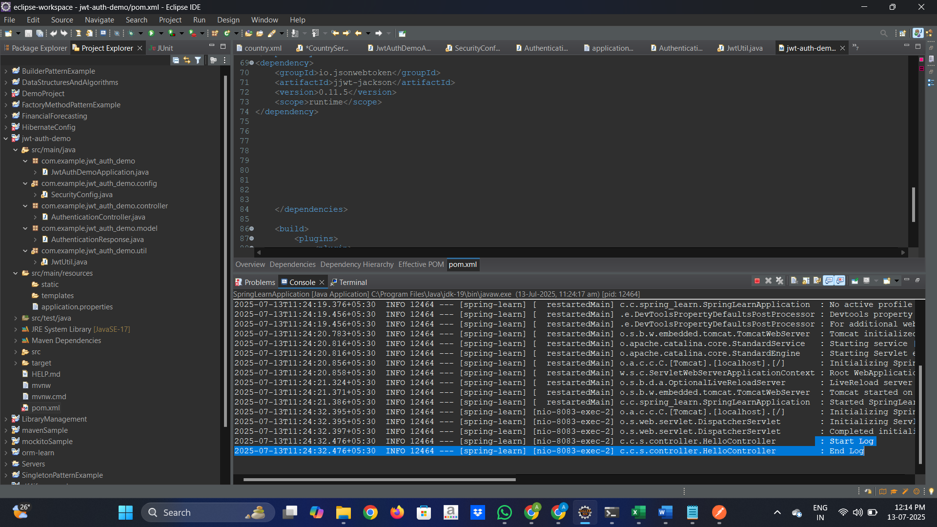

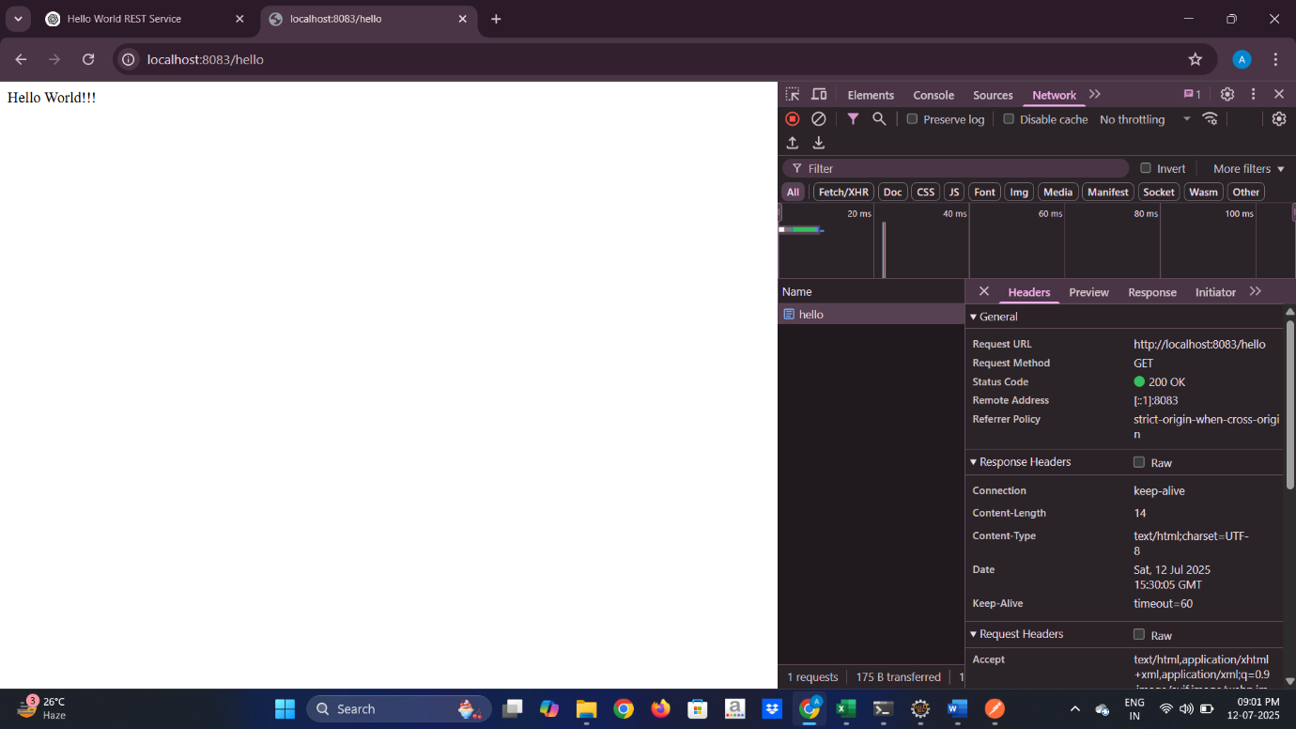

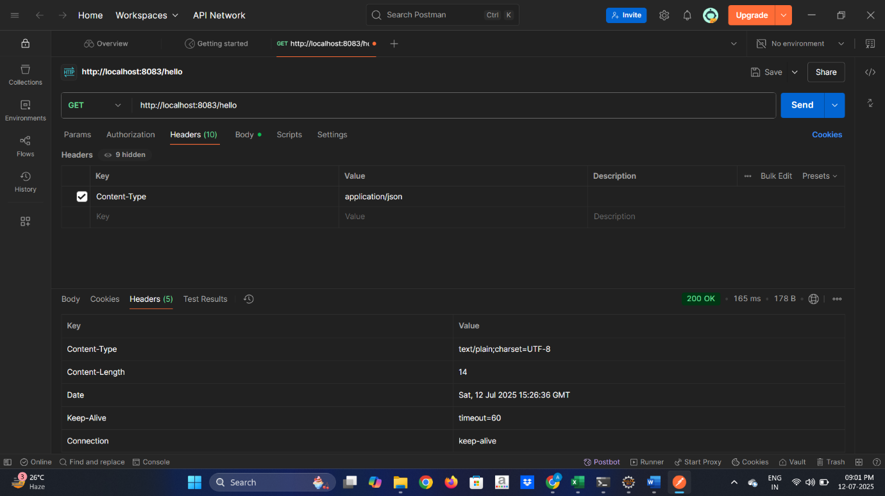

**REST – COUNTRY WEB SERVICE**

**SCENARIO**

Write a REST service that returns India country details in the earlier created spring learn application.

CODE:

country.xml

<?xml version="1.0" encoding="UTF-8"?>

<beans xmlns="http://www.springframework.org/schema/beans"

xmlns:xsi="http://www.w3.org/2001/XMLSchema-instance"

xsi:schemaLocation="http://www.springframework.org/schema/beans

https://www.springframework.org/schema/beans/spring-beans.xsd">

<bean id="in" class="com.cognizant.spring_learn.model.Country">

<property name="code" value="IN"/>

<property name="name" value="India"/>

</bean>

</beans>

**Application.properties**

spring.application.name=spring-learn

server.port=8083

**SpringLearnApplication.java**

package com.cognizant.spring_learn;

import org.springframework.boot.SpringApplication;

import org.springframework.boot.autoconfigure.SpringBootApplication;

import org.springframework.context.annotation.ImportResource;

*@SpringBootApplication*

*@ImportResource*("classpath:country.xml")

public class SpringLearnApplication {

public static void main(String[] args) {

SpringApplication.*run*(SpringLearnApplication.class, args);

}

}

**CountryController.java**

package com.cognizant.spring_learn.controller;

import org.springframework.web.bind.annotation.GetMapping;

import org.springframework.web.bind.annotation.PathVariable;

import org.springframework.web.bind.annotation.RequestMapping;

import org.springframework.web.bind.annotation.RestController;

import com.cognizant.spring_learn.model.Country;

import com.cognizant.spring_learn.service.CountryService;

import org.springframework.beans.factory.annotation.Autowired;

import org.springframework.context.ApplicationContext;

import org.springframework.context.support.ClassPathXmlApplicationContext;

@RestController

public class CountryController {

@Autowired

private CountryService countryService;

@RequestMapping("/country")

public Country getCountryIndia() {

ApplicationContext context = new ClassPathXmlApplicationContext("country.xml");

return (Country) context.getBean("in");

}

}

**Country.java**

package com.cognizant.spring_learn.model;

public class Country {

private String code;

private String name;

public void setCode(String code) {

this.code = code;

}

public String getCode() {

return code;

}

public void setName(String name) {

this.name = name;

}

public String getName() {

return name;

}}

OUTPUT

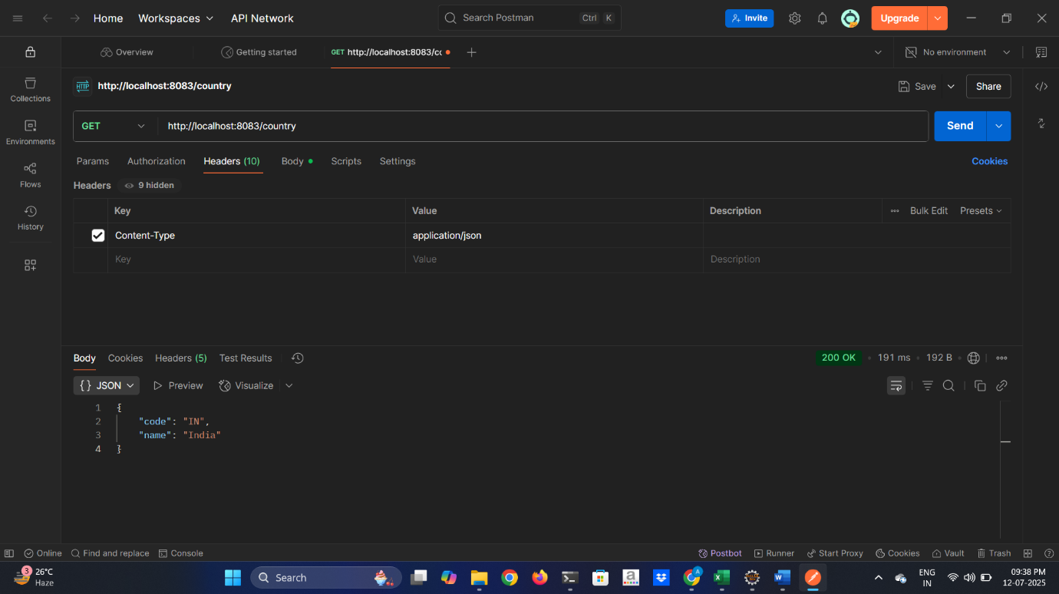

**REST – GET COUNTRY BASED ON COUNTRY CODE** 

**SCENARIO**

Write a REST service that returns a specific country based on country code. The country code should be case insensitive.

**CODE:**

**country.xml**

<?xml version="1.0" encoding="UTF-8"?>

<?xml version="1.0" encoding="UTF-8"?>

<beans xmlns="http://www.springframework.org/schema/beans"

xmlns:xsi="http://www.w3.org/2001/XMLSchema-instance"

xsi:schemaLocation="http://www.springframework.org/schema/beans

https://www.springframework.org/schema/beans/spring-beans.xsd">

<bean id="countryList" class="java.util.ArrayList">

<constructor-arg>

<list>

<bean class="com.cognizant.spring_learn.model.Country">

<property name="code" value="IN"/>

<property name="name" value="India"/>

</bean>

<bean class="com.cognizant.spring_learn.model.Country">

<property name="code" value="US"/>

<property name="name" value="United States"/>

</bean>

<bean class="com.cognizant.spring_learn.model.Country">

<property name="code" value="FR"/>

<property name="name" value="France"/>

</bean>

<bean class="com.cognizant.spring_learn.model.Country">

<property name="code" value="JP"/>

<property name="name" value="Japan"/>

</bean>

</list>

</constructor-arg>

</bean>

</beans>

**Application.properties**

spring.application.name=spring-learn

server.port=8083

**SpringLearnApplication.java**

package com.cognizant.spring_learn;

import org.springframework.boot.SpringApplication;

import org.springframework.boot.autoconfigure.SpringBootApplication;

import org.springframework.context.annotation.ImportResource;

*@SpringBootApplication*

*@ImportResource*("classpath:country.xml")

public class SpringLearnApplication {

public static void main(String[] args) {

SpringApplication.*run*(SpringLearnApplication.class, args);

}

}

**CountryController.java**

package com.cognizant.spring_learn.controller;

import org.springframework.web.bind.annotation.GetMapping;

import org.springframework.web.bind.annotation.PathVariable;

import org.springframework.web.bind.annotation.RequestMapping;

import org.springframework.web.bind.annotation.RestController;

import com.cognizant.spring_learn.model.Country;

import com.cognizant.spring_learn.service.CountryService;

import org.springframework.beans.factory.annotation.Autowired;

import org.springframework.context.ApplicationContext;

import org.springframework.context.support.ClassPathXmlApplicationContext;

@RestController

public class CountryController {

@Autowired

private CountryService countryService;

@GetMapping("/country/{code}")

public Country getCountry(@PathVariable String code) {

return countryService.getCountry(code);

}

}

**Country.java**

package com.cognizant.spring_learn.model;

public class Country {

private String code;

private String name;

public void setCode(String code) {

this.code = code;

}

public String getCode() {

return code;

}

public void setName(String name) {

this.name = name;

}

public String getName() {

return name;

}

}

**CountryService.java**

package com.cognizant.spring_learn.service;

import java.util.List;

import org.springframework.stereotype.Service;

import org.springframework.context.ApplicationContext;

import org.springframework.context.support.ClassPathXmlApplicationContext;

import com.cognizant.spring_learn.model.Country;

@Service

public class CountryService {

public Country getCountry(String code) {

ApplicationContext context = new ClassPathXmlApplicationContext("country.xml");

List<Country> countryList = (List<Country>) context.getBean("countryList");

return countryList.stream()

.filter(c -> c.getCode().equalsIgnoreCase(code))

.findFirst()

.orElse(null);

}

}

OUTPUT

