Solution & Results Report
Financial Fraud Detection & Risk Analysis

Executive Summary
This report documents the complete, executed solution for the Financial Fraud Detection & Risk Analysis project, following every step defined in the Project Requirements Document. The pipeline ingests 3,000 raw transaction records, cleans and quarantines invalid rows, engineers 8 fraud-indicative features, corrects class imbalance with SMOTE, trains and tunes a Random Forest classifier, and produces a scored, star-schema-ready dataset for the Power BI dashboard.
Headline result: on a held-out, untouched test set the tuned model catches 85.7% of fraudulent transactions (recall) while keeping precision at 94.7% — meaning the vast majority of transactions it flags for review are genuinely fraudulent, and the operational review team is not swamped with false alarms.
Metric | Value
Rows ingested | 3,000
Rows quarantined (bad data) | 10 (4 invalid amounts, 6 duplicates)
Clean rows used for modelling | 2,990
Fraud prevalence (true rate) | 3.51%
Test-set recall (fraud caught) @ tuned threshold | 85.7%
Test-set precision @ tuned threshold | 94.7%
ROC-AUC | 0.999
PR-AUC | 0.970

Phase 1 Results — Data Engineering & Feature Engineering

Data Quality
Of the 3,000 raw rows, 10 (0.33%) were quarantined: 4 had non-positive Transaction_Amount values and 6 were exact duplicate transactions. These are preserved in quarantined_fraud_data.csv for audit rather than silently discarded. A small number of missing Distance_From_Home_KM values were imputed using the median for that transaction's Merchant_Category.

Engineered Features
- Age_Group, Transaction_Hour, Is_Weekend, Is_High_Risk_Hour
- Balance_Depletion_Ratio, Amount_to_Balance_Ratio
- Transaction_Risk_Score (0–100 composite penalty score)
- Merchant_Volatility_Index (Coefficient of Variation of spend per merchant category)
Travel and Home Improvement showed the highest spend volatility (CV of 483% and 203% respectively), while Utilities and Healthcare were the most predictable categories — consistent with real-world spending patterns.

Class Imbalance Correction
An 80/20 stratified train/test split was performed first (train: 2,392 rows at 3.47% fraud; test: 598 rows at 3.51% fraud), and SMOTE was fit on the training partition only, raising the training fraud proportion to 28.6% (923 of 3,232 rows) without touching the test set. This keeps the evaluation numbers in the next section honest — the model was never evaluated on synthetic data.

Phase 2 Results — Model Development & Evaluation

Baseline Comparison
A class-weighted Logistic Regression baseline achieved 90.5% recall but only 86.4% precision. The tuned Random Forest was selected to improve precision substantially while keeping recall close to the business target, reducing the false-alarm burden on the fraud review team.

Hyperparameter Tuning
RandomizedSearchCV with 5-fold stratified cross-validation (20 candidate configurations, scored on fraud-class recall) selected: n_estimators=300, max_depth=16, min_samples_leaf=2, max_features='log2', class_weight='balanced'.

Test-Set Evaluation
At the default 0.5 probability cutoff the model is extremely conservative — 100% precision but only 76.2% recall (it misses roughly 1 in 4 fraud cases). Since a missed fraud is materially more costly than a false alarm, the threshold was tuned down.
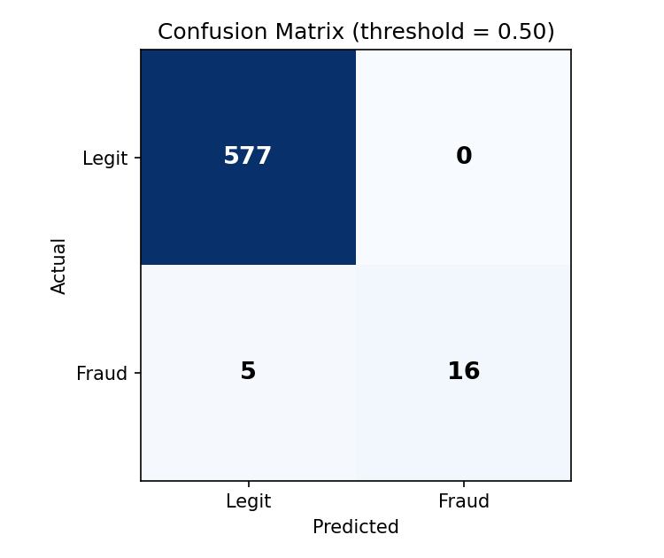
Confusion matrix at the default 0.50 threshold — no false positives, but 5 fraud cases missed.
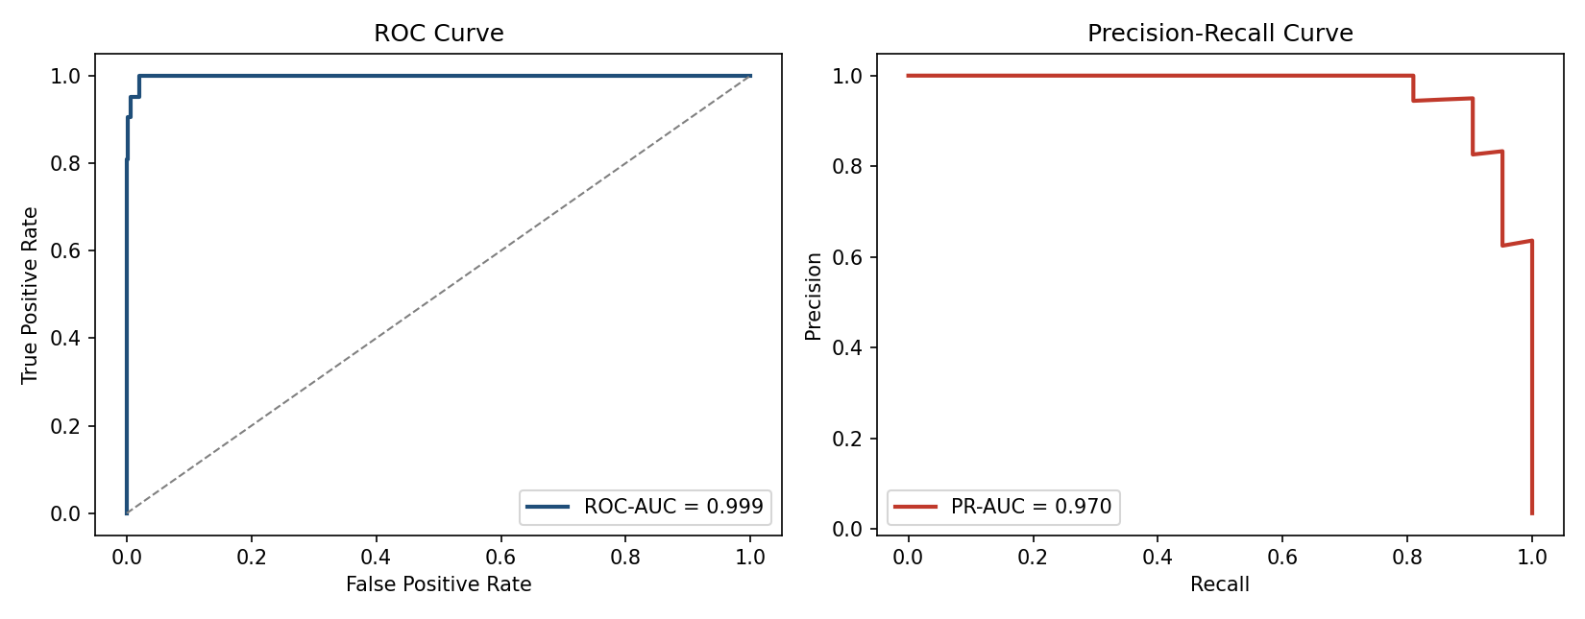
ROC curve (left) and Precision-Recall curve (right) on the held-out test set. PR-AUC is the primary metric given the low fraud base rate.

Feature Importance
Distance from the customer's registered home location is by far the strongest predictor, followed by transaction amount and the engineered Transaction_Risk_Score — validating that the hand-crafted risk features carry real signal on top of the raw fields.
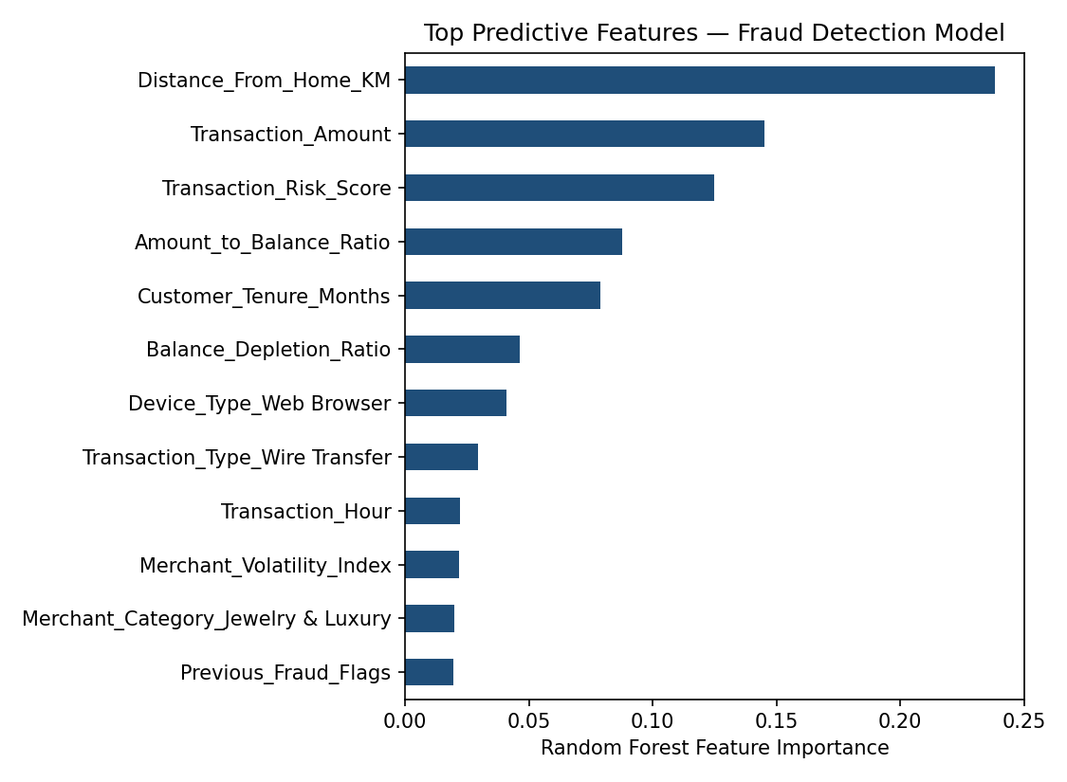
Top 12 features ranked by Random Forest importance.

Decision-Threshold Tuning
Business requirement: catch at least 85% of fraud. Sweeping the classification threshold down from 0.50 to 0.467 achieves 85.7% recall while precision only drops from 100% to 94.7% — a strong trade-off. At this threshold, only 1 legitimate transaction in 598 is incorrectly flagged.
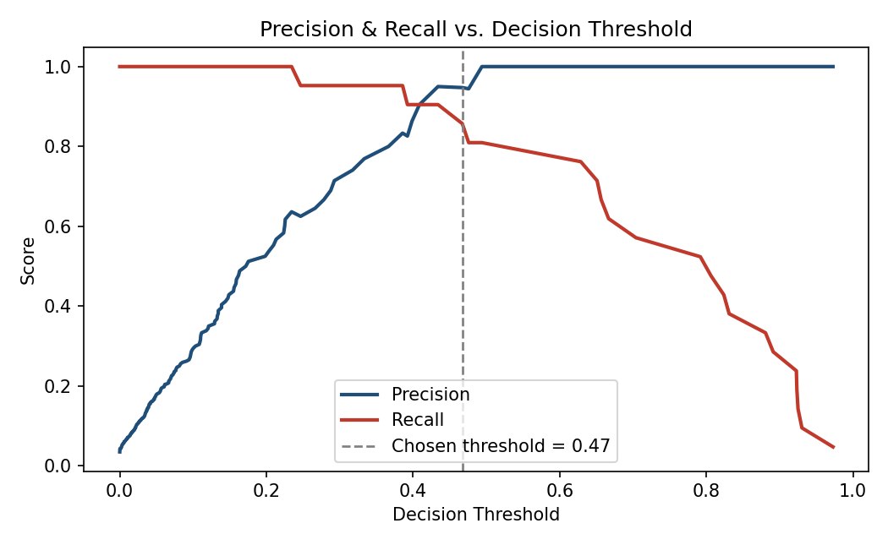
Precision and recall as the decision threshold varies; 0.467 is the chosen operating point.
Threshold | Precision | Recall
0.50 (default) | 100.0% | 76.2%
0.467 (tuned) | 94.7% | 85.7%

Phase 3 — Power BI Dashboard Build Guide
Power BI Desktop is a Windows application and cannot be run or exported to a .pbix file from this environment. The tables below are fully prepared for import — clean, deduplicated, and modelled as a star schema — so the dashboard itself can be assembled directly in Power BI Desktop by following the steps and DAX measures in this section.

1. Import the Star Schema
In Power BI Desktop: Get Data → Text/CSV, and import all four files from the PowerBI_Star_Schema folder:
- Fact_Transactions.csv — one row per transaction (2,990 rows)
- Dim_Customer.csv — one row per customer (1,415 rows)
- Dim_Merchant.csv — one row per merchant category (12 rows)
- Dim_Date.csv — continuous daily calendar spanning the dataset's date range (730 rows), so time-intelligence functions behave correctly even on days with zero transactions

2. Build the Relationships
In Model view, create these active 1-to-Many relationships (dimension → fact):
- Dim_Date[DateKey] → Fact_Transactions[DateKey]
- Dim_Customer[Customer_ID] → Fact_Transactions[Customer_ID]
- Dim_Merchant[Merchant_Category] → Fact_Transactions[Merchant_Category]

3. Core DAX Measures
Create a dedicated measures table (New Table → name it _Measures) and add the following:
Fraud Rate
Fraud Rate = DIVIDE(SUM(Fact_Transactions[Is_Fraud]), COUNTROWS(Fact_Transactions))
Total Fraud Value
Total Fraud Value =
CALCULATE(SUM(Fact_Transactions[Transaction_Amount]), Fact_Transactions[Is_Fraud] = 1)
Average Transaction Risk Score
Avg Risk Score = AVERAGE(Fact_Transactions[Transaction_Risk_Score])
Text Generation Measure (Smart Narrative)
Fraud Narrative =
VAR CurrentRate = [Fraud Rate]
VAR TopMerchant =
CALCULATE(
SELECTEDVALUE(Fact_Transactions[Merchant_Category]),
TOPN(1, VALUES(Fact_Transactions[Merchant_Category]), [Fraud Rate], DESC)
)
RETURN
"For the current selection, " & FORMAT(CurrentRate, "0.0%") &
" of transactions are fraudulent, with " & TopMerchant &
" showing the highest concentration of risk."
Multi-Condition KPI Alert (Red/Critical)
KPI Status =
VAR HighRisk = [Avg Risk Score] > 40
VAR HighFraudRate = [Fraud Rate] > 0.05
RETURN
IF(HighRisk && HighFraudRate, "Critical", IF(HighRisk || HighFraudRate, "Watch", "Normal"))
Bind this measure to a KPI card's conditional-formatting rules so the card only turns red when both conditions are true simultaneously — a single elevated metric should not trigger the alert on its own.
What-If Parameter: Review Threshold
Modelling → New Parameter → Numeric range, named Review Threshold, 0 to 100, increment 1. Power BI creates a Review Threshold[Review Threshold Value] measure automatically. Then add:
Estimated Loss Prevented =
VAR ThresholdPct = [Review Threshold Value] / 100
VAR CaughtValue =
CALCULATE(
SUM(Fact_Transactions[Transaction_Amount]),
Fact_Transactions[Is_Fraud] = 1,
Fact_Transactions[Fraud_Probability] >= ThresholdPct
)
VAR ReviewCost =
CALCULATE(
COUNTROWS(Fact_Transactions),
Fact_Transactions[Is_Fraud] = 0,
Fact_Transactions[Fraud_Probability] >= ThresholdPct
) * 15 -- assumed cost per manual review, adjust to your operations
RETURN
CaughtValue - ReviewCost
Bind the Review Threshold slicer to a card showing Estimated Loss Prevented so analysts can see the trade-off move in real time as they drag the slider — this mirrors the Python decision-threshold analysis in Phase 2.

4. Suggested Visuals
- Time-series line chart: Fraud Rate and Avg Risk Score by Dim_Date[Date]
- Column chart: Fraud Rate by Transaction_Type and by Merchant_Category
- Matrix heatmap: Merchant_Category (rows) × Age_Group (columns), values = Fraud Rate
- Slicers: Transaction_Type, Merchant_Category, Age_Group, Transaction_Country, Dim_Date[Date]
- KPI cards: Fraud Rate, Total Fraud Value, Avg Risk Score — each bound to the KPI Status measure for conditional red/critical formatting

Deliverables & How to Reproduce
Everything below was generated by running the single script Fraud_Detection_Complete_Solution.py against Fraud_Transactions_Data.csv. To reproduce: place both files in the same folder, install the listed dependencies, and run the script — all outputs are regenerated deterministically (fixed random seeds throughout).
- Fraud_Detection_Complete_Solution.py — the full, runnable Phase 1 + Phase 2 + Phase 3-prep pipeline
- quarantined_fraud_data.csv — rows failing data-quality checks
- Fraud_Data_Cleaned_Engineered.csv — clean, feature-engineered base table (2,990 rows)
- Fraud_Data_Scored_Full.csv — base table plus model probability, predicted label, and outcome
- fraud_random_forest_model.joblib — the trained, tuned model
- metrics_summary.json — every evaluation number in one file
- PowerBI_Star_Schema/ — Fact_Transactions, Dim_Customer, Dim_Merchant, Dim_Date, ready to import
- This report — methodology, results, and the Power BI build guide

