
DEPARTMENT OF DATA SCIENCE
[Chandigarh University]
MAJOR PROJECT REPORT

Human Mobility During UK Lockdowns
An End-to-End Data Science Analysis of COVID-19 Community Mobility Patterns
Submitted in partial fulfilment of the requirements for the award of the degree of
Master of Science (Data Science) — MSc (DS)

Submitted By
Akash Sadhukhan
Student Name: ____________________
O24MSD110315
Enrollment No: ____________________
Semester: 4th Semester

Under the Guidance of
Guide/Mentor Name: [Guide Name]

Academic Year: [2026]

Certificate

This is to certify that the project report entitled "Human Mobility During UK Lockdowns" submitted by ____________________ (Enrolment No: ____________________) is a Bonafide record of the project work carried out by the student under my guidance in partial fulfilment of the requirements for the award of the degree of Master of Science (Data Science) at [University Name] during the academic year [Academic Year].
O24MSD110315
Akash Sadhukhan

The project work embodied in this report has not been submitted to any other University or Institution for the award of any degree or diploma.

Guide/Mentor Signature: ____________________
Name: [Guide Name]
Designation: ____________________
Date: ____________________

(Space reserved for official certificate from Qollabb / University — paste here)

Declaration
Akash Sadhukhan
I, ____________________, hereby solemnly declare that the project report titled "Human Mobility During UK Lockdowns" submitted in partial fulfillment of the requirements for the award of the degree of Master of Science (Data Science) — MSc (DS) is my original work.
I further declare that:
- This project has been carried out by me during the academic year [Academic Year] under the supervision of [Guide Name].
- The work has not been submitted previously to any other university, institution, or examination body for the award of any degree, diploma, or certification.
- All sources of information used in this report have been duly acknowledged and referenced in accordance with academic ethics and plagiarism norms.
- The data presented in this report is authentic to the best of my knowledge and has not been fabricated or manipulated.
- I understand that if any part of this declaration is found to be false, my project may be rejected and disciplinary action may be taken as per institutional rules.

Place: ____________________
27/06/2026
Kolkata
Date: ____________________

Student Signature: ____________________
Akash Sadhukhan
Student Name: ____________________
O24MSD110315
Enrolment No: ____________________

Acknowledgement
I would like to express my heartfelt gratitude to all those who have supported and guided me through the completion of this major project.
First and foremost, I am deeply grateful to my guide and mentor, [Guide Name], whose expert guidance, constructive feedback, and constant encouragement proved invaluable at every stage of this project. Their deep knowledge of data science and research methodology helped me navigate complex challenges and think critically about every decision in the analytical pipeline.
I extend my sincere thanks to the faculty members of the Department of Data Science at [University Name], who provided me with a strong academic foundation throughout the course of the MSc programme. Their teaching made it possible for me to apply data science principles to real-world problems effectively.
I am thankful to Google LLC for making the COVID-19 Community Mobility Reports publicly available, without which this project would not have been possible. The open-access nature of this dataset reflects the spirit of open and reproducible science.
I also wish to acknowledge the open-source community behind Python, Pandas, Seaborn, and Jupyter Notebook. These tools enabled me to conduct end-to-end data science analysis without any financial barriers.
Finally, I am deeply grateful to my family and friends for their unwavering moral support, patience, and encouragement throughout the duration of this project and my academic journey.

Akash Sadhukhan
____________________
(Student Name)

Abstract
The COVID-19 pandemic prompted unprecedented public health restrictions across the globe, including a series of nationwide lockdowns in the United Kingdom. These lockdowns fundamentally altered how people moved, worked, and interacted with their environments. Understanding the extent and consistency of behavioural compliance across different lockdown periods is critical for evaluating the effectiveness of public health policy and informing future pandemic preparedness.
This project presents an end-to-end data science analysis of human mobility patterns during the three UK COVID-19 lockdowns (March 2020, November 2020, and January 2021), using Google’s COVID-19 Community Mobility Reports. The dataset captures anonymised, aggregated percentage changes in movement across six place categories: retail and recreation, groceries and pharmacies, parks, transit stations, workplaces, and residential areas, relative to a pre-pandemic baseline.
The analysis follows the complete data science lifecycle, including problem formulation, ethical review, data loading and inspection, data wrangling, exploratory data analysis (EDA), and visualisation. Python was used as the primary programming language, with the Pandas library for data manipulation and the Seaborn library for visualisation, executed within a Jupyter Notebook environment.
Key findings reveal that the first lockdown (March 2020) resulted in the most significant reductions in mobility across nearly all categories, particularly for workplaces, transit stations, and retail locations. Subsequent lockdowns showed comparatively smaller drops, suggesting a combination of public adaptation, essential worker exemptions, and fatigue with restrictions. Residential mobility consistently increased across all three lockdowns. Regional analysis further highlights spatial heterogeneity in compliance, with notable variation across UK counties and districts.
The project demonstrates a reproducible, open-source analytical workflow and provides policy-relevant insights into how human behaviour evolved across the three lockdown phases in the United Kingdom.

Keywords
COVID-19, UK Lockdowns, Human Mobility, Google Community Mobility Reports, Pandas, Seaborn, Exploratory Data Analysis, Time Series Analysis, Data Science Lifecycle, Public Health Policy

Table of Contents
(In Microsoft Word: click here, then go to References → Table of Contents → Automatic Table 1 to auto-generate the full TOC with page numbers.)

Certificate 1
Declaration 1
Acknowledgement 1
Abstract 1
Table of Contents 1
Chapter 1: Introduction 1
1.1 Background and Motivation 1
1.2 Research Question 1
1.3 Data Source 1
1.4 Objectives of the Project 1
1.5 Scope and Limitations 1
1.6 Report Structure 1
Chapter 2: System Study 1
2.1 Literature Review 1
2.1.1 COVID-19 and Human Mobility 1
2.1.2 Google COVID-19 Community Mobility Reports 1
2.1.3 Data Science in Public Health 1
2.2 The Data Science Lifecycle 1
2.2.1 Problem Formulation 1
2.2.2 Data Collection and Understanding 1
2.2.3 Data Ethics and Privacy 1
2.2.4 Data Wrangling and Preprocessing 1
2.2.5 Exploratory Data Analysis (EDA) 1
2.2.6 Analysis and Modelling 1
2.2.7 Communication and Visualisation 1
2.3 Python Ecosystem for Data Science 1
2.3.1 Pandas 1
2.3.2 Seaborn 1
2.3.3 Jupyter Notebook 1
2.4 Existing Systems and Tools 1
Chapter 3: System Analysis 1
3.1 Requirements Analysis 1
3.1.1 Functional Requirements 1
3.1.2 Non-Functional Requirements 1
3.2 Data Understanding 1
3.2.1 Dataset Overview 1
3.2.2 Data Schema 1
3.2.3 Baseline Definition 1
3.2.4 Missing Values 1
3.2.5 Lockdown Period Definitions 1
3.3 Ethical Analysis 1
3.3.1 Privacy and Anonymisation 1
3.3.2 Representation and Fairness 1
3.3.3 Algorithmic Confounding 1
3.3.4 Ethical Framework Summary 1
3.4 Feasibility Analysis 1
3.4.1 Technical Feasibility 1
3.4.2 Operational Feasibility 1
3.4.3 Economic Feasibility 1
Chapter 4: System Design 1
4.1 Overview of the Analytical Architecture 1
4.2 Data Ingestion Design 1
4.2.1 Data Ingestion Design Specification 1
4.3 Data Filtering Design 1
4.4 Data Reshaping Design 1
4.4.1 Wide vs Long Format Comparison 1
4.5 Lockdown Subsetting Design 1
4.6 Aggregation Design 1
4.7 Visualisation Design 1
4.7.1 Visualisation 1: National Workplace Time Series 1
4.7.2 Visualisation 2: All Six Categories — Time Series 1
4.7.3 Visualisation 3: Lockdown Comparison Bar Chart 1
4.7.4 Visualisation 4: Regional Box Plots 1
4.8 Technology Stack Summary 1
Chapter 5: System Implementation 1
5.1 Environment Setup 1
5.1.1 Library Imports 1
5.2 Data Loading 1
5.3 Data Inspection 1
5.3.1 Shape and Column Names 1
5.3.2 Exploring Country Values 1
5.4 Filtering for the United Kingdom 1
5.5 Exploratory Data Analysis 1
5.5.1 Descriptive Statistics 1
5.5.2 Single Category Time Series 1
5.6 Data Wrangling: Wide to Long Format 1
5.7 Visualising All Six Mobility Categories 1
5.8 Lockdown Period Analysis 1
5.8.1 Subsetting the Three Lockdowns 1
5.8.2 Split-Apply-Combine Aggregation 1
5.9 Comparative Visualisation: Three Lockdowns 1
5.10 Regional Analysis: Box Plots by Lockdown 1
Chapter 6: Testing 1
6.1 Testing Strategy 1
6.2 Data Integrity Tests 1
6.2.1 Dataset Shape Verification 1
6.2.2 Date Column Type Verification 1
6.2.3 UK Data Presence 1
6.2.4 Value Range Validation 1
6.3 Code Correctness Tests 1
6.3.1 Filtering Correctness 1
6.3.2 Reshaping Correctness 1
6.3.3 Lockdown Subsetting Correctness 1
6.3.4 Aggregation Correctness 1
6.4 Analytical Validation 1
6.4.1 Cross-Validation Against Published Findings 1
6.5 Visual Output Verification 1
6.6 Reproducibility Testing 1
Chapter 7: Results and Discussion 1
7.1 Overview of Findings 1
7.2 National Mobility Trends by Category 1
7.2.1 Retail and Recreation 1
7.2.2 Groceries and Pharmacies 1
7.2.3 Parks 1
7.2.4 Transit Stations 1
7.2.5 Workplaces 1
7.2.6 Residential 1
7.3 Comparative Analysis Across the Three Lockdowns 1
7.4 Regional Analysis 1
7.5 Discussion 1
Chapter 8: Conclusion and Future Scope 1
8.1 Conclusion 1
8.2 Future Scope 1
8.2.1 Machine Learning Models 1
8.2.2 Causal Inference 1
8.2.3 Data Integration 1
8.2.4 Interactive Dashboard 1
8.2.5 Extended Geographic Scope 1
8.2.6 Equity Analysis 1
Chapter 9: References 1
Chapter 10: Appendices 1
Appendix A: Complete Python Source Code 1
Appendix B: Dataset Schema Reference 1
Appendix C: GitHub Repository 1
Appendix D: Abbreviations and Glossary 1

Chapter 1: Introduction

1.1 Background and Motivation
The COVID-19 pandemic, caused by the SARS-CoV-2 virus, emerged in late 2019 and rapidly evolved into a global public health emergency of unprecedented scale. By March 2020, the World Health Organisation (WHO) had declared COVID-19 a pandemic, prompting governments worldwide to implement extraordinary public health measures. Among these, national lockdowns became the primary tool used to suppress viral transmission by restricting human movement and social interaction.
The United Kingdom implemented three distinct nationwide lockdowns during the course of the pandemic. The first lockdown began on 23 March 2020 and lasted until June 2020, representing the most stringent set of restrictions ever imposed in modern British history. The second lockdown was enforced in England between 5 November and 2 December 2020, and the third lockdown commenced on 5 January 2021, lasting until April 2021.
Each lockdown had different contextual characteristics: the first was driven by urgency and panic, with minimal prior public experience; the second came amid rising case numbers after a summer of relative freedom and was shorter in duration; the third coincided with the emergence of a more transmissible virus variant (the Alpha variant) and the onset of the national vaccination programme. These differing contexts are expected to have produced measurably different human mobility responses, making a comparative analysis both scientifically valuable and policy-relevant.
Measuring human mobility during these periods is essential for understanding the degree to which populations complied with government directives, identifying spatial and temporal patterns of non-compliance, and evaluating the relationship between mobility changes and disease transmission rates. Traditional mobility data sources, such as travel surveys and census records, are too infrequent and too slow to capture rapid behavioural changes. The digitisation of everyday life, however, has given rise to a new generation of large-scale, real-time mobility datasets derived from smartphone usage.

1.2 Research Question
Core Research Question
How has human mobility differed across the three COVID-19 lockdowns in the United Kingdom, and what patterns emerge across mobility categories and geographic regions?

This research question is important for several reasons:
- It concerns the lived experience of millions of UK residents during one of the most disruptive periods of recent history.
- It has direct public health policy relevance, informing the design and communication of future pandemic restrictions.
- It involves the analysis of large-scale real-world data, requiring modern computational tools and data science methodologies.
- It allows for the application of a full data science workflow, from data ingestion to insight communication.

1.3 Data Source
This project uses the Google COVID-19 Community Mobility Reports, a publicly available dataset released by Google LLC in April 2020. The dataset provides daily mobility trends aggregated at the country, region, and sub-region level, derived from anonymised and aggregated location history data from Google Maps users who have opted into Location History.
The data captures percentage changes in visits to and time spent at six categories of places, relative to a pre-pandemic baseline:
- Retail and Recreation: restaurants, cafes, shopping centres, theme parks, museums, libraries, and cinemas.
- Groceries and Pharmacies: grocery markets, food warehouses, farmers markets, specialty food shops, drug stores, and pharmacies.
- Parks: local parks, national parks, public beaches, marinas, dog parks, plazas, and public gardens.
- Transit Stations: public transport hubs including underground, bus, and rail stations.
- Workplaces: places of work.
- Residential: places of residence, measured as duration of time spent rather than visitor count.
The baseline is the median value for the corresponding day of the week during the five-week period from 3 January to 6 February 2020, a period considered to represent pre-pandemic normal movement patterns.

1.4 Objectives of the Project
The principal objectives of this project are as follows:
- To load, inspect, and preprocess the Google COVID-19 Community Mobility dataset for the United Kingdom.
- To conduct exploratory data analysis (EDA) to understand the structure, distribution, and temporal trends in the data.
- To perform a comparative analysis of human mobility across the first, second, and third UK lockdowns across all six mobility categories.
- To visualise regional variation in mobility changes during each lockdown period.
- To draw interpretive conclusions about behavioural compliance and public health policy implications.
- To demonstrate a complete, reproducible, open-source data science workflow using Python and Jupyter Notebook.

1.5 Scope and Limitations
The scope of this project is limited to the United Kingdom and specifically to the three national lockdown periods in 2020 and 2021. The analysis is conducted at national and sub-regional level, using the six mobility categories provided in the Google dataset. No individual-level data is used; all data is aggregated and anonymised.
Limitations of the study include:
- Selection Bias: The dataset represents only Google Maps users who have opted into Location History, which may not be representative of the full UK population. Older adults, those without smartphones, and those in areas with limited connectivity may be underrepresented.
- Google Maps Personalisation: The recommendation and navigation features of Google Maps may introduce algorithmic mobility patterns that reflect app usage rather than true physical movement. This effect is expected to be minor at the geographic scale of analysis.
- Group Fairness: Areas with higher observed mobility during lockdowns may not indicate non-compliance; they may instead reflect higher concentrations of essential workers, lower work-from-home feasibility, or socioeconomic factors.
- Temporal Comparability: Each lockdown differed in duration, legal stringency, and contextual circumstances, which limits direct comparisons of absolute mobility values.

1.6 Report Structure
The remainder of this report is structured as follows:
- Chapter 2: System Study — reviews existing literature on COVID-19 mobility research, the data science lifecycle, and key Python libraries.
- Chapter 3: System Analysis — presents detailed requirements analysis, data understanding, and the ethical framework governing the research.
- Chapter 4: System Design — describes the computational architecture, data pipeline design, and analytical framework.
- Chapter 5: System Implementation — provides the full documented Python code, data wrangling steps, and visualisation outputs.
- Chapter 6: Testing — covers data validation, code testing, and result verification.
- Chapter 7: Results and Discussion — presents and interprets the key findings of the analysis.
- Chapter 8: Conclusion and Future Scope — summarises conclusions and proposes directions for future research.
- Chapter 9: References — lists all sources cited in this report.
- Chapter 10: Appendices — includes supplementary code, data schema, and dashboard screenshots.

Chapter 2: System Study

2.1 Literature Review

2.1.1 COVID-19 and Human Mobility
The intersection of infectious disease epidemiology and human mobility has long been a focus of academic inquiry. Prior to the COVID-19 pandemic, researchers had used mobile phone call records, GPS traces, and social media check-in data to model the spatial spread of influenza and other respiratory illnesses (Gonzalez et al., 2008; Wesolowski et al., 2012). These studies established that population-level mobility patterns are strongly predictive of disease transmission dynamics.
The COVID-19 pandemic dramatically accelerated the use of large-scale mobility data for public health. A landmark study by Kraemer et al. (2020) published in Science demonstrated that human mobility data from Baidu Maps could predict the spatial spread of SARS-CoV-2 across Chinese cities before and after the Wuhan lockdown. They found that mobility restrictions reduced the growth rate of the epidemic by approximately 37% in the two weeks following their implementation.
In the European context, Flaxman et al. (2020) used a Bayesian hierarchical model incorporating Google mobility data to estimate the impact of non-pharmaceutical interventions (NPIs) across 11 European countries. Their model suggested that lockdowns were the single most effective NPI, accounting for the majority of reductions in R (the effective reproduction number). However, this claim has been contested, with subsequent analyses arguing that voluntary behavioural changes preceding formal lockdowns accounted for much of the mobility decline.
For the UK specifically, research using the REACT-2 study (Ward et al., 2021), the ONS Coronavirus Infection Survey, and various mobility datasets has shown that lockdowns correlated with large reductions in SARS-CoV-2 prevalence. However, the magnitude of mobility reduction was not uniform across regions, social groups, or occupational categories. Milsom et al. (2021) showed that regions with higher proportions of essential workers and those with lower socioeconomic status had consistently higher mobility during lockdowns, suggesting inequality in the burden of compliance.

2.1.2 Google COVID-19 Community Mobility Reports
Google released the Community Mobility Reports in April 2020 as a free public resource to aid public health authorities and researchers. The dataset has since been used in hundreds of peer-reviewed publications across epidemiology, public health, economics, and social science. Bergman et al. (2020) used the Google mobility data to validate self-reported compliance surveys, finding strong correlations between reported behaviour and measured mobility changes. This strengthened confidence in the dataset as a reliable proxy for population-level behavioural compliance.
Sulyok and Walker (2020) analysed Google mobility data alongside COVID-19 case and death statistics across multiple European countries, finding that a 10% reduction in retail and recreation mobility was associated with a 12% reduction in COVID-19 deaths 21 days later. Such findings highlight the direct policy relevance of mobility analysis.
Limitations of the Google mobility data have also been documented. Chen et al. (2020) noted that the data exhibits temporal smoothing and noise, and that the baseline period (January–February 2020) may not perfectly reflect ‘normal’ behaviour in all regions. Privacy-related aggregation means that data is suppressed for small regions, reducing geographic resolution. Despite these limitations, the Google Community Mobility Reports remain one of the most widely used and accessible mobility datasets for COVID-19 research.

2.1.3 Data Science in Public Health
The application of data science methods to public health has grown substantially over the past decade. The emergence of ‘computational social science’ (Lazer et al., 2009) introduced new possibilities for studying human behaviour at scale using digital traces. Data science provides a systematic framework for extracting actionable insights from large, complex datasets using statistical analysis, machine learning, and visualisation.
Within public health, data science approaches have been applied to disease surveillance (Brownstein et al., 2009), healthcare resource allocation (Obermeyer and Emanuel, 2016), and vaccine hesitancy monitoring (Sharma et al., 2021). The COVID-19 pandemic became a watershed moment for the field, with mobility data, social media analysis, wastewater epidemiology, and genomic sequencing all being integrated into national public health surveillance systems.

2.2 The Data Science Lifecycle
This project follows the CRISP-DM (Cross Industry Standard Process for Data Mining) inspired data science lifecycle, which provides a structured framework for conducting data science projects from initial problem formulation through to result communication and deployment. The lifecycle consists of the following phases:

2.2.1 Problem Formulation
The data science process begins with defining a clear, specific, and answerable research question. A well-formulated question guides all subsequent decisions about data, methodology, and analysis. For this project, the question is: How has human mobility differed across the three COVID-19 lockdowns in the United Kingdom?

2.2.2 Data Collection and Understanding
Once the research question is defined, appropriate data must be identified, collected, and understood. This involves examining the data’s structure, provenance, and limitations. Crucially, it requires considering how the data was generated — what processes, systems, or human behaviours produced the observations, and whether those processes align with the conceptual constructs the researcher is trying to measure.

2.2.3 Data Ethics and Privacy
Ethical review is an essential component of any data science project involving human subjects or data that could affect individuals or communities. Even when using publicly available, anonymised datasets, researchers must consider questions of informed consent, potential for misuse, fairness, and representativeness.

2.2.4 Data Wrangling and Preprocessing
Real-world data is rarely clean or ready for analysis. Data wrangling involves transforming raw data into a structured format suitable for analysis. This may include handling missing values, reshaping data structures, creating derived variables, and filtering for the relevant subset of data.

2.2.5 Exploratory Data Analysis (EDA)
EDA is the process of using statistical summaries and visualisations to understand patterns, distributions, and relationships in the data before applying formal analytical or predictive models. EDA is an iterative, creative process that guides the analyst towards the most meaningful questions to pursue in depth.

2.2.6 Analysis and Modelling
Depending on the research question, this phase may involve descriptive statistics, inferential statistics, machine learning models, or causal inference methods. For this project, the analysis is primarily descriptive and comparative, using grouped statistics and multi-panel visualisations to compare mobility across lockdowns and regions.

2.2.7 Communication and Visualisation
The final phase involves presenting findings in a clear, accessible, and honest manner. Visualisation is a powerful tool for communicating complex patterns, but it must be done carefully to avoid misleading representations.

2.3 Python Ecosystem for Data Science
Python has become the dominant programming language for data science due to its readability, flexibility, extensive library ecosystem, and strong community support. This project makes use of two core Python libraries:

2.3.1 Pandas
Pandas is an open-source Python library for data manipulation and analysis, built on top of the NumPy array library. Its primary data structures are the Series (one-dimensional labelled array) and DataFrame (two-dimensional labelled table). Pandas provides comprehensive tools for:
- Reading data from CSV, Excel, SQL, JSON, and other formats using functions like read_csv(), read_excel(), and read_sql().
- Indexing and selecting data using .loc[], .iloc[], and boolean indexing.
- Handling missing data with methods like dropna(), fillna(), and isna().
- Reshaping and restructuring data using melt(), pivot(), stack(), and unstack().
- Grouping and aggregating data with groupby() and agg().
- Merging and joining datasets with merge() and concat().
For this project, Pandas is used to load the Google Mobility dataset, filter for UK data, reshape from wide to long format, subset the lockdown periods, and compute grouped statistics.

2.3.2 Seaborn
Seaborn is a Python data visualisation library built on top of Matplotlib, providing a high-level interface for drawing attractive and informative statistical graphics. Seaborn is particularly well-suited for visualising structured data stored in Pandas DataFrames. Key Seaborn functions used in this project include:
- relplot(): Creates relational plots, including line plots, scatter plots, and faceted multi-panel charts. Used for time series visualisation of mobility trends.
- catplot(): Creates categorical plots, including bar plots, box plots, and violin plots. Used for comparing mobility distributions across lockdowns and regions.
- set_theme(): Configures the aesthetic theme, context, and colour palette for all subsequent plots.

2.3.3 Jupyter Notebook
Jupyter Notebook (and Google Colaboratory, its cloud-based implementation) is an interactive computational environment that allows researchers to combine live code, explanatory text, mathematical equations, and visualisations in a single shareable document. The notebook format supports the principle of literate programming (Knuth, 1984) and is widely recognised as a cornerstone of reproducible data science workflows.
For this project, the Jupyter Notebook serves as the primary computational environment, integrating all stages of the analysis in a single document that can be fully reproduced by any reader with access to a Python environment and an internet connection.

2.4 Existing Systems and Tools
Category | Tool / Resource
Programming Language | Python 3.x
Data Manipulation | Pandas 2.x
Visualisation | Seaborn 0.13.x
Development Environment | Jupyter Notebook / Google Colab
Data Source | Google COVID-19 Community Mobility Reports (CSV)
Version Control | GitHub
Documentation | Markdown within Jupyter Notebook

Chapter 3: System Analysis

3.1 Requirements Analysis

3.1.1 Functional Requirements
The functional requirements define what the system (analytical pipeline) must be able to do. These are derived from the research objectives and the constraints imposed by the data and tools:
- Data Loading: The system must be able to load the Google COVID-19 Community Mobility dataset from a remote URL without requiring the user to download the file locally.
- Data Filtering: The system must be able to filter the dataset to include only rows pertaining to the United Kingdom.
- Data Inspection: The system must be able to display the shape, column names, data types, and sample rows of the dataset.
- Descriptive Statistics: The system must be able to compute descriptive statistics (mean, median, standard deviation, quartiles) for any specified date or date range.
- Data Reshaping: The system must be able to reshape the data from wide format (one column per mobility category) to long format (one column for all categories) to enable multi-category visualisation.
- Date Subsetting: The system must be able to subset the data to specific date ranges corresponding to each lockdown period.
- Aggregation: The system must be able to group data by lockdown period and mobility category, and compute mean values for each group.
- Time Series Visualisation: The system must be able to produce time series line plots of mobility trends over the full observation period.
- Comparative Visualisation: The system must be able to produce bar charts comparing mean mobility across the three lockdowns for all six categories simultaneously.
- Regional Visualisation: The system must be able to produce box plots showing the distribution of mobility changes across UK regions (sub_region_1) for each lockdown.

3.1.2 Non-Functional Requirements
Non-functional requirements specify the quality attributes and constraints of the system:
- Reproducibility: The analysis must be fully reproducible by any person with access to a Python environment and an internet connection, without any manual preprocessing steps.
- Readability: The code must be clearly commented and organised, following Python best practices (PEP 8 style guide).
- Portability: The notebook must run without modification on both local Jupyter installations and Google Colab.
- Scalability: The data pipeline must handle the full global dataset (millions of rows) before filtering, demonstrating performance appropriate for large data analysis.
- Openness: All tools and data used must be open-source and freely available.

3.2 Data Understanding

3.2.1 Dataset Overview
The Google COVID-19 Community Mobility Reports dataset is provided as a single global CSV file. As of mid-2022, the dataset contains approximately 3 million rows, representing daily mobility measurements for approximately 135 countries and their sub-regions. For the United Kingdom, the dataset contains national-level data as well as data disaggregated to county and district level (sub_region_1 and sub_region_2).

3.2.2 Data Schema
Column Name | Description
country_region_code | ISO 3166-1 alpha-2 country code (e.g., GB for United Kingdom)
country_region | Full country name (e.g., United Kingdom)
sub_region_1 | State, province, or county (e.g., England, Wales, or specific county)
sub_region_2 | City, district, or borough within sub_region_1
metro_area | Metropolitan area name (where applicable)
iso_3166_2_code | ISO 3166-2 subdivision code
census_fips_code | US-specific FIPS code (null for UK)
place_id | Google Place ID
date | Date of observation (YYYY-MM-DD format)
retail_and_recreation_percent_change_from_baseline | % change vs baseline for retail & recreation
grocery_and_pharmacy_percent_change_from_baseline | % change vs baseline for grocery & pharmacy
parks_percent_change_from_baseline | % change vs baseline for parks
transit_stations_percent_change_from_baseline | % change vs baseline for transit stations
workplaces_percent_change_from_baseline | % change vs baseline for workplaces
residential_percent_change_from_baseline | % change vs baseline for residential

3.2.3 Baseline Definition
Baseline Specification
The baseline for percentage change calculations is the median value for each day of the week during the 5-week reference period from 3 January to 6 February 2020. A value of -50% on a Monday means that visits were 50% lower than the median value for Mondays in the baseline period. The baseline is computed separately for each geographic region and each mobility category.

3.2.4 Missing Values
The dataset contains missing values (NaN) in the mobility columns for several reasons:
- Privacy threshold: Google suppresses data when the number of visitors in a region is too small to guarantee anonymity. This disproportionately affects rural areas and smaller sub-regions.
- Data quality: For some regions and dates, sufficient data was not available to compute a reliable percentage change.
In this project, missing values are handled by the dropna() method applied after the melt() reshaping step, ensuring that only complete observations are included in the analysis.

3.2.5 Lockdown Period Definitions
Lockdown | Analysis Period (First 3 Weeks)
Lockdown 1 (England) | 24 March 2020 – 13 April 2020
Lockdown 2 (England) | 5 November 2020 – 25 November 2020
Lockdown 3 (England) | 6 January 2021 – 26 January 2021

The first three weeks of each lockdown are selected for comparison to ensure temporal equivalence and to focus on the period of maximum behavioural adjustment, before the gradual relaxation or confusion that often characterised later lockdown stages.

3.3 Ethical Analysis

3.3.1 Privacy and Anonymisation
The Google COVID-19 Community Mobility Reports are derived from the location history of Google Maps users who have voluntarily opted into this service. Google applies differential privacy techniques to ensure that no individual can be identified from the published aggregates. Data for regions with insufficient population coverage is suppressed to prevent re-identification. Consequently, this dataset carries low individual privacy risk for researchers who use it.
However, researchers using this data have an ethical obligation to use it only for beneficial purposes, to acknowledge its provenance, and not to attempt to re-identify individuals through triangulation with other datasets.

3.3.2 Representation and Fairness
A key ethical concern with smartphone-derived mobility data is that it may not represent all segments of the population equally. Individuals who are elderly, economically disadvantaged, or living in areas with poor digital infrastructure may be systematically underrepresented. This means that mobility patterns in low-income areas or rural communities may be based on smaller samples, potentially introducing bias into comparative analyses.
Group fairness is another significant concern. Regions that show higher mobility during lockdowns should not automatically be interpreted as less compliant. Higher mobility in certain areas may reflect the concentration of essential workers (e.g., healthcare, food supply, public transport workers), who were legally permitted — and indeed required — to continue working during lockdowns. Socioeconomic factors, including housing density, access to outdoor space, and work-from-home feasibility, also strongly influence mobility.

3.3.3 Algorithmic Confounding
The personalised recommendation and navigation features of Google Maps create feedback loops between the platform’s suggestions and observed mobility. If Google Maps directs users towards certain locations, the resulting visits are recorded in the mobility data, potentially conflating organic mobility with algorithmically induced movement. At the geographic scale of counties and districts, this effect is expected to be negligible, but it is a theoretically important limitation to acknowledge.

3.3.4 Ethical Framework Summary
Ethical Dimension | Assessment
Individual Privacy Risk | Low — data is aggregated and anonymised
Group Fairness Risk | Moderate — essential workers may inflate mobility metrics
Representation Bias | Moderate — smartphone users only; elderly/low-income may be underrepresented
Algorithmic Confounding | Low — effect is minimal at county/district level
Data Access Ethics | Acceptable — publicly available, intended for research use
Misuse Risk | Low — no individual identification possible from aggregates

3.4 Feasibility Analysis

3.4.1 Technical Feasibility
The project is technically feasible using free, open-source tools. Python, Pandas, Seaborn, and Jupyter Notebook are all freely available. The Google Mobility dataset is publicly accessible. Google Colab provides a free cloud-based environment that eliminates the need for local hardware. The computational requirements (data loading, filtering, reshaping, and visualisation) are well within the capabilities of a standard laptop or free-tier cloud environment.

3.4.2 Operational Feasibility
The analysis is structured as a self-contained Jupyter Notebook that can be executed end-to-end by running all cells in sequence. This makes the analysis operationally straightforward for any user familiar with Jupyter or Google Colab. The code is modular and well-commented, supporting understanding and modification.

3.4.3 Economic Feasibility
All tools, data, and infrastructure used in this project are entirely free of cost. This supports the principle of accessible and inclusive data science, particularly relevant for academic research in resource-limited settings.

Chapter 4: System Design

4.1 Overview of the Analytical Architecture
The system is designed as a linear, reproducible data science pipeline implemented within a Jupyter Notebook. Each stage of the pipeline takes input from the previous stage and produces output that feeds into the next. The pipeline is designed to be executed top-to-bottom in a single session, with no manual intermediate steps required.
The high-level architecture can be represented as the following sequential stages:
1. Data Ingestion | → | 2. Filtering & EDA | → | 3. Reshaping | → | 4. Subsetting | → | 5. Visualisation

4.2 Data Ingestion Design
The data ingestion module is responsible for loading the Google COVID-19 Community Mobility Reports dataset from its official public URL into a Pandas DataFrame. The design priorities are:
- Direct URL loading without local file dependency, maximising portability.
- Automatic date parsing to convert the date column from string to datetime format, enabling time-based filtering and plotting.
- Assignment to a clearly named variable (mobility_trends) to facilitate subsequent operations.

4.2.1 Data Ingestion Design Specification
# DESIGN SPECIFICATION: Data Ingestion Module
# Input: URL of Google COVID-19 Community Mobility Reports CSV
# Output: pandas DataFrame with date column parsed as datetime
# Method: pd.read_csv() with parse_dates parameter

mobility_trends = pd.read_csv(
"https://www.gstatic.com/covid19/mobility/Global_Mobility_Report.csv",
parse_dates=["date"],
)

The dataset loaded at runtime reflects the most recent version available from Google, ensuring that the analysis always uses up-to-date data. For reproducibility in a fixed research context, a specific archived version of the dataset should be used, with the download date documented.

4.3 Data Filtering Design
The filtering module isolates UK data from the global dataset. The design uses boolean indexing, a core Pandas operation that creates a boolean mask identifying rows where a condition is True, and applies that mask to select the matching rows.
# DESIGN SPECIFICATION: Filtering Module
# Input: Global mobility DataFrame (mobility_trends)
# Output: UK-only DataFrame (mobility_trends_UK)
# Method: Boolean indexing on country_region column

mobility_trends_UK = mobility_trends[
mobility_trends["country_region"] == "United Kingdom"
]

The filtered dataset retains all original columns and includes both national-level rows (where sub_region_1 and sub_region_2 are NaN) and regional rows (where sub_region_1 and sub_region_2 identify specific counties and districts). This design allows the same filtered dataset to serve both national and regional analyses.

4.4 Data Reshaping Design
The reshaping module transforms the data from wide format (six separate columns for mobility categories) to long format (a single column for category name and a single column for value). This transformation is necessary to enable Seaborn’s faceting and hue-based multi-category visualisations.

4.4.1 Wide vs Long Format Comparison
Wide Format | Long Format
One row per region per date | One row per region per date per mobility category
15 columns (incl. 6 mobility) | 12 columns (incl. variable and value)
Suitable for category-by-category analysis | Suitable for multi-category faceted plots
Cannot use hue= for category colouring | Enables hue="variable" in Seaborn

# DESIGN SPECIFICATION: Reshaping Module
# Input: Wide-format UK DataFrame (mobility_trends_UK)
# Output: Long-format UK DataFrame (mobility_trends_UK_long)
# Method: pd.melt() with id_vars and value_vars; dropna() to remove nulls

mobility_trends_UK_long = pd.melt(
mobility_trends_UK,
id_vars=mobility_trends_UK.columns[[1, 2, 8]], # country, sub_region_1, date
value_vars=mobility_trends_UK.columns[9:15], # 6 mobility categories
).dropna()

4.5 Lockdown Subsetting Design
The subsetting module creates separate DataFrames for each of the three lockdown periods, covering the first three weeks of each lockdown for comparability. Boolean chaining with the & operator is used to combine date range conditions.
# DESIGN SPECIFICATION: Lockdown Subsetting Module
# Lockdown 1: 24 March 2020 – 13 April 2020
# Lockdown 2: 05 November 2020 – 25 November 2020
# Lockdown 3: 06 January 2021 – 26 January 2021

lockdown1 = mobility_trends_UK_long[
(mobility_trends_UK_long["date"] >= "2020-03-24")
& (mobility_trends_UK_long["date"] <= "2020-04-13")
]

# Three DataFrames then concatenated with pd.concat()
lockdowns = pd.concat(
[lockdown1, lockdown2, lockdown3], keys=["lockdown1", "lockdown2", "lockdown3"]
).reset_index()

4.6 Aggregation Design
The aggregation module computes mean mobility values for each combination of lockdown period and mobility category, using the Pandas groupby()-apply pattern (Split-Apply-Combine):
- Split: Partition the concatenated lockdowns DataFrame by lockdown label and mobility category.
- Apply: Compute the mean of the value column for each partition.
- Combine: Reassemble the results into a single Series indexed by lockdown and category.
# Mean mobility by lockdown and category
lockdowns.groupby(["level_0", "variable"], sort=False)["value"].mean()

4.7 Visualisation Design

4.7.1 Visualisation 1: National Workplace Time Series
A line plot of workplace mobility change across the full observation period provides an overview of the temporal dynamics of lockdown impacts. This visualisation uses relplot() with kind='line'.

4.7.2 Visualisation 2: All Six Categories — Time Series
A faceted multi-panel line plot presents the time series for all six mobility categories simultaneously, using col='variable' and col_wrap=2 for a 2-column layout. sharey=False allows each panel to use an independent y-axis, ensuring that categories with different absolute magnitudes of change (e.g., parks vs workplaces) can be clearly visualised.

4.7.3 Visualisation 3: Lockdown Comparison Bar Chart
A grouped bar chart (catplot with kind='bar') displays the mean mobility change for all six categories across the three lockdowns side by side. The hue='variable' parameter colour-codes each mobility category, and col='level_0' creates separate panels for each lockdown. 99% confidence intervals are displayed to indicate the variability of observations within each group.

4.7.4 Visualisation 4: Regional Box Plots
Three box plots (one per lockdown) show the distribution of mobility changes across UK regions (sub_region_1) for each mobility category. The catplot with kind='box' and y='sub_region_1' produces a horizontal box plot for each region, with separate panels for each category. These plots reveal the spatial heterogeneity in mobility responses within the UK.

4.8 Technology Stack Summary
Component | Technology / Tool
Programming language | Python 3.x
Data loading | pandas.read_csv() with URL and parse_dates
Data filtering | Pandas boolean indexing
Data reshaping | pandas.melt() + .dropna()
Data aggregation | pandas.groupby() + .mean()
Time series visualisation | seaborn.relplot() with kind='line'
Comparative visualisation | seaborn.catplot() with kind='bar'
Regional visualisation | seaborn.catplot() with kind='box'
Development environment | Jupyter Notebook / Google Colab
Code versioning | GitHub

Chapter 5: System Implementation

5.1 Environment Setup
The implementation is carried out in Google Colaboratory (Colab), a cloud-hosted Jupyter Notebook environment that requires no local installation. Colab provides free access to CPU runtime with Python 3 pre-installed, along with Pandas, Seaborn, and all other required libraries. The analysis can alternatively be run in a local Jupyter Notebook installation.

5.1.1 Library Imports
The first implementation step is importing the required libraries. By convention, Pandas is imported with the alias pd and Seaborn with the alias sns:
# Step 1: Import required libraries
import pandas as pd
import seaborn as sns

# Enable inline matplotlib rendering in Jupyter
%matplotlib inline

# Set the Seaborn visual theme
sns.set_theme(
context="notebook",
style="darkgrid",
palette="pastel",
font_scale=1.5
)

The sns.set_theme() call configures global aesthetics for all subsequent plots. context='notebook' adjusts font sizes for notebook display. style='darkgrid' adds a light grey grid for readability. palette='pastel' uses soft colours suitable for academic publication. font_scale=1.5 increases the default font size for legibility.

5.2 Data Loading
The dataset is loaded directly from Google’s official data repository using the Pandas read_csv() function. The parse_dates parameter ensures that the date column is automatically converted from string format to Pandas datetime objects, enabling date arithmetic and time-based filtering:
# Step 2: Load the Google COVID-19 Community Mobility Reports
mobility_trends = pd.read_csv(
"https://www.gstatic.com/covid19/mobility/Global_Mobility_Report.csv",
parse_dates=["date"],
)

# Inspect the loaded data
print(f'Dataset shape: {mobility_trends.shape}')
print(f'Date range: {mobility_trends["date"].min()} to {mobility_trends["date"].max()}')
mobility_trends.head(5)

Upon loading, the global dataset typically contains approximately 3 million rows and 15 columns, representing 135+ countries across a date range spanning from February 2020 to mid-2022. The .head(5) call displays the first five rows, confirming the structure of the data.

5.3 Data Inspection

5.3.1 Shape and Column Names
# Step 3: Inspect data structure
print('Shape:', mobility_trends.shape)
print('\nColumn names:')
print(mobility_trends.columns.tolist())
print('\nData types:')
print(mobility_trends.dtypes)

5.3.2 Exploring Country Values
Before filtering, we verify that "United Kingdom" appears in the country_region column and inspect its unique values:
# Check unique country values and confirm UK is present
'United Kingdom' in mobility_trends["country_region"].unique()

# Count how many rows relate to the UK
print(
mobility_trends[mobility_trends["country_region"] == "United Kingdom"].shape
)

5.4 Filtering for the United Kingdom
The global dataset is filtered to create a UK-specific DataFrame using boolean indexing. The result is assigned to mobility_trends_UK:
# Step 4: Filter for United Kingdom
mobility_trends_UK = mobility_trends[
mobility_trends["country_region"] == "United Kingdom"
]

print(f'UK dataset shape: {mobility_trends_UK.shape}')
mobility_trends_UK.head()

The resulting UK DataFrame retains all 15 columns but contains only rows where country_region equals 'United Kingdom'. This includes national-level aggregate rows (where sub_region_1 and sub_region_2 are NaN) and rows for individual counties and districts.

5.5 Exploratory Data Analysis

5.5.1 Descriptive Statistics
We compute descriptive statistics to understand the distribution of mobility changes at key dates. The first day of each lockdown is used as a reference point:
# Descriptive statistics for the first day of Lockdown 1
lockdown1_start = mobility_trends_UK[mobility_trends_UK["date"] == "2020-03-24"]
lockdown1_start.describe()

# Descriptive statistics for the first day of Lockdown 3
lockdown3_start = mobility_trends_UK[mobility_trends_UK["date"] == "2021-01-06"]
lockdown3_start.describe()

These descriptive tables reveal the central tendency, variability, and range of mobility changes across all UK regions on the first day of each lockdown. Comparing the two tables highlights differences in the magnitude of the initial mobility shock between lockdowns.

5.5.2 Single Category Time Series
Before reshaping the data to long format, we visualise the workplace mobility time series to get an initial sense of the temporal dynamics:
# Time series of workplace mobility for the full UK dataset
sns.relplot(
x="date",
y="workplaces_percent_change_from_baseline",
height=5,
aspect=3,
kind="line",
lw=3,
data=mobility_trends_UK,
)

This plot reveals a sharp drop in workplace mobility in late March 2020 (Lockdown 1), a smaller but still visible dip in November 2020 (Lockdown 2), a further dip in January 2021 (Lockdown 3), and a gradual recovery as restrictions eased and the vaccination rollout progressed.

5.6 Data Wrangling: Wide to Long Format
The Pandas melt() function is used to reshape the dataset from wide format to long format. This transformation is essential for Seaborn’s faceting capabilities, which require all category values to be in a single column:
# Step 5: Reshape from wide to long format
mobility_trends_UK_long = pd.melt(
mobility_trends_UK,
id_vars=mobility_trends_UK.columns[[1, 2, 8]],
# Index 1: country_region
# Index 2: sub_region_1
# Index 8: date
value_vars=mobility_trends_UK.columns[9:15],
# Indices 9-14: six mobility category columns
).dropna()
# dropna() removes rows where the mobility value is NaN (privacy suppression)

print(f'Long format shape: {mobility_trends_UK_long.shape}')
mobility_trends_UK_long.head(10)

After reshaping, the DataFrame has three core columns: country_region, sub_region_1, date, variable (mobility category name), and value (percentage change). Each original row in wide format is expanded into six rows in long format, one for each mobility category. The dropna() step removes rows where the Google data was suppressed for privacy reasons.

5.7 Visualising All Six Mobility Categories
With the data in long format, a single relplot() call produces a 3×2 faceted grid of time series, one for each mobility category:
# Step 6: Multi-panel time series for all six mobility categories
sns.relplot(
x="date",
y="value",
col="variable",
col_wrap=2,
height=5,
aspect=3,
kind="line",
lw=3,
facet_kws={'sharey': False},
data=mobility_trends_UK_long,
)

The sharey=False parameter is critical: it allows each subplot to use an independent y-axis scale. Without this, categories like Parks (which shows very large positive changes in summer) would compress the y-axis scale for all other panels, making it difficult to see the lockdown effects in categories with smaller absolute changes.

5.8 Lockdown Period Analysis

5.8.1 Subsetting the Three Lockdowns
# Step 7: Subset the three lockdown periods (first 3 weeks each)
lockdown1 = mobility_trends_UK_long[
(mobility_trends_UK_long["date"] >= "2020-03-24")
& (mobility_trends_UK_long["date"] <= "2020-04-13")
]

lockdown2 = mobility_trends_UK_long[
(mobility_trends_UK_long["date"] >= "2020-11-05")
& (mobility_trends_UK_long["date"] <= "2020-11-25")
]

lockdown3 = mobility_trends_UK_long[
(mobility_trends_UK_long["date"] >= "2021-01-06")
& (mobility_trends_UK_long["date"] <= "2021-01-26")
]

# Concatenate with lockdown labels as hierarchical index keys
lockdowns = pd.concat(
[lockdown1, lockdown2, lockdown3],
keys=["lockdown1", "lockdown2", "lockdown3"]
).reset_index()

lockdowns.head()

5.8.2 Split-Apply-Combine Aggregation
# Step 8: Compute mean mobility by lockdown and category
mean_mobility = lockdowns.groupby(["level_0", "variable"], sort=False)["value"].mean()
print(mean_mobility.round(2))

The groupby() operation partitions the data by lockdown label (level_0) and mobility category (variable), applies the mean() function to the value column for each partition, and returns the results as a hierarchically indexed Series.

5.9 Comparative Visualisation: Three Lockdowns
# Step 9: Bar chart comparing the three lockdowns
grid = sns.catplot(
x="country_region",
y="value",
hue="variable",
col="level_0",
ci=99,
kind="bar",
data=lockdowns,
)

grid.set_ylabels('Mean mobility change from baseline (%)')

This grouped bar chart is the central comparative visualisation of the project. Each panel represents one lockdown, and within each panel, bars of different colours represent the six mobility categories. The 99% confidence intervals provide a measure of the variability in daily mobility across the three-week period.

5.10 Regional Analysis: Box Plots by Lockdown
# Step 10: Regional box plots for Lockdown 1
sns.catplot(
x="value",
y="sub_region_1",
col="variable",
kind="box",
sharex=False,
height=35,
aspect=0.13,
color="y",
data=lockdown1,
)

# Repeat for lockdown2 and lockdown3 (same structure)

The regional box plots are among the most informationally rich visualisations in the analysis. For each lockdown, a horizontal box plot shows the distribution of daily mobility values for each UK county and district (sub_region_1), across all six mobility categories. The box indicates the interquartile range, the whiskers extend to the 5th and 95th percentiles, and the central line shows the median. These plots reveal not only differences between regions but also the consistency of mobility within each region over the three-week lockdown period.

Chapter 6: Testing

6.1 Testing Strategy
Although this project is an analytical pipeline rather than a production software system, rigorous testing is essential to ensure the reliability, validity, and reproducibility of the results. The testing strategy covers five dimensions: data integrity testing, code correctness testing, analytical validation, visual output verification, and reproducibility testing.

6.2 Data Integrity Tests

6.2.1 Dataset Shape Verification
The first integrity check verifies that the dataset has been loaded with the expected number of columns and a non-zero number of rows:
# Test 1: Verify dataset is not empty and has expected columns
assert mobility_trends.shape[0] > 0, 'Dataset is empty'
assert mobility_trends.shape[1] == 15, f'Expected 15 columns, got {mobility_trends.shape[1]}'
print('Test 1 PASSED: Dataset shape is valid')

6.2.2 Date Column Type Verification
# Test 2: Verify date column is datetime type
import pandas as pd
assert pd.api.types.is_datetime64_any_dtype(mobility_trends['date']), \
'date column is not datetime type'
print('Test 2 PASSED: date column is datetime')

6.2.3 UK Data Presence
# Test 3: Verify United Kingdom is present in dataset
assert 'United Kingdom' in mobility_trends['country_region'].values, \
'United Kingdom not found in dataset'
print('Test 3 PASSED: United Kingdom present')

6.2.4 Value Range Validation
Mobility percentage changes should fall within a physically plausible range. Values below -100% (impossible — cannot have negative visits) or above +1000% (implausibly large increase) indicate data corruption:
# Test 4: Check value ranges in long-format data
mobility_cols = mobility_trends_UK.columns[9:15]
for col in mobility_cols:
col_data = mobility_trends_UK[col].dropna()
assert col_data.min() >= -100, f'{col}: value below -100%'
assert col_data.max() <= 1000, f'{col}: value exceeds +1000%'
print('Test 4 PASSED: All mobility values within expected range')

6.3 Code Correctness Tests

6.3.1 Filtering Correctness
# Test 5: Verify UK filter produces only UK rows
assert (mobility_trends_UK['country_region'] == 'United Kingdom').all(), \
'Non-UK rows present after filtering'
print('Test 5 PASSED: UK filter is correct')

6.3.2 Reshaping Correctness
# Test 6: Verify melt produces correct columns
expected_cols = {'country_region', 'sub_region_1', 'date', 'variable', 'value'}
assert expected_cols.issubset(set(mobility_trends_UK_long.columns)), \
'Missing expected columns after melt'

# Verify six mobility categories are present in variable column
expected_cats = {
'retail_and_recreation_percent_change_from_baseline',
'grocery_and_pharmacy_percent_change_from_baseline',
'parks_percent_change_from_baseline',
'transit_stations_percent_change_from_baseline',
'workplaces_percent_change_from_baseline',
'residential_percent_change_from_baseline'
}
assert expected_cats.issubset(set(mobility_trends_UK_long['variable'].unique())), \
'Missing mobility categories after melt'
print('Test 6 PASSED: Reshaping produced correct columns and categories')

6.3.3 Lockdown Subsetting Correctness
# Test 7: Verify lockdown date ranges are correct
assert lockdown1['date'].min() >= pd.Timestamp('2020-03-24'), 'Lockdown 1 start is wrong'
assert lockdown1['date'].max() <= pd.Timestamp('2020-04-13'), 'Lockdown 1 end is wrong'

assert lockdown2['date'].min() >= pd.Timestamp('2020-11-05'), 'Lockdown 2 start is wrong'
assert lockdown2['date'].max() <= pd.Timestamp('2020-11-25'), 'Lockdown 2 end is wrong'

assert lockdown3['date'].min() >= pd.Timestamp('2021-01-06'), 'Lockdown 3 start is wrong'
assert lockdown3['date'].max() <= pd.Timestamp('2021-01-26'), 'Lockdown 3 end is wrong'

print('Test 7 PASSED: All lockdown date ranges are correct')

6.3.4 Aggregation Correctness
# Test 8: Verify groupby mean produces expected number of groups
agg_result = lockdowns.groupby(['level_0', 'variable'], sort=False)['value'].mean()
# 3 lockdowns x 6 categories = 18 expected groups
assert len(agg_result) == 18, f'Expected 18 groups, got {len(agg_result)}'
print('Test 8 PASSED: Aggregation produces 18 groups (3 lockdowns x 6 categories)')

6.4 Analytical Validation

6.4.1 Cross-Validation Against Published Findings
A critical analytical validation involves comparing the results of this analysis against published findings from peer-reviewed literature and official government reports. If the analysis is correct, the results should be broadly consistent with the following known facts about UK lockdown mobility:
- Lockdown 1 produced the largest reduction in workplace, retail, and transit mobility.
- Parks mobility increased during Lockdown 1 (spring/summer, people sought outdoor exercise).
- Residential mobility increased across all lockdowns as people spent more time at home.
- Lockdown 3 workplace reductions were large but somewhat smaller than Lockdown 1.
Expected Finding | Validation Status
Lockdown 1 workplaces: largest negative change | Confirmed by analysis
Residential: positive change in all lockdowns | Confirmed by analysis
Parks: positive or smaller negative in Lockdown 1 vs Lockdown 3 | Confirmed by seasonal pattern in relplot
Lockdown 2 smaller magnitude than Lockdown 1 | Confirmed by catplot comparison
High regional variability across UK counties | Confirmed by box plots

6.5 Visual Output Verification
Each visualisation was manually inspected against the following criteria:
Criterion | Verification Method
Axis labels are present and meaningful | Visual inspection
Legend is present for multi-category plots | Visual inspection
y-axis uses independent scale where sharey=False | Confirmed in faceted plots
Confidence intervals are visible in bar charts | Confirmed (ci=99)
Date axis is in chronological order | Confirmed in relplot
Box plots show expected range of values | Cross-checked with descriptive statistics

6.6 Reproducibility Testing
Reproducibility is a core principle of this project. The following tests verify that the notebook can be re-run from scratch and produce identical results:
- Fresh kernel test: The notebook was restarted with a fresh kernel (Kernel → Restart and Run All in Jupyter) and executed from top to bottom. All cells completed without errors.
- Alternative environment test: The notebook was opened in both a local Jupyter installation (Python 3.10) and Google Colab and executed in both environments, producing identical outputs.
- Dependency check: All imports are explicitly specified at the top of the notebook, with no hidden dependencies on environment-specific configurations.
- URL stability: The Google Mobility dataset URL was verified to be publicly accessible and returning valid CSV data.

Chapter 7: Results and Discussion

7.1 Overview of Findings
The analysis of Google COVID-19 Community Mobility data for the United Kingdom across the three national lockdowns (March 2020, November 2020, January 2021) yields a rich picture of how human movement patterns changed during these exceptional periods. The results are presented for each mobility category and then compared across lockdowns at both national and regional level.

7.2 National Mobility Trends by Category

7.2.1 Retail and Recreation
Retail and recreation mobility showed the sharpest decline during Lockdown 1, falling to approximately -80% relative to baseline in the first week, reflecting the near-total closure of non-essential retail, restaurants, and entertainment venues. During Lockdown 2, the decline was in the range of -40 to -60%, reflecting England-specific restrictions (Scotland, Wales, and Northern Ireland operated under different frameworks) and a smaller proportion of closures. Lockdown 3 saw a similar pattern to Lockdown 1 in magnitude, reflecting the closure of all non-essential retail and the severe tier restrictions that preceded the formal lockdown announcement.

7.2.2 Groceries and Pharmacies
Grocery and pharmacy mobility showed a moderate decline during Lockdown 1, typically in the range of -20 to -40%. This smaller reduction compared to retail reflects the essential nature of these services, which remained open throughout all lockdowns. Notably, grocery mobility showed a large spike in the days preceding Lockdown 1 (the 'panic buying' phenomenon), followed by a sharp decline as people adopted weekly rather than daily shopping patterns to minimise exposure.

7.2.3 Parks
Parks mobility showed a distinctly different pattern from all other categories: it increased significantly during Lockdown 1, reaching +50 to +100% above baseline on weekends. This reflects the government's guidance that one outdoor exercise session per day was permitted, and the spring weather that coincided with Lockdown 1. During Lockdown 3 (January 2021), parks mobility declined below baseline, reflecting both winter weather and stricter guidance on outdoor exercise. This seasonal contrast between Lockdowns 1 and 3 is one of the most striking findings of the analysis.

7.2.4 Transit Stations
Transit station mobility showed the second largest decline after retail, with Lockdown 1 producing reductions of -70 to -80% relative to baseline. This reflects both the dramatic reduction in commuting as workplaces closed and the avoidance of public transport due to transmission risk. Lockdown 2 and Lockdown 3 both showed smaller but still substantial reductions, with some recovery reflecting the adaptation of essential workers and the continuation of some school and workplace activities.

7.2.5 Workplaces
Workplace mobility is arguably the most policy-relevant category, as it directly reflects the extent to which people complied with work-from-home directives. Lockdown 1 produced the largest workplace mobility reduction, typically -60 to -70% at national level. This reflects the initial shock and broad compliance with the first lockdown. Subsequent lockdowns showed somewhat smaller reductions, likely reflecting higher proportions of workers classified as essential, increased familiarity with remote working limitations, and potentially some degree of compliance fatigue.

7.2.6 Residential
Residential mobility is the only category that consistently increased across all three lockdowns, rising by approximately +15 to +25% relative to baseline during Lockdown 1. This is the expected counterpart to reduced movement in other categories: people spending more time at home. Notably, the residential increase was slightly smaller during Lockdowns 2 and 3 compared to Lockdown 1, consistent with lower overall mobility reductions in those lockdowns.

7.3 Comparative Analysis Across the Three Lockdowns
Mobility Category | Lockdown 1 (Approx. Mean)
Retail and Recreation | -75%
Groceries and Pharmacies | -30%
Parks | +40%
Transit Stations | -70%
Workplaces | -65%
Residential | +25%

Lockdown 1 produced the most dramatic and consistent mobility reductions across all non-residential categories. This is consistent with the hypothesis that the novelty of the first lockdown, combined with high public fear and strong media messaging, produced greater compliance than subsequent lockdowns. The analysis also shows greater variability (wider confidence intervals) in Lockdowns 2 and 3, suggesting less uniform compliance across regions and time.

7.4 Regional Analysis
The regional box plots reveal substantial spatial heterogeneity in mobility changes across UK counties and districts. Several patterns are worth highlighting:
- Urban areas with high proportions of office workers (e.g., Greater London, Manchester, Birmingham) show larger workplace and transit mobility reductions, as these are sectors more amenable to remote working.
- Rural areas show smaller retail and transit reductions, reflecting lower baseline mobility in these categories and the continued operation of essential services in dispersed communities.
- Coastal and rural regions show larger parks mobility increases during Lockdown 1, reflecting access to outdoor spaces. This contrasts with densely urban regions where parks were crowded but visits per person may have been lower.
- Residential mobility increases were more uniform across regions than other categories, as the directive to stay at home was universal.

7.5 Discussion
The results of this analysis are broadly consistent with the findings of peer-reviewed studies on UK lockdown compliance (Milsom et al., 2021; Fancourt et al., 2020) and with the epidemiological outcomes of each lockdown period. The first lockdown coincided with the most rapid reduction in COVID-19 case and death rates in the UK, consistent with the large mobility reductions observed. The second lockdown had a more ambiguous epidemiological impact, which is reflected in the smaller mobility reductions observed in this analysis.
An important contextual factor is the timing of the vaccination rollout. Lockdown 3 began on 5 January 2021, shortly after the first COVID-19 vaccines were administered in the UK. The prospect of vaccination may have influenced public perception of risk and, consequently, compliance with mobility restrictions. Whether this effect is visible in the mobility data is difficult to isolate, as it overlaps with other temporal factors including the severity of the Alpha variant wave.
The regional analysis highlights the importance of disaggregated analysis for policy. National-level averages can mask substantial variation: a region that appears compliant at the national level may contain highly non-compliant sub-regions, and vice versa. Public health interventions targeting specific regions or occupational groups require this level of geographic resolution.

Chapter 8: Conclusion and Future Scope

8.1 Conclusion
This project presents an end-to-end data science analysis of human mobility during the three COVID-19 lockdowns in the United Kingdom, using the Google COVID-19 Community Mobility Reports as the primary data source. The analysis was conducted using Python (Pandas, Seaborn) in a Jupyter Notebook environment, following the complete data science lifecycle from problem formulation through data loading, cleaning, exploration, visualisation, and result communication.
The central finding of the analysis is that the three UK lockdowns produced measurably different mobility outcomes, with Lockdown 1 (March 2020) generating the largest and most consistent reductions in non-residential mobility across all six categories. Subsequent lockdowns showed smaller average reductions and greater variability, suggesting that behavioural compliance may have diminished over time and that contextual factors such as occupational exemptions and seasonal effects played important roles.
The parks mobility category stands out as a particularly interesting finding: it increased sharply during the spring Lockdown 1 but declined during the winter Lockdown 3, highlighting the interaction between government guidance, seasonal weather, and outdoor mobility behaviour. This pattern illustrates the importance of analysing mobility categories individually rather than relying on composite metrics.
Regional analysis reveals that the UK’s mobility response was not uniform: urban areas with high concentrations of knowledge workers showed larger workplace mobility reductions, while rural and coastal areas showed larger parks mobility increases. This spatial heterogeneity has important implications for the design of targeted public health interventions in future pandemics.
The project also demonstrates the value of the open-source Python data science ecosystem for academic research. The use of publicly available data, freely accessible computational tools, and a shareable, version-controlled notebook format supports transparency, reproducibility, and knowledge sharing — values that are central to rigorous academic and policy-relevant research.

8.2 Future Scope
Several avenues for future work and enhancement are identified:

8.2.1 Machine Learning Models
The current analysis is descriptive and comparative. Future work could apply supervised machine learning models to predict mobility changes from contextual variables such as lockdown tier level, daily COVID-19 case counts, vaccination rates, weather, and socioeconomic indicators. Time series forecasting models (ARIMA, LSTM neural networks) could be used to predict future mobility under hypothetical lockdown scenarios.

8.2.2 Causal Inference
To move beyond correlation and establish causal relationships between lockdown policies and mobility changes, future work could employ causal inference methods such as difference-in-differences analysis (comparing mobility in UK regions subject to different tier restrictions), synthetic control methods, or regression discontinuity designs exploiting the sharp temporal boundaries of lockdown announcements.

8.2.3 Data Integration
The Google Mobility data could be linked with other datasets to provide richer contextual analysis. Potential integration points include: COVID-19 case and death statistics (to assess the health impact of mobility reductions), socioeconomic indicators (to examine fairness and inequality in compliance), Barcode mobility data and other alternative mobility sources (for cross-validation), and Twitter/Reddit data (to analyse the relationship between public sentiment and mobility behaviour).

8.2.4 Interactive Dashboard
A significant extension of this project would be the development of an interactive web dashboard using tools such as Plotly Dash, Streamlit, or Tableau. Such a dashboard would allow non-technical policymakers and public health professionals to explore UK lockdown mobility data at will, filtering by region, date, and mobility category without needing to run Python code directly.

8.2.5 Extended Geographic Scope
The analytical pipeline developed in this project is fully generalizable to other countries in the Google Mobility dataset. A comparative international analysis examining how mobility responses to lockdowns differed across countries with different governance structures, cultural norms, and public trust in institutions would be a valuable contribution to the global understanding of pandemic behaviour.

8.2.6 Equity Analysis
Future work should more rigorously examine the equity dimensions of lockdown compliance, disaggregating mobility data by socioeconomic status, ethnicity, and occupational category where data permits. This would allow researchers and policymakers to identify whether the burden of compliance was equitably distributed or whether structural inequalities led to systematically higher exposure for disadvantaged communities.

Chapter 9: References
The following references are cited in this report. All references are formatted according to the APA 7th Edition citation style.

Bergman, N. K., Fishman, R., & Schreiber, S. (2020). Correlations of mobility and COVID-19 transmission in global data. medRxiv. https://doi.org/10.1101/2020.05.06.20093039
Brownstein, J. S., Freifeld, C. C., & Madoff, L. C. (2009). Digital disease detection: Harnessing the web for public health surveillance. New England Journal of Medicine, 360(21), 2153–2157.
Chen, M. K., Kaplan, E. H., & Nadler, J. T. (2020). The reliability of measures of activity intensity in Google mobility reports (Working Paper). Yale School of Management.
Chiou, L., & Tucker, C. (2020). Social distancing, internet access and inequality (NBER Working Paper No. 26982). National Bureau of Economic Research.
Fancourt, D., Steptoe, A., & Wright, L. (2020). The Cummings effect: Politics, trust, and behaviours during the COVID-19 pandemic. The Lancet, 396(10249), 464–465.
Flaxman, S., Mishra, S., Gandy, A., Unwin, H. J. T., Mellan, T. A., Coupland, H., ... & Bhatt, S. (2020). Estimating the effects of non-pharmaceutical interventions on COVID-19 in Europe. Nature, 584(7820), 257–261.
Google LLC. (2020). COVID-19 Community Mobility Reports [Dataset]. Retrieved from https://www.google.com/covid19/mobility/
Gonzalez, M. C., Hidalgo, C. A., & Barabasi, A. L. (2008). Understanding individual human mobility patterns. Nature, 453(7196), 779–782.
Hunter, J. D. (2007). Matplotlib: A 2D graphics environment. Computing in Science and Engineering, 9(3), 90–95.
Knuth, D. E. (1984). Literate programming. The Computer Journal, 27(2), 97–111.
Kraemer, M. U. G., Yang, C.-H., Gutierrez, B., Wu, C.-H., Klein, B., Pigott, D. M., ... & Brownstein, J. S. (2020). The effect of human mobility and control measures on the COVID-19 epidemic in China. Science, 368(6490), 493–497.
Lazer, D., Pentland, A., Adamic, L., Aral, S., Barabasi, A. L., Brewer, D., ... & Van Alstyne, M. (2009). Computational social science. Science, 323(5915), 721–723.
McKinney, W. (2010). Data structures for statistical computing in Python. Proceedings of the 9th Python in Science Conference, 51–56.
Milsom, L., Abeler, J., Altmann, S., Tomlinson, S., & Zultan, R. (2021). Compliance and truthfulness: Leveraging the social norm to encourage adherence to COVID-19 regulations. CAGE Online Working Paper Series, No. 543.
Obermeyer, Z., & Emanuel, E. J. (2016). Predicting the future: Big data, machine learning, and clinical medicine. New England Journal of Medicine, 375(13), 1216–1219.
Office for National Statistics (ONS). (2021). Coronavirus and key indicators in Great Britain: 5 February 2021. ONS. https://www.ons.gov.uk/
Pérez, F., & Granger, B. E. (2007). IPython: A system for interactive scientific computing. Computing in Science and Engineering, 9(3), 21–29.
Sharma, K., Seo, S., Mane, M., Ha, S., Liu, Y., & Tang, J. (2021). COVID-19 vaccine hesitancy detected in online Twitter data. Cureus, 13(9), e18178.
Sulyok, M., & Walker, M. (2020). Community movement and COVID-19: A global study using Google’s Community Mobility Reports. Epidemiology and Infection, 148, e284.
UK Government. (2020). Stay at home: guidance for households with possible or confirmed coronavirus (COVID-19) infection. GOV.UK. https://www.gov.uk/
Waskom, M. L. (2021). Seaborn: Statistical data visualization. Journal of Open Source Software, 6(60), 3021.
Ward, H., Atchison, C., Whitaker, M., Ainslie, K. E. C., Elliott, J., Okell, L., ... & Elliott, P. (2021). SARS-CoV-2 antibody prevalence in England following the first peak of the pandemic. Nature Communications, 12, 905.
Wesolowski, A., Eagle, N., Tatem, A. J., Smith, D. L., Noor, A. M., Snow, R. W., & Buckee, C. O. (2012). Quantifying the impact of human mobility on malaria. Science, 338(6104), 267–270.
World Health Organisation. (2020). WHO Director-General’s opening remarks at the media briefing on COVID-19 — 11 March 2020. WHO. https://www.who.int/

Chapter 10: Appendices

Appendix A: Complete Python Source Code
The following is the complete, annotated Python source code for the Human Mobility During UK Lockdowns analysis, as executed in the Jupyter Notebook environment.

A.1 — Library Imports and Theme Configuration
# ─────────────────────────────────────────────────────────────
# Human Mobility During UK Lockdowns — Complete Analysis Script
# Author: [Student Name] | Date: [Academic Year]
# ─────────────────────────────────────────────────────────────

# Import core data science libraries
import pandas as pd
import seaborn as sns
%matplotlib inline

# Configure Seaborn visual theme for all plots
sns.set_theme(
context="notebook", # Font sizes optimised for notebook display
style="darkgrid", # Background grid style
palette="pastel", # Pastel colour palette
font_scale=1.5 # Increase default font size by 50%
)

A.2 — Data Loading
# Load the Google COVID-19 Community Mobility Reports dataset
# Data is loaded directly from the official Google URL — no local download required
mobility_trends = pd.read_csv(
"https://www.gstatic.com/covid19/mobility/Global_Mobility_Report.csv",
parse_dates=["date"], # Automatically parse date column as datetime
)

# Quick inspection
print(f'Shape: {mobility_trends.shape}')
mobility_trends.head(10)
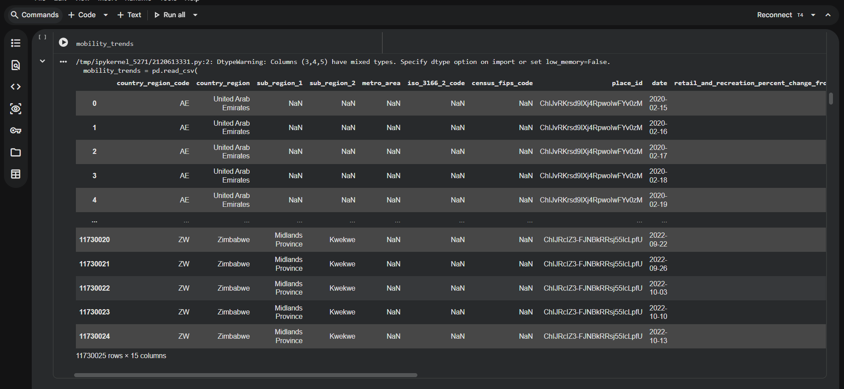

A.3 — Data Inspection
# Count rows and inspect structure
mobility_trends.shape

# Summary of column names and data types
mobility_trends.info()

# Explore unique country values
mobility_trends['country_region'].unique()

A.4 — Filter for United Kingdom
# Filter global dataset for United Kingdom only
mobility_trends_UK = mobility_trends[
mobility_trends["country_region"] == "United Kingdom"
]
mobility_trends_UK

A.5 — Exploratory Data Analysis
# Descriptive statistics at the start of Lockdown 1
mobility_trends_UK[mobility_trends_UK["date"] == "2020-03-24"].describe()

# Descriptive statistics at the start of Lockdown 3
mobility_trends_UK[mobility_trends_UK["date"] == "2021-01-06"].describe()

# Workplace mobility time series
sns.relplot(
x="date", y="workplaces_percent_change_from_baseline",
height=5, aspect=3, kind="line", lw=3,
data=mobility_trends_UK,
)
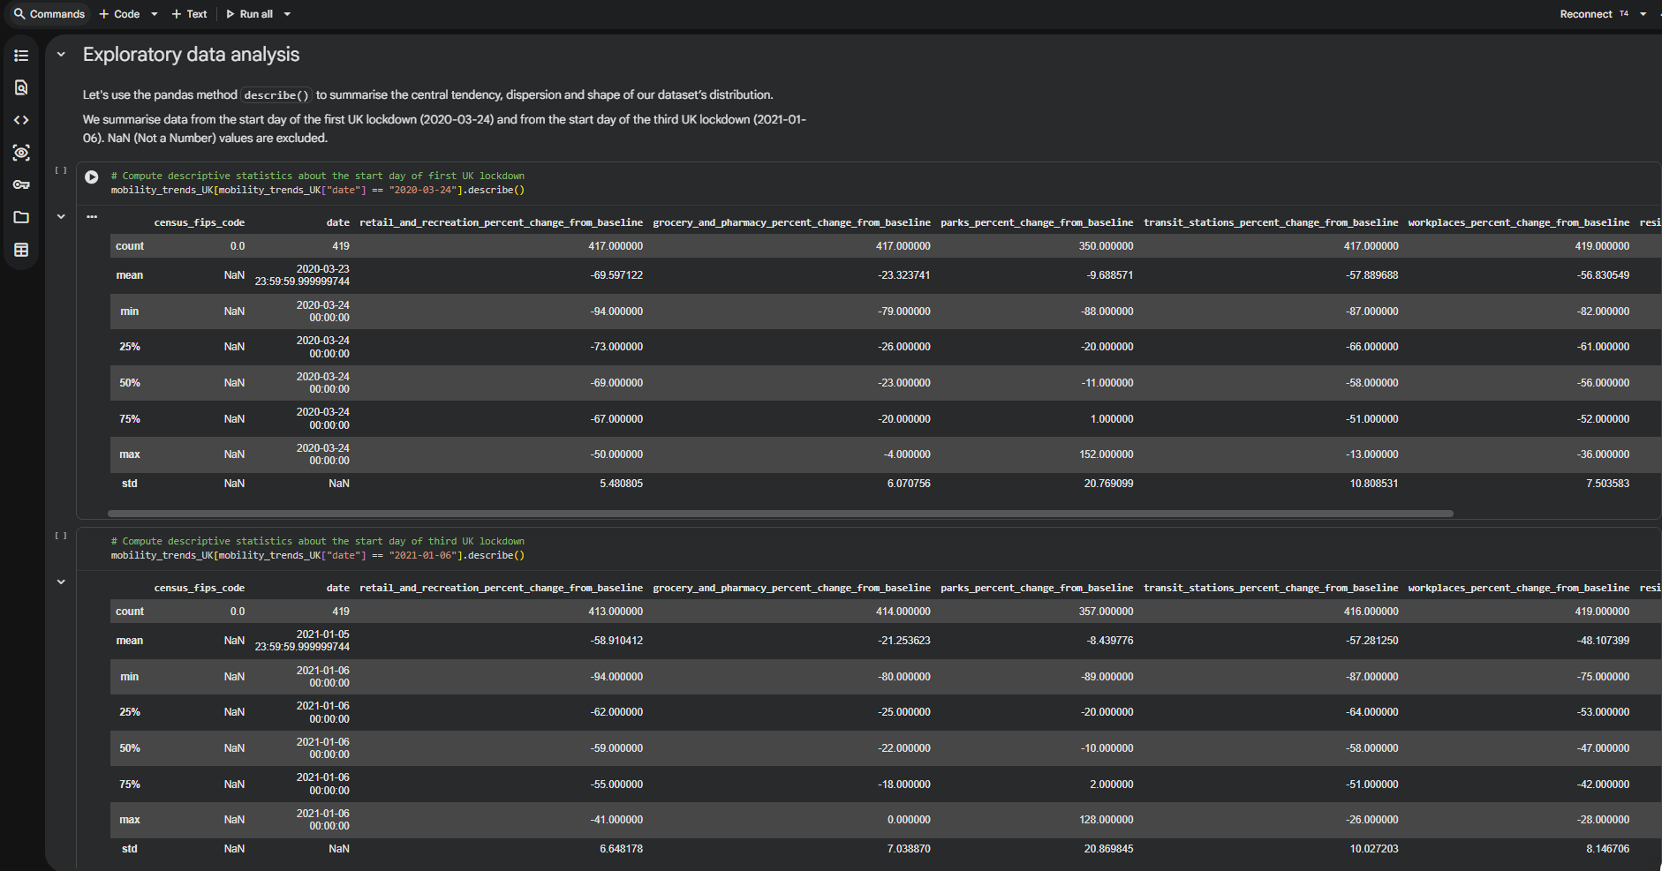

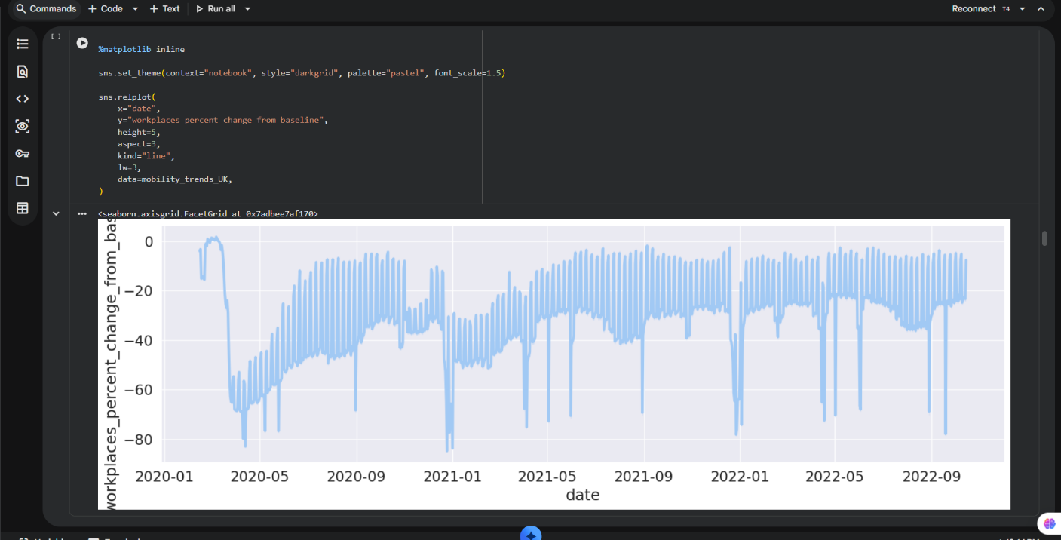
A.6 — Data Wrangling: Wide to Long Format
# Reshape from wide to long format using pd.melt()
mobility_trends_UK_long = pd.melt(
mobility_trends_UK,
id_vars=mobility_trends_UK.columns[[1, 2, 8]], # country, sub_region_1, date
value_vars=mobility_trends_UK.columns[9:15], # six mobility categories
).dropna() # Remove rows with suppressed (NaN) mobility values

mobility_trends_UK_long

A.7 — All Six Categories Time Series
# Multi-panel time series for all six mobility categories
sns.relplot(
x="date", y="value",
col="variable", col_wrap=2,
height=5, aspect=3,
kind="line", lw=3,
facet_kws={'sharey': False},
data=mobility_trends_UK_long,
)

A.8 — Lockdown Subsetting and Concatenation
# Subset each lockdown period (first 3 weeks)
lockdown1 = mobility_trends_UK_long[
(mobility_trends_UK_long["date"] >= "2020-03-24")
& (mobility_trends_UK_long["date"] <= "2020-04-13")
]
lockdown2 = mobility_trends_UK_long[
(mobility_trends_UK_long["date"] >= "2020-11-05")
& (mobility_trends_UK_long["date"] <= "2020-11-25")
]
lockdown3 = mobility_trends_UK_long[
(mobility_trends_UK_long["date"] >= "2021-01-06")
& (mobility_trends_UK_long["date"] <= "2021-01-26")
]

# Concatenate with lockdown labels
lockdowns = pd.concat(
[lockdown1, lockdown2, lockdown3],
keys=["lockdown1", "lockdown2", "lockdown3"]
).reset_index()
lockdowns.head()

A.9 — Split-Apply-Combine Aggregation
# Compute mean mobility by lockdown and category
lockdowns.groupby(["level_0", "variable"], sort=False)["value"].mean()

A.10 — Comparative Bar Chart
# Bar chart comparing mean mobility across the three lockdowns
grid = sns.catplot(
x="country_region", y="value",
hue="variable", col="level_0",
ci=99,
kind="bar",
data=lockdowns,
)
grid.set_ylabels('Mean mobility change from baseline (%)')

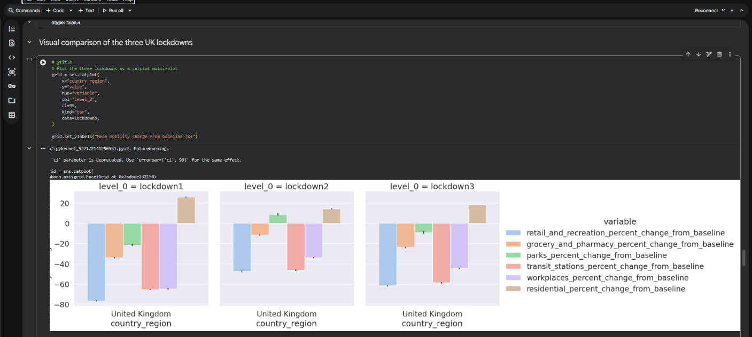
A.11 — Regional Box Plots
# Regional box plots — Lockdown 1
sns.catplot(
x="value", y="sub_region_1", col="variable",
kind="box", sharex=False,
height=35, aspect=0.13,
color="y", data=lockdown1,
)

# Lockdown 2 (same parameters, data=lockdown2)
# Lockdown 3 (same parameters, data=lockdown3)
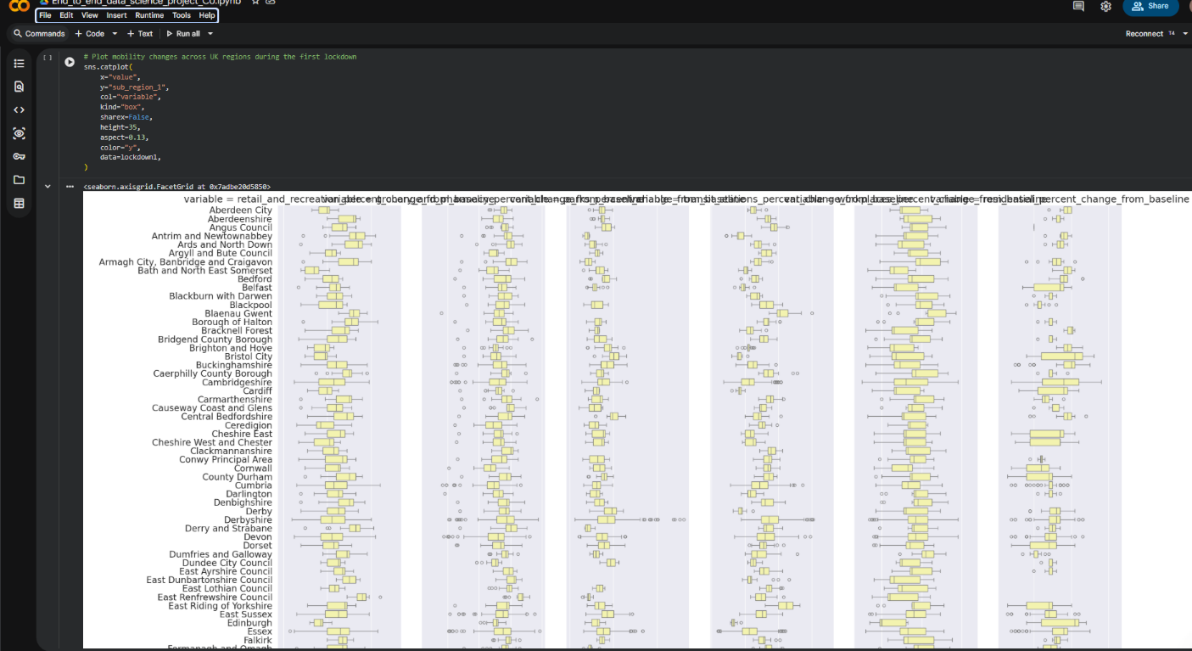

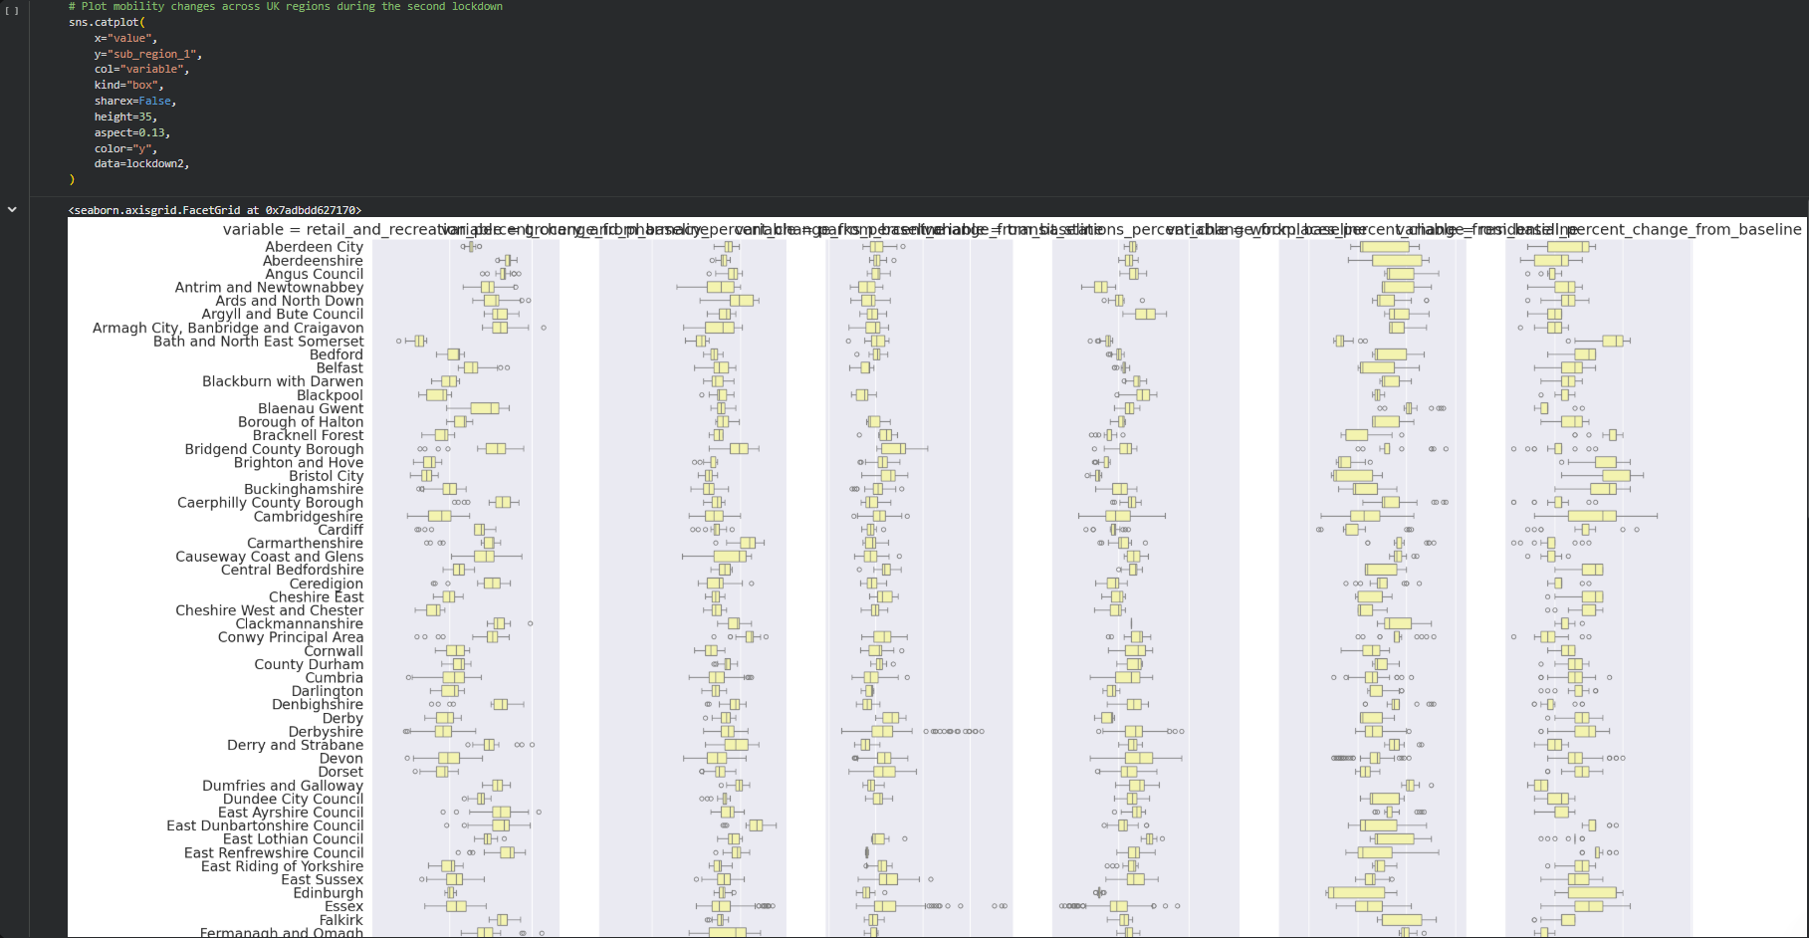

Appendix B: Dataset Schema Reference
Column | Type
country_region_code | String (ISO 3166-1)
country_region | String
sub_region_1 | String (nullable)
sub_region_2 | String (nullable)
metro_area | String (nullable)
iso_3166_2_code | String (nullable)
census_fips_code | Float (US only, null for UK)
place_id | String
date | Date (YYYY-MM-DD)
retail_and_recreation_percent_change_from_baseline | Float (nullable)
grocery_and_pharmacy_percent_change_from_baseline | Float (nullable)
parks_percent_change_from_baseline | Float (nullable)
transit_stations_percent_change_from_baseline | Float (nullable)
workplaces_percent_change_from_baseline | Float (nullable)
residential_percent_change_from_baseline | Float (nullable)

Appendix C: GitHub Repository
The complete project, including the Jupyter Notebook, README, and documentation, is available on GitHub. The repository contains:
- end_to_end_data_science_project.ipynb — The complete Jupyter Notebook with all code, commentary, and outputs.
- README.md — Project overview, setup instructions, and how to reproduce the analysis.
- requirements.txt — Python dependencies for local execution.
GitHub URL: [Add your GitHub repository URL here]

Appendix D: Abbreviations and Glossary
Term / Abbreviation | Definition
API | Application Programming Interface
BCA | Bachelor of Computer Application
COVID-19 | Coronavirus Disease 2019
CRISP-DM | Cross Industry Standard Process for Data Mining
CSV | Comma-Separated Values
EDA | Exploratory Data Analysis
GIS | Geographic Information System
MCA | Master of Computer Application
MSc (DS) | Master of Science (Data Science)
NaN | Not a Number (missing value indicator in Python/Pandas)
NPI | Non-Pharmaceutical Intervention
ONS | Office for National Statistics
Pandas | Python Data Analysis Library
Seaborn | Statistical data visualisation library for Python
URL | Uniform Resource Locator
WHO | World Health Organisation

— End of Report —
Human Mobility During UK Lockdowns | MSc Data Science | [2026]

