INDEX

## Introduction

1. SystemRequirementSpecificationDocument

## SoftwareRequirement

* + Hardware Requirement

3.Design

## UserInterface

* + System Architecture

4.Implementation

## Theview

* + The Model

5.Code

6. Future scope

7.Conclusion

8.References

# INTRODUCTION

I am a visual learner and hence more suited to acquire topics by watching themthan by reading about them. In this case, I found that seeing at the source code and trying to figure out where the data was supposedto go. My project was born out of my curiosity about the world clock widget for showing the current time and the time difference in the form of widget of countries.

I wanted the animation to appeal to a wide spectrum of individuals utilizingvarious technology media, and so I had it made in a web-based format. Insteadof requiring the user to install extra software or attempt to organize setups to usethe tool, this helps to remove this source of (HypertextMarkupTextLanguage)JavaScript,andCSSforthewebsite'slayout(CascadingStyleSheets).

**OBJECTIVE:**

The world clock widget is developing to shows the time of many countries and its time difference at time. This project provides the facility of multiple widgets for tracking and comparing the time of many countries in a single page.

# SYSTEM REQUIREMENTSPECIFICATION

## SOFTWAREREQUIREMENT:

OperatingSystem : Windows11

ApplicationLogic : javascript ,html ,css,json

IDE/Workbench : Atom.

## HARDWAREREQUIREMENT:

Processor : IntelCorei5

HardDisk : SSD/HDD

RAM : 128MBorabove

# DESIGN

## USERINTERFACE:

Thedesignandstructureoftheuserinterfacecomponentshasremainedunchangedeveniftheunderlyingback-endcodewasrefactoredmidwaythrough the construction. Right from the name,Simple World Clock Widget for web makes everything simplified. This is not a fan app, though; it is a home screen widget that can help you keep track of time across the globe. Each component has its own feature. The canvas area has + button for searching the desire country that can show the time and time difference in the form of widgets.to choose the desire country time go to the Add New Country button then it opens the search bar after it you can easily choose any country across the world after choosing the country it opens the widget of selected country.

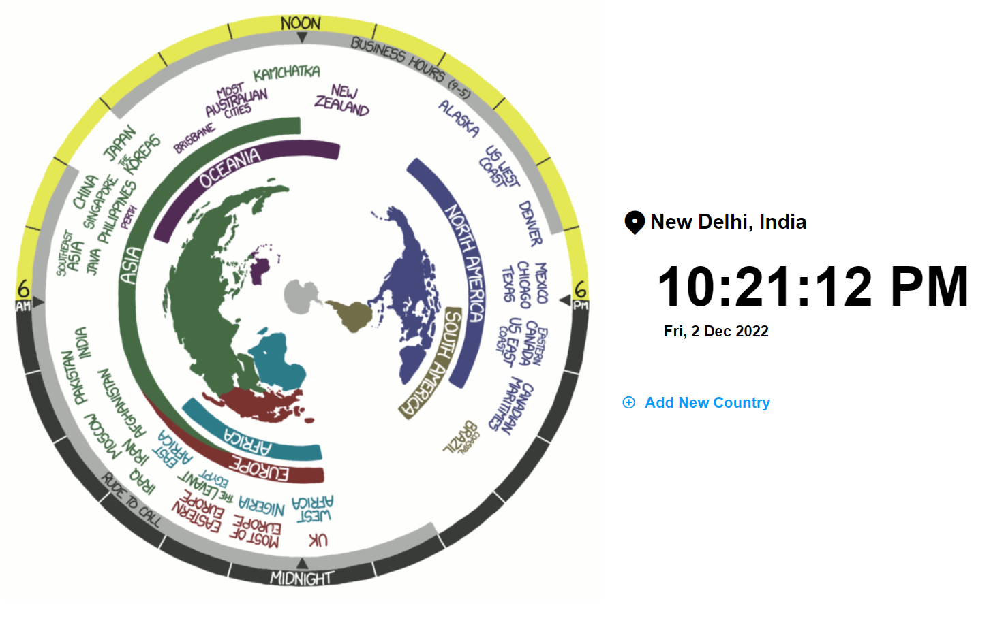

## SYSTEMARCHITECTURE:

HTML5, CSS, JavaScript,JSON make up the back-end code. As you can see, these coding languages are the only important components.However, sinceJavaScript runs immediately in the browser, HTML5 and CSS are employed inwebdevelopment.

As illustrated with a single, bidirectional arrow, the HTML5 and JavaScriptcommunicate to run the relevant clock and update the interface. The codefor HTML5 and CSS did not change significantly throughout the project. Theparts of HTML5 that were updated were the function calls for each button, sincethey were altered from a functional programming mindset to an object-orientedone.

# IMPLEMENTATION

TheuseofHTML5(HypertextMarkupLanguage5),JavaScript,CSS and JSONcombine to form this project's implementation (Cascading Style Sheets). Beforethe final phase of development, the design was almost completely functional,where only four objects were used: one to control the canvas that displayed theanimation, another to represent a piece of data. Although, because of itsfunctional character, which means it has a multitudeof functions that directly alter the View and Controller. The major module in theHTML code between the tags is known as the global scope. Everything withintheframeworkis abletoaccesstheaforementionedvariablesandmethods.

## THEVIEW:

There are three item on the web view,first is the current or default country second is the current time and date. Second is a button of adding various countries you can select the desire country and it how its time and time difference in the form of widget.

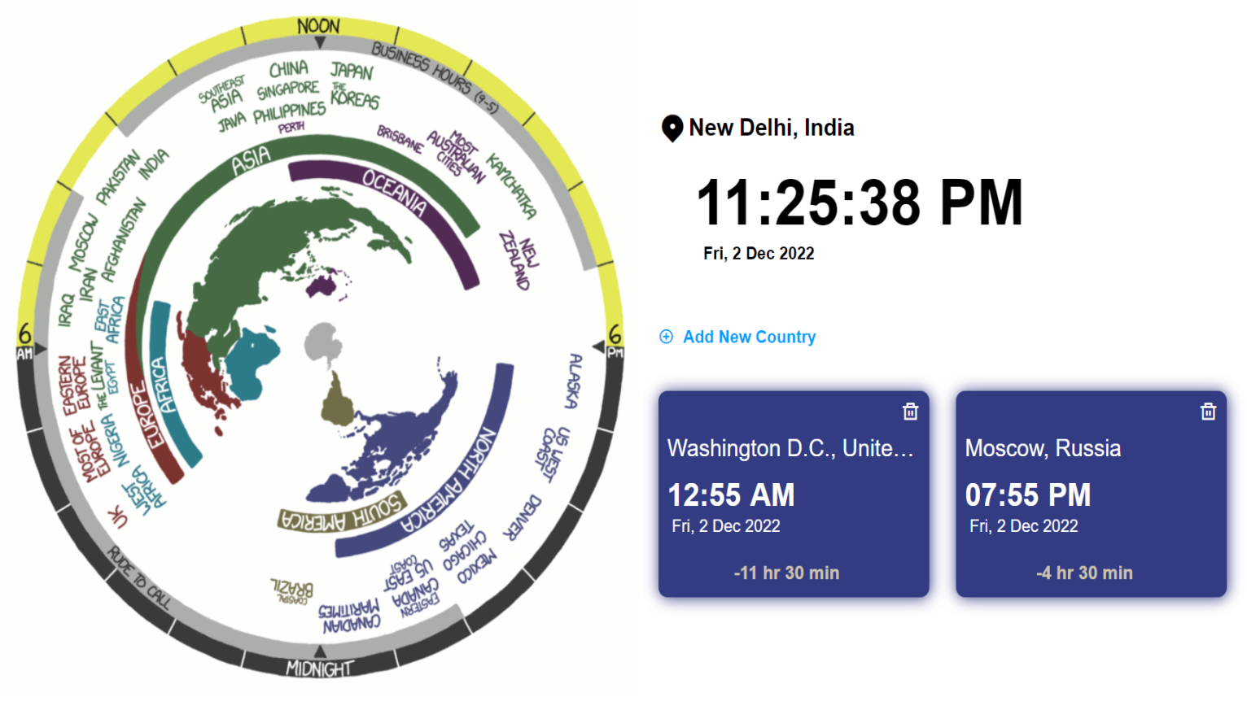

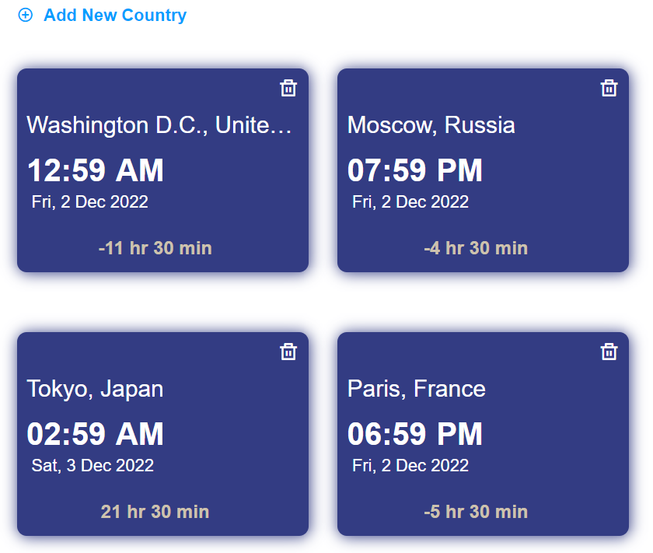

World Time Widget brings the world clock to your Notification Center making it quicker and easier to see the correct time and date anywhere in the world - all within a single swipe.

## THEMODEL:

This is a simple and easy to use world clock app for web. There is nothing much to the app apart from a great interface and simple usability. Tap on the menu button to add clocks to the table. This widget is a streamlined process that hardly takes more than a few seconds.

Is there a World Clock widget for Windows 11.

To add a location and compare times from around the world: To launch the app, select Start and select Alarms & Clock from the app list or type its name into the searchbox.

HTML-CODE

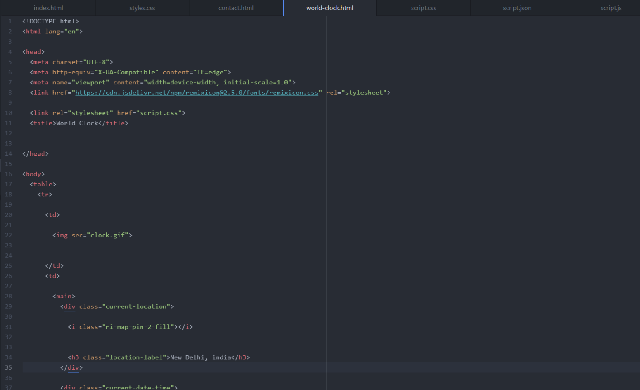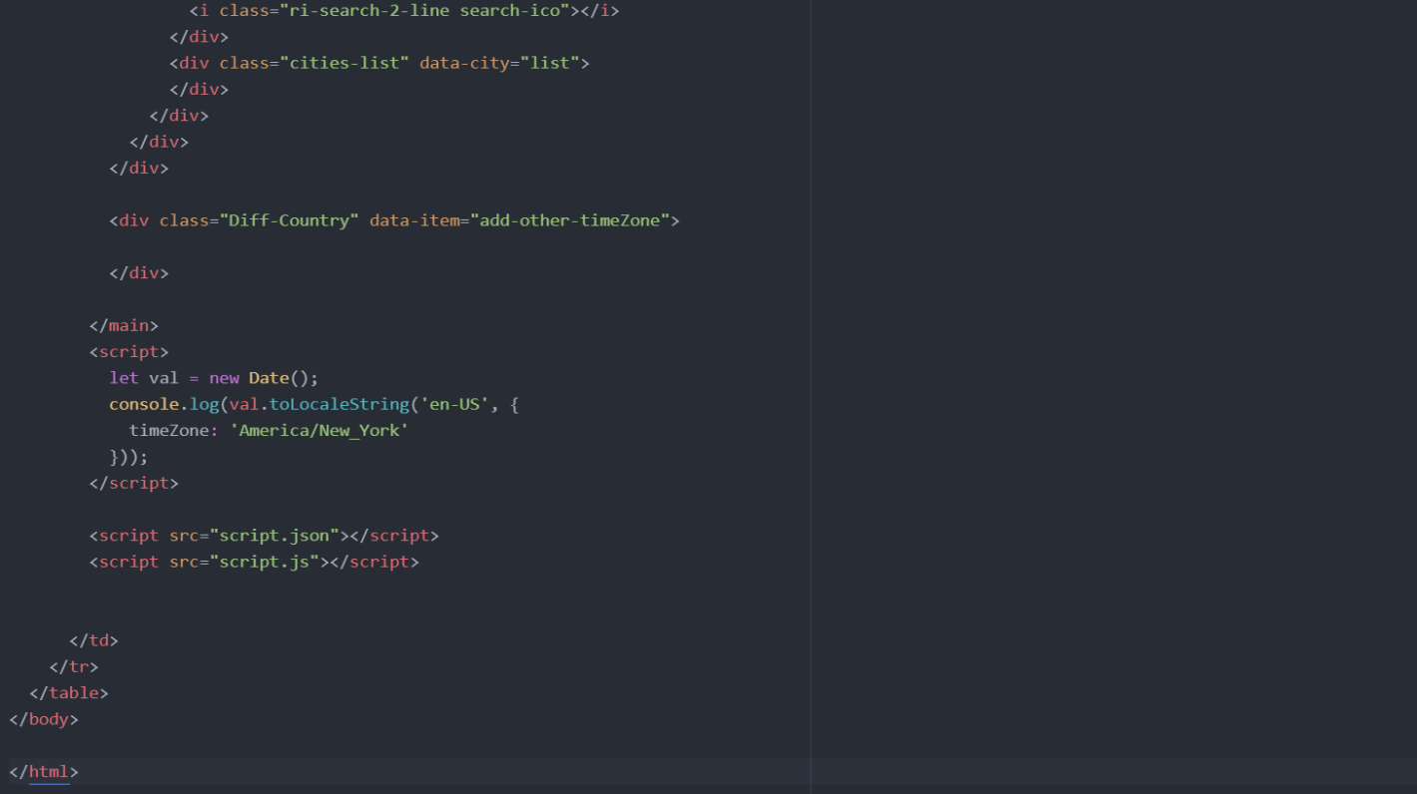

CSS-CODE

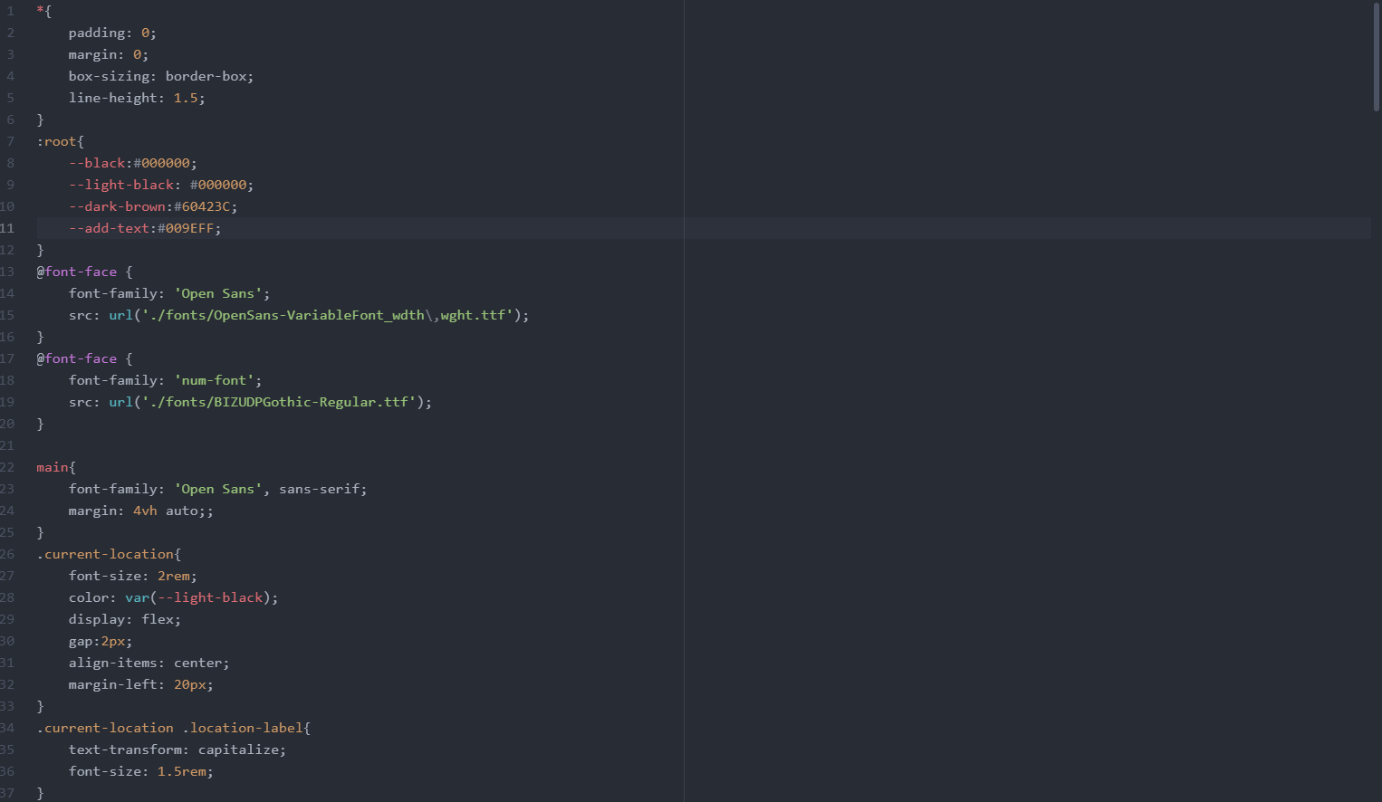

JAVASCRIPT-CODE

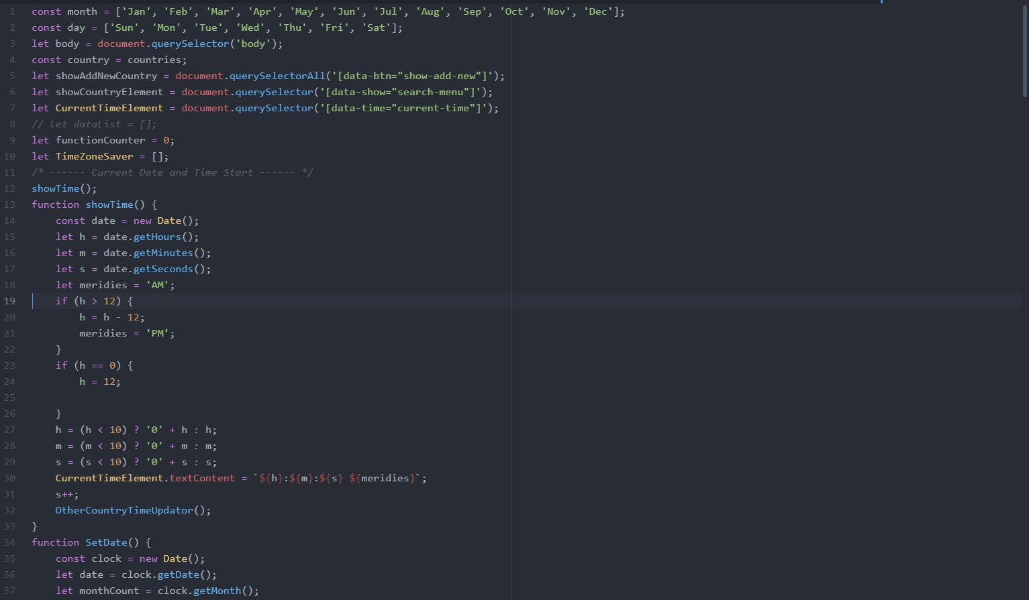

JSON

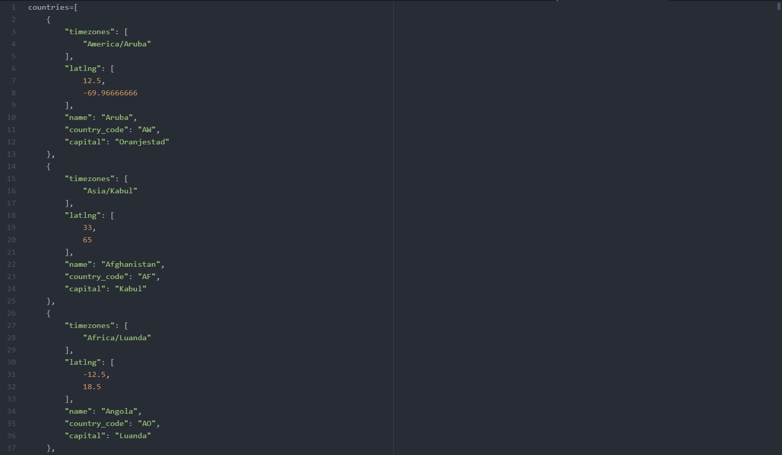

FUTURESCOPE

* Till now it is running on browsers by making the code more efficient and effective in the future, I want to add this as a desktop widget.
* It needs little more effort but will run very fluently and effectively.
* After some improvement and customization it will work as a fully functional desktop widget.
* It shows the time and time difference in the form of widgets.
* Right from the name , Simple World Clock Widget for web makes everything simplified. This is not a an app, though; it is a home screen widget that can help you keep track of time across the globe.

# CONCLUSION

This web-based World-Clock is capable of showing the current time and the time difference of many countries itsfunctions has great part because of all the time and effort that I invested into it. Inspite of itsmemory overhead,the feedback givento itwas mostly goodfromthe students thatworked with it.This isconsistent with mypriorresearch,whichrevealedthattherewasnosubstantialdifferenceinlearningthecontent.

What I do agree with totally is the attitude that holds there is a great need toinvestigate and produce animated presentations to enhance education in theclassroom.Overall,IamnotconcernedthatalargereworktoadifferentlanguagewillberequiredsoonbecauseJavaScriptisstilloneofthemostpopularweb languages.

# REFRENCES

* file:///C:/Users/ROHIT/Desktop/start%20web%20development/HTML%20-%20Personal%20site/world-clock.html
* <https://www.timeanddate.com/worldclock/>
* <https://developer.mozilla.org/en-US/docs/Web/HTML>
* <https://developer.mozilla.org/en-US/docs/Web/CSS>
* <https://developer.mozilla.org/en-US/docs/Web/JavaScript>
* <https://colorhunt.co/>
* <https://developer.mozilla.org/en-US/docs/Web/JavaScript/Reference/Global_Objects/JSON>