CUSTOMER DATA NORMALIZATION USING NUMPY MATRICES
Ex No:-1 Name:Akash S
Reg.no:192324298
Slot:B
Course:Deep learning
Semester: MS2Sept 2026
SCENARIO:
A retail company collects customer age, annual income, and purchase frequency. Represent the customer data as a matrix, normalize the features using min-max normalization, and visualize the transformed values to compare customers on a common scale.
ALGORITHM:
Experiment 1: Customer feature normalization
Step | Algorithm / method used
Data representation | NumPy 2D array / feature matrix
Normalization | Min-max scaling: (x − min) / (max − min)
Visualization | Matplotlib grouped line plots
Data handling | NumPy array operations
Data handling | NumPy array operations
Purpose: to represent customer features as a NumPy matrix, normalize each column to the range 0–1, and visualize the original and normalized values.

SOURCE CODE OF EACH MODULE:
import numpy as np
import matplotlib.pyplot as plt
# Rows are customers; columns are age, annual income ($1000s), purchases/month
customers = np.array([
[22, 28, 2],
[35, 55, 5],
[48, 82, 8],
[29, 42, 3],
[41, 68, 6]
], dtype=float)
feature_names = ["Age", "Income ($1000s)", "Purchases/month"]
minimum = customers.min(axis=0)
maximum = customers.max(axis=0)
normalized = (customers - minimum) / (maximum - minimum)
print("Original customer matrix:\n", customers)
print("Min-max normalized matrix:\n", np.round(normalized, 3))
plt.figure(figsize=(7, 4))
for i, name in enumerate(feature_names):
plt.plot(range(1, len(customers)+1), normalized[:, i],
marker="o", label=name)
plt.xlabel("Customer")
plt.ylabel("Normalized value (0–1)")
plt.title("Normalized Customer Features")
plt.xticks(range(1, len(customers)+1))
plt.legend()
plt.tight_layout()
plt.savefig("plot1.png", dpi=150)
plt.close()
plt.figure(figsize=(6, 4))
plt.imshow(normalized, cmap="viridis", aspect="auto", vmin=0, vmax=1)
plt.colorbar(label="Normalized value")
plt.xticks(range(3), feature_names, rotation=20)
plt.yticks(range(5), [f"C{i}" for i in range(1, 6)])
plt.title("Customer Feature Heatmap")
plt.tight_layout()
plt.savefig("plot2.png", dpi=150)
plt.close()
plt.figure(figsize=(6, 4))
plt.bar(feature_names, normalized.mean(axis=0))
plt.ylabel("Mean normalized value")
plt.title("Average Normalized Feature Values")
plt.tight_layout()
plt.savefig("plot3.png", dpi=150)
plt.close()
OUTPUT: TABLE 1 — Key results
Original matrix shape: 5 customers × 3 features.
TABLE 2 — Interpretation
Min-max normalization maps the minimum of each feature to 0 and its maximum to 1.
TABLE 3 — Additional result
Normalized values (rounded): [[0.000, 0.000, 0.000], [0.885, 0.444, 0.500], [1.000, 1.000, 1.000], [0.269, 0.259, 0.167], [0.731, 0.741, 0.667]].
TABLE 4 — Conclusion of analysis
Refer to the three plots below and the source code above for the complete numerical and visual analysis.
PLOT 1 — Primary visualization
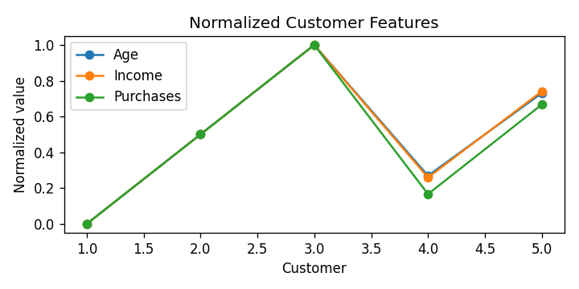
PLOT 2 — Supporting visualization
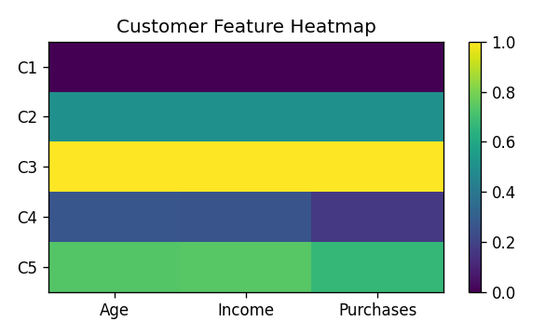
PLOT 3 — Supporting visualization
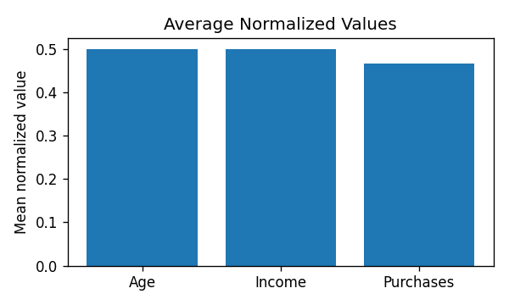
CONCLUSION: The customer data was represented as a matrix and normalized feature-wise to a common 0–1 scale. Normalization makes age, income, and purchase frequency comparable for subsequent machine-learning tasks.

