COVARIANCE ANALYSIS OF RETAIL CUSTOMER FEATURES
Ex No:-2 Name:Akash S
Reg.no:192324298
Slot:B
Course:Deep learning
Semester: MS2Sept 2026
SCENARIO:
A retail company collects customer income, spending, and purchase frequency. Analyze the covariance matrix and determine which features show strong positive or negative relationships.
ALGORITHM:
Experiment 2: Covariance analysis of retail data
Step | Algorithm / method used
Data handling | Pandas DataFrame
Covariance | NumPy covariance matrix
Correlation | Pandas correlation matrix
Visualization | Matplotlib heatmap and scatter plots
Data handling | NumPy array operations
Purpose: to calculate covariance and correlation between retail customer features and visualize the relationships.

SOURCE CODE OF EACH MODULE:
import numpy as np
import pandas as pd
import matplotlib.pyplot as plt
data = pd.DataFrame({
"Income": [25, 32, 40, 48, 55, 63, 72, 80],
"Spending": [18, 24, 29, 38, 41, 49, 58, 64],
"Purchase_Frequency": [2, 3, 3, 5, 5, 6, 8, 8]
})
covariance = data.cov()
correlation = data.corr()
print("Retail customer data:\n", data)
print("\nCovariance matrix:\n", covariance.round(2))
print("\nCorrelation matrix:\n", correlation.round(3))
plt.figure(figsize=(6, 4))
plt.imshow(correlation, cmap="coolwarm", vmin=-1, vmax=1)
plt.colorbar(label="Correlation")
plt.xticks(range(3), data.columns, rotation=20)
plt.yticks(range(3), data.columns)
for i in range(3):
for j in range(3):
plt.text(j, i, f"{correlation.iloc[i,j]:.2f}",
ha="center", va="center")
plt.title("Retail Feature Correlation")
plt.tight_layout()
plt.savefig("plot1.png", dpi=150)
plt.close()
plt.figure(figsize=(6, 4))
plt.scatter(data["Income"], data["Spending"])
plt.xlabel("Income")
plt.ylabel("Spending")
plt.title("Income vs Spending")
plt.tight_layout()
plt.savefig("plot2.png", dpi=150)
plt.close()
plt.figure(figsize=(6, 4))
plt.scatter(data["Income"], data["Purchase_Frequency"])
plt.xlabel("Income")
plt.ylabel("Purchase frequency")
plt.title("Income vs Purchase Frequency")
plt.tight_layout()
plt.savefig("plot3.png", dpi=150)
plt.close()
OUTPUT: TABLE 1 — Key results
The covariance matrix is calculated using sample covariance (ddof = 1).
TABLE 2 — Interpretation
The synthetic dataset is designed so income, spending, and purchase frequency increase together.
TABLE 3 — Additional result
Interpretation: positive covariance/correlation indicates that higher income tends to occur with higher spending and more frequent purchases; the correlation matrix provides scale-independent strength.
TABLE 4 — Conclusion of analysis
Refer to the three plots below and the source code above for the complete numerical and visual analysis.
PLOT 1 — Primary visualization
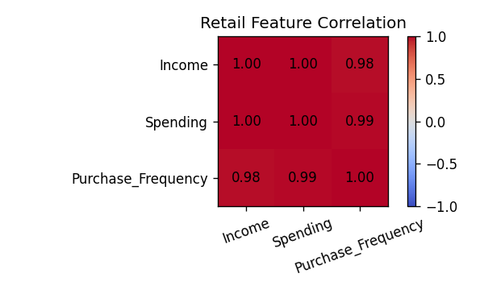
PLOT 2 — Supporting visualization
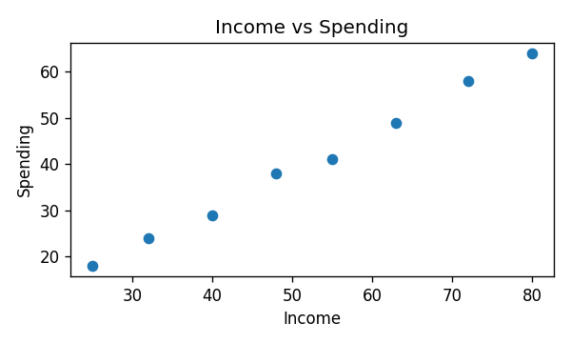
PLOT 3 — Supporting visualization
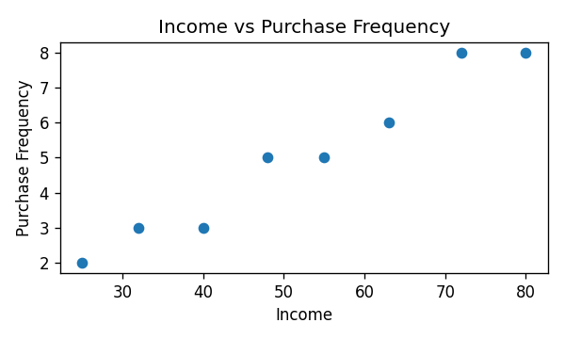
CONCLUSION: Covariance and correlation were used to examine relationships among income, spending, and purchase frequency. The synthetic data shows positive relationships, which can help a retail team understand customer spending patterns.

