POISSON DISTRIBUTION FOR MANUFACTURING DEFECTS
Ex No:-3 Name:Akash S
Reg.no:192324298
Slot:B
Course:Deep learning
Semester: MS2Sept 2026
SCENARIO:
A manufacturing unit records the number of defective products in different batches. Model the defect counts using a suitable probability distribution and estimate the probability of observing a specified number of defects.
ALGORITHM:
Experiment 3: Defect-count probability estimation
Step | Algorithm / method used
Data handling | NumPy arrays
Distribution | Poisson probability mass function
Parameter estimation | Sample mean λ
Visualization | SciPy and Matplotlib
Data handling | NumPy array operations
Purpose: to model defect counts with a Poisson distribution, estimate its rate from observed batches, and calculate the probability of exactly three defects.

SOURCE CODE OF EACH MODULE:
import numpy as np
import matplotlib.pyplot as plt
from scipy.stats import poisson
# Observed defect counts in 12 production batches
defects = np.array([2, 1, 3, 0, 2, 4, 1, 3, 2, 2, 5, 1])
lam = defects.mean()
target_defects = 3
probability = poisson.pmf(target_defects, mu=lam)
print("Observed defect counts:", defects)
print(f"Estimated Poisson rate (lambda): {lam:.3f}")
print(f"P(X = {target_defects}) = {probability:.4f}")
x = np.arange(0, max(defects.max(), 8) + 1)
pmf = poisson.pmf(x, mu=lam)
plt.figure(figsize=(7, 4))
plt.bar(x, pmf)
plt.xlabel("Number of defects per batch")
plt.ylabel("Probability")
plt.title(f"Poisson Distribution (lambda={lam:.2f})")
plt.xticks(x)
plt.tight_layout()
plt.savefig("plot1.png", dpi=150)
plt.close()
plt.figure(figsize=(6, 4))
plt.hist(defects, bins=np.arange(-0.5, defects.max()+1.5, 1), density=True)
plt.xlabel("Defects per batch")
plt.ylabel("Relative frequency density")
plt.title("Observed Defect Counts")
plt.tight_layout()
plt.savefig("plot2.png", dpi=150)
plt.close()
plt.figure(figsize=(6, 4))
plt.plot(x, np.cumsum(pmf), marker="o")
plt.xlabel("Defects or fewer")
plt.ylabel("Cumulative probability")
plt.title("Poisson Cumulative Probability")
plt.ylim(0, 1.05)
plt.tight_layout()
plt.savefig("plot3.png", dpi=150)
plt.close()
OUTPUT: TABLE 1 — Key results
Observed defect counts: [2, 1, 3, 0, 2, 4, 1, 3, 2, 2, 5, 1].
TABLE 2 — Interpretation
Estimated rate λ = 2.167 defects per batch.
TABLE 3 — Additional result
The probability of exactly 3 defects is approximately 0.194 (19.4%), using the fitted Poisson model.
TABLE 4 — Conclusion of analysis
Refer to the three plots below and the source code above for the complete numerical and visual analysis.
PLOT 1 — Primary visualization
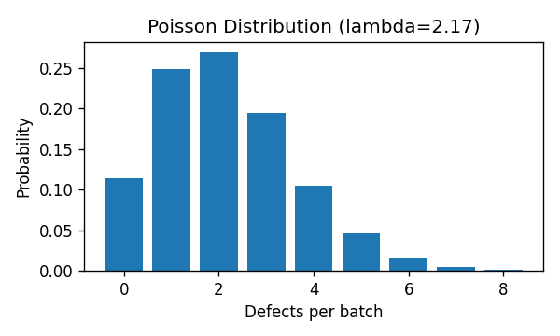
PLOT 2 — Supporting visualization
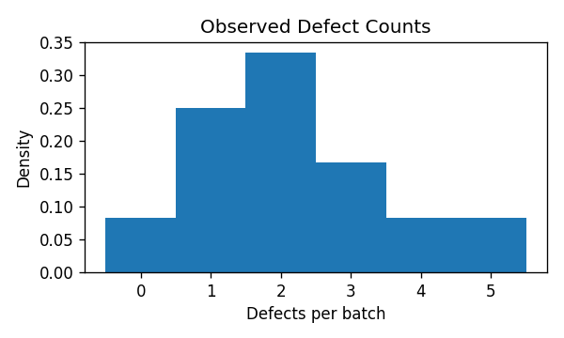
PLOT 3 — Supporting visualization
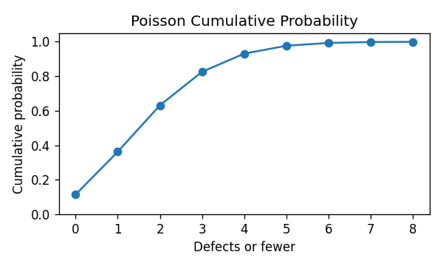
CONCLUSION: The Poisson model estimates the probability of a specified defect count from the average number of defects per batch. This provides a simple baseline for monitoring manufacturing quality.

