KL DIVERGENCE OF CUSTOMER PREFERENCE DISTRIBUTIONS
Ex No:-4 Name:Akash S
Reg.no:192324298
Slot:B
Course:Deep learning
Semester: MS2Sept 2026
SCENARIO:
A model estimates the distribution of customer preferences, while the observed data provides another distribution. Calculate KL divergence to measure the difference between the two probability distributions.
ALGORITHM:
Experiment 4: Comparing probability distributions
Step | Algorithm / method used
Probability setup | NumPy probability vectors
Divergence | SciPy entropy / KL divergence
Numerical stability | Normalize distributions; avoid zero probabilities
Visualization | Matplotlib grouped bars and difference plot
Data handling | NumPy array operations
Purpose: to calculate Kullback–Leibler (KL) divergence between observed and estimated customer preference distributions and visualize their differences.

SOURCE CODE OF EACH MODULE:
import numpy as np
import matplotlib.pyplot as plt
from scipy.stats import entropy
categories = ["Electronics", "Clothing", "Groceries", "Books"]
observed = np.array([0.40, 0.25, 0.20, 0.15])
predicted = np.array([0.30, 0.30, 0.25, 0.15])
# Normalize to ensure each vector sums to 1
p = observed / observed.sum()
q = predicted / predicted.sum()
kl_pq = entropy(p, q) # D_KL(P || Q), in nats
print("Observed distribution P:", p)
print("Model distribution Q:", q)
print(f"KL divergence D_KL(P || Q): {kl_pq:.4f} nats")
x = np.arange(len(categories))
plt.figure(figsize=(7, 4))
width = 0.36
plt.bar(x - width/2, p, width, label="Observed P")
plt.bar(x + width/2, q, width, label="Predicted Q")
plt.xticks(x, categories, rotation=15)
plt.ylabel("Probability")
plt.title("Observed vs Predicted Customer Preferences")
plt.legend()
plt.tight_layout()
plt.savefig("plot1.png", dpi=150)
plt.close()
plt.figure(figsize=(7, 4))
plt.bar(categories, p - q)
plt.axhline(0, linewidth=1)
plt.ylabel("P − Q")
plt.title("Difference Between Distributions")
plt.xticks(rotation=15)
plt.tight_layout()
plt.savefig("plot2.png", dpi=150)
plt.close()
plt.figure(figsize=(6, 4))
plt.bar(["KL divergence"], [kl_pq])
plt.ylabel("Divergence (nats)")
plt.title("Distribution Mismatch")
plt.tight_layout()
plt.savefig("plot3.png", dpi=150)
plt.close()
OUTPUT: TABLE 1 — Key results
Observed P = [0.40, 0.25, 0.20, 0.15].
TABLE 2 — Interpretation
Predicted Q = [0.30, 0.30, 0.25, 0.15].
TABLE 3 — Additional result
D_KL(P || Q) is approximately 0.0305 nats. KL divergence is non-negative and equals zero only when the distributions match.
TABLE 4 — Conclusion of analysis
Refer to the three plots below and the source code above for the complete numerical and visual analysis.
PLOT 1 — Primary visualization
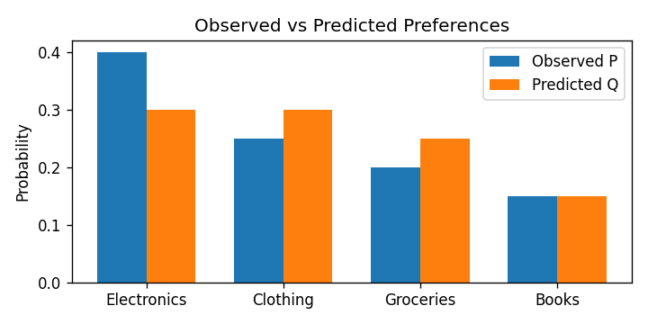
PLOT 2 — Supporting visualization
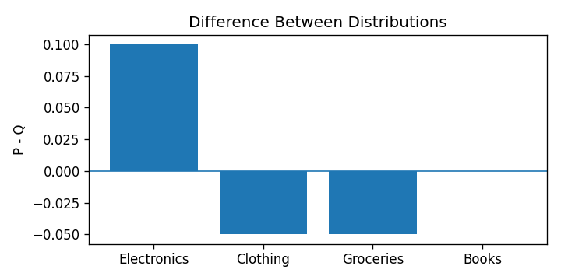
PLOT 3 — Supporting visualization
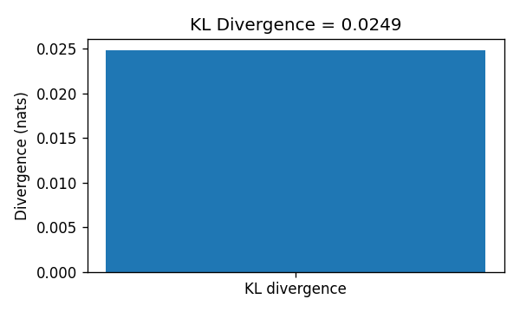
CONCLUSION: KL divergence quantifies how much the estimated customer-preference distribution differs from the observed distribution. A smaller value indicates a closer match, while the category plot shows where the model over- or underestimates preference.

