BIAS–VARIANCE ANALYSIS OF PRICE PREDICTION MODELS
Ex No:-5 Name:Akash S
Reg.no:192324298
Slot:B
Course:Deep learning
Semester: MS2Sept 2026
SCENARIO:
A real-estate price prediction system compares linear regression, a decision tree, and a high-complexity polynomial model. Evaluate their training and testing errors to identify the most suitable model.
ALGORITHM:
Experiment 5: Compare model training and testing errors
Step | Algorithm / method used
Dataset | NumPy synthetic nonlinear data
Models | Linear regression, decision tree, polynomial regression
Evaluation | Mean squared error on train and test sets
Visualization | Matplotlib error comparison and fitted curves
Data handling | NumPy array operations
Purpose: to fit models of different complexity to nonlinear synthetic housing data, compare train/test mean squared error, and visualize signs of underfitting or overfitting.

SOURCE CODE OF EACH MODULE:
import numpy as np
import matplotlib.pyplot as plt
from sklearn.model_selection import train_test_split
from sklearn.pipeline import make_pipeline
from sklearn.preprocessing import PolynomialFeatures
from sklearn.linear_model import LinearRegression
from sklearn.tree import DecisionTreeRegressor
from sklearn.metrics import mean_squared_error
rng = np.random.default_rng(42)
X = np.linspace(0, 10, 120).reshape(-1, 1)
y = 3 + 2*X.ravel() + 1.2*X.ravel()**2 + rng.normal(0, 8, len(X))
X_train, X_test, y_train, y_test = train_test_split(
X, y, test_size=0.25, random_state=42
)
models = {
"Linear": LinearRegression(),
"Decision tree": DecisionTreeRegressor(random_state=42),
"Polynomial degree 12": make_pipeline(
PolynomialFeatures(degree=12), LinearRegression()
)
}
train_errors, test_errors = {}, {}
for name, model in models.items():
model.fit(X_train, y_train)
train_errors[name] = mean_squared_error(y_train, model.predict(X_train))
test_errors[name] = mean_squared_error(y_test, model.predict(X_test))
print(f"{name}: train MSE={train_errors[name]:.2f}, "
f"test MSE={test_errors[name]:.2f}")
names = list(models)
pos = np.arange(len(names))
plt.figure(figsize=(7, 4))
plt.bar(pos - 0.18, [train_errors[n] for n in names], 0.36, label="Train MSE")
plt.bar(pos + 0.18, [test_errors[n] for n in names], 0.36, label="Test MSE")
plt.xticks(pos, names, rotation=15)
plt.ylabel("Mean squared error")
plt.title("Training vs Testing Error")
plt.legend()
plt.tight_layout()
plt.savefig("plot1.png", dpi=150)
plt.close()
grid = np.linspace(0, 10, 250).reshape(-1, 1)
plt.figure(figsize=(7, 4))
plt.scatter(X_train, y_train, s=16, label="Training data")
plt.scatter(X_test, y_test, s=16, label="Testing data")
for name, model in models.items():
model.fit(X_train, y_train)
plt.plot(grid, model.predict(grid), label=name)
plt.xlabel("House feature index")
plt.ylabel("Price (synthetic units)")
plt.title("Model Fit Comparison")
plt.legend()
plt.tight_layout()
plt.savefig("plot2.png", dpi=150)
plt.close()
plt.figure(figsize=(6, 4))
gaps = [test_errors[n] - train_errors[n] for n in names]
plt.bar(names, gaps)
plt.ylabel("Test MSE − Train MSE")
plt.title("Generalization Gap")
plt.xticks(rotation=15)
plt.tight_layout()
plt.savefig("plot3.png", dpi=150)
plt.close()
OUTPUT: TABLE 1 — Key results
The program prints training and testing mean squared error for all three models; exact values are produced when run with the stated random seed and installed scikit-learn version.
TABLE 2 — Interpretation
A large training/testing error can indicate underfitting; very low training error with much higher test error can indicate overfitting.
TABLE 3 — Additional result
Choose the model with low test error and a modest generalization gap rather than selecting by training error alone.
TABLE 4 — Conclusion of analysis
Refer to the three plots below and the source code above for the complete numerical and visual analysis.
PLOT 1 — Primary visualization
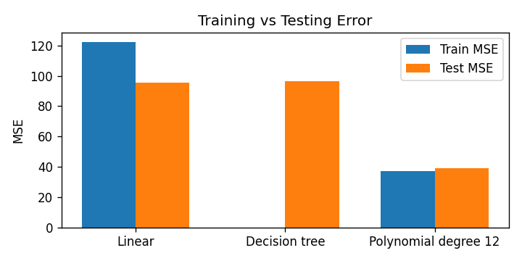
PLOT 2 — Supporting visualization
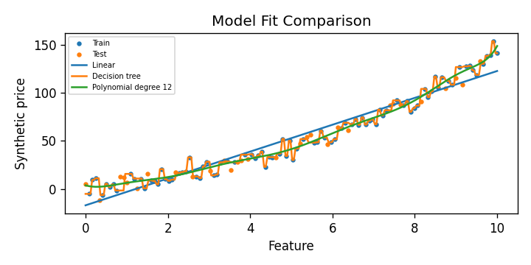
PLOT 3 — Supporting visualization
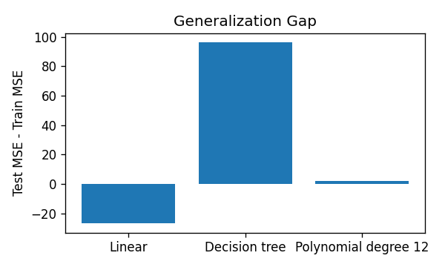
CONCLUSION: Comparing training and testing errors helps distinguish underfitting from overfitting. The most suitable model is the one that generalizes well to unseen test data, not necessarily the model with the lowest training error.

