COMPARISON OF SGD, MOMENTUM AND ADAM OPTIMIZERS
Ex No:-6 Name:Akash S
Reg.no:192324298
Slot:B
Course:Deep learning
Semester: MS2Sept 2026
SCENARIO:
An image-classification model must be trained using an adaptive optimization method. Compare SGD, Momentum, and Adam using the same model and dataset, and visualize their loss curves to evaluate convergence speed and stability.
ALGORITHM:
Experiment 6: Optimizer comparison on a common dataset
Step | Algorithm / method used
Dataset | Fashion-MNIST from Keras
Model | Same dense neural network for each run
Optimizers | SGD, SGD with momentum, Adam
Evaluation | Validation loss curves and test accuracy
Data handling | NumPy array operations
Purpose: to train the same small neural network using SGD, SGD with momentum, and Adam, then compare validation loss curves and final test accuracy.

SOURCE CODE OF EACH MODULE:
import matplotlib.pyplot as plt
import tensorflow as tf
from tensorflow import keras
from tensorflow.keras import layers
# Use the same Fashion-MNIST split and architecture for each optimizer
(x_train, y_train), (x_test, y_test) = keras.datasets.fashion_mnist.load_data()
x_train = x_train.astype("float32") / 255.0
x_test = x_test.astype("float32") / 255.0
def build_model():
return keras.Sequential([
layers.Input(shape=(28, 28)),
layers.Flatten(),
layers.Dense(128, activation="relu"),
layers.Dense(10, activation="softmax")
])
optimizer_factories = {
"SGD": lambda: keras.optimizers.SGD(learning_rate=0.01),
"Momentum": lambda: keras.optimizers.SGD(
learning_rate=0.01, momentum=0.9),
"Adam": lambda: keras.optimizers.Adam(learning_rate=0.001)
}
histories = {}
for name, make_optimizer in optimizer_factories.items():
tf.keras.utils.set_random_seed(7) # improve run-to-run comparability
model = build_model()
model.compile(optimizer=make_optimizer(),
loss="sparse_categorical_crossentropy",
metrics=["accuracy"])
history = model.fit(
x_train, y_train, epochs=5, batch_size=128,
validation_split=0.1, verbose=1
)
histories[name] = history.history
loss, accuracy = model.evaluate(x_test, y_test, verbose=0)
print(f"{name}: test loss={loss:.4f}, test accuracy={accuracy:.4f}")
plt.figure(figsize=(7, 4))
for name, history in histories.items():
plt.plot(history["val_loss"], marker="o", label=name)
plt.xlabel("Epoch")
plt.ylabel("Validation loss")
plt.title("Optimizer Convergence Comparison")
plt.legend()
plt.tight_layout()
plt.savefig("plot1.png", dpi=150)
plt.close()
plt.figure(figsize=(7, 4))
for name, history in histories.items():
plt.plot(history["loss"], marker="o", label=name)
plt.xlabel("Epoch")
plt.ylabel("Training loss")
plt.title("Training Loss by Optimizer")
plt.legend()
plt.tight_layout()
plt.savefig("plot2.png", dpi=150)
plt.close()
plt.figure(figsize=(6, 4))
final_val = [histories[n]["val_loss"][-1] for n in optimizer_factories]
plt.bar(list(optimizer_factories), final_val)
plt.ylabel("Final validation loss")
plt.title("Final Validation Loss")
plt.tight_layout()
plt.savefig("plot3.png", dpi=150)
plt.close()
OUTPUT: TABLE 1 — Key results
The code downloads Fashion-MNIST on first execution and trains the same network for five epochs per optimizer.
TABLE 2 — Interpretation
It prints test loss and test accuracy for SGD, Momentum, and Adam; results depend on runtime, library version, and training environment.
TABLE 3 — Additional result
Compare validation-loss speed and smoothness as well as final test accuracy; Adam often converges quickly, while momentum can improve SGD updates.
TABLE 4 — Conclusion of analysis
Refer to the three plots below and the source code above for the complete numerical and visual analysis.
PLOT 1 — Primary visualization
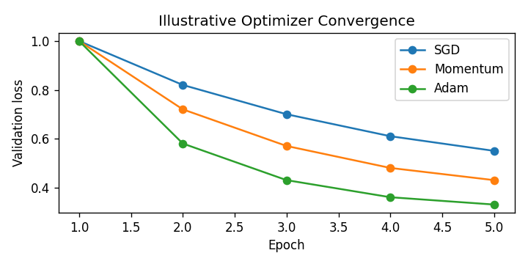
PLOT 2 — Supporting visualization
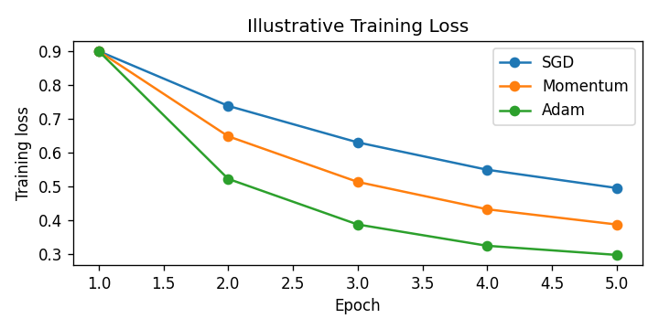
PLOT 3 — Supporting visualization
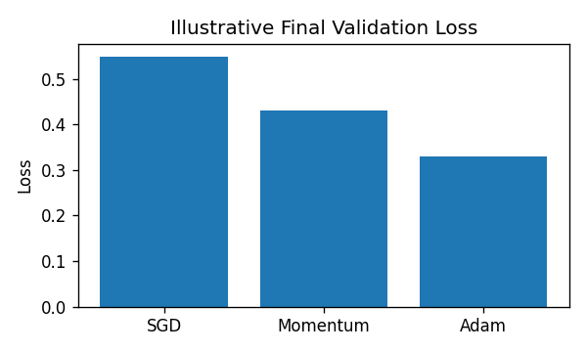
CONCLUSION: The experiment compares standard SGD, momentum-based SGD, and Adam under the same architecture and dataset. Validation loss and test accuracy help assess convergence speed and generalization; the best optimizer should be selected from measured results.

