**Code:**

#include<bits/stdc++.h>

using namespace std;

#define ll long long int

#define mod 1000000007

#define mx 3000010

#define endl "\n"

//pair<ll,ll>a[5001],b[5001];

ll b[mx];

ll a[mx];

void solve()

{

ll a[26][26]= {' '};

char b[26][26]= {' '};

ll n;

cin>>n;

char T;

cin>>T;

ll j=0;

for(char i='a'; j<n; i++,j++)b[0][j]=i;

j=0;

for(char i=b[0][n-1]; j<n; i--,j++)b[n-1][j]=i;

j=0;

for(char i='a'; j<n; i++,j++)b[j][0]=i;

j=0;

for(char i=b[0][n-1]; j<n; i--,j++)b[j][n-1]=i;

if(T=='a')

{

for(ll i=0; i<n; i++)

{

for(ll j=0; j<n; j++)

cout<<b[i][j];

cout<<endl;

}

}

else

{

for(ll i=0; i<n; i++)

{

for(ll j=0; j<n; j++)

{

ll l=b[i][j]-'a'+1;

if(l!=-96)cout<<l;

else cout<<b[i][j];

}

cout<<endl;

}

}

cout<<endl;

}

/*Read the damn question carefully,show base case*/

int main()

{

ios_base::sync_with_stdio(0);

cin.tie(0);

cout.tie(0);

ll t=1;

//prime();

//cin>>t;

while(t--)

solve();

return 0;

}

**Sample input output-1:**

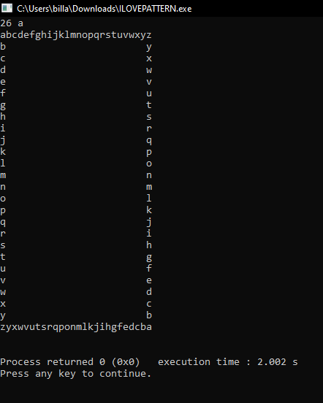

**Sample input and output -2:**

