High Level Design (HLD)

Online Book Shop

|  |
| --- |
| Contents |
| 1. **Abstract** |
| 1. **Introduction** |
| 1. **General Description**    1. **Product Perspective**    2. **Problem statement**    3. **Proposed Solution**    4. **Tools used** |
| 1. **Design Details**    1. **Process Flow**    2. **Activity Diagram**    3. **Component Diagram** |
| 1. **Further Improvements** |
| **conclusion** |

Abstract

Online Book Shop keeps things simple. It's like a virtual store where students can find and buy new books or sell their old ones hassle-free. They don't need to go anywhere else – everything happens on our website. When they want a new book for their courses, they can easily browse and purchase it. And when they're done with their old books, they can sell them to others who might need them. The system takes care of all the technical stuff behind the scenes, ensuring security for transactions. Even for us, managing the shop is easy. We can add or remove books without getting into complicated computer stuff. This makes our project user-friendly and reliable for our college mates.

1Introduction

In today's digital era, online shopping has made life easier for everyone. But for us students, finding the right books for our studies can still be a hassle. We often end up with stacks of old books we don't need anymore, while also needing to buy new ones for our courses. That's where our Online Book Shop comes in – it's like a virtual store just for students.

Our project is all about making it simple for students to buy new books they need and sell their old ones to others. We've created a website where you can easily find the books you're looking for and get rid of the ones you no longer need. It's a one-stop solution for all your book needs, right from your computer or phone.

With our Online Book Shop, we want to make buying and selling books easy and affordable for students. We believe in making education more accessible and sustainable by promoting the reuse of books. By encouraging the reuse of paper, we're helping to save trees, water, and the environment. Plus, it's a great way for students to connect and help each other out. So, let's get started and make studying a little bit easier for all of us!

# 2 General Description

## 2.1 Product Perspective

The primary objective of the Online Book Shop project is to create an online platform that replicates the experience of browsing and purchasing books from a physical bookstore. It aims to provide a seamless shopping experience, secure payment processing, and efficient management of inventory and orders. The system should be user-friendly, scalable, and robust.

Online Book Shop project is only for learning & hands on experience about Core Java, Advance Java concepts, Hibernate, DBMS, Servlet, JSP and demo model of Online Book Shop.

### 2.2 Problem statement

To create an Online Book Shop the following use cases.

1.Register Admin, User

2.Add Books for Sale

4.Sale Old Books

5.Sale New Books

6.Show Books

7.Cart Book

8.Old Book Management

9. Track Orders

### 2.3 PROPOSED SOLUTION

The proposed solution is to develop an Online Book Shop catering specifically to the needs of students. This platform will allow students to buy new books for their courses and sell their old books to others. It will provide a user-friendly interface where students can easily browse through available books, search for specific titles, and complete transactions securely.

The Online Book Shop will offer competitive prices for new books and provide a marketplace for students to sell their used books at reasonable rates. This will address the financial constraints often faced by students while also promoting the reuse of educational materials.

Secure payment gateways will be integrated to ensure the safety of transactions, and user profiles will enable students to manage their orders and track their purchases.

Overall, the proposed solution aims to simplify the process of acquiring and disposing of academic books for students, providing them with a convenient and cost-effective solution tailored to their needs.

User Module:

Handles user-related functionalities such as registration, login, and profile management.

Users can search for books, view book details, and add books to their cart for purchase.

Allows users to list their used books for sale, edit book details, and manage their listings.

Users can view their order history, track orders, and communicate with sellers or buyers.

Admin Module:

Provides functionalities for site administration and management.

Administrators can add, edit, or remove book listings, manage user accounts, and monitor user activity.

Access to a dashboard where administrators can view statistics, track orders, and manage system settings.

Allows administrators to add new books for sale, including details such as title, author, description, price, and availability.

Book Management Module:

Responsible for managing the inventory of books available on the platform.

Includes functionalities for adding new books to the catalog, updating book details, and removing books that are no longer available.

Handles book categorization, allowing users to browse books by genre, author, or subject.

Order Management Module:

Tracks the lifecycle of orders from placement to fulfillment.

Functionalities for users to view order status, track shipments, and manage returns or cancellations.

Administrators can monitor order processing, manage inventory levels, and generate reports on sales performance.

#### 2.4 Tools used

**Java**: Core programming language for backend development.

**Servlet**: For handling requests and generating dynamic web content.

**JSP** (JavaServer Pages): For creating dynamic web pages.

**MySQL**: Relational database management system for storing book data, user information, and orders.

**HTML/CSS**: For frontend user interface design.

**Bootstrap**: Frontend framework for creating responsive web design.

**Apache Tomcat**: Servlet container for running Java web applications.

# 3 Design Details

3.1 Process Flow

Below is the process flow diagram is as shown below.

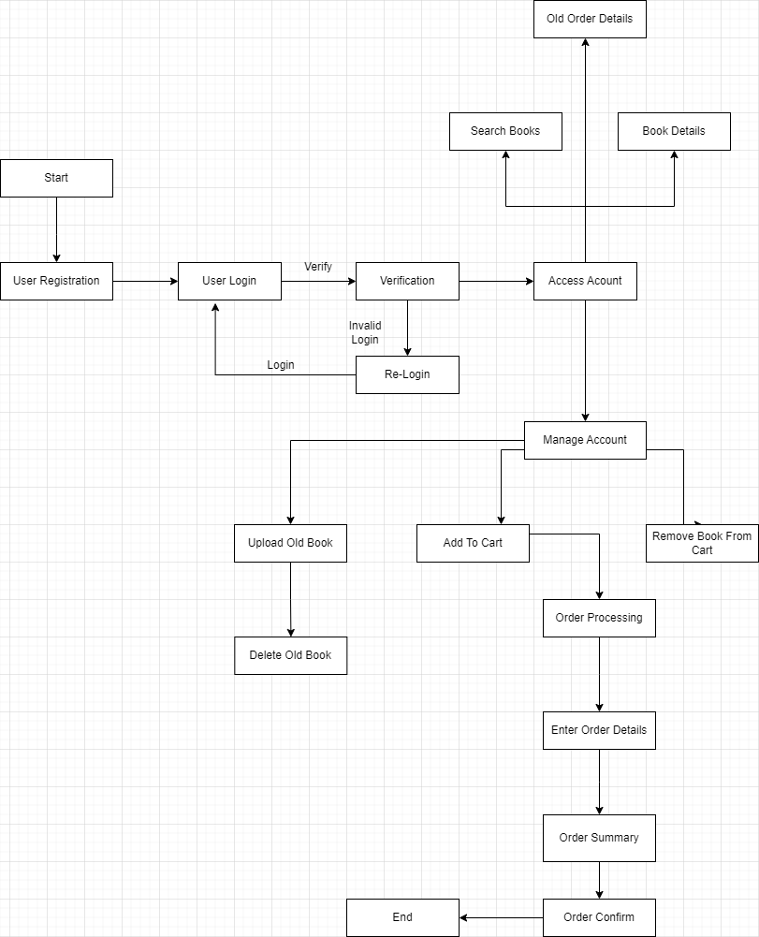

**3.2 Activity Diagram**

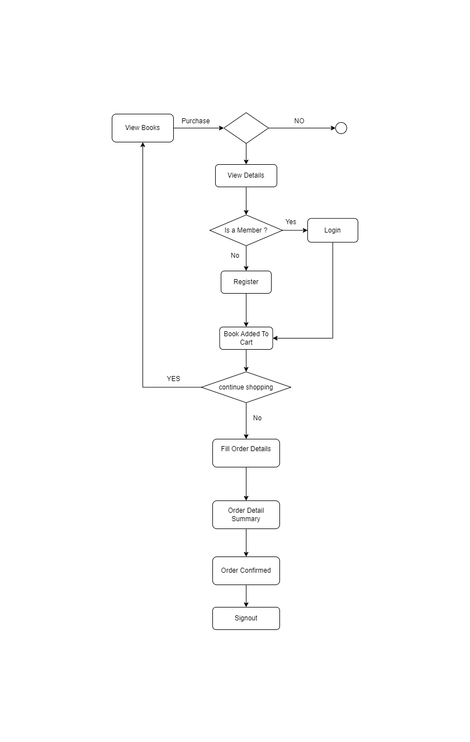

**3.3 Component Diagram:**

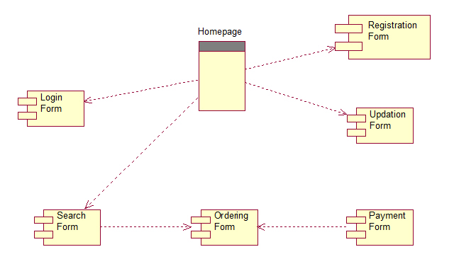

1. **Future Enhancements:**

**Integration of Advanced Search Features:** Enhance the search functionality to include filters such as price range, publication date, and book condition to provide users with more precise search results.

**Implementing User Reviews and Ratings:** Allow users to leave reviews and ratings for books they have purchased, enabling others to make informed decisions based on peer feedback.

**Introducing Wishlists and Book Recommendations**: Enable users to create wishlists of books they are interested in purchasing and provide personalized book recommendations based on their browsing and purchase history.

**Expanding Payment Options:** Integrate additional payment gateways such as PayPal, Google Pay, or UPI to offer users more flexibility in making payments.

**Enhancing Admin Dashboard Functionality**: Expand the capabilities of the admin dashboard to include advanced analytics, sales reports, and inventory management tools for better decision-making.

**Implementing Social Media Integration:** Allow users to share their favorite books or purchases on social media platforms, increasing visibility and engagement with the platform.

**Introducing Book Rental Services:** Expand the platform to include a book rental feature, allowing users to rent books for a specified duration instead of purchasing them outright.

**Implementing Mobile Applications:** Develop mobile applications for iOS and Android platforms to provide users with a seamless and optimized experience on mobile devices.

**Integrating AI-based Book Recommendation Systems**: Implement artificial intelligence algorithms to analyze user preferences and behavior and provide personalized book recommendations tailored to individual users.

**Enhancing Accessibility Features:** Ensure compliance with accessibility standards such as WCAG (Web Content Accessibility Guidelines) to make the platform accessible to users with disabilities.

1. Conclusion

The Online Book Shop project not only simplifies the process of buying and selling books but also promotes sustainability by encouraging the reuse of educational materials. By providing a centralized marketplace for students to access and exchange books, we aim to foster a sense of community and collaboration within the academic community. We believe that the Online Book Shop will serve as a valuable resource for students, educators, and book enthusiasts alike, empowering them to make informed choices and contribute to a more sustainable and inclusive learning environment.