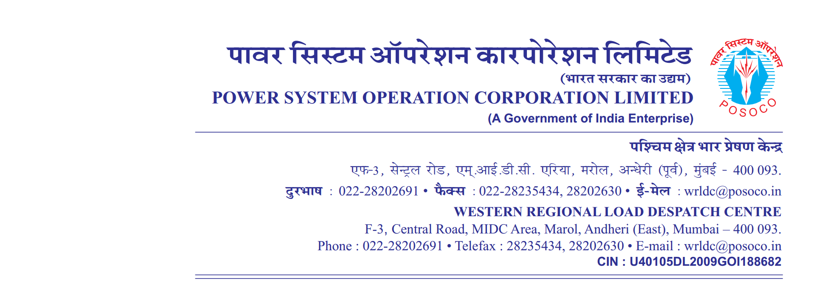

**साप्ताहिक विवरण**

Weekly Report वर्ष {{year_str}}/ / सप्ताह संख्या {{week_no}} अवधि {{start_dt}} से {{end_dt}}

**Year {{year_str}}/ / Week No {{week_no}} Period from {{start_dt}} to {{end_dt}}**

A. (**आवृति रूपरेखा**) **Frequency Profile**

|  |  |  |  |  |  |  |  |  |  |  |  |
| --- | --- | --- | --- | --- | --- | --- | --- | --- | --- | --- | --- |
| **दिनांक** | **अधिकतम तात्कालिक** | **न्युनतम तात्कालिक** | **औसत** | **% of time 49.9**  **से कम** | **% of time 49.9 से 50.05 तक** | **% of time 50.05 से उपर** | | **Per**  **centage of Time Frequency Remained outside IEGC Band** | **No’s of hours frequency remained outside IEGC Band** | **FDI =No. of hours out of IEGC band/24Hrs** | **Weekly FDI =No. of hours out of IEGC band/24*7Hrs** |
| **Date** | **Maximum Inst.** | **Minimum Inst.** | **Average** | **<49.9** | **49.9 – 50.05** | **>50.05** | |
|  | **(Hz)** | **(Hz)** | **(Hz)** | **(%)** | **(%)** | **(%)** | | **(%)** |
| **{%tr for row in derFreqList %}** | | | | |  | | | | |  | |
| {{  row.date  }} | {{  row.max  }} | {{  row.min  }} | {{  row.avg  }} | {{  row.less }} | {{  row.bw  }} | {{  row.great  }} | {{  row.out  }} | | {{  row.outHrs  }} | {{  row.fdi  }} |  |
| **{%tr endfor %}** | | | | | | | | | | | |

**Desired Output:**

B.**विद्युतदाब रूपरेखा** Voltage Profile (**Voltages in kV )**

|  |  |  |  |  |  |  |  |  |  |  |  |  |  |  |  |  |  |  |
| --- | --- | --- | --- | --- | --- | --- | --- | --- | --- | --- | --- | --- | --- | --- | --- | --- | --- | --- |
| **दिनांक**  **Date** | **भोपाल**  **Bhopal** | | **खंडवा**  **Khandwa** | | **इटारसी**  **Itarsi** | | **दमोह Damoh** | | **नागदा Nagda** | | **इंदौर**  **Indore** | | **ग्वालियर Gwalior** | | **रायपुर Raipur** | | **रायगढ़ Raigarh** | |
| **अधिकतम**  **Max** | **न्युनतम**  **Min** | **अधिकतम**  **Max** | **न्युनतम**  **Min** | **अधिकतम**  **Max** | **न्युनतम Min** | **अधिकतम**  **Max** | **न्युनतम**  **Min** | **अधिकतम**  **Max** | **न्युनतम Min** | **अधिकतम**  **Max** | **न्युनतम Min** | **अधिकतम**  **Max** | **न्युनतम Min** | **अधिकतम**  **Max** | **न्युनतम Min** | **अधिकतम**  **Max** | **न्युनतम Min** |
| **27** | **412** | **400** | **419** | **406** | **409** | **397** | **419** | **405** | **418** | **406** | **416** | **403** | **414** | **394** | **420** | **414** | **420** | **414** |
| **28** | **413** | **402** | **419** | **408** | **410** | **400** | **416** | **405** | **417** | **407** | **415** | **405** | **415** | **397** | **422** | **413** | **422** | **415** |
| **29** | **414** | **405** | **418** | **408** | **410** | **402** | **417** | **408** | **416** | **406** | **414** | **405** | **415** | **399** | **422** | **416** | **423** | **417** |
| **30** | **415** | **405** | **419** | **410** | **412** | **403** | **418** | **407** | **417** | **408** | **415** | **406** | **415** | **397** | **421** | **415** | **422** | **417** |
| **31** | **415** | **403** | **418** | **407** | **411** | **400** | **418** | **405** | **416** | **406** | **415** | **404** | **415** | **398** | **420** | **413** | **421** | **415** |
| **01** | **414** | **403** | **419** | **409** | **411** | **401** | **417** | **406** | **417** | **407** | **415** | **405** | **415** | **396** | **422** | **415** | **422** | **416** |
| **02** | **415** | **404** | **419** | **411** | **412** | **403** | **418** | **406** | **417** | **409** | **415** | **407** | **415** | **395** | **423** | **416** | **422** | **416** |

**Real output**

**B.विद्युतदाब रूपरेखा Voltage Profile (Voltages in kV )**

|  |  |  |  |  |  |  |  |  |  |  |  |  |  |  |  |  |  |  |
| --- | --- | --- | --- | --- | --- | --- | --- | --- | --- | --- | --- | --- | --- | --- | --- | --- | --- | --- |
| **दिनांक**  **Date** | **भोपाल**  **Bhopal** | | **खंडवा**  **Khandwa** | | **इटारसी**  **Itarsi** | | **दमोह Damoh** | | **नागदा Nagda** | | **इंदौर**  **Indore** | | **ग्वालियर Gwalior** | | **रायपुर Raipur** | | **रायगढ़ Raigarh** | |
| **अधिकतम**  **Max** | **न्युनतम**  **Min** | **अधिकतम**  **Max** | **न्युनतम**  **Min** | **अधिकतम**  **Max** | **न्युनतम Min** | **अधिकतम**  **Max** | **न्युनतम**  **Min** | **अधिकतम**  **Max** | **न्युनतम Min** | **अधिकतम**  **Max** | **न्युनतम Min** | **अधिकतम**  **Max** | **न्युनतम Min** | **अधिकतम**  **Max** | **न्युनतम Min** | **अधिकतम**  **Max** | **न्युनतम Min** |
|  |  |  | | | | | | | | | | | | | | | | |
|  | | | | | | | | | | | | | | | | | | |