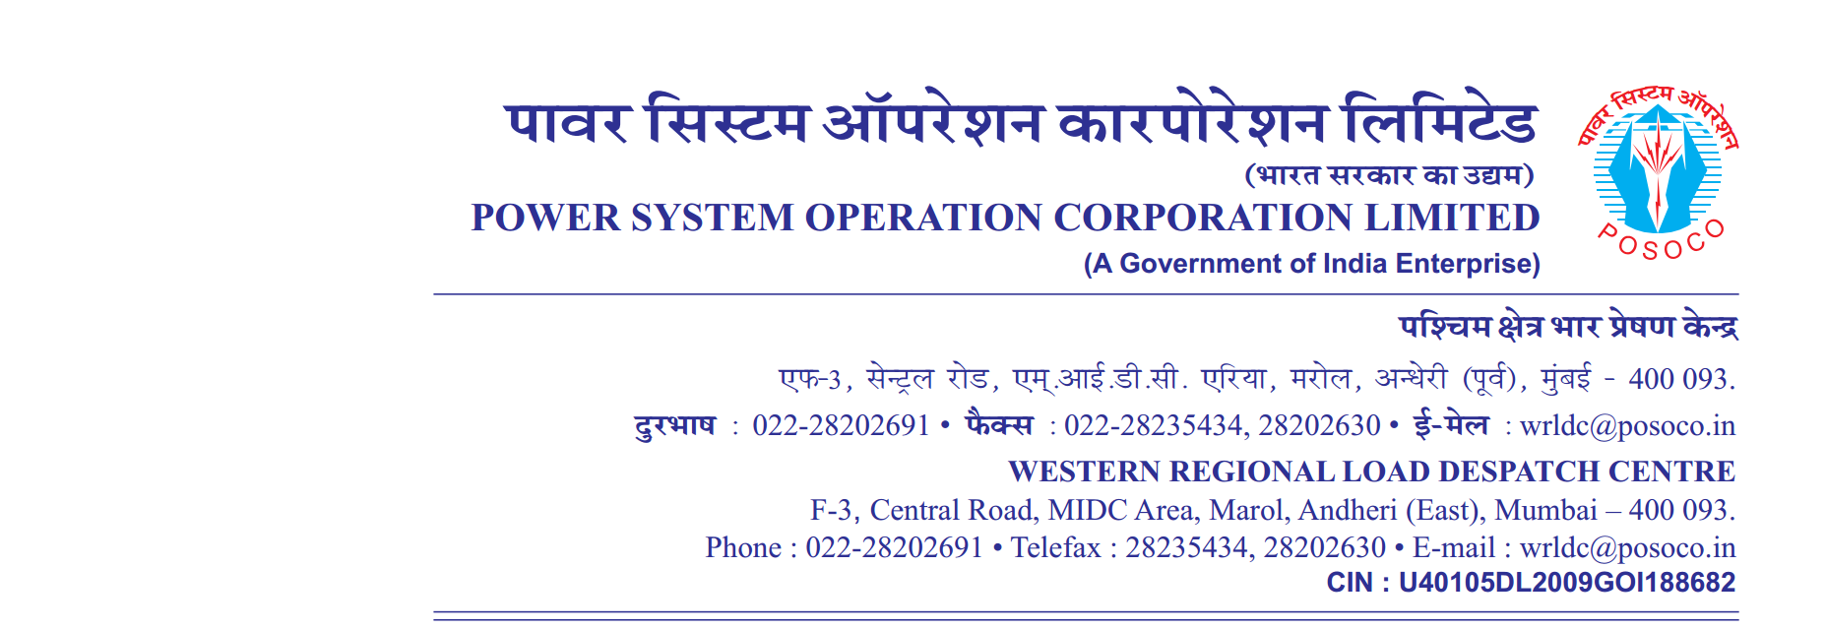

**साप्ताहिक विवरण**

Weekly Report वर्ष 2020-21/ सप्ताह संख्या 18 अवधि 27.07.2020 से 02.08.2020

**Year 2020-21 / Week No 18 Period from 27.07.2020 to 02.08.2020**

**Desired Output:(as per mis report)**

A. (**आवृति रूपरेखा**) **Frequency Profile**

|  |  |  |  |  |  |  |  |  |  |  |
| --- | --- | --- | --- | --- | --- | --- | --- | --- | --- | --- |
| **दिनांक** | **अधिकतम तात्कालिक** | **न्युनतम तात्कालिक** | **औसत** | **% of time 49.9**  **से कम** | **% of time 49.9 से 50.05 तक** | **% of time 50.05 से उपर** | **Per**  **centage of Time Frequency Remained outside IEGC Band** | **No’s of hours frequency remained outside IEGC Band** | **FDI =No. of hours out of IEGC band/24Hrs** | **Weekly FDI =No. of hours out of IEGC band/24*7Hrs** |
| **Date** | **Maximum Inst.** | **Minimum Inst.** | **Average** | **<49.9** | **49.9 – 50.05** | **>50.05** | **(Hours)** |
|  | **(Hz)** | **(Hz)** | **(Hz)** | **(%)** | **(%)** | **(%)** | **(%)** |  |
| **27** | **50.17** | **49.78** | **49.98** | **6.93** | **84.25** | **8.82** | **15.75** | **3.78** | **0.16** | **0.17** |
| **28** | **50.13** | **49.74** | **49.98** | **9.39** | **81.78** | **8.83** | **18.22** | **4.37** | **0.18** |
| **29** | **50.14** | **49.84** | **50.00** | **2.20** | **83.10** | **14.70** | **16.90** | **4.06** | **0.17** |
| **30** | **50.18** | **49.70** | **50.00** | **5.10** | **79.10** | **15.80** | **20.90** | **5.02** | **0.21** |
| **31** | **50.13** | **49.76** | **49.98** | **7.60** | **87.60** | **4.80** | **12.40** | **2.98** | **0.12** |
| **01** | **50.16** | **49.76** | **49.99** | **4.14** | **87.36** | **8.50** | **12.64** | **3.03** | **0.13** |
| **02** | **50.21** | **49.78** | **50.00** | **6.39** | **77.62** | **16.00** | **22.38** | **5.37** | **0.22** |

**Real output(as per template syntax)**

A. (**आवृति रूपरेखा**) **Frequency Profile**

|  |  |  |  |  |  |  |  |  |  |  |
| --- | --- | --- | --- | --- | --- | --- | --- | --- | --- | --- |
| **दिनांक** | **अधिकतम तात्कालिक** | **न्युनतम तात्कालिक** | **औसत** | **% of time 49.9**  **से कम** | **% of time 49.9 से 50.05 तक** | **% of time 50.05 से उपर** | **Per**  **centage of Time Frequency Remained outside IEGC Band** | **No’s of hours frequency remained outside IEGC Band** | **FDI =No. of hours out of IEGC band/24Hrs** | **Weekly FDI =No. of hours out of IEGC band/24*7Hrs** |
| **Date** | **Maximum Inst.** | **Minimum Inst.** | **Average** | **<49.9** | **49.9 – 50.05** | **>50.05** |
|  | **(Hz)** | **(Hz)** | **(Hz)** | **(%)** | **(%)** | **(%)** | **(%)** |
| 22 | 7 | 53 | 34 | 94 | 41 | 65 | 12 | 80 | 22 | 52 |
| 48 | 95 | 11 | 97 | 81 | 34 | 94 | 48 | 82 | 79 | 76 |
| 40 | 63 | 86 | 74 | 89 | 73 | 27 | 56 | 17 | 58 | 32 |
| 2 | 92 | 5 | 17 | 67 | 92 | 82 | 19 | 66 | 95 | 25 |
| 48 | 90 | 3 | 59 | 36 | 40 | 23 | 8 | 22 | 91 | 16 |
| 59 | 19 | 15 | 82 | 87 | 42 | 34 | 17 | 86 | 50 | 2 |
| 44 | 92 | 6 | 28 | 38 | 26 | 47 | 88 | 62 | 47 | 0 |

**Desired Output:**

B.**विद्युतदाब रूपरेखा** Voltage Profile (**Voltages in kV )**

|  |  |  |  |  |  |  |  |  |  |  |  |  |  |  |  |  |  |  |  |  |  |  |  |  |  |  |
| --- | --- | --- | --- | --- | --- | --- | --- | --- | --- | --- | --- | --- | --- | --- | --- | --- | --- | --- | --- | --- | --- | --- | --- | --- | --- | --- |
| **दिनांक**  **Date** | **भोपाल**  **Bhopal** | | | **खंडवा**  **Khandwa** | | | **इटारसी**  **Itarsi** | | | **दमोह Damoh** | | | **नागदा Nagda** | | | **इंदौर**  **Indore** | | | **ग्वालियर Gwalior** | | | **रायपुर Raipur** | | | **रायगढ़ Raigarh** | |
| **अधिकतम**  **Max** | **न्युनतम**  **Min** | **अधिकतम**  **Max** | | **न्युनतम**  **Min** | **अधिकतम**  **Max** | | **न्युनतम Min** | **अधिकतम**  **Max** | | **न्युनतम**  **Min** | **अधिकतम**  **Max** | | **न्युनतम Min** | **अधिकतम**  **Max** | | **न्युनतम Min** | **अधिकतम**  **Max** | | **न्युनतम Min** | **अधिकतम**  **Max** | | **न्युनतम Min** | **अधिकतम**  **Max** | | **न्युनतम Min** |
| **27** | **412** | **400** | **419** | | **406** | **409** | | **397** | **419** | | **405** | **418** | | **406** | **416** | | **403** | **414** | | **394** | **420** | | **414** | **420** | | **414** |
| **28** | **413** | **402** | **419** | | **408** | **410** | | **400** | **416** | | **405** | **417** | | **407** | **415** | | **405** | **415** | | **397** | **422** | | **413** | **422** | | **415** |
| **29** | **414** | **405** | **418** | | **408** | **410** | | **402** | **417** | | **408** | **416** | | **406** | **414** | | **405** | **415** | | **399** | **422** | | **416** | **423** | | **417** |
| **30** | **415** | **405** | **419** | | **410** | **412** | | **403** | **418** | | **407** | **417** | | **408** | **415** | | **406** | **415** | | **397** | **421** | | **415** | **422** | | **417** |
| **31** | **415** | **403** | **418** | | **407** | **411** | | **400** | **418** | | **405** | **416** | | **406** | **415** | | **404** | **415** | | **398** | **420** | | **413** | **421** | | **415** |
| **01** | **414** | **403** | **419** | | **409** | **411** | | **401** | **417** | | **406** | **417** | | **407** | **415** | | **405** | **415** | | **396** | **422** | | **415** | **422** | | **416** |
| **02** | **415** | **404** | **419** | | **411** | **412** | | **403** | **418** | | **406** | **417** | | **409** | **415** | | **407** | **415** | | **395** | **423** | | **416** | **422** | | **416** |

**Real output**

**B.विद्युतदाब रूपरेखा Voltage Profile (Voltages in kV )**

|  |  |  |  |  |  |  |  |  |  |  |  |  |  |  |  |  |  |  |
| --- | --- | --- | --- | --- | --- | --- | --- | --- | --- | --- | --- | --- | --- | --- | --- | --- | --- | --- |
| **दिनांक**  **Date** | **भोपाल**  **Bhopal** | | **खंडवा**  **Khandwa** | | **इटारसी**  **Itarsi** | | **दमोह Damoh** | | **नागदा Nagda** | | **इंदौर**  **Indore** | | **ग्वालियर Gwalior** | | **रायपुर Raipur** | | **रायगढ़ Raigarh** | |
| **अधिकतम**  **Max** | **न्युनतम**  **Min** | **अधिकतम**  **Max** | **न्युनतम**  **Min** | **अधिकतम**  **Max** | **न्युनतम Min** | **अधिकतम**  **Max** | **न्युनतम**  **Min** | **अधिकतम**  **Max** | **न्युनतम Min** | **अधिकतम**  **Max** | **न्युनतम Min** | **अधिकतम**  **Max** | **न्युनतम Min** | **अधिकतम**  **Max** | **न्युनतम Min** | **अधिकतम**  **Max** | **न्युनतम Min** |
| 63 | 77 | 22 | 43 | 12 | 19 | 32 | 68 | 58 | 5 | 10 | 76 | 90 | 54 | 53 | 3 | 49 | 70 | 95 |
| 11 | 70 | 89 | 5 | 50 | 3 | 10 | 47 | 61 | 0 | 7 | 36 | 47 | 13 | 35 | 28 | 55 | 0 | 88 |
| 5 | 25 | 61 | 11 | 19 | 71 | 53 | 60 | 89 | 83 | 47 | 23 | 57 | 20 | 96 | 98 | 93 | 88 | 18 |
| 80 | 73 | 8 | 8 | 34 | 77 | 33 | 17 | 7 | 69 | 28 | 69 | 36 | 36 | 40 | 81 | 66 | 47 | 49 |
| 39 | 1 | 36 | 30 | 8 | 62 | 43 | 63 | 18 | 23 | 40 | 56 | 99 | 98 | 68 | 90 | 0 | 47 | 60 |
| 75 | 88 | 44 | 70 | 51 | 94 | 7 | 37 | 16 | 72 | 9 | 59 | 13 | 0 | 11 | 60 | 0 | 37 | 8 |
| 91 | 51 | 49 | 85 | 84 | 71 | 13 | 98 | 6 | 71 | 64 | 71 | 34 | 25 | 35 | 57 | 44 | 61 | 91 |