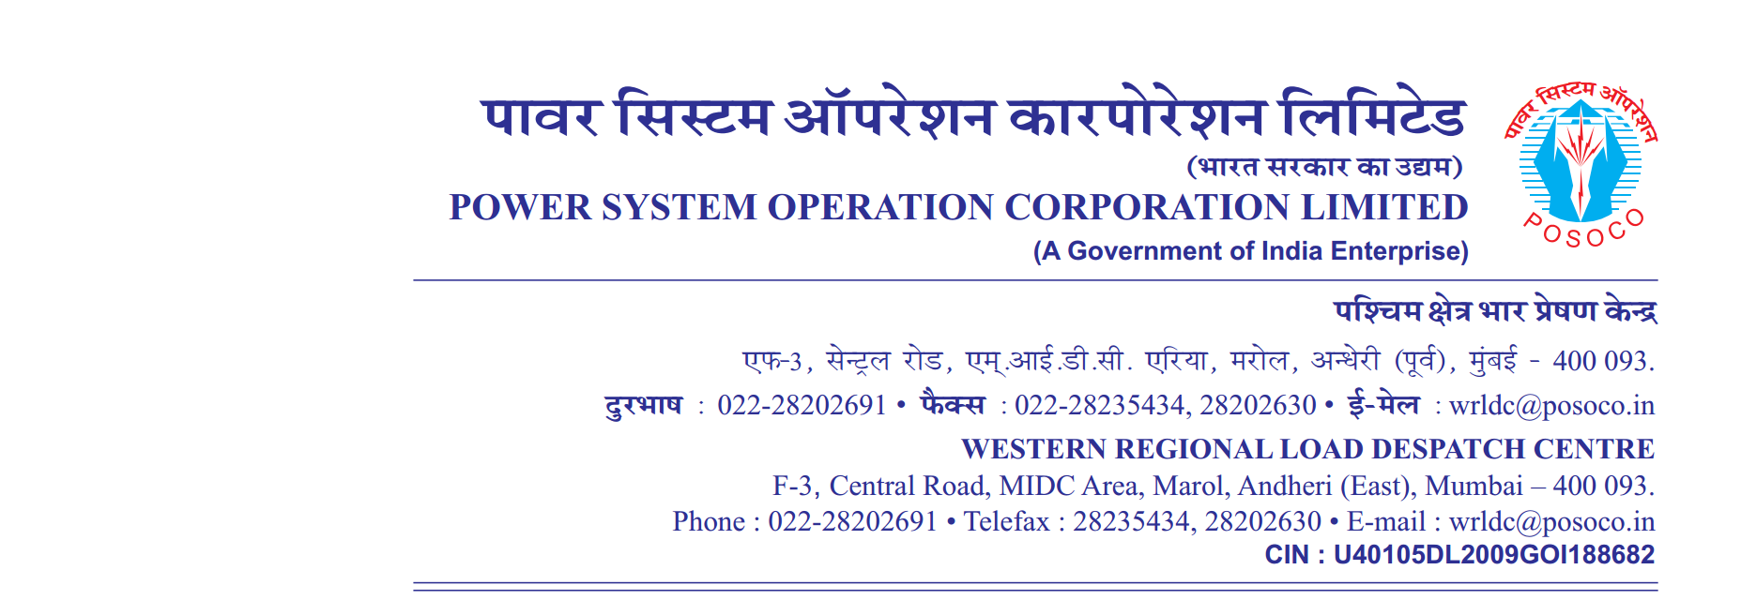

**साप्ताहिक विवरण**

Weekly Report वर्ष 2019/ / सप्ताह संख्या 30 अवधि 2019-07-22 से 2019-07-28

**Year 2019/ / Week No 30 Period from 2019-07-22 to 2019-07-28**

A. (**आवृति रूपरेखा**) **Frequency Profile**

|  |  |  |  |  |  |  |  |  |  |  |  |  |
| --- | --- | --- | --- | --- | --- | --- | --- | --- | --- | --- | --- | --- |
| **दिनांक** | **अधिकतम तात्कालिक** | **न्युनतम तात्कालिक** | **औसत** | **% of time 49.9**  **से कम** | **% of time 49.9 से 50.05 तक** | **% of time 50.05 से उपर** | | **Per**  **centage of Time Frequency Remained outside IEGC Band** | **No’s of hours frequency remained outside IEGC Band** | **FDI =No. of hours out of IEGC band/24Hrs** | **Weekly FDI =No. of hours out of IEGC band/24*7Hrs** | |
| **Date** | **Maximum Inst.** | **Minimum Inst.** | **Average** | **<49.9** | **49.9 – 50.05** | **>50.05** | |
|  | **(Hz)** | **(Hz)** | **(Hz)** | **(%)** | **(%)** | **(%)** | | **(%)** |  |  | 0.3 | |
| 22 | 50.14 | 49.74 | 49.98 | 15.31 | 72.25 | 12.44 | 27.75 | | 6.66 | 0.28 |
| 23 | 50.16 | 49.66 | 49.98 | 14.54 | 71.06 | 14.4 | 28.94 | | 6.94 | 0.29 |
| 24 | 50.32 | 49.81 | 50.03 | 2.04 | 63.08 | 34.88 | 36.92 | | 8.86 | 0.37 |
| 25 | 50.13 | 49.78 | 49.96 | 15.84 | 78.46 | 5.7 | 21.54 | | 5.17 | 0.22 |
| 26 | 50.22 | 49.76 | 50.01 | 5.79 | 69.98 | 24.24 | 30.02 | | 7.21 | 0.3 |
| 27 | 50.29 | 49.78 | 50.01 | 4.54 | 68.43 | 27.04 | 31.57 | | 7.58 | 0.32 |
| 28 | 50.22 | 49.85 | 50.03 | 1.27 | 67.85 | 30.88 | 32.15 | | 7.72 | 0.32 |

**Desired Output:**

B.**विद्युतदाब रूपरेखा** Voltage Profile (**Voltages in kV )**

|  |  |  |  |  |  |  |  |  |  |  |  |  |  |  |  |  |  |  |
| --- | --- | --- | --- | --- | --- | --- | --- | --- | --- | --- | --- | --- | --- | --- | --- | --- | --- | --- |
| **दिनांक**  **Date** | **भोपाल**  **Bhopal** | | **खंडवा**  **Khandwa** | | **इटारसी**  **Itarsi** | | **दमोह Damoh** | | **नागदा Nagda** | | **इंदौर**  **Indore** | | **ग्वालियर Gwalior** | | **रायपुर Raipur** | | **रायगढ़ Raigarh** | |
| **अधिकतम**  **Max** | **न्युनतम**  **Min** | **अधिकतम**  **Max** | **न्युनतम**  **Min** | **अधिकतम**  **Max** | **न्युनतम Min** | **अधिकतम**  **Max** | **न्युनतम**  **Min** | **अधिकतम**  **Max** | **न्युनतम Min** | **अधिकतम**  **Max** | **न्युनतम Min** | **अधिकतम**  **Max** | **न्युनतम Min** | **अधिकतम**  **Max** | **न्युनतम Min** | **अधिकतम**  **Max** | **न्युनतम Min** |
| **27** | **412** | **400** | **419** | **406** | **409** | **397** | **419** | **405** | **418** | **406** | **416** | **403** | **414** | **394** | **420** | **414** | **420** | **414** |
| **28** | **413** | **402** | **419** | **408** | **410** | **400** | **416** | **405** | **417** | **407** | **415** | **405** | **415** | **397** | **422** | **413** | **422** | **415** |
| **29** | **414** | **405** | **418** | **408** | **410** | **402** | **417** | **408** | **416** | **406** | **414** | **405** | **415** | **399** | **422** | **416** | **423** | **417** |
| **30** | **415** | **405** | **419** | **410** | **412** | **403** | **418** | **407** | **417** | **408** | **415** | **406** | **415** | **397** | **421** | **415** | **422** | **417** |
| **31** | **415** | **403** | **418** | **407** | **411** | **400** | **418** | **405** | **416** | **406** | **415** | **404** | **415** | **398** | **420** | **413** | **421** | **415** |
| **01** | **414** | **403** | **419** | **409** | **411** | **401** | **417** | **406** | **417** | **407** | **415** | **405** | **415** | **396** | **422** | **415** | **422** | **416** |
| **02** | **415** | **404** | **419** | **411** | **412** | **403** | **418** | **406** | **417** | **409** | **415** | **407** | **415** | **395** | **423** | **416** | **422** | **416** |

**Real output**

**B.विद्युतदाब रूपरेखा Voltage Profile (Voltages in kV )**

|  |  |  |  |  |  |  |  |  |  |  |  |  |  |  |  |  |  |  |
| --- | --- | --- | --- | --- | --- | --- | --- | --- | --- | --- | --- | --- | --- | --- | --- | --- | --- | --- |
| **दिनांक**  **Date** | **भोपाल**  **Bhopal** | | **खंडवा**  **Khandwa** | | **इटारसी**  **Itarsi** | | **दमोह Damoh** | | **नागदा Nagda** | | **इंदौर**  **Indore** | | **ग्वालियर Gwalior** | | **रायपुर Raipur** | | **रायगढ़ Raigarh** | |
| **अधिकतम**  **Max** | **न्युनतम**  **Min** | **अधिकतम**  **Max** | **न्युनतम**  **Min** | **अधिकतम**  **Max** | **न्युनतम Min** | **अधिकतम**  **Max** | **न्युनतम**  **Min** | **अधिकतम**  **Max** | **न्युनतम Min** | **अधिकतम**  **Max** | **न्युनतम Min** | **अधिकतम**  **Max** | **न्युनतम Min** | **अधिकतम**  **Max** | **न्युनतम Min** | **अधिकतम**  **Max** | **न्युनतम Min** |
|  |  |  | | | | | | | | | | | | | | | | |
|  | | | | | | | | | | | | | | | | | | |