1. netstat -a: All active TCP

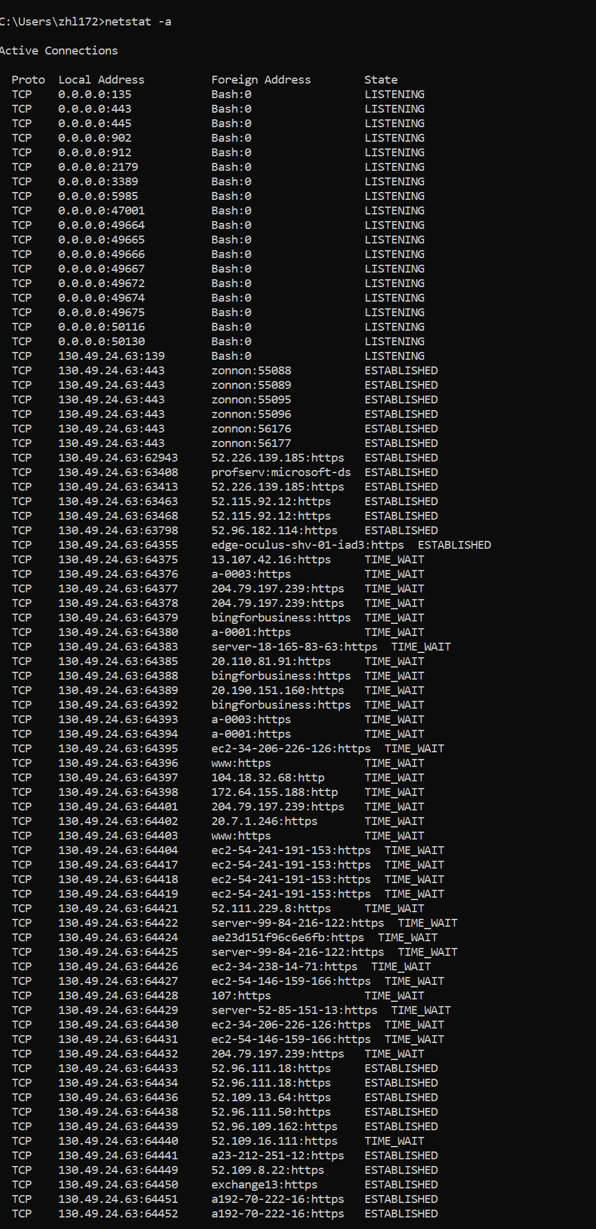

1. netstat -e: Ethernet statistics

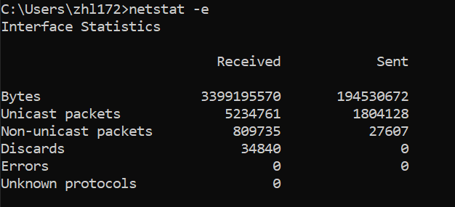

1. netstat -n: Active TCP connections (number)

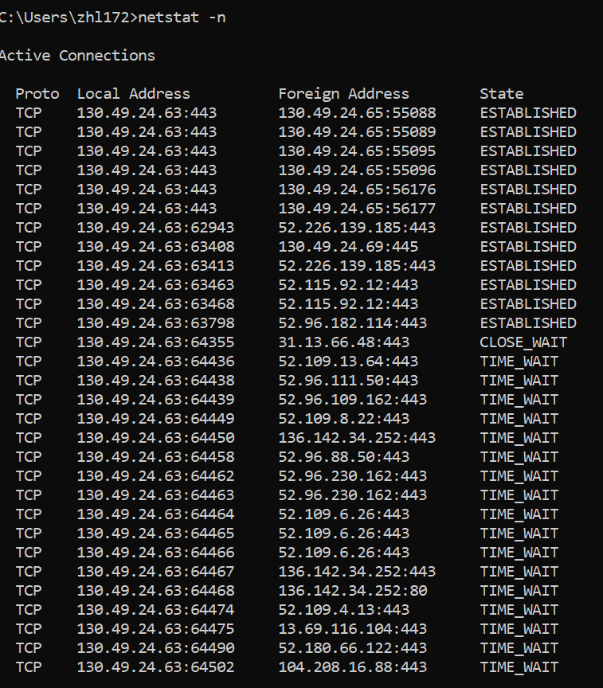

1. netstat -o: Active TCP connections

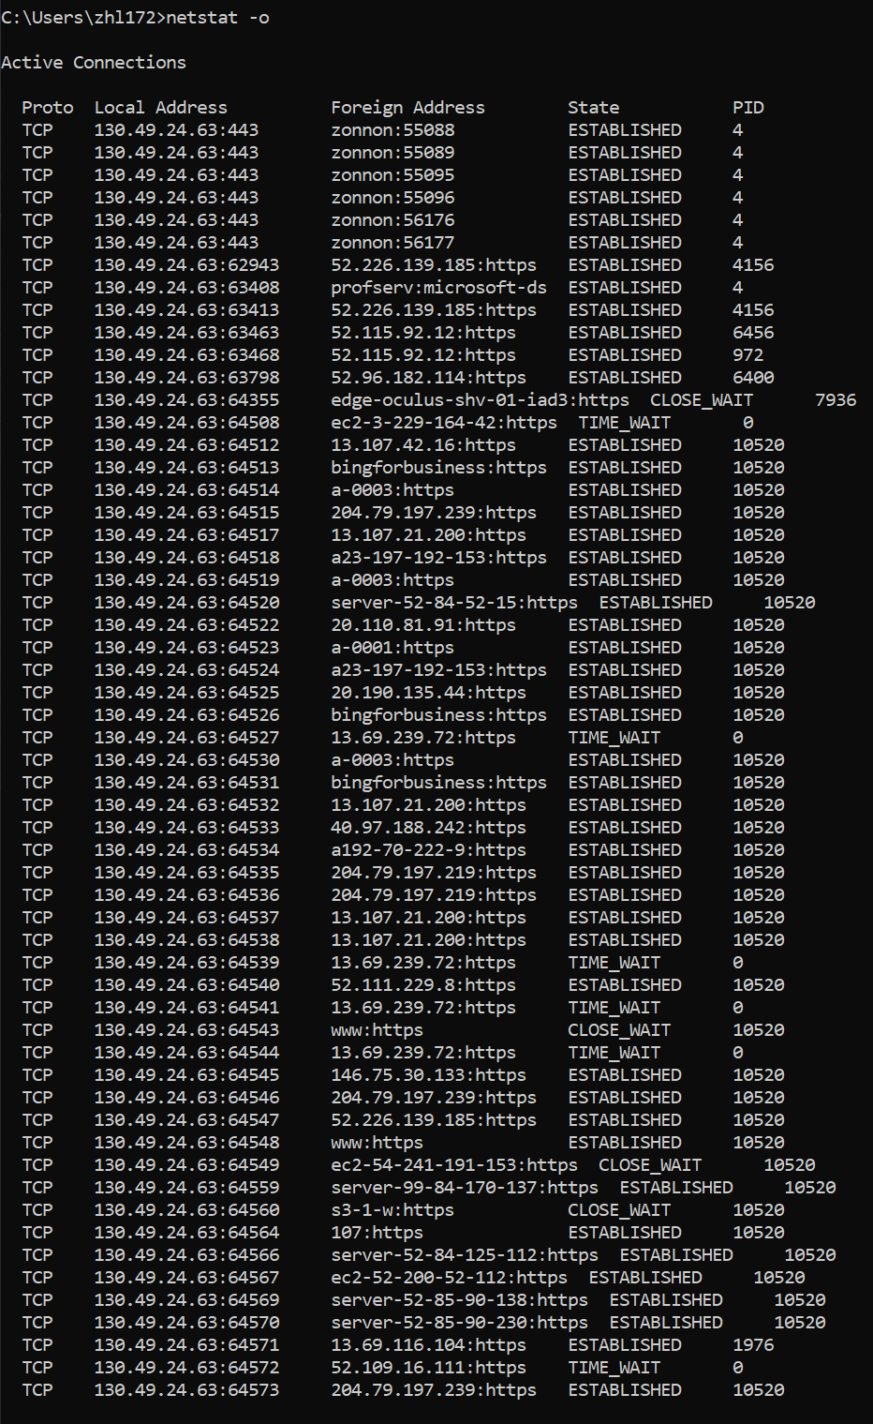

1. netstat -p: connections for protocol specified by protocol

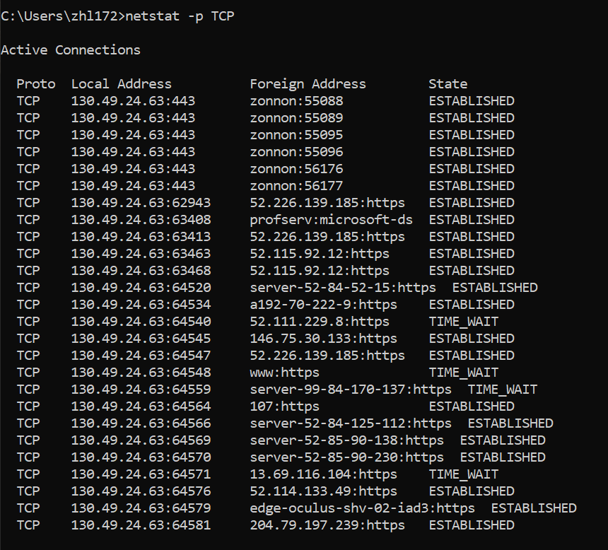

1. netstat -s: Statistics by protocol

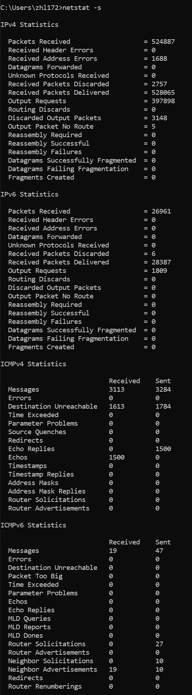

1. netstat -r: contents of the IP routing table

