**IRIS FLOWER DATASET ANALYSIS**

Dataset reference -> ( <https://www.kaggle.com/datasets/uciml/iris> )

We used the iris flower dataset to Calculate the range, Q1, Q3, IQR.

**Step-1**

Import the required Libraries

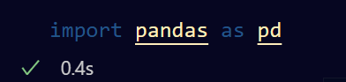

**Step-2**

Load the dataset using Pandas library

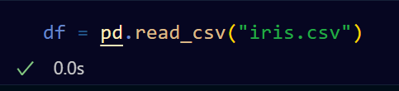

**Step-3**

Calculate the the range, Q1, Q3, IQR using Pandas Built-in Functions.

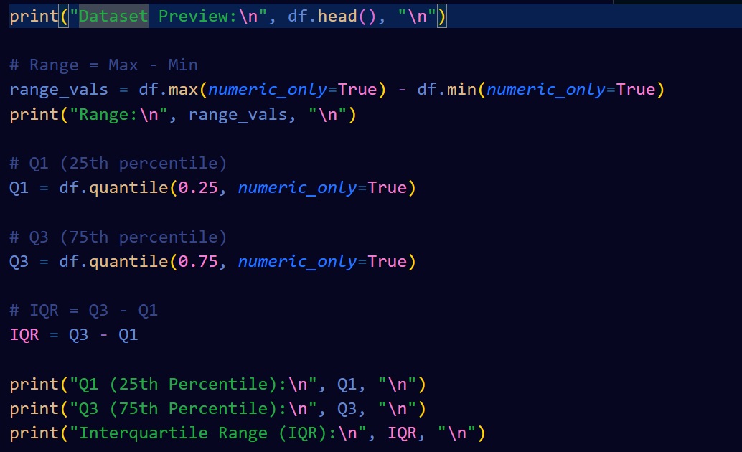

**Results: -**

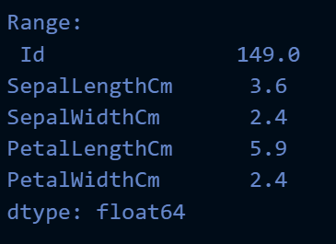 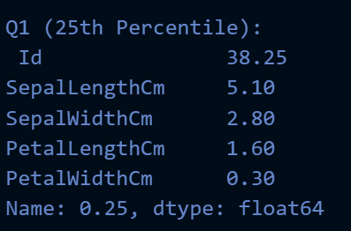 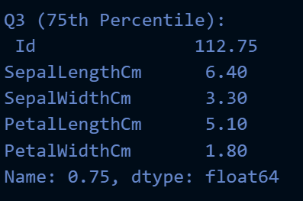 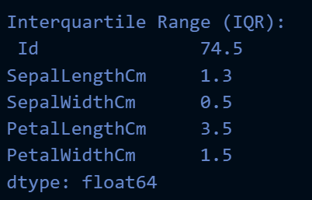

**Author:**

**Name: Asutosh Kataruka**

**ID: B122029**

**7th Semester CSE Dept.**

**IIIT Bhubaneswar**