**IRIS FLOWER DATASET ANALYSIS**

Dataset reference -> ( <https://www.kaggle.com/datasets/uciml/iris> )

We used the iris flower dataset to Lab plot Box and whisker diagram, Histogram , Q-plot, Scatter plot , Bar plot

**Step-1**

Import the required Libraries

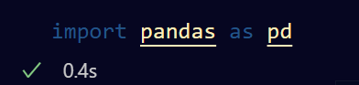

**Step-2**

Load the dataset using Pandas library

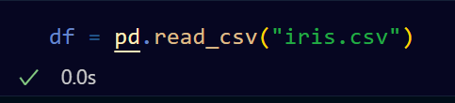

**Step-3**

**Box and whisker diagram**

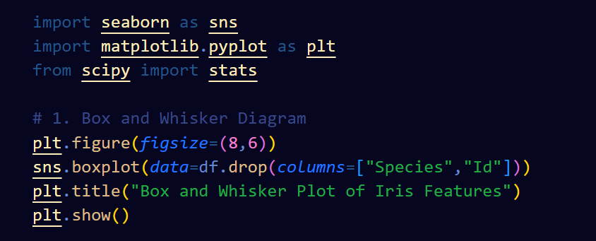

**Results: -**

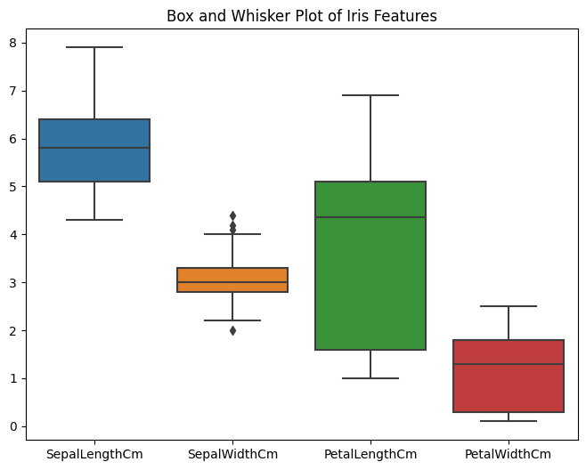

**Histogram**

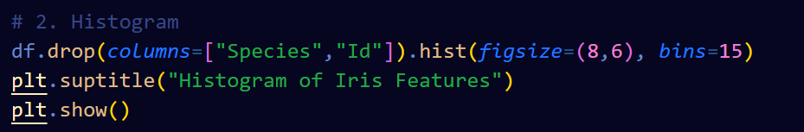

**Results: -**

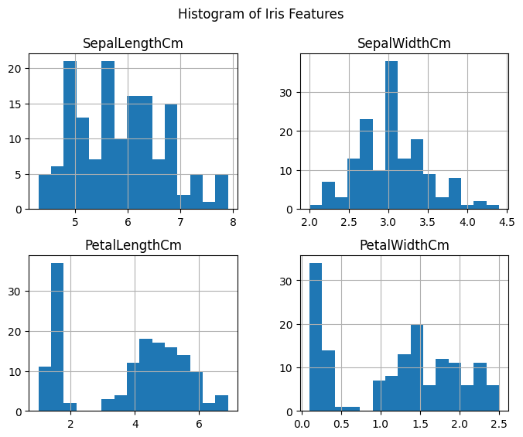

**Q-Q Plot**

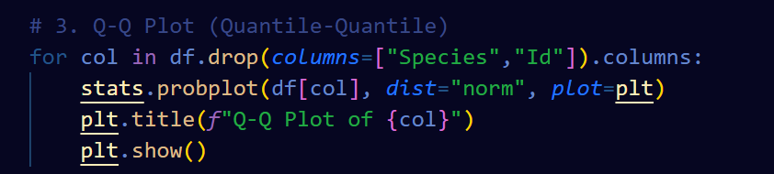

**Results: -**

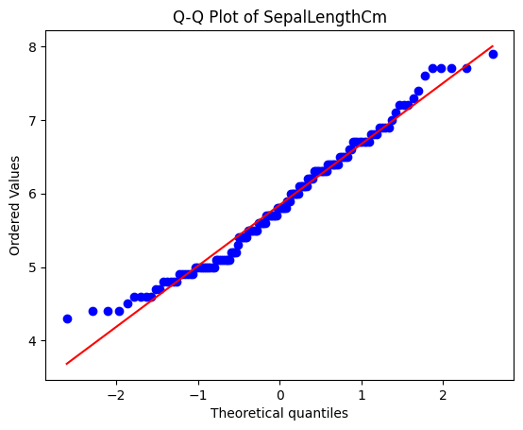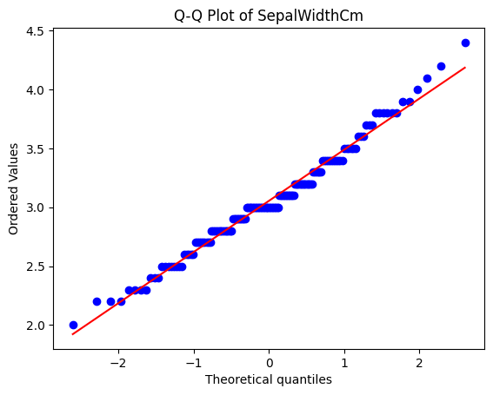

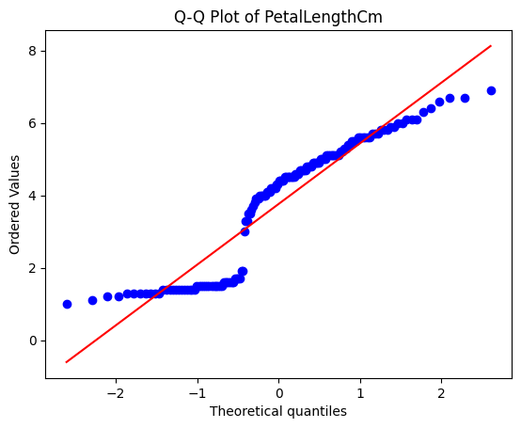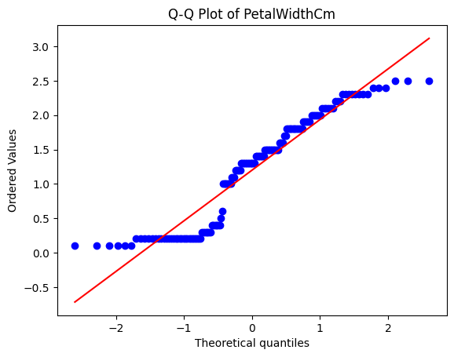

**Scatter plots**

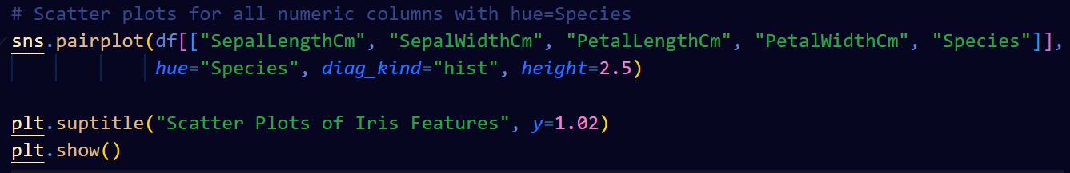

**Results: -**

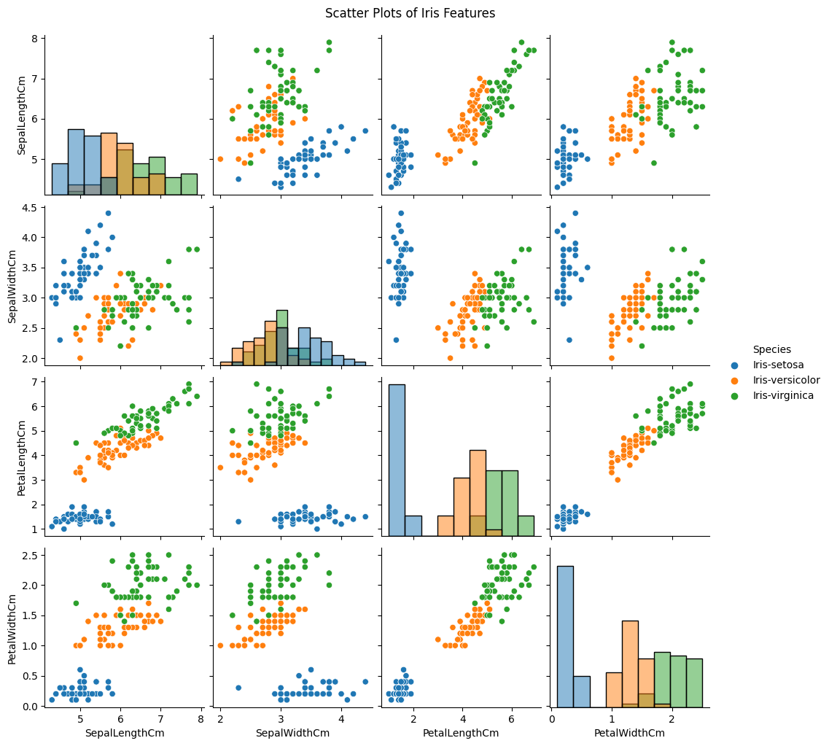

**Bar Plot**

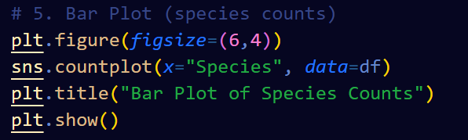

**Results: -**

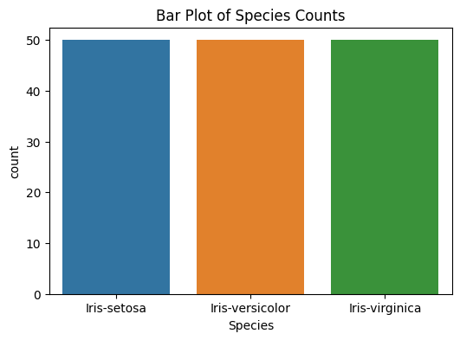

**Author:**

**Name: Asutosh Kataruka**

**ID: B122029**

**7th Semester CSE Dept.**

**IIIT Bhubaneswar**