Software Engineering

Lab 5

Name: Sahil Kothari

ID: 202001112

Date: 15-03-2023

We chose the tool pylint in python for static analysis of python projects.

1. Installed pylint using pip install pylint command in command prompt
2. Took sample codes from python files.
3. Ran the command py -m pylint filename.py in command prompt
4. Took screenshots of the errors.
5. Music.py file

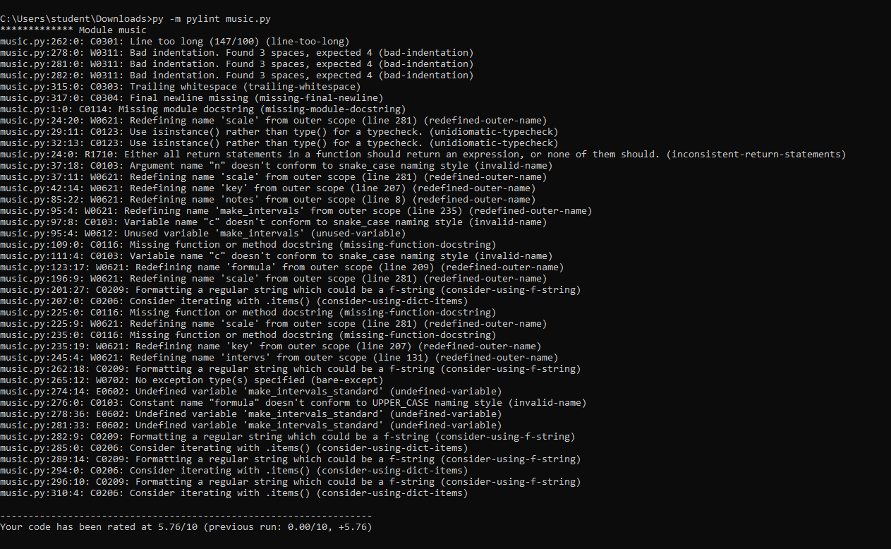

1. Stream.py file

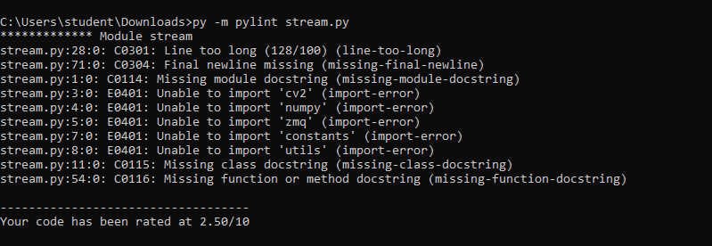

1. Cowin.py file

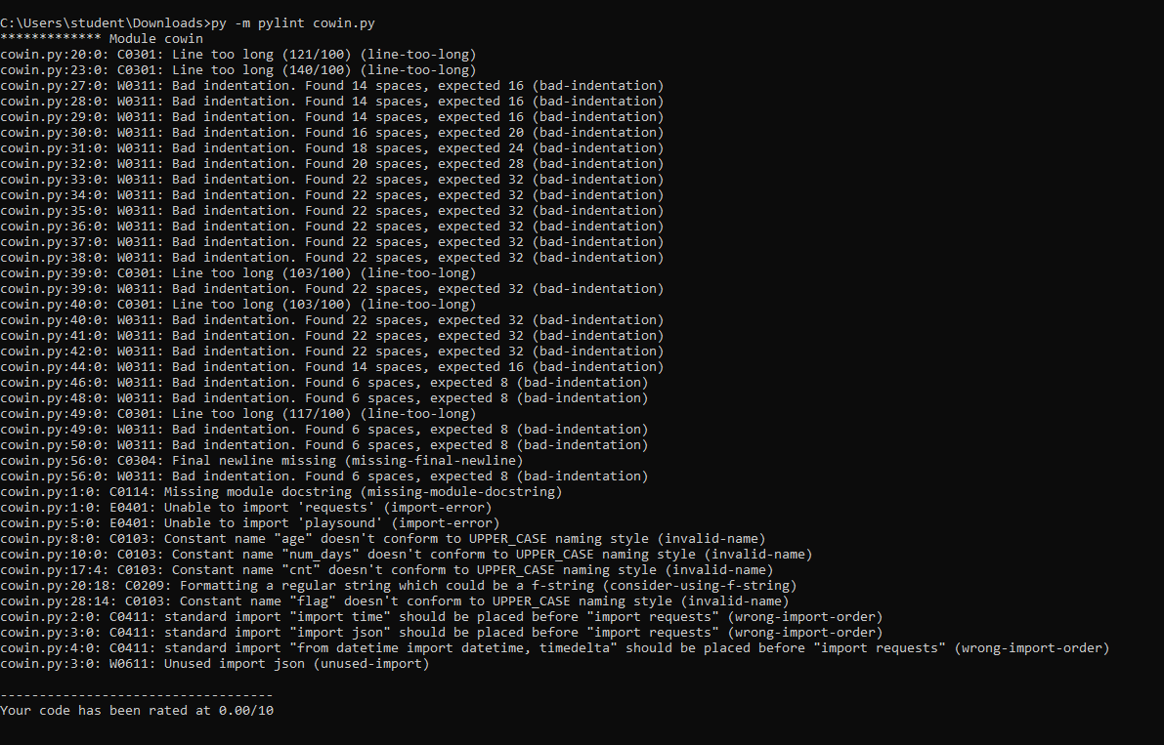

1. Algorithm.py

