***Practical 3: Universal NAND logic***

*30‘*

### Apparatus

*pinout:*

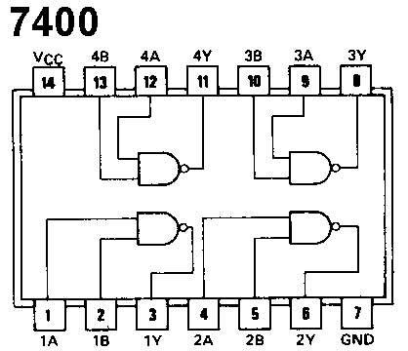Digitalexperimenter, I.C. 7400, connecting wires

### Method

Label the pin’s in circuit 3 and 4 with the correct number. Connect the supply to the I.C. at pins 7 (0 volts) and 14 (+5 V). With the aid of the connecting wires construct the circuits 1 to 4 and complete the truth table for each. Carry out the conclusion!

### Circuit 1

Diagram : Truth table :

|  |  |
| --- | --- |
| Input A | Output |
| 0 | 1 |
| 1 | 0 |

&

Output

**12**

A

**13**

**11**

### Circuit 2

Diagram : Truth table :

&

**1**

A

**2**

**3**

&

Output

**4**

B

**5**

**6**

|  |  |  |
| --- | --- | --- |
| Input A | Input B | Output |
| 0 | 0 | 0 |
| 0 | 1 | 0 |
| 1 | 0 | 0 |
| 1 | 1 | 1 |

### Circuit 3

Diagram :

&

**…**

**…**

**…**

Output

&

**…**

A

**…**

**…**

&

**…**

B

**…**

**…**

Truth table:

|  |  |  |
| --- | --- | --- |
| Input A | Input B | Output |
| 0 | 0 | 0 |
| 0 | 1 | 1 |
| 1 | 0 | 1 |
| 1 | 1 | 1 |

### Circuit 4

Diagram :

&

**…**

**…**

**…**

&

Output

**…**

**…**

**…**

&

**…**

A

**…**

**…**

&

**…**

B

**…**

**…**

Truth table :

|  |  |  |
| --- | --- | --- |
| Input A | Input B | Output |
| 0 | 0 | 1 |
| 0 | 1 | 0 |
| 1 | 0 | 0 |
| 1 | 1 | 0 |

### Conclusion

Each circuit has been made solely with NAND gates. Identify the gate which each of the circuits above may replace.

|  |  |
| --- | --- |
| circuit 1 | NOT |
| circuit 2 | AND |
| circuit 3 | OR |
| circuit 4 | NOR |

Please note the different standards to draw a NAND gate:

|  |  |
| --- | --- |
| **IEC**  *International Electrotechnical Commission* | neu-5 |
| **ANSI**  *American National Standards Institute* | neu-6 |
| **DIN**  *Deutsches Institut für Normung* | neu-7 |

[*http://de.wikipedia.org/wiki/Logikgatter*](http://de.wikipedia.org/wiki/Logikgatter)