***Signalling Technology***

**Introduction**

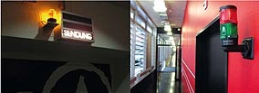**Warning – Recording!**   
In the corridors of the Swiss TV station SRF’s recording studios, the signal towers indicate exactly what is taking place inside at a particular time. If they are lit red, then a recording is taking place and there is no admittance to the studios. This also means that there must be complete silence in the corridors. A green signal indicates that a rehearsal is taking place. Noise and other disturbances should be avoided during these times.

**Goal**

At the end of this sequence you should know more about optical and audible signalling devices. You should be able to name different signalling devices and mention application possibilities.

**Task**

Open the document *AUF3.2.1_Befehls-UndMeldegeräte_UE3_Anhang.pdf*. You can find this document in the Moodle-course **AutomatikerIn_09: Elektrische Steuerungen**, **Kapitel Befehls- und Meldegeräte**. Work through the handbook and answer all the questions on this worksheet according to the text. Work in pairs.

**available time:**

**45 minutes**

**Questions**

1. Note down the key to optical signals. Complete the table!

|  |  |
| --- | --- |
| colour | key |
|  | extreme danger/ hazardous conditions |
| red |
|  | Beware/ dangerous conditins imminent |
| yellow |
|  | Normal conditions |
| green |
|  | Conditions requiring defined actions |
| blue |
|  | No particular meaning |
| white/ clear |

1. Write down three specific uses of optical signals in everyday life?

* Traffic lights,
* In the car, Industrie
* Obstructions, alarmsystem
* S14

1. Complete the sentence!

Any number of uses can also be found in the industrial sector, particularly in the signalisation of the operating status of machines.

1. Translate the completed sentence in c) into German.

Diese Anwendungen findet man auch in der Industrie, allen voran das Signalisieren von Betreibszustanden

1. Light can be generated in various ways. Note down at least three sources which are used in signalling technology?

* Bulbs
* Halogen bulbs
* Electric discharge tubes
* LED
* In the PDF explanation S.14

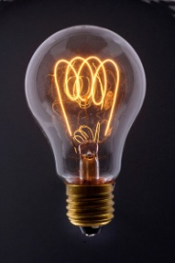

1. What kind of metal is used for the filament in bulbs?

Tungsten, (Wolfram)

1. What determines the colour of the light emitted in LEDs?

Material of the semiconductor ( Gallium, Arsenic etc. )

1. LED – beacons have many advantages! Match the advantages with the German equivalents!

|  |  |  |
| --- | --- | --- |
| 1. minute dimensions |  | 1. verzögerungsfreies Aufleuchten |
| 1. all major colours can be realised |  | 1. Resistenz gegen Erschütterung und Vibration |
| 1. low current consumption |  | 1. niedrige Wärmeentwicklung |
| 1. vibration and shock resistance |  | 1. alle wichtigen Farben sind realisierbar |
| 1. low heat generation |  | 1. geringer Stromverbrauch |
| 1. immediate illumination |  | 1. kleinste Abmessungen |

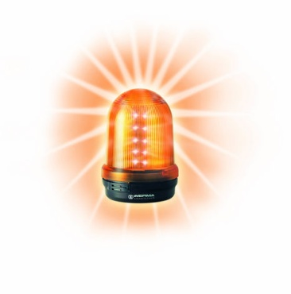

|  |  |
| --- | --- |
| http://img.directindustry.com/images_di/photo-g/tower-light-386219.jpgEnglish | German |
| 1 | F |
| 2 | D |
| 3 | E |
| 4 | B |
| 5 | C |
| 6 | A |

1. Complete the sentence!

The life duration of LEDs totals up to 50'000 (S15) hours.

1. Note down three specific uses of audible signals in everyday life?

* Car horn
* Of an egg timer
* Siren of am emergency car
* S18

1. Complete the sentence!

Audible devices also enjoy a wide range of applications in industrial environments where they are deployed to indicate malfunction or to provide early warning of dangeraus situations.

1. Translate the completed sentence in k) into German!

Auch in der Industie finden diese Geräte bereits Anwendung, wo sie meldung über Störungen geben oder Warnen bei gefählrlichen Situationen.

1. What is the main advantage of optical-audible signals? Complete the sentence !

The combination of optical and audible signals rules out the possibility of mistakes: by not seeing or not hearing the signal.

1. Note down the difference between **modular signal towers** and **completely pre-assembled signal towers**?

Modular : **completls free combination** and audible signal, mechanical and electical connection, safe bulb changes without tools

Pre-assembled : completey pre-assembled LED signal Tower, complet tower can ve ordered using a singel number, Available in hem ost commonly use signal combination, 70’00 hours life,

S. 32 genauer

Modular systemallows a totally free combination of optival ans audible signal elements

1. 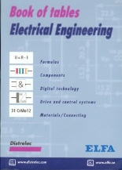One of the good things about the „Kompakt 36“ is the high protection rating **IP 65**. What does the code **IP 65** mean? Answer this question using your book of tables!

|  |  |  |  |
| --- | --- | --- | --- |
|  |  | *general description:* | *specific description:* |
| *code letters* | **IP** | Protection against accidental contact and penetration of foreign objects and water. | IP refers to international protection    S243 book (E) 280(D) |
| *first code digit* | **6** | Protection against contact (people) and solid objects (equipment). | Contact with wires(test porbe, ),  Penetration if fireigne Objects, dustproof |
| *second code digit* | **5** | Protection against penetration of water. | Penetration of waterjets |

1. Technical specifications about the „Kompakt 71“: Complete the table!

|  |  |
| --- | --- |
| Operating voltage | 24VDC |
| Current consumption | 40mA per tier |
| Starting current | 500MA can be triggerd via PLC |

1. Translate the completed table in p) into German!

|  |  |
| --- | --- |
| Betrieebsspannung | 24VDC |
| Stromaufnahme | 40mA pro Stufe |
| Einschaltstrom | 500MA SPS-ansteuerbar |

1. Name the different signalling devices (English and German)!

|  |  |  |
| --- | --- | --- |
| signalling device | name | Bezeichnung |
|  | Buzzer | Summer |
|  | LED/ Buzzer combination | Kombination LED/ Summer |
|  | LED/ Horn combination | Kombination LED/ Horn |
|  | Horn | Horn |

1. Complete the wordlist.

|  |  |
| --- | --- |
| English: | German: |
| Signalling technology | Signaltechnik |
| Hazedrous condition . | gefährlicher Zustand |
| Dangerous condition | kritischer Zustand |
| Normal conditions | normaler Zustand |
| Operating status. | Betriebszustand |
| Bulb | Glühlampe |
| filament | Glühfaden |
| life duration | Lebensdauer |
| Optical signal | optisches Signal |
| Audible signal | akustisches Signal |
| Malfunction | Störung |
| Pre-assambled | vormontiert |
| Protection rating | Schutzart |
| Signal tower | Signalsäule |
| ... | ... |

1. Make your own vocab cards and learn the new vocabulary!