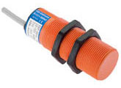***Capacitive proximity sensors***

**Introduction**

**The functional principle is similar to that of the inductive proximity sensor. The capacitive proximity sensor detects conducting and non-conducting objects. Since it works with an electric field which develops between the electrodes at the front, each workpiece entering the field is understood as a charge in the dielectric. This results in a switch signal.**

**Tasks**

1. Read the introduction carefully and match the English to the German expressions in the table below. Work on your own and do it without the aid of a dictionary.

|  |  |  |  |  |
| --- | --- | --- | --- | --- |
| No. | English |  | Nr. | German |
| 1 | inductive proximity sensor |  | 5 | elektrisches Feld |
| 2 | capacitive proximity sensor |  | 1 | induktiver Näherungsschalter |
| 3 | conducting |  | 4 | nicht-leitend |
| 4 | non-conducting |  | 2 | kapazitiver Näherungsschalter |
| 5 | electric field |  | 6 | Schaltsignal |
| 6 | switch signal |  | 3 | leitend |

1. Work in pairs and translate the introduction into German. **Goal: You understand every detail of the text.**
2. Tick all non-conducting materials.

***Please note: 5 answers are correct!***

* plastics

X

X

* carton

* aluminium
* glass

_

Xx

* copper
* wood

X

* silver

_

* oil

X

Learning objectives:

By the end of this learning sequence you will be …

* … more familiar with capacitive proximity sensors.
* … able to deal with a typical datasheet.



**Optional homework**

Create your own vocab cards and learn the new vocabulary.

**Operating distance**

The operating distance (=sensing range) is highly dependent on the material and dimensions. For example, a thick material results in a larger operating distance than a thin one. A teach-in function is therefore frequently provided with which the sensor can be calibrated.

**Tasks**

1. Read the paragraph above carefully and then complete the paragraph below using the correct German expressions. Work in pairs and do it without the aid of a dictionary.

*Der Schaltabstand ist stark material - und abmessungsabhängig. So führt ein dickes Material zu einem höheren Schaltabstand als ein dünnes . Oft besteht daher eine “teachin”-Funktion mit der der Sensor kalibriert werden kann.*

**Reduction factor R**

As with the inductive proximity sensors, the reduction factor depends on the material. It describes the factor by which the sensing range s is reduced by a certain material, with reference to the nominal sensing range sn, which results from the use of a metal plate (E320/ST37) as sensing flag.

|  |  |
| --- | --- |
| English | German |
| sensing range s | Schaltabstand s |
| nominal sensing range sn | Norm-Schaltabstand sn |

1. Work in pairs and translate the text above into German using the words given. **Goal: You understand every detail of the text.**
2. Complete the table below. Refer to your „Fachbuch Mechatronik“.



|  |  |  |
| --- | --- | --- |
| Material | material | reduction factor R |
| alle Metalle | all metals | 1 |
| Wasser | water | 1 |
| Alkohol | alcohol | 0.75 |
| Keramik | ceramic | 0.6 |
| Glass | glass | 0.5 |
| PVC Plastik | PVC (plastics) | 0.45 |
| Öl | oil | 0.28 |

**Datasheet**

Work through tasks g) to p) using the datasheet of FESTO‘s capacitive proximity sensor no. 178575.

**Tasks**

1. Tick the **symbol** of a **capacitive proximity sensor** below. Refer to your script „Sensoren“ if necessary.

_

_

X

_

_

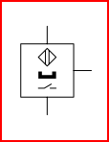 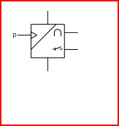 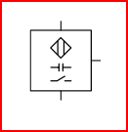 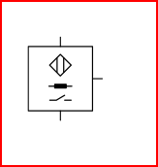 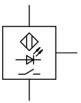

1. What is the **code letter** for a **capacitive proximity sensor**?

B

1. Complete the table below.

|  |  |  |
| --- | --- | --- |
| Parameter/Funktion | parameter/function |  |
| Nennschaltabstand | nominal switching distance | 4mm |
| Schaltstrom | output current | Max. 200mA |
| Schutzart | protection class | IP65 |
| Kurzschlussschutz | short circuit protection | Ja |
| Verpolungsschutz | reverse polarity protection | Ja |

1. What type of **output circuit** does the capacitive proximity sensor have?

* PNP

_

X

* NPN

1. Calculate the **sensing range s** for detection of a workpiece made of PVC.
$$\underline{\underline{s_{PVC}}}=4∙0.45=1.8mm$$

2. Which is the **colour** of the **control wire**?

* blue

_

_

* red
* black

_

X §

* brown

1. Complete the following sentence:

*Die Wiederholgenauigkeit des Realschaltabstandes des Sensors beträgt gleich oder weniger als 0.1 mm bei kontstanter Temperatur.*

1. Berechnen Sie die Zeit, welche der kapazitive Näherungsschalter mindestens benötigt, damit der Schaltausgang “sicher” einmal ein- und wieder ausschalten kann.

$$\underline{\underline{T_{min.}}}=\frac{1s}{100Hz}=\underline{\underline{10ms }}$$

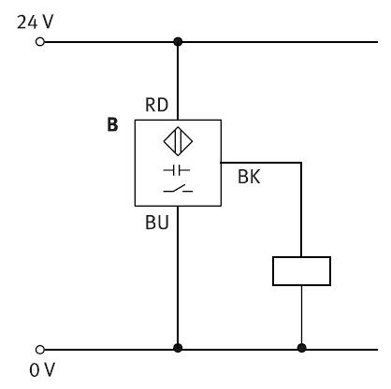

1. 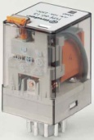The ratings for the relay in the circuit given are as follows:

*Nominal voltage: 24 VDC*

*Rated power: 1,3 W*

Calculate the **current consumption** of the coil.

$$\underline{\underline{I}}=\frac{P}{U}=\frac{1.3W}{24V}=0.054A=\underline{\underline{54mA}}$$

1. Is the output current of the capacitive proximity sensor sufficient to switch on the relay in o)?

* Yes

_

X

* No

**Application**

**Task**

1. Have a look at the three different applications given below. Find out the function of the capacitive proximity sensor and discuss it with your partner. Match the English and the German descriptions to the applications.

|  |  |
| --- | --- |
| Beschreibung | Description |
| 1 | 4 |
|  | |

|  |  |
| --- | --- |
| Beschreibung | Description |
| 3 | 6 |
|  | |

|  |  |
| --- | --- |
| Beschreibung | Description |
| 2 | 5 |
|  | |

|  |  |
| --- | --- |
| 1 | Kontrolle Werkstück vorhanden |
| 2 | Kontrolle „Behälter voll“ |
| 3 | Abfrage von min. und max. Füllstand |
| 4 | workpiece present |
| 5 | „container full“ verification |
| 6 | high and low level detection |