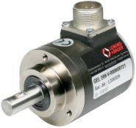***Incremental rotary encoder***

**Introduction**

The incremental rotary encoder is the most widely used of all rotary encoders due to its low cost: only two sensors are required.The fact that incremental encoders use only two sensors does not compromise their accuracy. One can find in the market incremental encoders with up to 10,000 counts per revolu-tion, or more.Incremental encoders are used to track motion and can be used to determine position (angle) and velocity. This can be either linear or rotary motion. The direction can be determined using the second sensor.

**Tasks**

1. Read the introduction carefully and match the English to the German expressions in the table below. Work on your own and do it without the aid of a dictionary.

|  |  |  |  |  |
| --- | --- | --- | --- | --- |
| No. | English |  | Nr. | German |
| 1 | rotary encoder |  | 3 | Umdrehung |
| 2 | compromise |  | 4 | Bewegung |
| 3 | revolution |  | 1 | Drehgeber |
| 4 | motion |  | 2 | beeinträchtigen |
| 5 | velocity |  | 5 | Geschwindigkeit |



1. Work in pairs and translate the introduction into German. **Goal: You understand every detail of the text.**
2. Open your textbook on mechatronics to page 510 and read carefully the paragraphs „Inkrementale Drehgeber“ and „Drehrichtungserkennung.“ Explain the forward-reverse evaluation using the following sequence diagram:

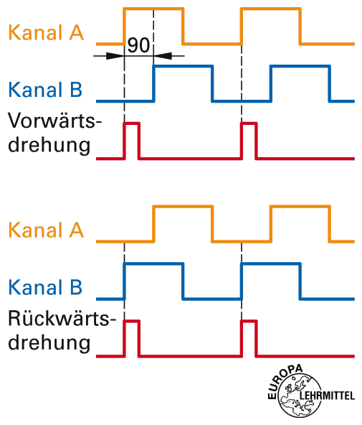

clockwise rotation

counter-clockwise rotation

signal A

signal B

signal A

signal B

Es wird mit Lichtschranken auf eine Drehscheibe oder Streifen geleuchtet die Drehscheibe hat nun in regelmässigen Abständen Lücken anhand der Anzahl Lücken und den mit Hilfe der Lichtschranken gezählten Lücken kann nun die Position angegeben werden. Um die Drehrichtung zu bestimmen nimmt man einfach noch eine Scheibe und Sensor. Bsp. Signal A kommt vor Signal B dann ist es Linkslauf komm aber B vor A ist es Rechtslauf

Learning objectives

By the end of this learning sequence you will be …

* … more familiar with incremental rotary encoders.
* … able to calculate an application of an incremental encoder.



**Optional homework**

Create your own vocab cards and learn the new vocabulary.

**Application**

An optical incremental rotary sensor is used to determine the speed of a motor. To visualize the speed on a display, the encoder is connected to a PLC. The encoder has a resolution up to 2048 pulses (= 2048 pulses per revolution). The maximum input frequency of the PLC for rectangular signals is 100 kHz.

**Tasks**

1. Read the application carefully and match the English to the German expressions in the table below. Work on your own and do it without the aid of a dictionary.

|  |  |  |  |  |
| --- | --- | --- | --- | --- |
| No. | English |  | Nr. | German |
| 1 | speed |  | 2 | Auflösung |
| 2 | resolution |  | 1 | Drehzahl |
| 3 | input frequency |  | 4 | Rechtecksignal |
| 4 | rectangular signal |  | 3 | Eingangsfrequenz |

1. Work in pairs and translate the introduction into German. **Goal: You understand every detail of the text.**
2. Calculate the **maximum speed** which the PLC is able to detect?

Note: Write down the procedure for the solution exactly. Give the result in r.p.m. (=revolutions per minute) and round it to one decimal place.

$$\underline{\underline{n_{max}}}=\frac{f}{PZ}=\frac{100000Hz}{2048}∙60=2929.69r.p.m$$