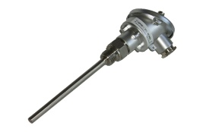***PT100 Sensor***

**Introduction**

**Platinum resistance temperature detectors (PRTs)** offer excellent accuracy over a wide temperature range (from -200 to +850 °C). Standard Sensors are available from many manufacturers with various accuracy specifications and numerous packaging options to suit most applications.

The principle of operation is to measure the resistance of a platinum element. The most common type (PT100) has a resistance of 100 ohms at 0 °C. There are also PT1000 sensors that have a resistance of 1000 ohms at 0 °C.

The relationship between temperature and resistance is approximately linear over a small temperature range: for example, if you assume that it is linear over the 0 to 100 °C range, the error at 50 °C is 0.4 °C. For precision measurement, it is necessary to linearise the resistance to give an accurate temperature.

**Tasks**

1. Read the introduction carefully and match the English to the German expressions in the table below. Work on your own and do it without the aid of a dictionary.

|  |  |  |  |  |
| --- | --- | --- | --- | --- |
| No. | English |  | Nr. | German |
| 1 | accuracy |  | 8 | genau |
| 2 | temperature range |  | 4 | Widerstandswert |
| 3 | application |  | 1 | Genauigkeit |
| 4 | resistance |  | 7 | Messung |
| 5 | (to) measure |  | 3 | Anwendung |
| 6 | (to) assume |  | 6 | annehmen |
| 7 | measurement |  | 2 | Temperaturbereich |
| 8 | accurate |  | 5 | messen |

1. Work in pairs and translate the introduction into German. **Goal: You understand every detail of the text.**
2. Write down 3 main features of a PT100 sensor.

* Relationship between temperature and resistance is approximately linear
* Excellent accuracy over wild temperature range (from -200°C to +850°C
* Resistance 100Ω at 0°C

Learning objectives:

By the end of this learning sequence you will be …

* … more familiar with PT100 sensors.
* … able to calculate an application of a PT100 sensor.



**Optional homework**

Create your own vocab cards and learn the new vocabulary.

**Datasheet**

Have a look at the datasheet of Rhopoint’s PT100 sensor „Stikon TM“ below. If you want, you can download the datasheet using the following link: <http://www.istitutoprimolevi.gov.it/elettrobox/Datasheet_PT100%20Platinum%20Resistance%20Temperature%20Detector.pdf>

Work through tasks d) and e).

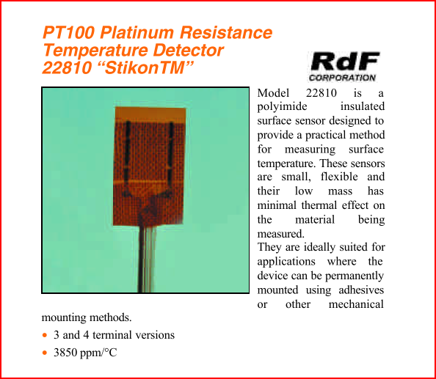 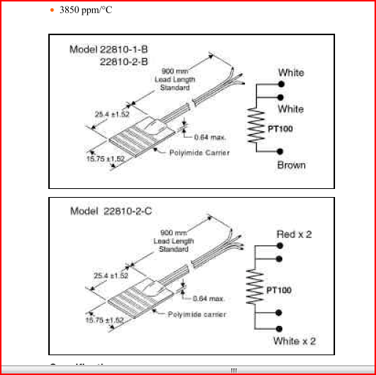

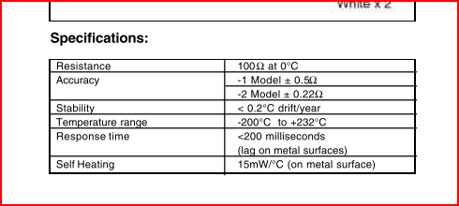



1. Why is this sensor suited for measuring surface temperature?
2. These sensors are small, flexible and their low mass has minimal thermal effect on the material being measure

1. Complete the following sentence:

For this PT100 sensor, a 1 °C temperature change will cause a 0.385 ohm change in resistance.

**The basics about PT100 sensors**



1. Look up the symbol of a PT100 sensor in your book of tables and tick the correct version below.

X

_

_

_

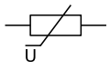 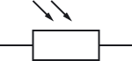 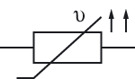 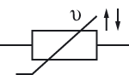

1. Use the word bank given below to complete the following statement about the function of a PT100 sensor:

|  |  |
| --- | --- |
| English | German |
| (to) increase | ansteigen |
| (to) decrease | abnehmen |

Statement:

The ohmic value of the PT100 sensor increase as the temperature increase .

1. The performance of a PT100 sensor is equal to the performance of a ...

***Note: 2 answers are correct!***

* negative [temperature](http://www.dict.cc/englisch-deutsch/temperature.html) [coefficient](http://www.dict.cc/englisch-deutsch/coefficient.html) [thermistor](http://www.dict.cc/englisch-deutsch/thermistor.html)

_

* [positive](http://www.dict.cc/englisch-deutsch/positive.html) [temperature](http://www.dict.cc/englisch-deutsch/temperature.html) [coefficient](http://www.dict.cc/englisch-deutsch/coefficient.html) [thermistor](http://www.dict.cc/englisch-deutsch/thermistor.html)

X

_

* LDR-resistor

_

* NTC-resistor

_

* VDR-resistor

X

* PTC-resistor

**Connection types**

According task e) a small error in measurement of the resistance (for example, the resistance of the wires leading to the sensor) can cause a large error in the measurement of the temperature. For precision work, sensors have four wires- two to carry the sense current, and two to measure the voltage across the sensor element. It is also possible to obtain three-wire and two-wire sensors. These operate on the assumption that the resistance of each of the three resp. two wires is the same.

1. Read the paragraph above carefully and match the English to the German expressions in the table below. Work on your own and do it without the aid of a dictionary.

|  |  |  |  |  |
| --- | --- | --- | --- | --- |
| No. | English |  | Nr. | German |
| 1 | (to) cause |  | 2 | Präzisionsarbeit |
| 2 | precision work |  | 5 | beziehen (kaufen) |
| 3 | (to) carry |  | 4 | Messstrom |
| 4 | sense current |  | 6 | Annahme |
| 5 | (to) obtain |  | 1 | verursachen |
| 6 | assumption |  | 3 | übertragen |

1. Work in pairs and translate the paragraph above into German. **Goal: You understand every detail of the text.**
2. Work through the following chapters of JUMO’s eLearning course “Resistance Thermometer and Thermocouples” and answer the questions in l), m) and n).

* Widerstandsthermometer / resistance thermometer
* Linearisierung / linearization
* Zweileiteranschluss / 2-wire circuit
* Dreileiteranschluss / 3-wire circuit
* Vierleiteranschluss / 4-wire circuit

* Click [here](http://www.jumo.de/media/movies/de/elearning/widerstandsthermometer_thermoelemente/index.html) for the German version.
* Click [here](http://www.jumo.de/media/movies/en/elearning/rtd_temperature/Start.html) for the English version.

1. Which connection type is mostly used in industrial applications?

3-wire circuit

1. Which connection type has a very high accuracy?

4wire-circuit

1. *Datasheet:* The Rhopoint’s PT100 sensor is also available for 2-wire connection. True or false?

* True

X

_

* False

**Application**

For monitoring the temperature at a welding wheel, you need to measure the temperature using Rhopoint’s PT100 sensor.

1. Which of the following formulas is suitable to determine the resistance at ϑ2 (R2)? Refer to your book of tables if necessary.

***Note: 2 answers are correct!***

$R_{2}=R_{1}+\left(1∙α∙∆ϑ\right)$

X

$R_{2}=R_{1}∙\left(1∙α+∆ϑ\right)$

X

$R_{2}=R_{1}+∆R→ ∆R=α∙R_{1}∙∆ϑ$

$R_{2}=R_{1}-∆R→ ∆R=α∙R_{1}∙∆ϑ$

$R_{2}=R_{1}∙\left(1+α∙∆ϑ\right)$

_

* 

1. Complete the table below using your book of tables.

|  |  |  |  |
| --- | --- | --- | --- |
| abbr. | English | German | unit |
| R2 | Resistance at ϑ2 | Widerstand bei ϑ2 |  |
| R1 | Resistance at ϑ1 | Widerstand bei ϑ1 |  |
| α | Temperatur coeffizient | Temperaturkoeffizient | $$\frac{1}{K}$$ |
| Δϑ | Temperature difference | Temperaturdifferenz | $$K$$ |

1. Calculate the resistance of the sensor at a temperature of 75 °C. Take notice of the datasheet on page 2 in this document.

$geg:{}_{1}=0℃; {}_{2}=75℃;R_{1}=100Ω;α=0,00385\frac{1}{K}$

$ges:R_{2}$

$Δϑ=ϑ_{2}-ϑ_{2}=75°C-0°C=75°C$

$R_{2}=R_{1}+\left(1∙α∙∆ϑ\right)=100Ω∙\left(1+0,00385\frac{1}{K}∙75°C\right)=\underline{\underline{128.875Ω}}$