***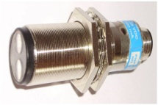Optical proximity sensors***

**Introduction**

**Optical proximity sensors use optical and electronic means for object detection. Red or infrared light is used. Light-emitting diodes (LEDs) are particularly reliable sources of red or infrared light. They are small and rugged and have a long service life. Photodiodes or phototransistors are used as receivers. Red light has the advantage that the light beam can be seen during adjustment of the optical axes of the proximity switch.**

**Tasks**

1. Read the introduction carefully and match the English to the German expressions in the table below. Work on your own and do it without the aid of a dictionary.

|  |  |  |  |  |
| --- | --- | --- | --- | --- |
| No. | English |  | Nr. | German |
| 1 | optical proximity sensor |  | ... | Objekterkennung |
| 2 | object detection |  | ... | Lebensdauer |
| 3 | service life |  | ... | Lichtstrahl |
| 4 | receiver |  | ... | optischer Näherungsschalter |
| 5 | light beam |  | ... | Justierung |
| 6 | adjustment |  | ... | Empfänger |

1. Work in pairs and translate the introduction into German. **Goal: You understand every detail of the text.**
2. Which statement is correct?

***Note: 2 answers are correct!***

\_

* Leuchtdioden sind klein und robust sowie von kurzer Lebensdauer.
* Leuchtdioden sind klein und robust sowie von langer Lebensdauer.

\_

* Infrarotes Licht hat den Nachteil, dass es bei der Justierung der optischen Achsen der verwendeten Näherungsschalter mit blossem Auge nicht erkannt werden kann.

\_

* Infrarotes Licht hat den Vorteil, dass es bei der Justierung der optischen Achsen der verwendeten Näherungsschalter mit blossem Auge erkannt werden kann.

\_

Learning objectives:

By the end of this learning sequence you will be …

* … more familiar with optical proximity sensors.
* … able to calculate an application of a retro-reflective sensor.

****

**Optional homework**

Create your own vocab cards and learn the new vocabulary.

**The basics about optical proximity sensors**

Three types of optical proximity switch are differentiated:

* through-beam sensor (= one-way light barrier)
* retro-reflective sensor
* diffuse-reflective sensor

**Tasks:**

1. Open the following link on the internet and get an idea of …

* … [Einweglichtschranke](http://www.datasensor.de/basics/einweg_nt.htm) *[=through-beam]*
* … [Reflexlichtschranke](http://www.datasensor.de/basics/reflex_nt.htm) (=Reflexionslichtschranke) *[=retroflex]*
* … [Reflextaster](http://www.datasensor.de/basics/reflextast_nt.htm) (=Reflexionslichttaster) *[=diffuse proximity]*

[](http://www.google.de/imgres?imgurl=http://www.peterkroener.de/wp-content/uploads/2008/08/internet_explorer.png&imgrefurl=http://www.peterkroener.de/innovationsmaschine-internet-explorer/&usg=__ohOiVvQbza5H-k1LidAuUzAiHZg=&h=341&w=323&sz=67&hl=de&start=3&zoom=1&tbnid=6gwpc5H1K9F4WM:&tbnh=120&tbnw=114&ei=RTWFTtSgKIL_4QTaoMDMDw&prev=/search?q=internet&um=1&hl=de&sa=N&rlz=1I7ADFA_deCH446&biw=1301&bih=617&tbm=isch&um=1&itbs=1)

<http://www.xpertgate.de/produkte/Lichtschranken.html>

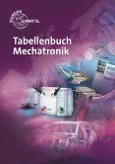

Answer the questions in e), f) and g). Refer to your „Tabellenbuch Mechatronik“ if necessary.

1. Read the following descriptions carefully. Match the technical terms given below to the descriptions and fill in the gaps. Discuss it with your partner.

* *retro-reflective sensor - Reflexionslichttaster*
* *through-beam sensor - Reflexionslichtschranke*
* *diffuse-reflective sensor - Einweglichtschranke*

|  |  |  |
| --- | --- | --- |
| Technical term | Fachbegriff | Description |
| ... | ... | The ... has spatially separate transmitter and receiver units. The parts are mounted in such a way that the transmitter beam is directed at the receiver. The output is switched if the beam is interrupted. |
| ... | ... | In the ..., the transmitter and receiver are mounted together in one housing. The reflector is mounted in such a way that the light beam transmitted by the transmitter is practically completely reflected to the receiver. The output is switched if the beam is interrupted. |
| ... | ... | In the ..., the transmitter and receiver are mounted together in one unit. If the light hits a reflective object, it is redirected to the receiver and causes the output of the sensor to switch. |

1. Have a look at the three different types of sensors below. Match the technical terms given below to the sensors. Discuss it with your partner.

* *retro-reflective sensor - Reflexionslichttaster*
* *through-beam sensor - Reflexionslichtschranke*
* *diffuse-reflective sensor - Einweglichtschranke*

|  |  |  |
| --- | --- | --- |
| Technical term | Fachbegriff | Type of sensor |
| ... | ... | http://www.luconda.com/artikeldetails/27/27/09/bilder/2036505-1-Sick-WT34-B440-REFLEXIONS-LICHTT.jpg |
| ... | ... | http://static.letsbuyit.com/filer/images/de/products/original/16/25/einweglichtschranke-sa1e-tp2-1625166.jpg |
| ... | ... | http://www.monacor.de/de/JPG/400/B/B0/B042940A.jpg |

1. Tick the **symbol** of an **optical proximity switch** below. Refer to your „Skript Sensoren“ if necessary.

\_

\_

\_

\_

\_

**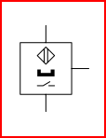 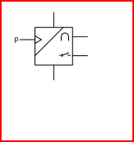 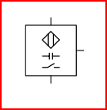 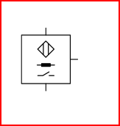** 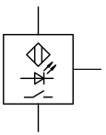

1. What is the **code letter** for an **optical proximity sensor**?

...

1. 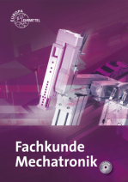Open your “Fachbuch Mechatronik” to page 503 and read the paragraph “Reflexionslichtschranke mit Polarisationsfilter” carefully. When are **retro-reflective sensors** fitted **with** a **polarising filter**? Read the text below and think of the word which best fits each space. Use only one word in each space.

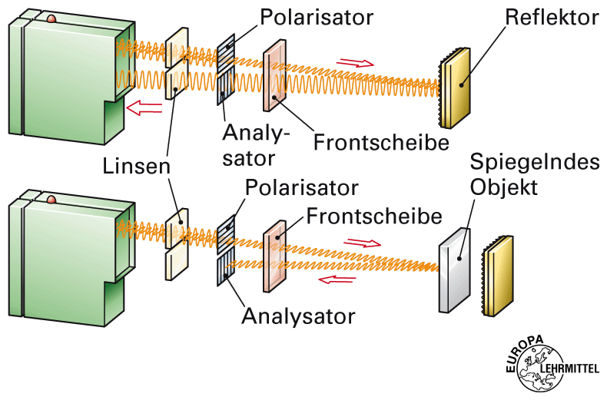Polarising filters should be used for the detection of … objects. Alternatively, the optical axis of the sensor can be mounted at an … to the reflective object. In this way the … light can’t affect the retro-reflective sensor. Function of the polarising filter: After passing the polarising filter, the emitted light of the transmitter oscillates only in the … plane. The receiver can absorb light only in the … plane of oscillation because the second polarisation filter is rotated by 90 °. The triple mirror ensures this rotation. Ideal … objects rotate the polarisation plane 180 °, so that the … oscillation level is maintained. This sort of light is … by the second filter. As a result of this the … object is reliably detected.

1. Use the illustration below to explain the **background suppression** [=Hintergrundausblendung] **of diffuse-reflective sensors**. Also refer to the following links on the internet:

<http://www.xpertgate.de/produkte/Lichtschranken.html>

https://de.wikipedia.org/wiki/Hintergrundausblendung

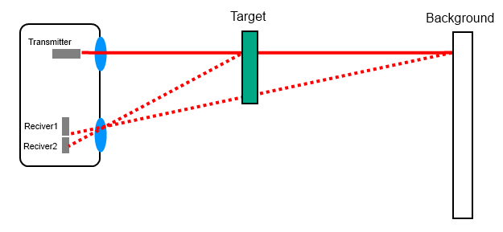

…

**Fork light barrier**

Fork light barriers are through-beam sensors. Transmitter, receiver and all the electronics are in one casing ensuring very simple and quick installation. Due to the high operating frequency, the short response time and the high resolution, even very small parts can be very precisely positioned and very fast movements reliably detected.

**Tasks**

1. Read the paragraph above carefully and match the English to the German expressions in the table below. Work on your own and do it without the aid of a dictionary.

|  |  |  |  |  |
| --- | --- | --- | --- | --- |
| No. | English |  | Nr. | German |
| 1 | fork light barrier |  | ... | Antwort |
| 2 | casing |  | ... | einfach |
| 3 | simple |  | ... | Gabellichtschranke |
| 4 | response |  | ... | Auflösung |
| 5 | resolution |  | ... | Gehäuse |

****

1. Work in pairs and translate the text into German. **Goal: You understand every detail of the text.**
2. Have a look at the three different applications given below. Find out the function of the fork light barrier and discuss it with your partner. Match the English and the German descriptions to the applications.

|  |  |
| --- | --- |
| Beschreibung | Description |
| … | … |
| K05_Gabellichtschranke_5.gif | |

|  |  |
| --- | --- |
| Beschreibung | Description |
| … | … |
| K05_Gabellichtschranke_fix_1.gif | |

|  |  |
| --- | --- |
| Beschreibung | Description |
| … | … |
| K05_Gabellichtschranke_4.gif | |

|  |  |
| --- | --- |
| A | Durchflusskontrolle in automatischen Abfüllanlagen |
| B | Stillstandskontrolle an Zuführeinheiten |
| C | Durchgangskontrolle an Transportbändern |
| 1 | Passageway control on conveyor belts |
| 2 | Standstill control in feeding units |
| 3 | Flow control in automatic filling units |

**Light operate / dark operate**

**Tasks**

1. 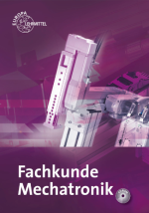Open your “Fachbuch Mechatronik” to page 507 and read the paragraph “Schaltungsarten” carefully. Complete the table below with the correct technical terms.

|  |  |
| --- | --- |
| English | German |
| light operate | ... |
| dark operate | ... |

1. Have a look at the schematic representations below. Understand their meaning and discuss it with your partner. Label the schematics using the expressions **light operate** and **dark operate**.

|  |  |
| --- | --- |
| ... | ... |

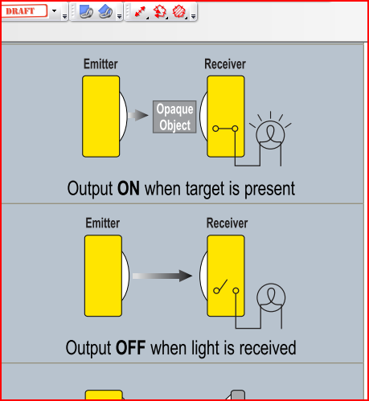 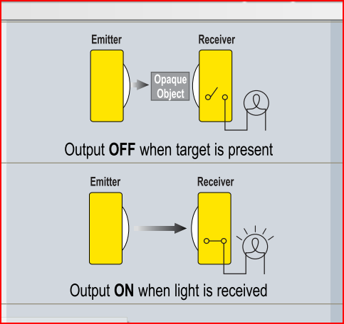

1. *Light operate:* The output of the sensor energizes when the receiver of the sensor sees its own light. True or false?

* True

\_

\_

* False

1. *Dark operate:* The output of the sensor energizes when the receiver of the sensor sees its own light. True or false?

* True

\_

\_

* False

**Datasheet**

Have a look at the datasheet of Baumer‘s retro-reflective sensor „FPDK 10P5101/S35A“ below.

Work through tasks p),q), r) and s).

**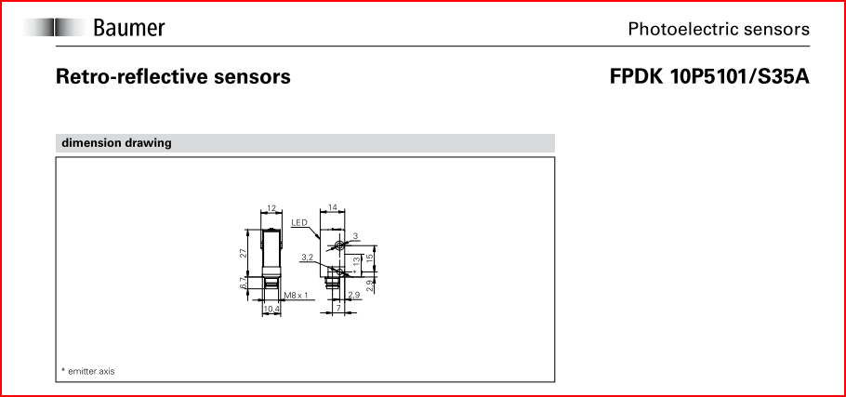**

**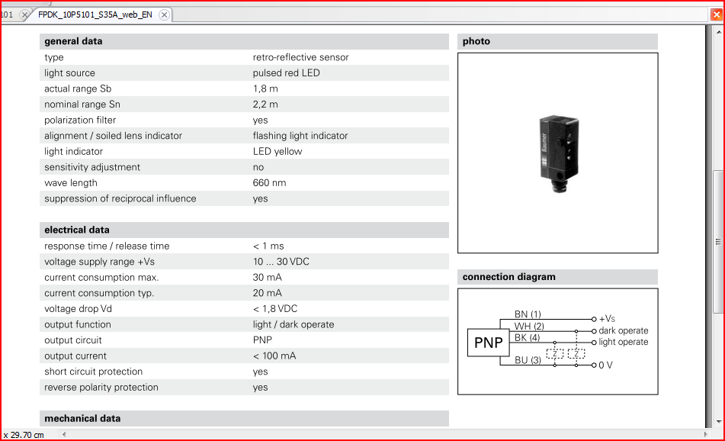**

****

****

**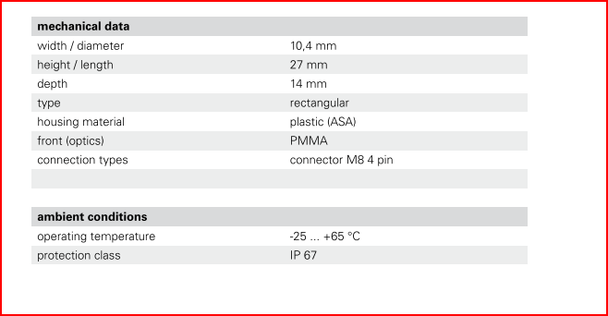**

1. *Datasheet:* The range of the sensor is between 1,8 m and 2,2 m. True or false?

* True

\_

\_

* False

1. *Datasheet:* Complete the table below.

|  |  |  |
| --- | --- | --- |
| Parameter/Funktion | parameter/function | value/type |
| Ansprechzeit | … | … |
| Abfallzeit | … | … |
| Schaltfunktion | … | … |
| Ausgangsschaltung | … | … |
| Kurzschlussfest | … | … |
| Verpolungsfest | … | … |



1. Explain the **protection class** of the sensor. Refer to your book of tables and your „Tabellenbuch Mechatronik“.

|  |  |  |  |
| --- | --- | --- | --- |
|  | | Description | Beschreibung |
| code letters | **IP** | … | … |
| first code digit | **6** | … | … |
| second code digit | **7** | … | … |

1. Tick the **symbols** for **waterproof** and **dustproof** below. Refer to your book of tables and your „Tabellenbuch Mechatronik“if necessary.

\_

\_

\_

\_

\_

**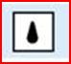  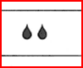  **

**Application**

In a bottling plant PET bottles are transported on a conveyor belt. Baumer’s retro-reflective sensor „FPDK 10P5101/S35A“ is used to detect the bottles. 3,3 dl, 5 dl or 1,5 l PET bottles can be transported on the conveyor belt (only one size at a time). The sensor operates in the dark operating mode and it has a pnp-output which is connected with a digital input of a PLC (programmable logic control). To ensure correct detection, the low signal as well as the high signal of the sensor’s output need to be present at the digital input of the PLC for at least 1 ms.

The diameters of the bottles are as follows:

|  |  |  |  |
| --- | --- | --- | --- |
| diameter: | 45 mm | 60 mm | 90 mm |
|  | http://somona-shop.ch/img/0_5017_10_DE_1.jpg | [Apfel Schorle (5dl / Pet)](javascript:popupWindow('http://www.sushikurier.ch/shop/popup_image.php/pID/106/imgID/0')) | http://www.alwa-mineralwasser.de/_extern/produktfotos/alwa_OrangenSchorle_1,5l_Ew_PET_Flasche.jpg  **Überlegung:**  **Bei welchem Flaschentyp kann das Förderband mit der höchsten Geschwindigkeit angetrieben werden?** |

**Tasks**

1. Calculate the **maximum permitted speed** of the conveyor belt. Take also notice of the datasheet.
$$\underline{\underline{v_{max}}}=$$

2. Write down your comments on the result in v)?

...

1. What is the minimum distance between the PET bottles on the conveyor belt?

...