***Signal storage***

*45‘*

**Introduction**

Most control circuits require storing signal statuses, which are only present for a short duration (e.g. the actuation of a pushbutton). This type of control is called sequential control *[=Ablaufsteuerung]* and it is commonly used in pneumatics, electronics and PLC programming.

**Goal**

****By the end of this learning sequence you will know the difference between storing *[=Speicherung]* with a latched switch and storing with a self-latching loop. You will also be familiar with the difference between a **dominant setting self-latching loop** and a **dominant resetting self-latching loop**.

**Tasks**

1. Use FluidSim to draw the following control circuits. Use the simulation mode to find out the function of each circuit.

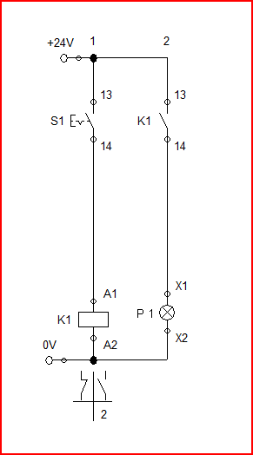 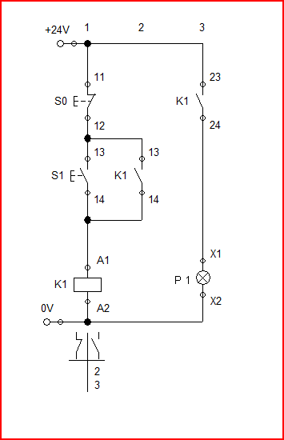

Fig. 1: Storing with a **latched switch** Fig. 2: Storing with a **self-latching loop**

1. Function of the control circuit **shown in figure 1**: Complete the following paragraph. The vocabulary word bank in taks i) might be helpful!

The Signal lampe is switched on by pressing latched switch S1 and it remains switched on until latched switch S1 is pressed again. One can say that the latched switch has a latching function.

1. Function of the control circuit **shown in figure 2**: Complete the following paragraph. The vocabulary word bank in taks i) might be helpful!

The current flows and the relay obtains its nominal voltage on pressing pushbutton S1. The relay gets activated and the two contacts of the relay close at the same time. The contact in parallel with pushbutton S1 is called «bridge» or self-latching. It is the function of the «bridge» that the relay remains engaged when pushbutton S1 is released. The second contact in K1 (23-24) allows the current to flow to the signal lamp P1 . The lamp indicates that the relay is energized. The circuit gets unlatched (broken) on pressing pushbutton S0 .

1. Use FluidSim to draw the control circuit **shown in figure 3**. Use the simulation mode to find out the function of the circuit.

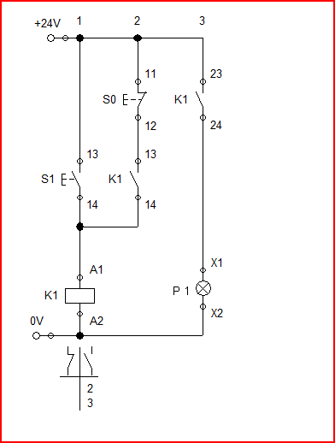

Fig. 3: Storing with a **self-latching loop**

1. Complete the truth table for the control circuit **shown in figure 2**:

Definitions:

|  |  |  |  |
| --- | --- | --- | --- |
| S1 | S0 | K1 | P1 |
| 0 | 0 | 0 | 0 |
| 0 | 1 | 0 | 0 |
| 1 | 0 | 1 | 1 |
| 1 | 1 | 0 | 0 |

If normally closed contact S0 is open then S0 = 1.

If normally closed contact S0 is closed then S0 = 0.

If normally open contact S1 is open then S1 = 0.

If normally open contact S1 is closed then S1 = 1.

Condition at the beginning:

The signal lamp P1 doesn’t light up!

1. Complete the truth table for the control circuit **shown in figure 3**:

|  |  |  |  |
| --- | --- | --- | --- |
| S1 | S0 | K1 | P1 |
| 0 | 0 | 0 | 0 |
| 0 | 1 | 0 | 0 |
| 1 | 0 | 1 | 1 |
| 1 | 1 | 1 | 1 |

Definitions:

If normally closed contact S0 is open then S0 = 1.

If normally closed contact S0 is closed then S0 = 0.

If normally open contact S1 is open then S1 = 0.

If normally open contact S1 is closed then S1 = 1.

Condition at the beginning:

The signal lamp P1 doesn’t light up!

1. Describe the difference between the circuits given in figure 2 and figure 3. Complete the sentences below! Work in pairs and use an online dictionary if necessary. Also refer to the vocabulary word bank given in task i)!

Both control circuits have generally the same function. If you press pushbutton S1 , then the signal lamp P1 lights up. If you press Pushbutton S0, then the signal lamp P1 turns off. If you press both pushbuttons at a time, only the signal lamp in circuit shown in figure 3 remains switched on. A latching function as shown in figure 3 is called a Dominant setting self-latching loop whereas a latching function as shown in figure 2 is called a dominant resetting self-latching loop .

1. Match the terms given to the circuits shown below!

* Dominant resetting
* Dominant setting

|  |  |
| --- | --- |
| Dominant setting | * Dominant   resetting |
|  |  |

1. Complete the wordlist using your book of tables and an online dictionary.

|  |  |
| --- | --- |
| English: | German: |
| sequential control | Ablaufsteuerung |
| storing | Speicherung |
| self holding | Selbsthaltung |
| latching circuit | Speicherschaltung |
| flip-flop circuit | Speicherschaltung |
| latching function | Speicherfunktion |
| (to) latch | setzen |
| (to) unlatch | rücksetzen |
| (to) break | unterbrechen |
| latched switch | Rastschalter |
| Self-latching loop | Selbsthaltung |
| Dominant setting | dominierend setzend |
| Dominant resssetting | dominierend rücksetzend |
| … | … |
| … | … |

1. Make your own vocab cards and learn the new vocabulary!