***Sequential circuit***

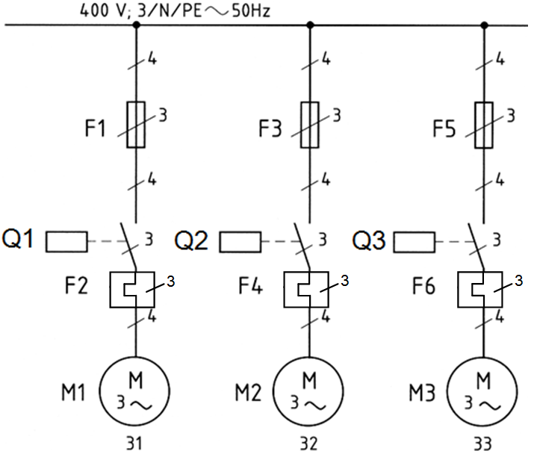**Tasks**

1. Have a look at the detached circuit diagram which is projected on the screen. Compare it with your own diagram that you have drawn in the last lesson and think through its function. Work in pairs.
2. Fill in the gaps in the functional description below using the items given!

Fig.: Block diagram

**Functional description**

Connect the circuit with live and neutral wires (net). An inline fuse F7 saves the circuit from overloading. Press the switch S1. The current flows and the contactor for motor M1 obtains its nominal voltage . The contactor is activated and the motor M1 runs . The contacts in the contactor close simultaneously. The contact in parallel to the switch S1 is called a bridge and is self-holding . It is the function of this bridge that the self-holding remains engaged when the button S1 is released . The closed contact Q1 in current path 3 allows the current to flow to the contactor Q2 when the switch S2 is pushed. The contactor for the motor M2 obtains its nominal voltage. The contactor is activated and the motor M2 runs. The contact Q2 in current path 4 works also as a bridge. The closed contact Q2 in current path 5 allows the current to flow to the contactor Q3 when the switch S3 is pushed. The contactor for the motor M3 obtains its nominal voltage. The contactor is activated and the motor M3 runs. The contact Q3 in current path 6 works also as a bridge. If any of the bimetal-strips (F2/F4/F6) breaks contact, all motors will stop. To stop the motors, press the switch S0.

Items:

**self-holding Q2 pushed runs neutral contacts Q3 contactor works overloading voltage Q2 breaks**

**parallel fuse current released S0**



**Homework**

Make your own vocab cards and learn the new vocabulary!