***Call System***

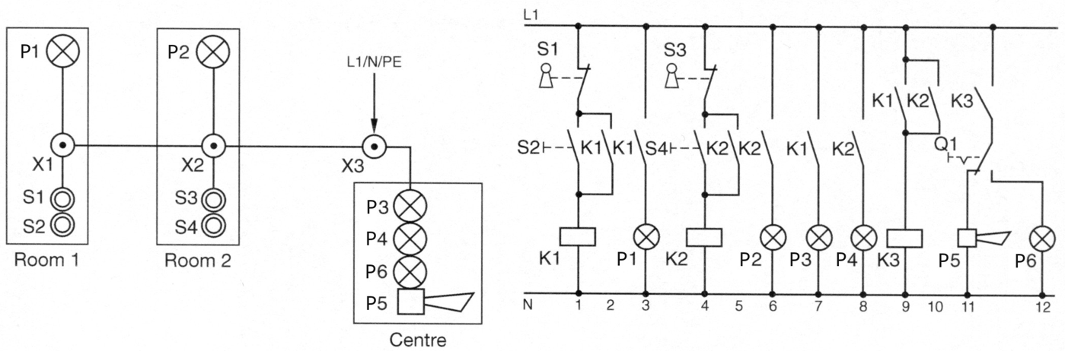Fig. 1: Block diagram Fig. 2: Circuit diagram in detached representation



**Tasks**

1. 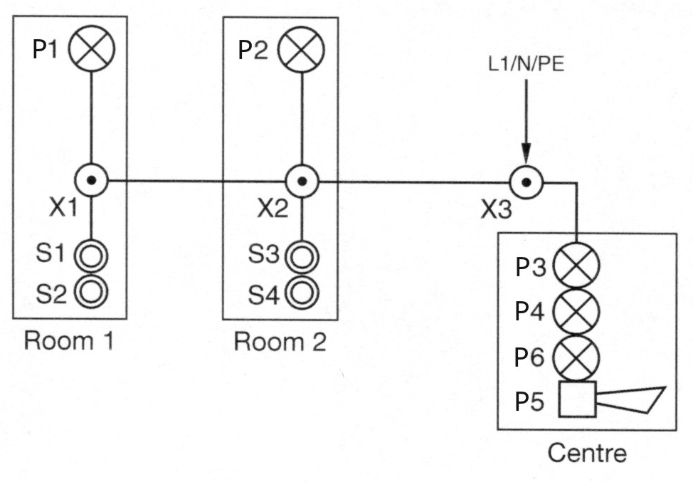Describe the structure of the system using the block diagram! Write down complete sentences in English. Work in pairs and use an online dictionary if necessary.

If you press S1 the lamps P1 in the Room1 and P3 in the Cnatre lights up. If you press S2 the lamps P2 in the Room2 and P4 in the Centre lights up. If if K1 or K2 is actvated the horn ist actvated with Q1 you swtich of the horn and P6 lights up.

|  |  |
| --- | --- |
| English | German |
| 1 | E |
| 2 | H |
| 3 | A |
| 4 | I |
| 5 | C |
| 6 | f |
| 7 | B |
| 8 | G |
| 9 |  |

1. Match the items in English to the items in German. Work in pairs and use an online dictionary if necessary.

|  |  |  |
| --- | --- | --- |
| 1. current path |  | 1. anziehen (Relais) |
| 1. (to) operate |  | 1. Rastschalter |
| 1. (to) energize |  | 1. Zentrale |
| 1. self-holding |  | 1. stromlos |
| 1. centre |  | 1. Strompfad |
| 1. (to) sound |  | 1. ertönen |
| 1. latched switch |  | 1. unterbrochen |
| 1. open-circuited |  | 1. betätigen |
| 1. currentless |  | 1. Selbsthaltung |

1. Explain the function of the system by describing in succession what happens when **S2** is operated.

Fig. 1: Block diagram Fig. 2: Circuit diagram in detached representation



Fill in the gaps in figure 3 using the items given!

closes P3 3 7 self-holding

S2 P1 energizes P5 K3

K1

energizes

K1 (current path …)

closes

K1 (current path …)

closes

K1 (current path 9) closes

… can be opened again

signal lamp … outside room 1 lights

signal lamp … in centre lights

K3

…

… (current path 11) closes

horn … in

centre sounds

K1 (current

path 2)

…

…

of K1

Fig. 3: Flow chart when S2 is operated

1. Explain the function of the system by describing in succession what happens when **Q1** is operated.

Fig. 1: Block diagram Fig. 2: Circuit diagram in detached representation



Fill in the gaps in figure 4 using the items given!

P6 switched off lights P5

horn …

…

signal lamp … in centre …

**Attention! Q1 is a latched switch. If the horn is supposed to sound at further operating of one push-button switch, Q1 has to be reset to the initial position.**

Fig. 4: Flow chart when Q1 is operated

1. Explain the function of the system by describing in succession what happens when **S1** is operated.

Fig. 1: Block diagram Fig. 2: Circuit diagram in detached representation



Fill in the gaps in figure 5 using the items given!

open circuited K1 K3 3 9 currentless currentless self-holding P1 P3

current path 1 open circuited

current path … …

current path 7 open circuited

current path … open circuited

… …

… currentless

… currentless

… currentless

P6 …

current path 2 open circuited

no …

of K1

Fig. 5: Flow chart when S1 is operated